Adaptive Thresholding TMS Task
Core Metrics and Logic Report
Simplified technical description of the current V6 Python implementation
Source basis: AdaptiveTh_TMS_task_ADPTPD_V6.py

1. Executive summary
The task records right-handle force at 500 Hz and makes adaptive stimulation decisions from the early force rise. All adaptive measurements are aligned to detected movement onset, not to the GO cue, so reaction-time differences do not shift the RFD measurement window. The main real-time RFD metric is the slope of smoothed force over the most recent 20 ms. Checks begin 20 ms after onset and repeat every 6 ms. Baseline trials individualize how long checking is allowed to continue, with a hard maximum of 180 ms after onset; on the current grid the latest possible checkpoint is 176 ms.
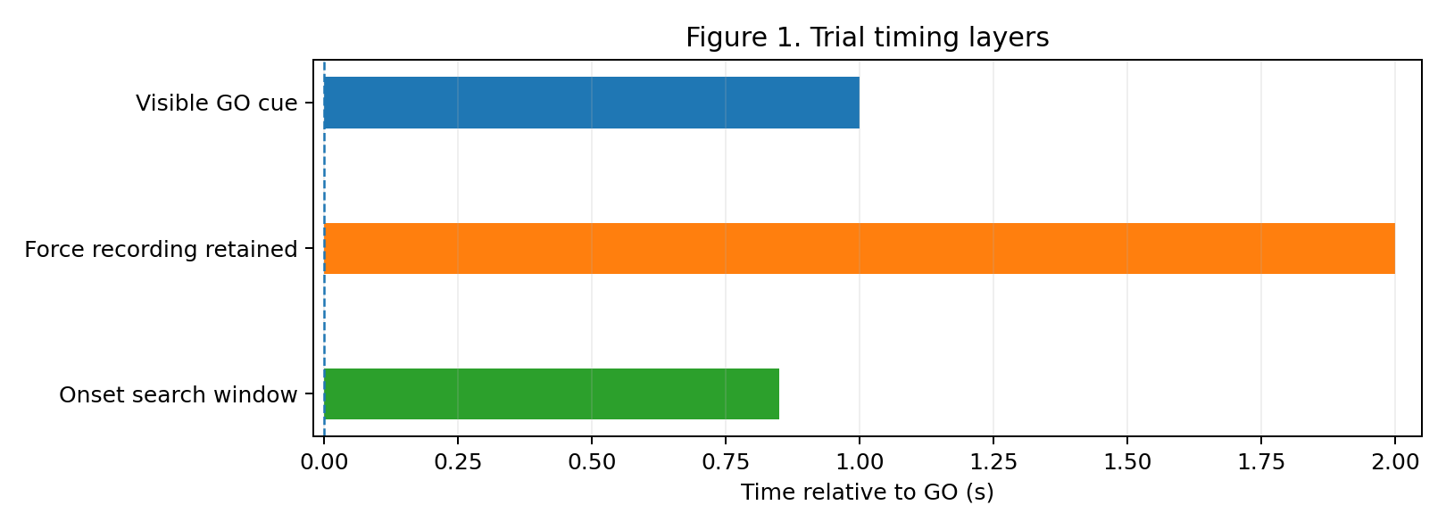

2. Core parameters
Parameter | Current V6 value | Role
Sampling rate | 500 Hz | Force acquisition / timing basis
Smoothing | 3 samples (~6 ms) | Before onset and RFD calculations
Onset threshold | 0.05 MVC | Candidate movement onset
Onset confirmation | 5 samples (~10 ms) | Rejects brief/noisy crossings
Onset search window | 0.850 s after GO | Latest accepted onset
Local RFD window | 20 ms | Linear-regression slope window
Checkpoint start | 20 ms after onset | First adaptive check
Checkpoint step | 6 ms | Near-continuous checking; 70% overlap
RFD adaptive history | Previous 3 profiles | Mean reference at same checkpoint
Force adaptive history | Previous 3 profiles | Mean force reference at same checkpoint
RFD decision margin | 10% | 0.90× BELOW; 1.10× ABOVE
Force decision margin | 10% | 0.90× BELOW; 1.10× ABOVE
Plateau definition | ≥95% peak for 50 ms | Baseline time-to-plateau
Maximum checking end | 180 ms | Hard cap; effective grid endpoint ≤176 ms
Target force | 0.85 MVC ±0.10 | Target region 0.75–0.95 MVC
Main-task trials | 15 | Trials per block
Baseline trials | 10 | Seed individualized references

3. Movement onset and local RFD
Force is smoothed with a 3-sample moving average. Movement onset is accepted when smoothed force reaches at least 0.05 MVC and remains at or above that level for 5 consecutive samples. If no valid onset is found within 0.850 s after GO, the trial cannot produce an adaptive trigger. Once onset is found, it becomes t = 0 for the adaptive measurements.
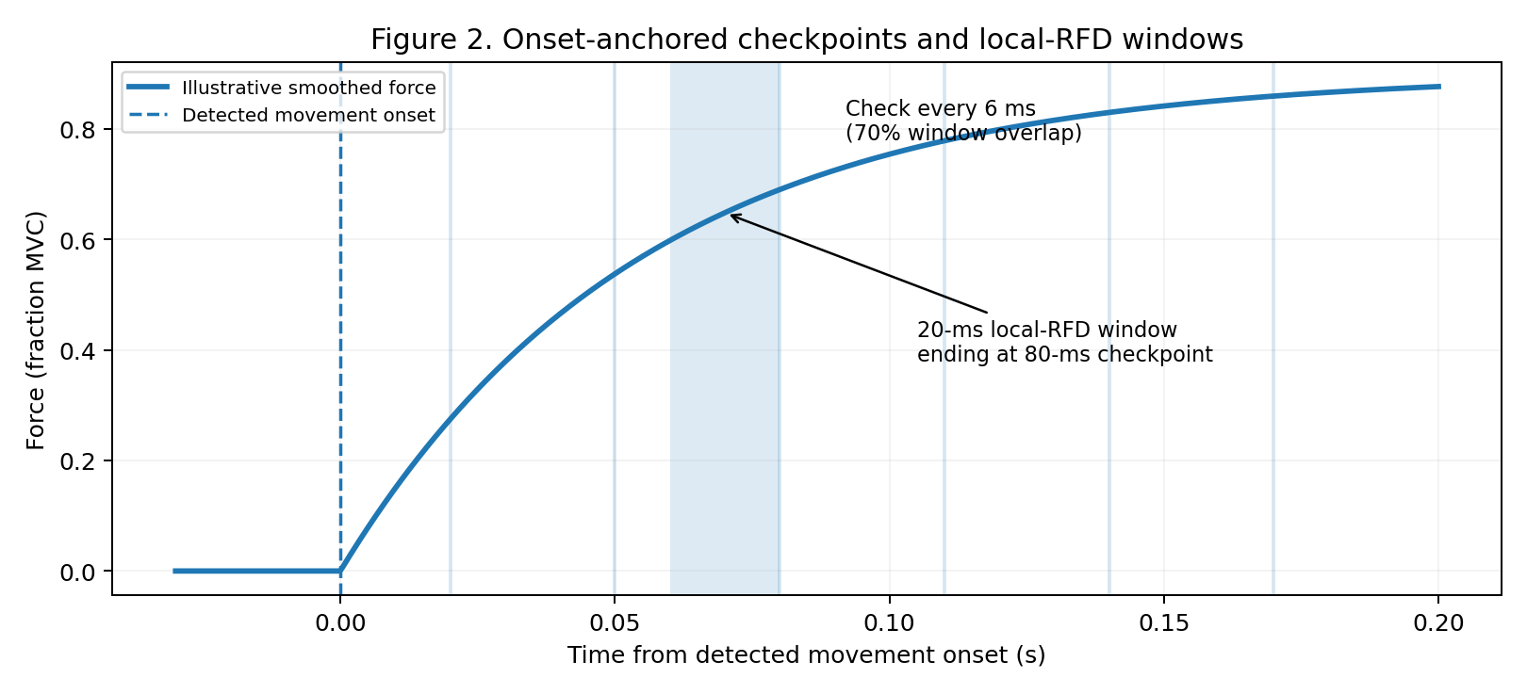
At each checkpoint, the program fits a straight line to the most recent 20 ms of smoothed force. The fitted slope is local RFD in MVC/s. Because checkpoints are only 6 ms apart, adjacent 20-ms windows overlap by 14 ms (70%). This provides frequent updates while the contraction develops. The primary reporting checkpoint is 80 ms after onset.

4. Baseline calibration and individualized checking window
Baseline contains 10 no-stimulation trials. For each valid trial, the code detects onset, finds the post-onset peak force, sets the plateau level to 95% of that peak, and finds the first point at which force remains at or above that level for 50 ms. The valid onset-to-plateau times are averaged. This participant-specific time determines the final adaptive checkpoint, rounded to the 6-ms grid and limited by the 180-ms safety/experimental cap.
Baseline also creates a mean RFD profile and mean force profile at every retained checkpoint. These profiles seed the Main Task. In V6, the main task therefore starts with baseline-derived references rather than waiting several trials before a threshold exists.

5. Adaptive references during the Main Task

5.1 RFD reference
For each checkpoint independently, the RFD reference is the mean of the previous 3 available completed-trial RFD values at that same checkpoint. The baseline mean profile is initially copied into the history, so early Main Task trials already have a usable reference. As trials are completed, real Main Task profiles progressively replace the baseline seed.

5.2 Force reference
The force reference uses the same checkpoint-specific idea and the previous 3 force profiles. It is used to confirm whether the participant's force trajectory is genuinely below or above recent performance rather than relying on RFD alone.

6. Trigger thresholds
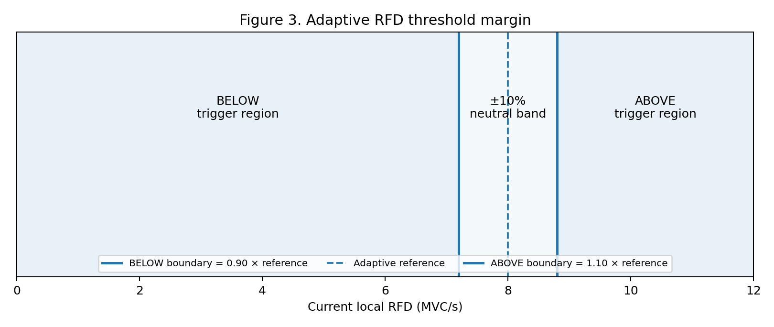
V6 applies a 10% relative margin around the adaptive reference. For RFD, BELOW requires current RFD < 0.90 × the checkpoint reference; ABOVE requires current RFD > 1.10 × the reference. Force uses the same 10% relative margin. In BELOW mode, force must also remain below the force ceiling of 0.75 MVC, which prevents corrective stimulation once force has already entered the target region.
Direction | RFD criterion | Force criterion
BELOW | RFD < 0.90 × adaptive RFD reference | Force < 0.90 × force reference AND force < 0.75 MVC
ABOVE | RFD > 1.10 × adaptive RFD reference | Force > 1.10 × force reference

7. Stimulation modes
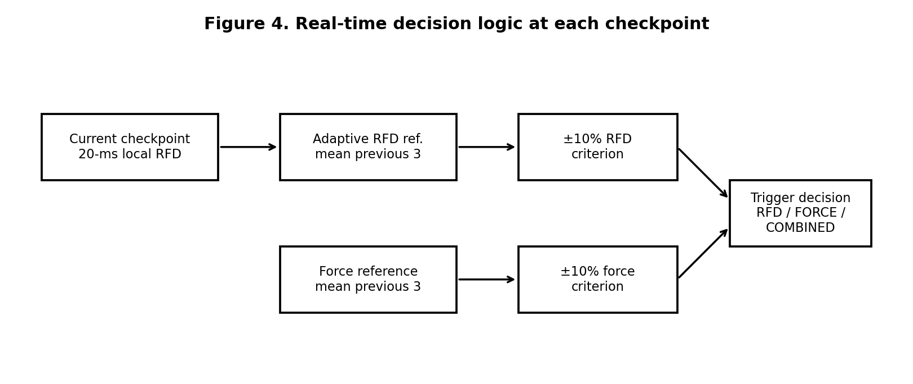
The operator selects one of three metric modes. RFD_ONLY triggers when the RFD criterion passes. FORCE_ONLY triggers when the force criterion passes. COMBINED requires both RFD and force criteria to be true at the same checkpoint. The monitor evaluates checkpoints in time order and sends stimulation at the first eligible checkpoint satisfying the selected rule; only one adaptive stimulation trigger can occur in a trial.

8. Timing and saved data
The visual task and the adaptive analysis use related but distinct timing layers. PREP and GO durations can include jitter. The adaptive monitor begins with GO but waits for detected force onset before starting its checkpoint clock. Force recording continues after the adaptive checking period so the full contraction can be analyzed and plotted. The default post-onset analysis window is 2.0 s.
Saved outputs include trial summaries, time-series force data, calibration information, baseline thresholds/plateau results, checkpoint RFD and force values, trigger timing, and MATLAB-compatible data. Post-hoc plots show the force trajectory, local RFD, adaptive references, and stimulation timing.

9. Compact processing pipeline
- Acquire right-handle force at 500 Hz and normalize it to MVC using the participant calibration.
- Smooth force over 3 samples.
- After GO, search up to 850 ms for force ≥0.05 MVC sustained for 5 samples.
- Set detected movement onset as t = 0 for adaptive metrics.
- Begin adaptive checking at 20 ms after onset and repeat every 6 ms.
- At each checkpoint, fit the most recent 20 ms of smoothed force to obtain local RFD and read force at the same time.
- Compare the current value(s) with checkpoint-specific rolling references using the selected BELOW or ABOVE rule and 10% margins.
- Apply RFD_ONLY, FORCE_ONLY, or COMBINED logic.
- Trigger at the first checkpoint satisfying the selected rule; otherwise stop when the individualized checking window ends.
- Continue retaining data for post-hoc analysis and visualization.

10. Key interpretation
The central idea is simple: the task asks whether the participant's early force development at this exact moment after movement onset is meaningfully lower or higher than their recent checkpoint-specific behavior. RFD captures how quickly force is changing, while the optional force criterion confirms where the actual force trajectory sits. Baseline establishes the participant-specific starting reference and the useful early checking window; subsequent trials continuously update that reference.

