Category C: Sockets

# What?

## Socket

### Network Socket

A socket is an endpoint in a IPC (Inter-process Communication) flow across a computer network. It is used for different processes to communicate with each other with the use of the TCP/IP protocol

### API

The Socket API is the Application Programming Interface used for the sockets, it’s actually a complete collection of different methods that allow the developer/programmer to easily create sockets based on these methods. These methods are mostly provided by the operating system.

Example: Connect(); BeginReceive(); Accept(), ...

### Address

A socket address is mostly made out of the IP address of the host and the port appended to it.

Example: 146.39.84.21:**3443**

**IP ADDRESS: The ip address of the host.**

**PORT: The given port number.**

## Server

A server is a socket that has been made to listen to incoming packets, if a packet has been found then it will check first if it is a connection packet to see if the server has to add this incoming connection to its pool of connected sockets.

## Client

A client is a socket that will send a request to the server, this can contain different data. For example: The client sends the server a request to see the current time, the server the returns this time to the client.

## Reverse Socket Connections

A reverse Socket Connection is a connection that is able to accept incoming connections and to request data from other servers, this is used in for example P2P networking.

## Multi-Threaded sockets

To be able to accept multiple connections and keep those connections alive we are using different threads for each connection.

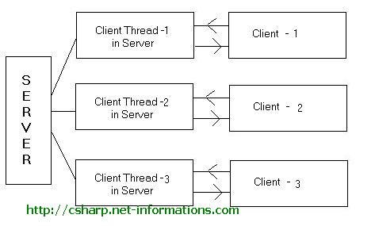

## TCP

The Transmission Control Protocol (TCP) is one of the core protocols of the Internet Protocol Suite. TCP is one of the two original components of the suite, complementing the Internet Protocol (IP), and therefore the entire suite is commonly referred to as TCP/IP. TCP Provide reliable, ordered delivery of a stream of octets from a program on one computer to another program on another computer.

Examples where TCP is used: WWW, Email, Remote Administration, File Transfer

## UDP

The User Datagram Protocol (UDP) is one of the core members of the Internet Protocol suite, the set of network protocols used for the internet. With UDP computer applications can send messages, in this case referred to as datagrams, to other hosts on a Internet Protocol (IP) network without prior communications to set up special transmission channels or data paths. Important to note is that with UDP the packets are not being checked on the validity of the packets, this means that it is much faster than TCP because the packets are not being checked.

Example of usage: Streaming Video, Streaming Audio

# How?

# References

<http://en.wikipedia.org/wiki/Network_socket>

<http://msdn.microsoft.com/en-us/library/system.net.sockets.socket.aspx>

<http://en.wikipedia.org/wiki/Transmission_Control_Protocol>

<http://en.wikipedia.org/wiki/User_Datagram_Protocol>

http://tech.pro/tutorial/704/csharp-tutorial-simple-threaded-tcp-server

# Conclusion

Out of this whole research we can conclude that Office has some great Automation Tools that allow a developer to create his own add-ins for Microsoft Office.

The API has been extended very well and it is possible to change almost anything in Microsoft Office.