Xavier Greer

CS267 – Computer Algorithms

Unit 3 Submission 2

November 22, 2020

The purpose of this academic mini paper is to demonstrate knowledge in multi-dimensional arrays and the Dijkstra algorithm. Since I created the program in C#, I was not able to use the priority queue method. In this program I feel like I may have made it more work than it had to be. The big class that was made for this program was the Graph class, it has a constructor method that sets a value for the vertex and creates a new list that holds integer arrays. A print method is made for printing the list of arrays and the shortest distance between a and z. There is a method for adding a new vertex with weight to the list called Add. Two more methods are within the Graph class, minDistance and Dijkstra. minDistance is used to determine the vertex with the minimum distance. Dijkstra method is an algorithm that finds the shortest path between two points. Within the main method I created a new object called graph and added all the necessary elements to graph’s list. I created a generic list method to convert the list into a multi-dimensional array. The new multi-dimensional array is passed into the method Dijkstra and printed to the command line. I had to look up how to convert the list into a multi-dimensional array. Since the assignment didn’t use the priority queue, I am more than happy to redo the assignment in another language if needed. Any additional guidance on how to write better code is also greatly appreciated.s

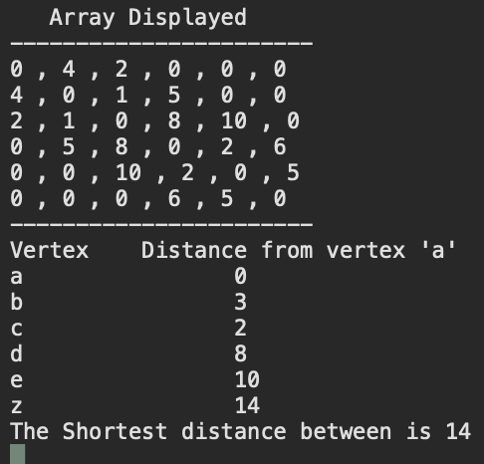

References:

https://stackoverflow.com/questions/1633690/generic-listt-as-parameter-on-method