CS2043

Requirements Specification Draft

Group 4:

Xavier Hébert-Couturier, Team leader 1

Arif Hasan, Team leader 2

Reid Hurlburt

Samuel Keenan

Benjamin Hieblinger Rempel

Greg Kean

University of New Brunswick

Friday October 9, 2019

Table of Contents:

Diagram

Use cases:

1. login

2. displayCourses

3. displayCourseHome

4. displayCourseContent

5. displayAssignments

6. displayGrades

7. updateProfile

8. takeQuiz

9. displayClasslist

10. sendCourseEmail

11. displayGroups

12. updateChecklist

13. contactSupport

14. addCourseContent

15. postCourseGrade

16. createGroups

17. createCourse

Diagram:

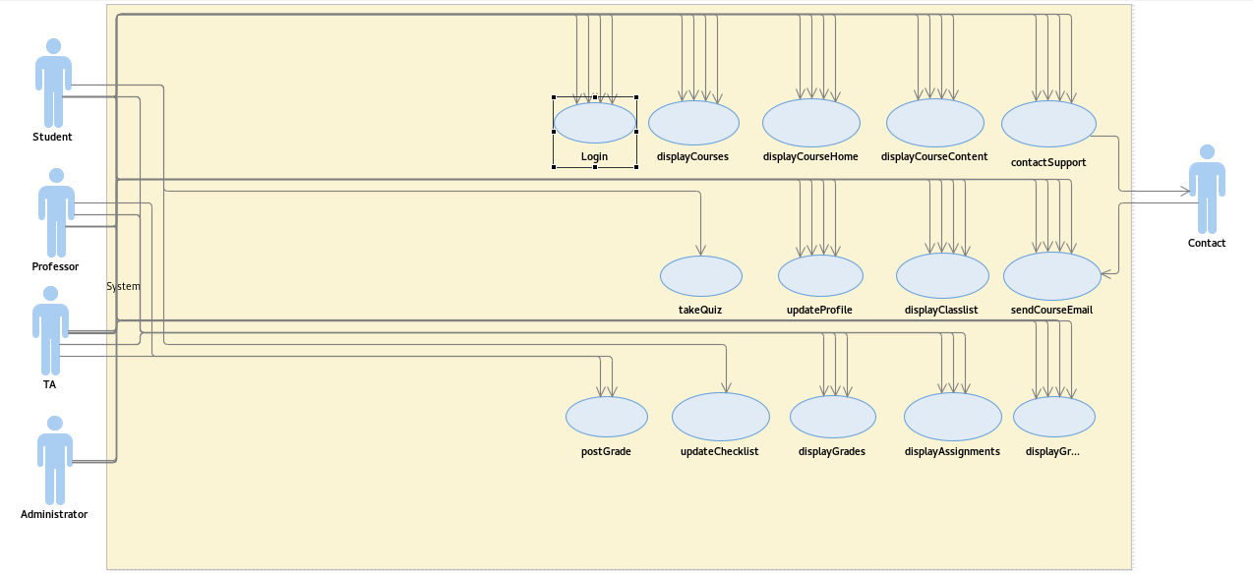

Use cases:

1. Use Case Name: login

Actors: Student, Professor, TA or Administrator

Description: Before accessing their profile’s information and functions, a user must prove their identity of the account by login in with their name and password. This use case is a precondition to access all further use cases.

2. Use Case Name: displayCourses

Actors: Student, Professor, TA or Administrator

Description: Display a list of courses organized by the semester (Fall 2019, Winter 2020, etc.). This shall lead to page with all contents related to the Course (Assignments, Outline, Quizzes, etc.).

3. Use Case Name: displayCourseHome

Actors: Student, Professor, TA or Administrator

Description: Display the contents of a particular course, for example: Assignments, Outline, Labs, Timeline, etc. Each of these contents shall be linked to a page that goes into detail about them. This shall be the central hub for any details related to the Course.

4. Use Case Name: displayCourseContent

Actors: Student, Professor, TA or Administrator

Description: Display the list of content associated with the particular course. This will summarize anything and everything linked to the particular course and shall have a list of links that lead to those particular use cases

5. Use Case Name: displayAssignments

Actors: Student, Professor or TA

Description: Display a list of assignments organized by time posted. One assignment can be selected to view in-depth information (requirements, due date, etc.). Will also be used to submit assignments for the student actors.

6. Use Case Name: displayGrades

Actors: Student, Professor or TA

Description: Display a list of grades, grouped by type (assignment, quiz) and date. One grade can be selected for marker's comments, if applicable.

7. Use Case Name: updateProfile

Actors: Student, Professor, TA or Administrator

Description: Should someone wish to change the information listed on their profile ( photo, address, etc.), they can opt to do so by navigating to the “Update Profile” page.

8. Use Case Name: takeQuiz

Actors: Student

Description: After a quiz has been added to a course’s content by the professor, the student can navigate to this page and opt to take the quiz. After the student completes the quiz, they choose to finalize and submit their answers.

9. Use Case Name: displayClasslist

Actors: Student, Professor, TA or Administrator

Description: The actor will have the option to display the class list. This use case will display a new page which contains every person who is either a professor, TA or student in the class. This list can be sorted alphabetically and by position. A link to email any person in the class can be brought up through this screen.

10. Use Case Name: sendCourseEmail

Actors: Student, Professor, TA or Administrator

Description: The actor will have the option to send and view emails from and to the class. The initial screen will have all emails received from the class. Emails can be composed by selecting a button that will create a new window containing a text editor. After the email is written, the address which the email is to be sent to can be entered in a separate text field.

11. Use Case Name: displayGroups

Actors: Student, Professor, TA or Administrator

Description: Allows actor to view in class groups created by the professor.

**1**2. Use Case Name: updateChecklist

Actors: Student

Description: Allows actor to create, mark complete or remove items from their own checklist.

13. Use Case Name: contactSupport

Actors: Student, Professor, TA or Administrator

Description: If any of the user actors has had an issue with the platform they can send a message directly to the most relevant support employee, whom will then fix the issue and reply to the customer through their contact information.

14. Use case Name: addCourseContent

Actors: Professor and TA

Description: This use case will allow for a professor to create a course and add students, TAs and initial content.

15. Use Case Name: postCourseGrade

Actors: Professor and TA

Description: After a particular piece of course work has been submitted and graded, the TA or Professor actor can choose to post the student’s grade.

16. Use Case Name: createGroups

Actors: Professor

Description: Allows professor actor to sort students from a particular class into groups.

17. Use case Name: createCourse

Actors: Administrators

Description: An administrator has the option to create a course and assign a professor to it.