jQuery prop()

The prop method in jQuery is used to get or set properties of DOM elements.

It is commonly used for boolean properties (like checked, disabled, selected, etc.) or for properties that are not directly related to CSS styling.

To set a property, you use the prop method with two arguments:
the name of the property
the value you want to set it to.

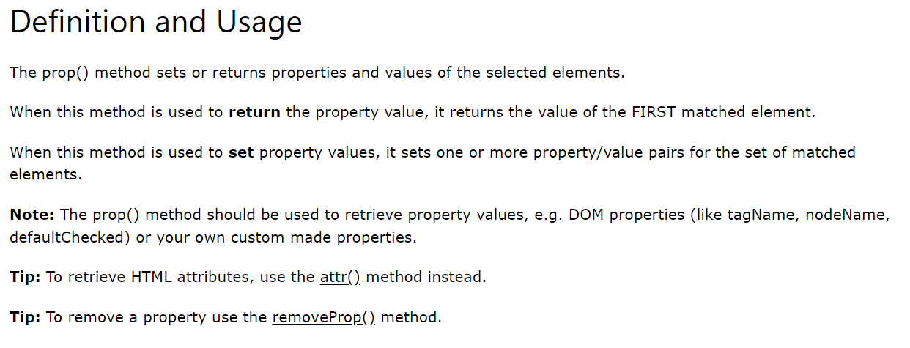

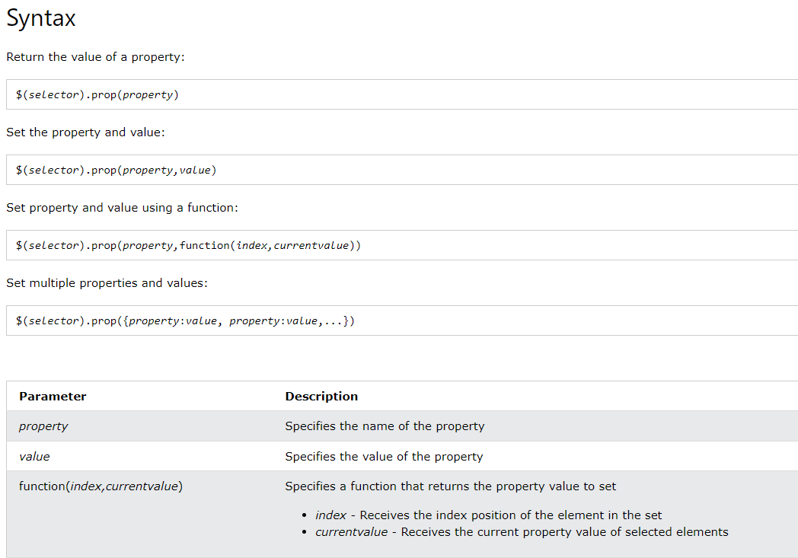

Eg: Consolidated example that demonstrates setting, getting, and toggling properties using the jQuery prop method.

<body>
<!-- Placing HTML Code for jQuery Code demonstrartion-->
<input type="checkbox" id="checkbox"> Checkbox<br>
<button id="button">Button</button><br><br>
<button id="setPropBtn">Set Properties</button>
<button id="getPropBtn">Get Properties</button>
<button id="togglePropBtn">Toggle Button Disabled</button>
<!--
This is the script link you have to put so jquery gets loaded first
else you get error , : $ is not defined
-->
<script src="/jQuery/node_modules/jquery/dist/jquery.min.js"></script>
<script>
$(document).ready(function () {
// Set property example
$("#setPropBtn").click(function () {
$("#checkbox").prop("checked", true); // Set the checked property
$("#button").prop("disabled", true); // Set the disabled property
});

// Get property example
$("#getPropBtn").click(function () {
var isChecked = $("#checkbox").prop("checked"); // Get the checked property
var isDisabled = $("#button").prop("disabled"); // Get the disabled property
alert("Checkbox checked: " + isChecked + "\nButton disabled: " + isDisabled);
});
// Toggle property example
$("#togglePropBtn").click(function () {
var isDisabled = $("#button").prop("disabled");
$("#button").prop("disabled", !isDisabled); // Toggle the disabled property
});
});
</script>
</body>

Output
