jQuery addClass()
The addClass() method adds one or more class names to the selected elements.
This method does not remove existing class attributes, it only adds one or more class names to the class attribute.
Tip: To add more than one class, separate the class names with spaces.

Syntax
$(selector).addClass(classname,function(index,currentclass))

Parameter | Description
classname | Required. Specifies one or more class names to be added
function(index,currentclass) | Optional. Specifies a function that returns one or more class names to be added  - index - Returns the index position of the element in the set  - currentclass - Returns the current class name of the selected element

Code - 1 - add Class

<body>
<!-- Placing HTML Code for jQuery Code demonstrartion-->
<button class="cl">Add Class</button>
<p>Add me some style!..</p>
<!--
This is the script link you have to put so jquery gets loaded first
else you get error , : $ is not defined
-->
<script src="/jQuery/node_modules/jquery/dist/jquery.min.js"></script>
<script>
$(document).ready(function(){
$(".cl").click(function(){
$("p").addClass("addClassStyle");
})
});
</script>
</body>

Code - 2 - add multiple class

<body>
<!-- Placing HTML Code for jQuery Code demonstrartion-->
<button class="cl">Add Class</button>
<p>Add me some style!..</p>
<!--
This is the script link you have to put so jquery gets loaded first
else you get error , : $ is not defined
-->
<script src="/jQuery/node_modules/jquery/dist/jquery.min.js"></script>
<script>
$(document).ready(function(){
$(".cl").click(function(){
$("p").addClass("addClassStyle addCurving");
})
});
</script>
</body>

Code - 3 - add using function

<body>
<!-- Placing HTML Code for jQuery Code demonstrartion-->
<button class="cl">Add Class</button>
<p>Add me some style!..</p>
<p>Add me some style!..</p>
<p>Add me some style!..</p>
<p>Add me some style!..</p>
<!--
This is the script link you have to put so jquery gets loaded first
else you get error , : $ is not defined
-->
<script src="/jQuery/node_modules/jquery/dist/jquery.min.js"></script>
<script>
$(document).ready(function(){
$(".cl").click(function(){
$("p").addClass(function(n){

console.log(n);//0 1 2 3

return "par_" + n;
});
})
});
</script>
</body>

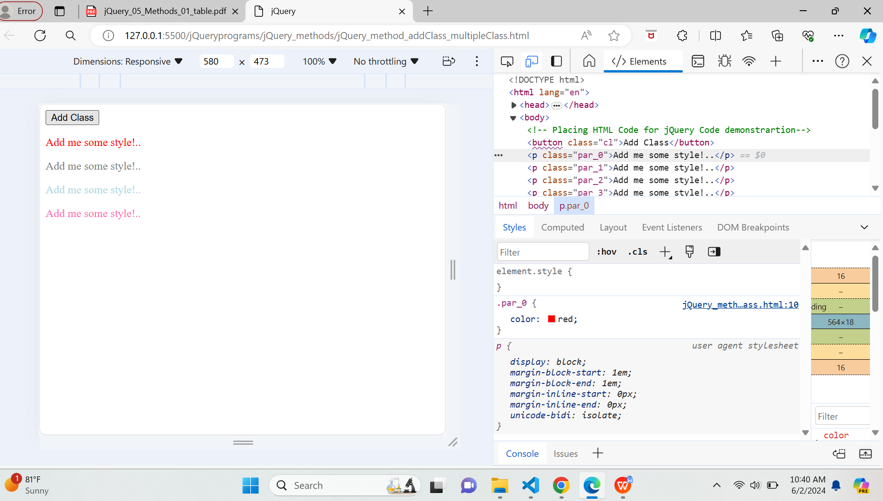

jQuery removeClass()
The removeClass() method removes one or more class names from the selected elements.
Note: If no parameter is specified, this method will remove ALL class names from the selected elements.

Syntax
$(selector).removeClass(classname,function(index,currentclass))
Parameter | Description
classname | Optional. Specifies one or more class names to remove. To remove several classes, separate the class names with space  Note: If this parameter is empty, all class names will be removed
function(index,currentclass) | Optional. A function that returns one or more class names to remove  - index - Returns the index position of the element in the set  - currentclass - Returns the current class name of selected elements

Code - 1 - remove Class

<body>
<!-- Placing HTML Code for jQuery Code demonstrartion-->
<label>Enter Email :</label>
<input type="email" id="email" class="email" value="" name="" />
<span class="validate"></span>
<input type="submit" class="sub" id="sub" value="Validate Email" />

<button class="removeClass">Remove Validations</button>
<!--
This is the script link you have to put so jquery gets loaded first
else you get error , : $ is not defined
-->
<script src="/jQuery/node_modules/jquery/dist/jquery.min.js"></script>
<script>
$(document).ready(function () {
$(".sub").click(function () {
let givemail = $("#email").val();
let printRes = $(".validate");
const emailEx = /^[^\s@]+@[^\s@]+\.[^\s@]+$/;
const res = givemail.match(emailEx);
//returns an array if the email is valid and null if it's invalid.
if (res) {
console.log(res);
printRes.text("Valid email").addClass("validEmail");
} else {
console.log(res);
printRes.text("Please enter the email again as it is invalid!").addClass("invalidEmail");
}
});
$(".removeClass").click(function(){
$(".validate").text("").removeClass("validEmail invalidEmail");//removeClass()
$("#email").val("");
});
});
</script>
</body>

jQuery hasClass()
The jQuery hasClass() method is used to check whether selected elements have specified class name or not.
It returns TRUE if the specified class is present in any of the selected elements otherwise it returns FALSE.
Syntax:
$(selector).hasClass(classname)

Parameters of jQuery hasClass() method
Parameter | Description
className | It is a mandatory parameter.  It specifies the name of the CSS class to search for in the selected elements.

Code - 1 - check Class

<body>
<!-- Placing HTML Code for jQuery Code demonstrartion-->
<button class="bl">Check Class</button>
<p class="classForBtn"></p>
<!--
This is the script link you have to put so jquery gets loaded first
else you get error , : $ is not defined
-->
<script src="/jQuery/node_modules/jquery/dist/jquery.min.js"></script>
<script>
$(document).ready(function(){
$(".bl").click(function(){
var doesItHasClass = $(".classForBtn").hasClass("classForBtn");
$(".classForBtn").text("Has Class ?" + doesItHasClass);//true
if(doesItHasClass){
alert("Selected!...")
}else{
alert("No Join!..")
}
})
});
</script>
</body>

jQuery toggleClass()
The toggleClass() method toggles between adding and removing one or more class names from the selected elements.
This method checks each element for the specified class names.
The class names are added if missing, and removed if already set - This creates a toggle effect.
However, by using the "switch" parameter, you can specify to only remove, or only add a class name.
Syntax
$(selector).toggleClass(classname,function(index,currentclass),switch)

Parameter | Description
classname | Required. Specifies one or more class names to add or remove. To specify several classes, separate the class names with a space
function(index,currentclass) | Optional. Specifies a function that returns one or more class names to add/remove  - index - Returns the index position of the element in the set  - currentclass - Returns current class name of selected elements
switch | Optional. A Boolean value specifying if the class should only be added (true), or only be removed (false)

Code - 1 - toggle Class

<body>
<!-- Placing HTML Code for jQuery Code demonstrartion-->
<button class="cl">Add Class</button>
<p>Add me some style!..</p>
<!--
This is the script link you have to put so jquery gets loaded first
else you get error , : $ is not defined
-->
<script src="/jQuery/node_modules/jquery/dist/jquery.min.js"></script>
<script>
$(document).ready(function(){
$(".cl").click(function(){
$("p").toggleClass("addClassStyle");
})
});
</script>
</body>

Code 2 - toggle class using switch parameter

<body>
<!-- Placing HTML Code for jQuery Code demonstrartion-->
<button class="cl">Add Class</button>
<button class="c2">Remove Class</button>
<p>Add me some style!..</p>
<!--
This is the script link you have to put so jquery gets loaded first
else you get error , : $ is not defined
-->
<script src="/jQuery/node_modules/jquery/dist/jquery.min.js"></script>
<script>
$(document).ready(function(){
$(".cl").click(function(){
$("p").toggleClass("addClassStyle", true);//adding
});
$(".c2").click(function(){
$("p").toggleClass("addClassStyle", false);//removing
})
});
</script>
</body>

