BASICS OF WEB DEVELOPMENT - HTML 1
Number | Topic | Link
1 | WHAT IS HTML? | WHAT IS HTML?
2 | A Simple HTML Document? | A Simple HTML Document?
3 | What is an HTML Element? | What is an HTML Element?
4 | What is Empty Tag? | What is Empty Tag?
5 | What is Web Browsers? | What is Web Browsers?
6 | HTML Terminologies of few basics? | HTML Terminologies of few basics?
7 | Is HTML Case Sensitive? | Is HTML Case Sensitive?
8 | What are Attributes? | What are Attributes?
9 | For attributes value, can we  use single or double quotes? | For attributes value, can we use single or double quotes?
10 | Html Comments | Html Comments
11 | HTML Text Formatting and Quotations? | HTML Text Formatting and Quotations?
12 | What are HTML Colors? | What are HTML Colors?
13 | What are HTML Links? | What are HTML Links?  Short Description Link
14 | What are HTML Links Uses? | What are HTML Links Uses?
15 | What are HTML Link Bookmarks? | What are HTML Link Bookmarks?
16 | HTML Images | HTML Images  HTML Images Short Details
17 | HTML - Screen Reader | HTML Screen Reader
18 | What are HTML Images Uses?  <picture> | What are HTML Images Uses?  Image Map

- WHAT IS HTML?

- HTML stands for Hyper Text Markup Language
- HTML is the standard markup language for creating Web pages
- HTML describes the structure of a Web page
- HTML consists of a series of elements
- HTML elements tell the browser how to display the content
- HTML elements label pieces of content such as "this is a heading", "this is a paragraph", "this is a link", etc.

- A Simple HTML Document?

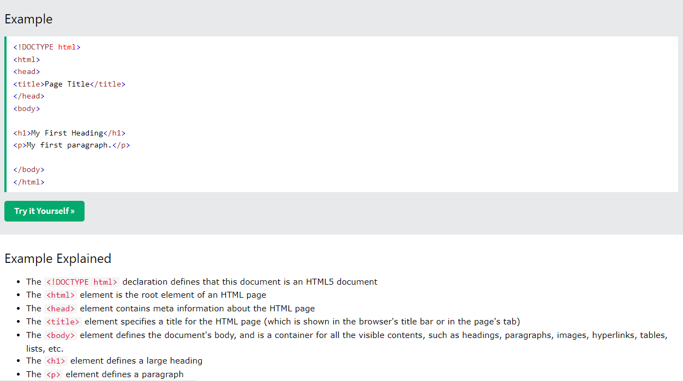

- What is an HTML Element?

- An HTML element is defined by a start tag, some content, and an end tag.
- Syntax : <tagname> Content goes here... </tagname>

- What is Empty Tag?

- Some HTML elements have no content (like the <br> element).
- These elements are called empty elements.
- Empty elements do not have an end tag!

- What is Web Browsers?

- The purpose of a web browser (Chrome, Edge, Firefox, Safari) is to read HTML documents and display them correctly.
- A browser does not display the HTML tags, but uses them to determine how to display the document.

- HTML Terminologies of few basics?
Number | Topic | Details
1 | The <!DOCTYPE> Declaration | The <!DOCTYPE> declaration represents the document type, and helps browsers to display web pages correctly.  It must only appear once, at the top of the page (before any HTML tags).  The <!DOCTYPE> declaration is not case sensitive.  The <!DOCTYPE> declaration for HTML5 is: <!DOCTYPE html>
2 | HTML Headings | HTML headings are defined with the <h1> to <h6> tags.  <h1> defines the most important heading. <h6> defines the least important heading.  Example  <h1>This is heading 1</h1>  <h2>This is heading 2</h2>  <h3>This is heading 3</h3>
3 | HTML Paragraphs | HTML paragraphs are defined with the <p> tag.  Example:  <p>This is a paragraph.</p>  <p>This is another paragraph.</p>
4 | HTML Links | HTML links are defined with the <a> tag.  Example:  <a href="https://www.w3schools.com">This is a link</a>  The link's destination is specified in the href attribute.  Click Here for more info!..  Click here to go back to index!..
5 | Attributes | Attributes are used to provide additional information about HTML elements.
6 | HTML Images | HTML images are defined with the <img> tag.  The source file (src), alternative text (alt), width, and height are provided as attributes.  Example  <img src="w3schools.jpg" alt="W3Schools.com" width="104" height="142">  Click here to get <picture> info!..  Click here to get more info!.. Click here to scroll to index
7 | How to View HTML Source | View HTML Source Code:  Click CTRL + U in an HTML page, or right-click on the page and select "View Page Source". This will open a new tab containing the HTML source code of the page.  Inspect an HTML Element:  Right-click on an element (or a blank area), and choose "Inspect" to see what elements are made up of (you will see both the HTML and the CSS). You can also edit the HTML or CSS on-the-fly in the Elements or Styles panel that opens.

- Is HTML Case Sensitive?

- HTML is Not Case Sensitive.
- HTML tags are not case sensitive: <P> means the same as <p>.
- The HTML standard does not require lowercase tags, but W3C recommend

- lowercase in HTML
- demands lowercase for stricter document types like XHTML.

- What are Attributes?

- HTML attributes provide additional information about HTML elements.
- All HTML elements can have attributes.
- Attributes are always specified in the start tag.
- Attributes usually come in name/value pairs like: name="value".

- For attributes value, can we use single or double quotes?

- Double quotes around attribute values are the most common in HTML, but single quotes can also be used.
- In some situations, when the attribute value itself contains double quotes, it is necessary to use single quotes.

- <p title='John "ShotGun" Nelson'>
Or vice versa:
<p title="John 'ShotGun' Nelson">

- What are HTML Comments?

- HTML comments are not displayed in the browser, but they can help document your HTML source code.

- HTML Comment Tag:
You can add comments to your HTML source by using the following syntax:

<!-- Write your comments here -->

- Notice that there is an exclamation point (!) in the start tag, but not in the end tag.

- Tell me some tags about HTML Text Formatting and Quotations? (16)
Tag Name | Tag | Details
Bold Tag | <b> | The HTML <b> element defines bold text, without any extra importance.
Strong Tag | <strong> | The HTML <strong> element defines text with strong importance. The content inside is typically displayed in bold.
Itallic Tag | <i> | The HTML <i> element defines a part of text in an alternate voice or mood. The content inside is typically displayed in italic.  The <i> tag is often used to indicate a technical term, a phrase from another language, a thought, a ship name, etc.
Emphazied Tag | <em> | The HTML <em> element defines emphasized text. The content inside is typically displayed in italic.  A screen reader will pronounce the words in <em> with an emphasis, using verbal stress.
Small Tag | <small> | This element defines smaller text.
Mark Tag | <mark> | This element defines text that should be marked or highlighted.
Del Tag | <del> | This element defines text that has been deleted from a document.  Browsers will usually strike a line through deleted text.
Insert Tag | <ins> | This element defines a text that has been inserted into a document.  Browsers will usually underline inserted text.
Sub Tag | <sub> | - This defines subscript text.  - Subscript text appears half a character below the normal line, and is sometimes rendered in a smaller font.  - Subscript text can be used for chemical formulas, like H2O.
Sup Tag | <sup> | - This element defines superscript text.  - Superscript text appears half a character above the normal line, and is sometimes rendered in a smaller font.  - Superscript text can be used for footnotes, like WWW[1].
BlockQuote | <blockquote> | This defines a section that is quoted from another source.
Short Quotations | <q> | The HTML <q> tag defines a short quotation.  Browsers normally insert quotation marks around the quotation.
Abberviation Tag | <abbr> | - This tag defines an abbreviation or an acronym.  - Marking abbreviations can give useful information to browsers, translation systems and search-engines.  - Use the global title attribute to show the description for the abbreviation/acronym when you mouse over the element.
Address Tag | <address> | - This tag defines the contact information for the author/owner of a document or an article.  - The contact information can be an email address, URL, physical address, phone number, social media handle, etc.  - The text in the <address> element usually renders in italic, and browsers will always add a line break before and after the <address> element.
Work Title | <cite> | - The HTML <cite> tag defines the title of a creative work (e.g. a book, a poem, a song, a movie, a painting, a sculpture, etc.).  - Note: A person's name is not the title of a work.  - The text in the <cite> element usually renders in italic.
Bi-Directional Override | <bdo> | - BDO stands for Bi-Directional Override.  - The HTML <bdo> tag is used to override the current text direction.  - Eg: <bdo dir="rtl">right to left</bdo>

- What are HTML Colors?
COLOR CODE  NAME | DETAILS | SYNTAX
RGB | - Each parameter (red, green, and blue) defines the intensity of the color with a value between 0 and 255.  - This means that there are 256 x 256 x 256 = 16777216 possible colors.  - For example, rgb(255, 0, 0) : It is displayed as red, because red is set to its highest value (255), and the other two (green and blue) are set to 0.  - Another example, rgb(0, 255, 0) is displayed as green, because green is set to its highest value (255), and the other two (red and blue) are set to 0.  - To display black, set all color parameters to 0, like this: rgb(0, 0, 0).  - To display white, set all color parameters to 255, like this: rgb(255, 255, 255). | In HTML, a color can be specified as an RGB value, using this formula:  rgb(red, green, blue)
RGBA | - RGBA color values are an extension of RGB color values with an Alpha channel- which specifies the opacity for a color.  - The alpha parameter is a number between 0.0 (fully transparent) and 1.0 (not transparent at all). | An RGBA color value is specified with:  rgba(red, green, blue, alpha)
HEX | - Where rr (red), gg (green) and bb (blue) are hexadecimal values between 00 and ff (same as decimal 0-255).  - For example, #ff0000 is displayed as red, because red is set to its highest value (ff), and the other two (green and blue) are set to 00.  - Another example, #00ff00 is displayed as green, because green is set to its highest value (ff), and the other two (red and blue) are set to 00.  - To display black, set all color parameters to 00, like this: #000000.  - To display white, set all color parameters to ff, like this: #ffffff.  - A hexadecimal color is specified with: #RRGGBB, where the RR (red), GG (green) and BB (blue) hexadecimal integers specify the components of the color. | In HTML, a color can be specified using a hexadecimal value in the form:  #rrggbb
HSL | - HSL stands for hue, saturation, and lightness.  - Hue is a degree on the color wheel from 0 to 360. 0 is red, 120 is green, and 240 is blue.  - Saturation is a percentage value. 0% means a shade of gray, and 100% is the full color.  - Lightness is also a percentage value. 0% is black, and 100% is white.  - Saturation can be described as the intensity of a color.  - 100% is pure color, no shades of gray.  - 50% is 50% gray, but you can still see the color.  - 0% is completely gray; you can no longer see the color.  - The lightness of a color can be described as how much light you want to give the color,where 0% means no light (black), 50% means 50% light (neither dark nor light), and 100% means full lightness (white). | In HTML, a color can be specified using hue, saturation, and lightness (HSL) in the form:  hsl(hue, saturation, lightness)
HSLA | - HSLA color values are an extension of HSL with an Alpha channel (opacity).  - The alpha parameter is a number between 0.0 (fully transparent) and 1.0 (not transparent at all). | An HSLA color value is specified with:  hsla(hue, saturation, lightness, alpha)

- What are HTML Links?

- Links are found in nearly all web pages.
- Links allow users to click their way from page to page. You can click on a link and jump to another document.
- HTML links are hyperlinks.

- When you move the mouse over a link, the mouse arrow will turn into a little hand.
- Note: A link does not have to be text. A link can be an image or any other HTML element!

- The most important attribute of the <a> element is the href attribute, which indicates the link's destination.
- The link text is the part that will be visible to the reader.
- Clicking on the link text, will send the reader to the specified URL address.

- HTML Links - Syntax
The HTML <a> tag defines a hyperlink. It has the following syntax:

<a href="url">link text</a>

- By default, a link will appear like this (in all browsers). You can change the link state colors, by using CSS.:-

- An unvisited link is underlined and blue.
- A visited link is underlined and purple.
- An active link is underlined and red.

- HTML Links - The target Attribute
- By default, the linked page will be displayed in the current browser window. To change this, you must specify another target for the link.The target attribute specifies where to open the linked document.

- The target attribute can have one of the following values.
Number | Name | Details
1 | _self | Default. Opens the document in the same window/tab as it was clicked.
2 | _blank | Opens the document in a new window or tab.
3 | _parent | Opens the document in the parent frame.
4 | _top | Opens the document in the full body of the window

- Absolute URLs vs. Relative URLs

- A local link (a link to a page within the same website) is specified with a relative URL (without the "https://www" part).

- Example:

<h2>Absolute URLs</h2>
<p><a href="https://www.w3.org/">W3C</a></p>
<p><a href="https://www.google.com/">Google</a></p>

<h2>Relative URLs</h2>
<p><a href="html_images.asp">HTML Images</a></p>
<p><a href="/css/default.asp">CSS Tutorial</a></p>

- HTML Links Uses

Number | Use Case Name | Details | Example
1 | Use an Image as a Link | To use an image as a link, just put the <img> tag inside the <a> tag. | <a href="default.asp">  <img src="smiley.gif" alt="HTML tutorial" style="width:42px;height:42px;">  </a>
2 | Link to an Email Address | Use mailto: inside the href attribute to create a link that opens the user's email program (to let them send a new email). | <a href="mailto:someone@example.com">Send email</a>
3 | Button as a Link | To use an HTML button as a link, you have to add some JavaScript code.  JavaScript allows you to specify what happens at certain events, such as a click of a button. | <button onclick="document.location='default.asp'">  HTML Tutorial  </button>
4 | Link Titles | The title attribute specifies extra information about an element. The information is most often shown as a tooltip text when the mouse moves over the element | <a href="https://www.w3schools.com/html/" title="Go to W3Schools HTML section">Visit our HTML Tutorial</a>

- What are HTML Links Bookmarks?

- HTML links can be used to create bookmarks, so that readers can jump to specific parts of a web page.
- Bookmarks can be useful if a web page is very long.

- Eg:

- First, use the id attribute to create a bookmark: <h2 id="C4">Chapter 4</h2>

- Then, add a link to the bookmark ("Jump to Chapter 4"), from within the same page:

<a href="#C4">Jump to Chapter 4</a>

- You can also add a link to a bookmark on another page: <a href="html_demo.html#C4">Jump to Chapter 4</a>

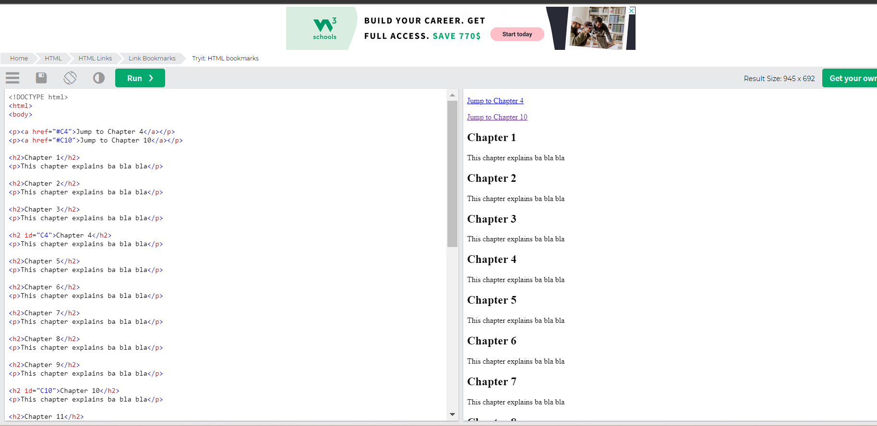

- What are HTML Images?

- Images can improve the design and the appearance of a web page.
- The HTML <img> tag is used to embed an image in a web page.

- Images are not technically inserted into a web page; images are linked to web pages.
- The <img> tag creates a holding space for the referenced image.

- The <img> tag is empty, it contains attributes only, and does not have a closing tag.
- The <img> tag has two required attributes:
- src - Specifies the path to the image.
- alt - Specifies an alternate text for the image.

- Syntax:

<img src="url" alt="alternatetext">

- Images Attributes:

Number | Attribute  Name | Details | Example
1 | src | - The required src attribute specifies the path (URL) to the image.  - When a web page loads, it is the browser, at that moment, that gets the image from a web server and inserts it into the page.  - Therefore, make sure that the image actually stays in the same spot in relation to the web page, otherwise your visitors will get a broken link icon.  - The broken link icon and the alt text are shown if the browser cannot find the image. | <img src="img_chania.jpg" alt="Flowers in Chania">
2 | alt | - The required alt attribute provides an alternate text for an image, if the user for some reason cannot view it (because of slow connection, an error in the src attribute, or if the user uses a screen reader).  - The value of the alt attribute should describe the image. | <img src="img_chania.jpg" alt="Flowers in Chania">
3 | Width and height | - You can use the style attribute to specify the width and height of an image.  - Alternatively, you can use the width and height attributes.  - The width and height attributes always define the width and height of the image in pixels.  - Always specify the width and height of an image. If width and height are not specified, the web page might flicker while the image loads. | <img src="img_girl.jpg" alt="Girl in a jacket" style="width:500px;height:600px;">

- What are HTML Images Uses?

Number | Use Case Name | Details | Example
1 | Images in Another Folder | If you have your images in a sub-folder, you must include the folder name in the src attribute. | <img src="/images/html5.gif" alt="HTML5 Icon" style="width:128px;height:128px;">
2 | Images on Another Server/Website | - Some web sites point to an image on another server.  - To point to an image on another server, you must specify an absolute (full) URL in the src attribute.  - External images might be under copyright. If you do not get permission to use it, you may be in violation of copyright laws. In addition, you cannot control external images; they can suddenly be removed or changed. | <img src="https://www.w3schools.com/images/w3schools_green.jpg" alt="W3Schools.com">
3 | Animated Images | HTML allows animated GIFs. | <img src="programming.gif" alt="Computer Man" style="width:48px;height:48px;">
4 | Image as a Link | To use an image as a link, put the <img> tag inside the <a> tag. | <a href="default.asp">  <img src="smiley.gif" alt="HTML tutorial" style="width:42px;height:42px;">  </a>
5 | Common Image  Formats
  Abbreviation | File Format | File Extension
  APNG | Animated Portable Network Graphics | .apng
  GIF | Graphics Interchange Format | .gif
  ICO | Microsoft Icon | .ico, .cur
  JPEG | Joint Photographic Expert Group image | .jpg, .jpeg, .jfif, .pjpeg, .pjp
  PNG | Portable Network Graphics | .png
  SVG | Scalable Vector Graphics | .svg

- HTML - Screen Reader

- A screen reader is a software program that reads the HTML code, and allows the user to "listen" to the content.
- Screen readers are useful for people who are visually impaired or learning disabled.

- HTML - Image Map

- The HTML <map> tag defines an image map.
- An image map is an image with clickable areas. The areas are defined with one or more <area> tags.

- How Does it Work?

- The idea behind an image map is that you should be able to perform different actions depending on where in the image you click.

- To create an image map you need an image, and some HTML code that describes the clickable areas.

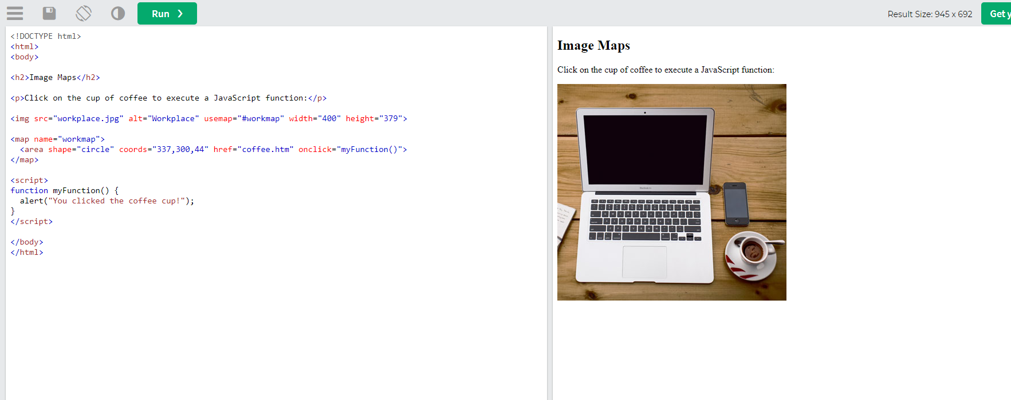

STEP NO | STEP DETAILS | EXAMPLE
1 | - The image is inserted using the <img> tag.  - The only difference from other images is that you must add a usemap attribute.  - The usemap value starts with a hash tag # followed by the name of the image map, and is used to create a relationship between the image and the image map.  - You can use any image as an image map. | <img src="workplace.jpg" alt="Workplace"  usemap="#workmap">
2 | - Create Image Map  - Then, add a <map> element.  - The <map> element is used to create an image map, and is linked to the image by using the required name attribute:  - The name attribute must have the same value as the <img>'s usemap attribute . | <map name="workmap">
3 | The Areas  Then, add the clickable areas.  A clickable area is defined using an <area> element.  Shape  You must define the shape of the clickable area, and you can choose one of these values.  You must also define some coordinates to be able to place the clickable area onto the image. | Rect - defines a rectangular region  circle - defines a circular region  Poly - defines a polygonal region.  default - defines the entire region  <area shape="rect" coords="34, 44, 270, 350" href="computer.htm">  <area shape="circle" coords="337, 300, 44" href="coffee.htm">  <area shape="poly" coords="140,121,181,116,204,160,204,222,191,270,140,329,85,355,58,352,37,322,40,259,103,161,128,147" href="croissant.htm">

- <picture>

- Click here to get more Images details!…

- The HTML <picture> element allows you to display different pictures for different devices or screen sizes.

- The HTML <picture> element gives web developers more flexibility in specifying image resources.

- The <picture> element contains one or more <source> elements, each referring to different images through the srcset attribute.

- This way the browser can choose the image that best fits the current view and/or device.

- Each <source> element has a media attribute that defines when the image is the most suitable.

- Always specify an <img> element as the last child element of the <picture> element.

- The <img> element is used by browsers that do not support the <picture> element, or if none of the <source> tags match.

When to use the Picture Element
There are two main purposes for the <picture> element:

1. Bandwidth
If you have a small screen or device, it is not necessary to load a large image file. The browser will use the first <source> element with matching attribute values, and ignore any of the following elements.

2. Format Support
Some browsers or devices may not support all image formats. By using the <picture> element, you can add images of all formats, and the browser will use the first format it recognizes, and ignore any of the following elements.
The browser will use the first <source> element with matching attribute values, and ignore any following <source> elements.
Eg:
<picture>
<source srcset="img_avatar.png">
<source srcset="img_girl.jpg">
<img src="img_beatles.gif" alt="Beatles" style="width:auto;">
</picture>

