BASICS OF WEB DEVELOPMENT - HTML 2

Number | Topic | Link
19 | WHAT IS HTML FAVICON? | WHAT IS HTML FAVICON?
20 | WHAT IS HTML TABLES? | WHAT IS HTML TABLES?
21 | HTML LISTS | HTML LISTS
22 | DIV TAG | DIV TAG
23 | HTML BLOCK AND INLINE ELEMENTS  SPAN TAG | HTML BLOCK AND INLINE ELEMENTS
24 | HTML ENTITIES | HTML ENTITIES
25 | HTML EMOJIS | HTML EMOJIS
26 | HTML IFRAMES | HTML IFRAMES

- WHAT IS HTML FAVICON ?

- A favicon is a small image displayed next to the page title in the browser tab. A favicon is a small image, so it should be a simple image with high contrast.
- You can use any image you like as your favicon. You can also create your own favicon on sites like : https://www.favicon.cc.
- To add a favicon to your website, either save your favicon image to the root directory of your webserver, or
- create a folder in the root directory called images, and save your favicon image in this folder. A common name for a favicon image is "favicon.ico".
- Next, add a <link> element to your HTML file, after the <title> element, like this : <link rel="icon" type="image/x-icon" href="/images/favicon.ico">
- Now, save the HTML file and reload it in your browser.
- Your browser tab should now display your favicon image to the left of the page title.
- Favicon File Format Support
Browser | ICO | PNG | GIF | JPEG | SVG
Edge | Yes | Yes | Yes | Yes | Yes
Chrome | Yes | Yes | Yes | Yes | Yes
Firefox | Yes | Yes | Yes | Yes | Yes
Opera | Yes | Yes | Yes | Yes | Yes
Safari | Yes | Yes | Yes | Yes | Yes

- <link> - Defines the relationship between a document and an external resource.

- WHAT IS HTML TABLES?
Number | Table  Element Name | Details
1 | Table Element -  <table> | HTML tables allow web developers to arrange data into rows and columns.  <table>  <tr>  <th>Company</th>  <th>Contact</th>  </tr>  <tr>  <td>Alfreds Futterkiste</td>  <td>Maria Anders</td>  </tr>  <tr>  <td>Centro comercial Moctezuma</td>  <td>Francisco Chang</td>  </tr>  </table>
2 | Table Cells | - td stands for table data.  - Each table cell is defined by a <td> and a </td> tag.  - Everything between <td> and </td> are the content of the table cell.
3 | Table Rows | - tr stands for table rows.  - Each table cell is defined by a <tr> and a </tr> tag.  - You can have as many rows as you like in a table; just make sure that the number of cells are the same in each row. There are times when a row can have less or more cells than another.
4 | Table Headers | - th stands for table headers.  - By default, the text in <th> elements are bold and centered, but you can change that with CSS.  - Sometimes you want your cells to be table header cells. In those cases use the <th> tag instead of the <td> tag.
5 | Header for Multiple Columns/Rows | - You can have a header that spans over two or more columns. To do this, use the colspan attribute on the <th> element.  - To make a cell span over multiple rows, use the rowspan attribute.
6 | Table Caption | - You can add a caption that serves as a heading for the entire table. To add a caption to a table, use the <caption> tag.  - The <caption> tag should be inserted immediately after the <table> tag.
  Monthly savings
  Month | Savings
  January | $100
  February | $50
7 | Table Colgroup | - The <colgroup> element is used to style specific columns of a table.  - If you want to style the two first columns of a table, use the <colgroup> and <col> elements.  - The <colgroup> element should be used as a container for the column specifications.  - Each group is specified with a <col> element.  - The span attribute specifies how many columns that get the style.  - The style attribute specifies the style to give the columns.  - The <colgroup> tag must be a child of a <table> element and should be placed before any other table elements, like <thead>, <tr>, <td> etc., but after the <caption> element, if present.
  MON | TUE | WED | THU | FRI | SAT | SUN
  1 | 2 | 3 | 4 | 5 | 6 | 7
  8 | 9 | 10 | 11 | 12 | 13 | 14
  15 | 16 | 17 | 18 | 19 | 20 | 21
  22 | 23 | 24 | 25 | 26 | 27 | 28

- WHAT IS HTML LISTS?

- HTML lists allow web developers to group a set of related items in lists.
List Type | Details | Tag with Example
Unordered List | An unordered list starts with the <ul> tag. Each list item starts with the <li> tag.  The list items will be marked with bullets (small black circles) by default. | <ul>  <li>Coffee</li>  <li>Tea</li>  <li>Milk</li>  </ul>
Ordered List | An ordered list starts with the <ol> tag. Each list item starts with the <li> tag.  The list items will be marked with numbers by default. | <ol>  <li>Coffee</li>  <li>Tea</li>  <li>Milk</li>  </ol>
Description Lists | HTML also supports description lists.  A description list is a list of terms, with a description of each term.  The <dl> tag defines the description list.  The <dt> tag defines the term (name).  The <dd> tag describes each term. | <dl>  <dt>Coffee</dt>  <dd>- black hot drink</dd>  <dt>Milk</dt>  <dd>- white cold drink</dd>  </dl>

- WHAT IS DIV TAG?
- The <div> tag defines a division or a section in an HTML document.
- The <div> tag is used as a container for HTML elements - which is then styled with CSS or manipulated with JavaScript. The <div> tag is easily styled by using the class or id attribute. Any sort of content can be put inside the <div> tag.
- By default, browsers always place a line break before and after the <div> element.Most browsers will display the <div> element with the following default values. div {display: block;}

- WHAT IS BLOCK AND INLINE ELEMENTS?

Block-level Elements
- A block-level element always starts on a new line, and the browsers automatically add some space (a margin) before and after the element.
- A block-level element always takes up the full width available (stretches out to the left and right as far as it can).
- Two commonly used block elements are: <p> and <div>.
- Here are the block-level elements in HTML.
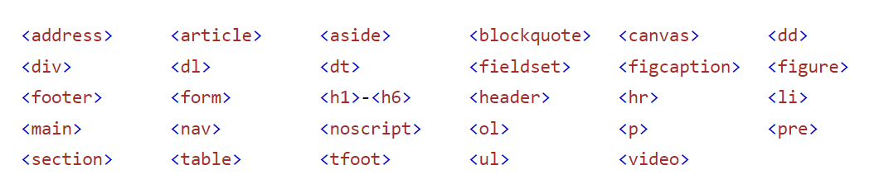

Inline Elements
- An inline element does not start on a new line. An inline element only takes up as much width as necessary.
- An inline element cannot contain a block-level element!
- Here are the inline elements in HTML.
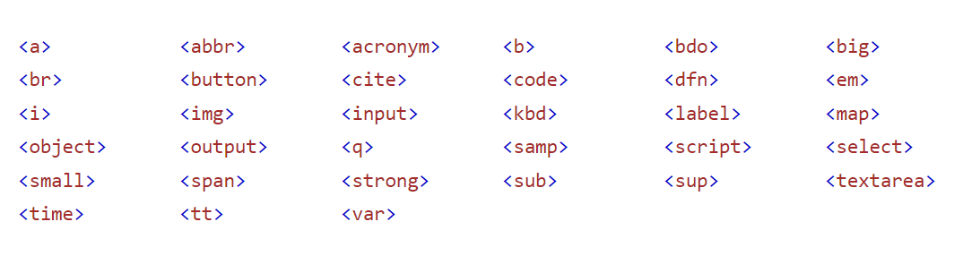

The <span> Element
- The <span> element is an inline container used to mark up a part of a text, or a part of a document.
- The <span> tag is easily styled by CSS or manipulated with JavaScript using the class or id attribute.
- The <span> tag is much like the <div> element, but <div> is a block-level element and <span> is an inline element.

- WHAT IS HTML ENTITIES?

- Some characters are reserved in HTML. Entity names are easier to remember than entity numbers.
- If you use the less than (<) or greater than (>) signs in your HTML text, the browser might mix them with tags.
- Entity names or entity numbers can be used to display reserved HTML characters.
- Entity names look like this : &entity_name;
- Entity numbers look like this : &#entity_number;
- To display a less than sign (<) we must write: &lt; or &#60;

- WHAT IS HTML EMOJIS?
- Emojis are characters from the UTF-8 character set.
- Emojis look like images, or icons, but they are not. They are letters (characters) from the UTF-8 (Unicode) character set.
- UTF-8 covers almost all of the characters and symbols in the world.
- To display an HTML page correctly, a web browser must know the character set used in the page. This is specified in the <meta> tag: <meta charset="UTF-8">
- If not specified, UTF-8 is the default character set in HTML.
- Emojis are characters, they can be copied, displayed, and sized just like any other character in HTML.

- WHAT IS HTML IFRAMES?

- An HTML iframe is used to display a web page within a web page.

Syntax : <iframe src="url" title="description"></iframe>

- It is a good practice to always include a title attribute for the <iframe>. This is used by screen readers to read out what the content of the iframe is.

- Use the height and width attributes to specify the size of the iframe.

