JAVASCRIPT OUTPUT?

- There are a total of nine (09) ways or methods in JS programming to get the output.
- innerHTML Property
- document.write() Method
- window.print() Method
- alert() Function
- prompt() Function
- console.log() Function
- console.table() Function
- console.error() Function
- console.warn() Function

Using innerHTML

- To access an HTML element, JavaScript can use the document.getElementById(id) method.

- The id attribute defines the HTML element.

- The innerHTML property defines the HTML content.

- Changing the innerHTML property of an HTML element is a common way to display data in HTML.

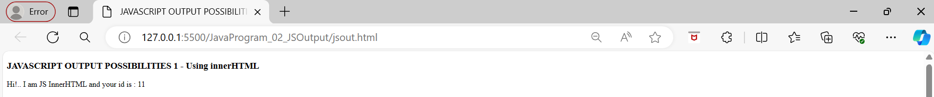

Using document.write()
- For testing purposes, it is convenient to use document.write().
- Using document.write() after an HTML document is loaded, will delete all existing HTML.
- The document.write() method should only be used for testing.

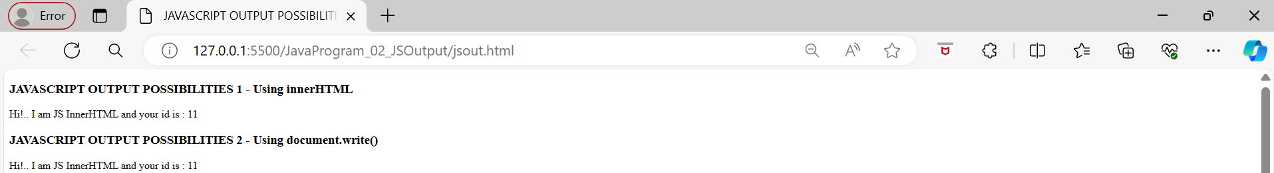

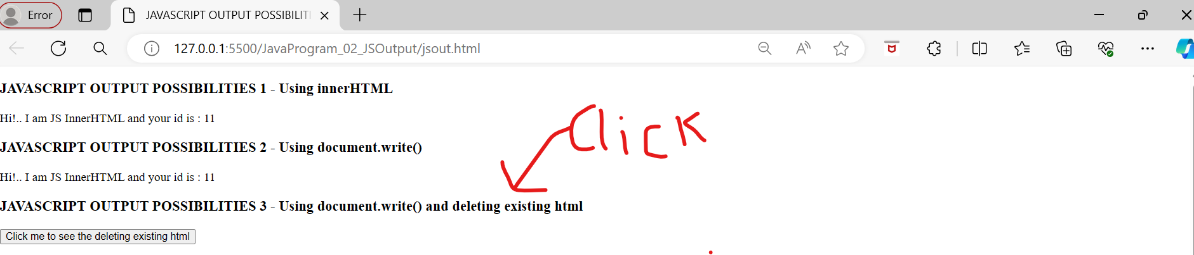

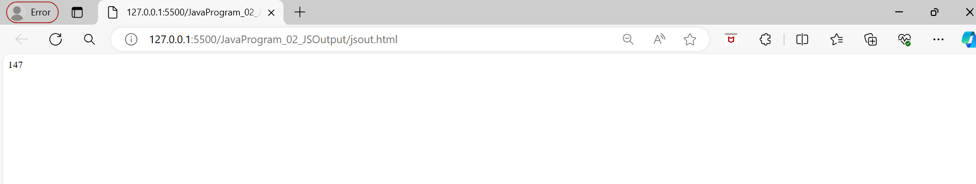

Using window.alert()
- You can use an alert box to display data.
- You can skip the window keyword.In JavaScript, the window object is the global scope object.
- This means that variables, properties, and methods by default belong to the window object.
- This also means that specifying the window keyword is optional.
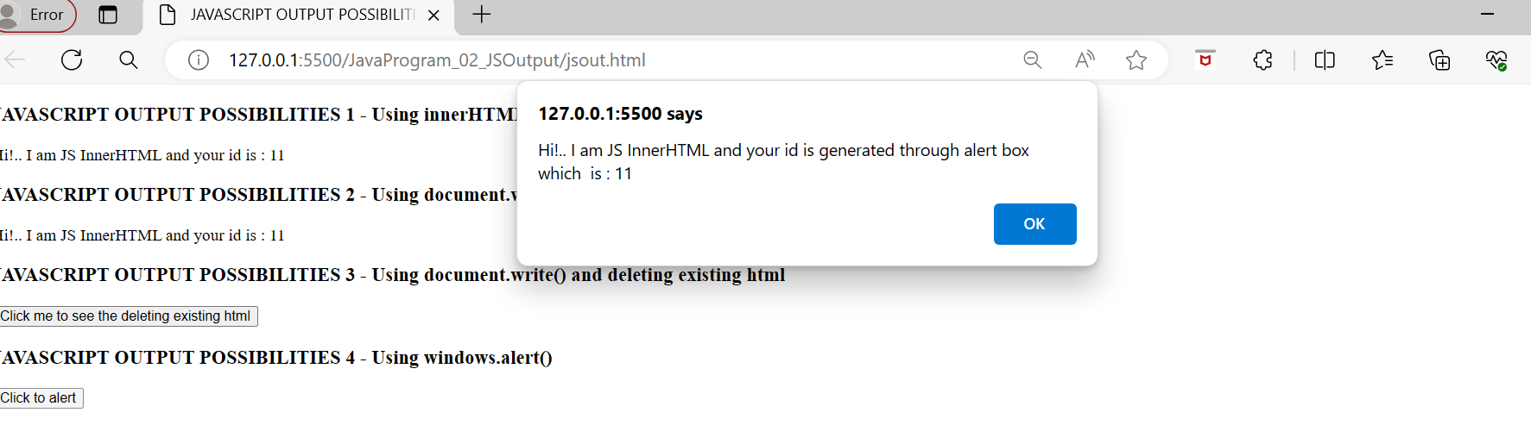
After Clicking this, you get above popup window.

Using console.log()
For debugging purposes, you can call the console.log() method in the browser to display data.
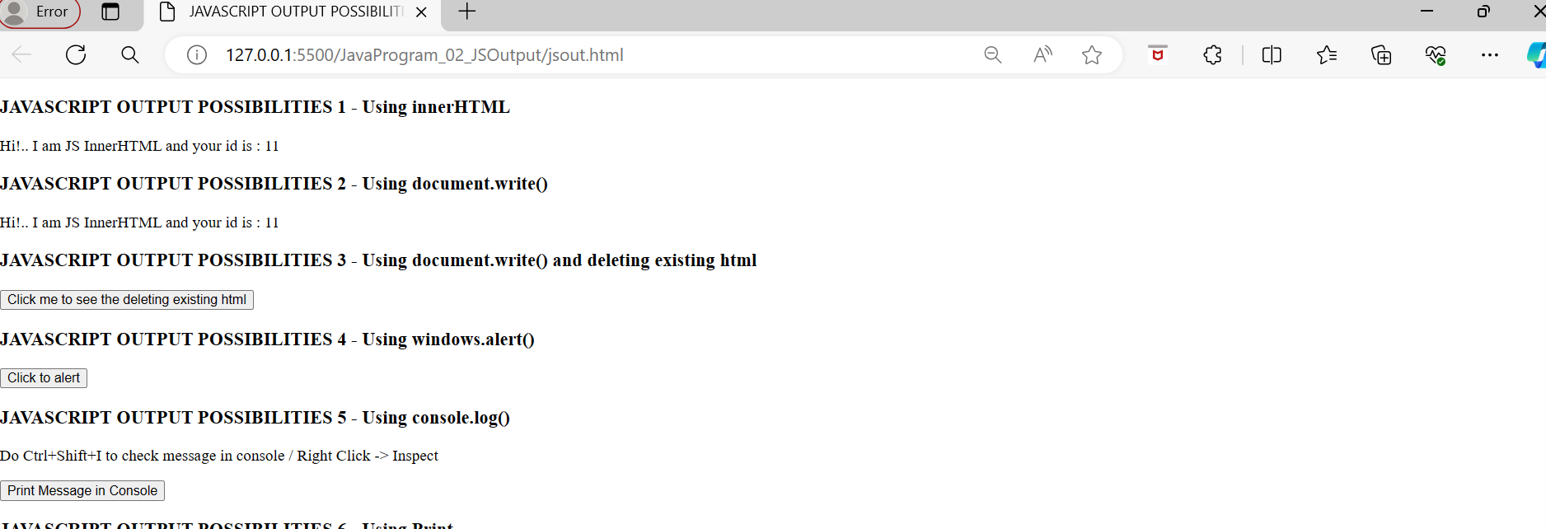
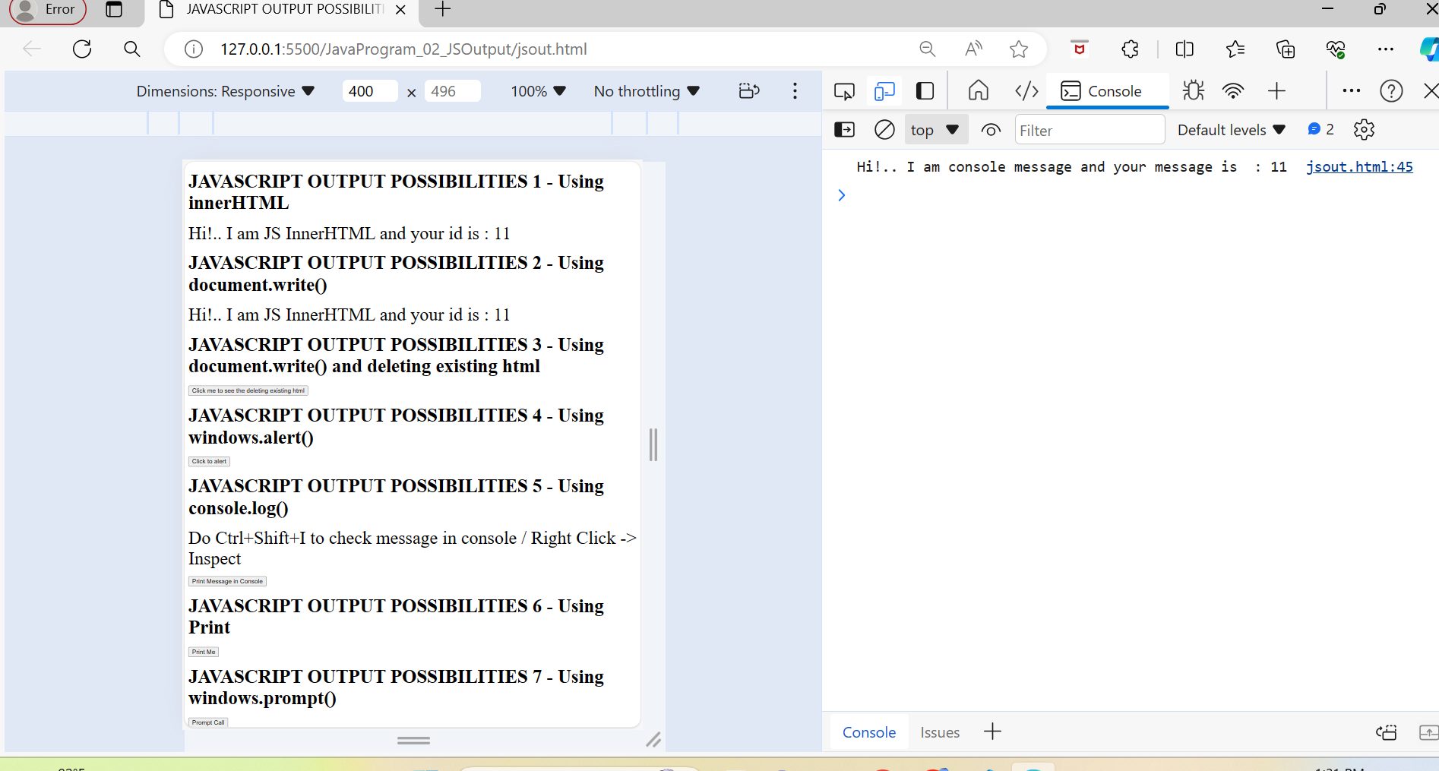

Using JS windows.print()
JavaScript does not have any print object or print methods.You cannot access output devices from JavaScript.The only exception is that you can call the window.print() method in the browser to print the content of the current window.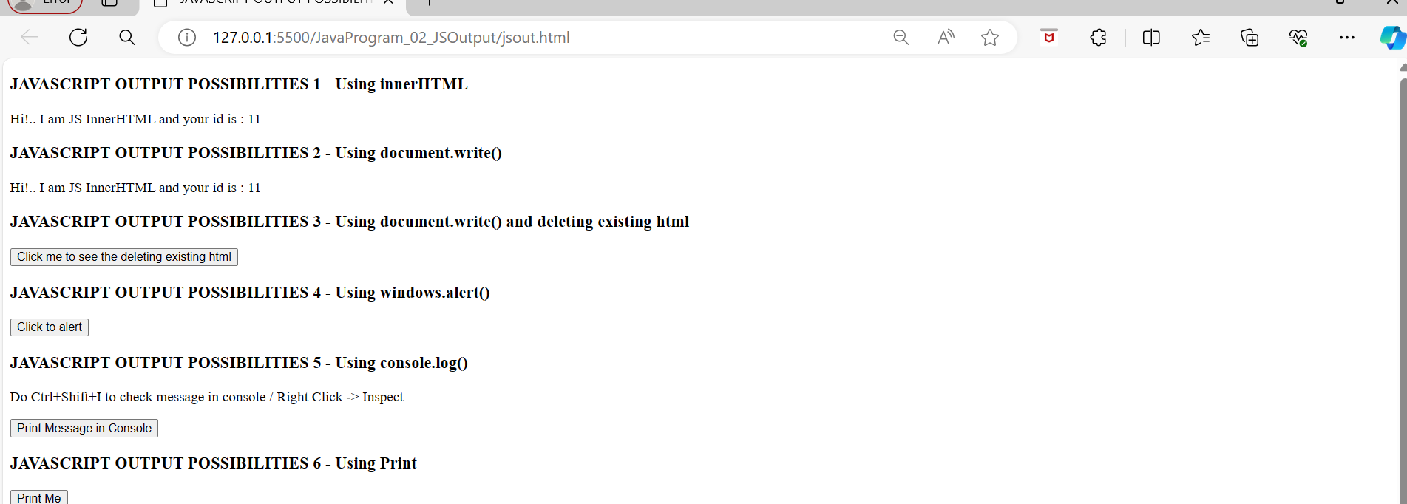

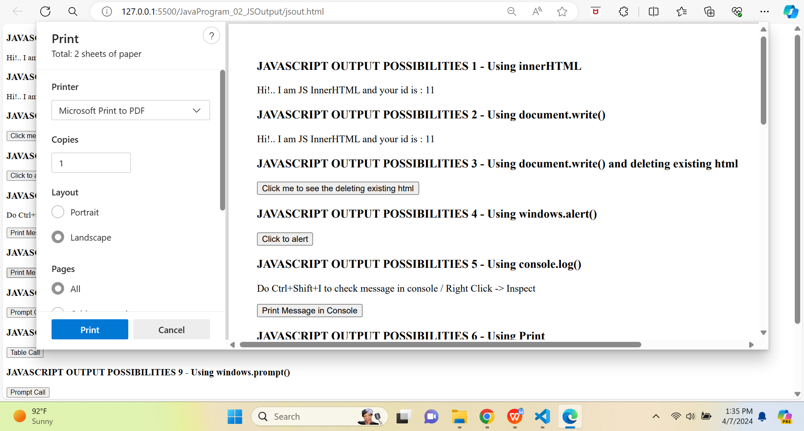

Using JS windows.prompt()
- The window.prompt() method is used to display a dialog box that prompts the user input. It returns the text entered by the user as a string. It doesn’t display output directly but captures user input.Note: This method is not used for output, it only use to take input from user.Syntax : window.prompt();

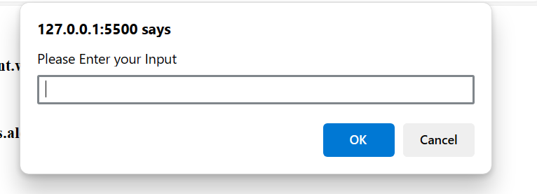

Using JS console.table()
- This function is widely utilized as it helps in debugging the JS code while developing our websites.
- The JS code displays information about three scientists in an array of objects.
- The above JS example uses the JavaScript console.table() function to print data to the console.The above JS code displays information about three scientists in an array of objectsWhen we run this code, we will get a table of this information in the console.

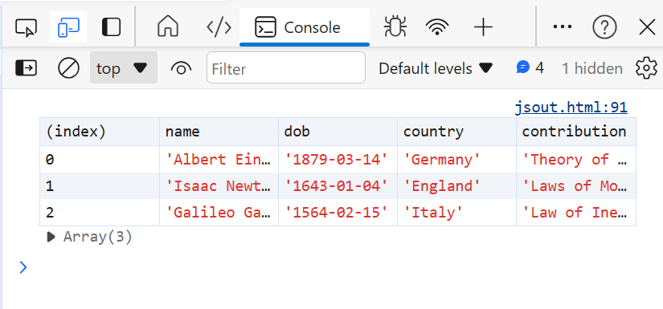

Using JS console.error()
- The console.error() function in JavaScript coding is used for debugging purposes only.
- Unlike the JS console.log() function, the console.error() prints the data in Red color marking it as a console error.
- We mostly use console.log() and console.error() functions for debugging purposes only.This JS example takes the age of the user with the prompt() function. It then prints the age to the console. It then makes a check based on the user's age. Then it prints the message to the console accordingly. If the age is less than 15 or an invalid number is entered, the console will log an error in Red color.

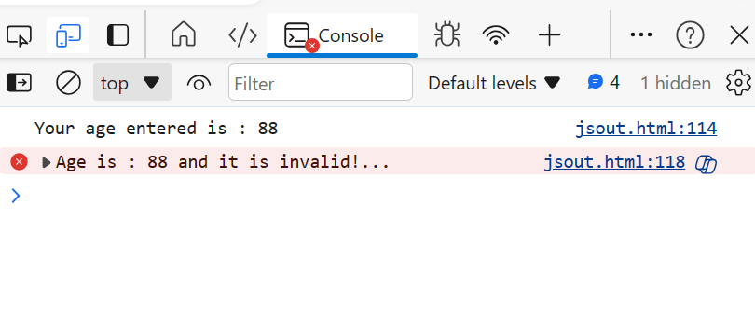Using JS console.warn()
- The console.warn() prints the data in Yellow color marking it as a console warning. We use the JavaScript console.warn() function for debugging the codeThe console will log a warning in Yellow color.
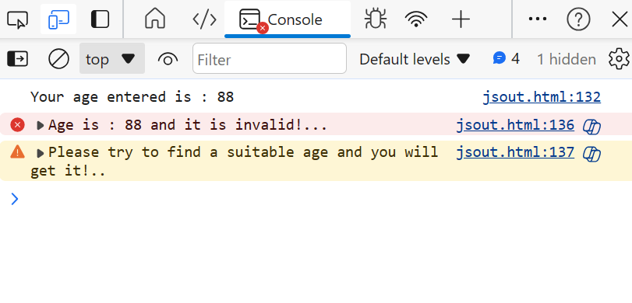

- Code for the JS Output Possibilities
<!DOCTYPE html>
<html>

<head>
<title>JAVASCRIPT OUTPUT POSSIBILITIES</title>
<link rel="stylesheet" href="../JavaProgram_02_JSOutput/jsout.css" />
</head>

<body>
<script>
var val = 5 + 6;
</script>

<h3>JAVASCRIPT OUTPUT POSSIBILITIES 1 - Using innerHTML</h3>
<div id="o1"></div>
<script>
document.getElementById("o1").innerHTML = "Hi!.. I am JS InnerHTML and your id is : " + val;
</script>

<h3>JAVASCRIPT OUTPUT POSSIBILITIES 2 - Using document.write()</h3>
<script>
document.write("Hi!.. I am JS InnerHTML and your id is : " + val);
</script>

<h3>JAVASCRIPT OUTPUT POSSIBILITIES 3 - Using document.write() and deleting existing html</h3>
<button type="button" onclick="document.write(67 + 80)">
Click me to see the deleting existing html
</button>

<h3>JAVASCRIPT OUTPUT POSSIBILITIES 4 - Using windows.alert()</h3>
<button type="button" onclick=alertCall()>
Click to alert
</button>
<script>
function alertCall() {
alert("Hi!.. I am JS InnerHTML and your id is generated through alert box which is : " + val);
}
</script>

<h3>JAVASCRIPT OUTPUT POSSIBILITIES 5 - Using console.log()</h3>
<p>Do Ctrl+Shift+I to check message in console / Right Click -> Inspect </p>
<button type="button" onclick="consoleCall()">Print Message in Console</button>
<script>
function consoleCall() {
console.log("Hi!.. I am console message and your message is : " + val);
}
</script>

<h3>JAVASCRIPT OUTPUT POSSIBILITIES 6 - Using Print</h3>
<button type="button" onclick="window.print()">Print Me</button>

<h3>JAVASCRIPT OUTPUT POSSIBILITIES 7 - Using windows.prompt()</h3>
<button type="button" onclick="letPromptCall()">Prompt Call</button>
<script>
function letPromptCall() {
let userInput = window.prompt("Please Enter your Input");

if (userInput !== null) {
window.alert("Hello, " + userInput + "!");
} else {
window.alert("You clicked Cancel or closed the prompt.");
}
}
</script>

<h3>JAVASCRIPT OUTPUT POSSIBILITIES 8 - Using console.table()</h3>
<button type="button" onclick="letTableCall()">Table Call</button>
<script>
function letTableCall() {
//Array of Objects - 3 Scientists details
let scientists = [
{
name: "Albert Einstein",
dob: "1879-03-14",
country: "Germany",
contribution: "Theory of General Relativity"
},
{
name: "Isaac Newton",
dob: "1643-01-04",
country: "England",
contribution: "Laws of Motion, Universal Gravitation"
},
{
name: "Galileo Galilei",
dob: "1564-02-15",
country: "Italy",
contribution: "Law of Inertia, Heliocentrism"
}
];
console.table(scientists);
}
</script>

<h3>JAVASCRIPT OUTPUT POSSIBILITIES 9 - Using windows.prompt()</h3>
<button type="button" onclick="letPromptCall()">Prompt Call</button>
<script>
function letPromptCall() {
let userInput = window.prompt("Please Enter your Input");

if (userInput !== null) {
window.alert("Hello, " + userInput + "!");
} else {
window.alert("You clicked Cancel or closed the prompt.");
}
}
</script>

<h3>JAVASCRIPT OUTPUT POSSIBILITIES 10 - Using console.error()</h3>
<button type="button" onclick="letConsoleErrorCall()">Console error Call</button>
<script>
function letConsoleErrorCall() {
let Promo = prompt("Enter the age")
console.log("Your age entered is : " + Promo);

//Console.Error()
if (Promo > 15) {
console.error("Age is : " + Promo + " and it is invalid!...")
} else if (Promo < 15) {
console.log("Age is : " + Promo + " and it is valid!...")
} else {
console.error("Enter a Valid age!..")
}
}
</script>

<h3>JAVASCRIPT OUTPUT POSSIBILITIES 11 - Using console.warn()</h3>
<button type="button" onclick="letConsoleWarnCall()">Console warn Call</button>
<script>
function letConsoleWarnCall() {
let Promo = prompt("Enter the age")
console.log("Your age entered is : " + Promo);

//Console.Warn()
if (Promo > 15) {
console.error("Age is : " + Promo + " and it is invalid!...")
console.warn("Please try to find a suitable age and you will get it!..")
} else if (Promo < 15) {
console.log("Age is : " + Promo + " and it is valid!...")
} else {
console.error("Enter a Valid age!..")
}
}
</script>
</body>

</html>

