Javascript Regular Expression or R.E

- It enables finding patterns in a string. There are 2 Use Cases
- Text Validation
- Search through string field( find number..)

Eg 1: Find 'hello world' in a string

<script>

//Eg 1 - Find 'hello world' in a string

//This is the text
const txt = "People often write hello world while programming";

//Which string to find?
const regex = /hello world/;

//Use match() to match the given text
const res = txt.match(regex);

console.log(res);

</script>

Output:
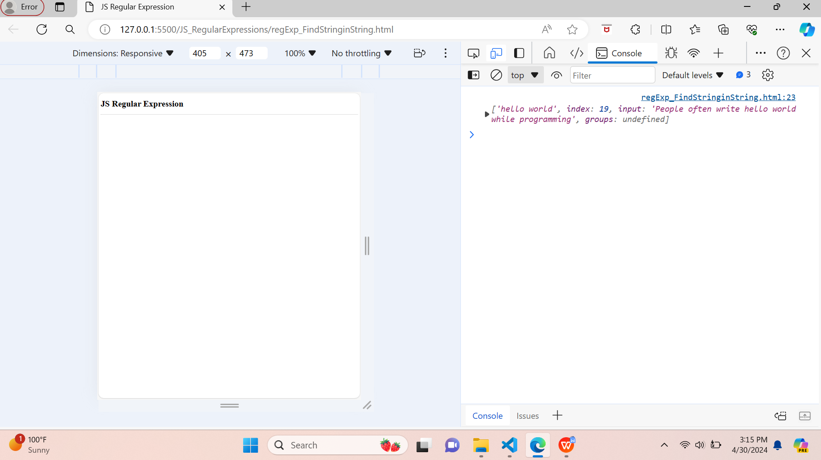

- Eg 2: Find many using match function

<script>
//Eg 2 - Find many using match

//This is the text
const txt2 = "People often write hello world while hello world programming";

//Which string to find?
const regex2 = /hello world/;

//Use match() to match the given text
const res2 = txt2.match(regex2);

console.log(res2);

</script>

Output:

