N | TYPE | JS DETAILS | JSEXAMPLE
1 | INTERNAL  OR  EMBEDDED | - Internal JavaScript code is code that's placed anywhere within the web page between the HTML tags .  - Many web developers choose to place their JavaScript code before the tag.  - When JavaScript was written within the section using element then it is called as internal JavaScript. | 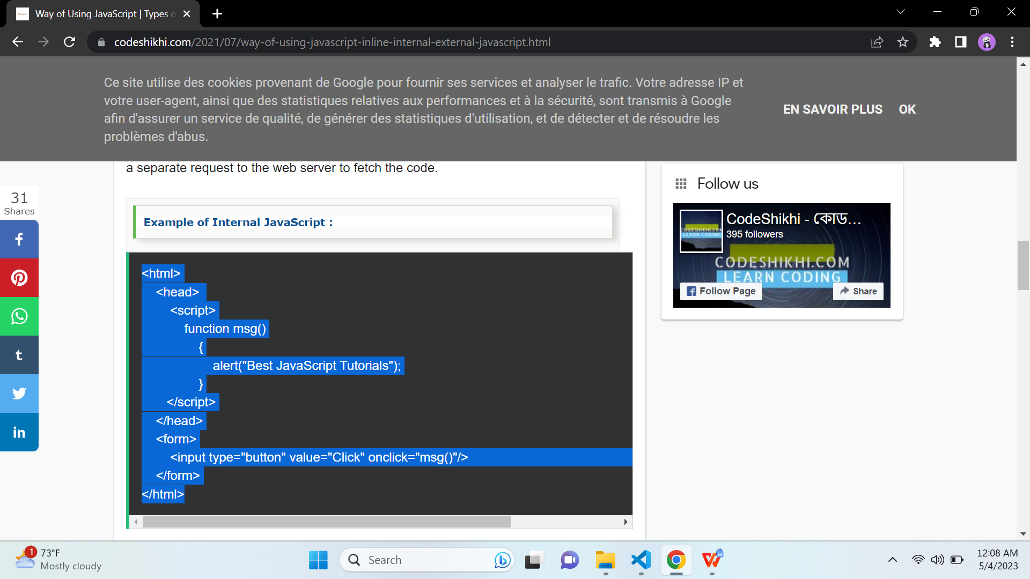
2 | INLINE | - When a script tag is used in the HTML file, it is called inlining.  - This means no external JS file is used instead JavaScript is put into an HTML file.  - This is extremely advantageous as it can save the web browser round trips to the server. This is because it no longer requires an external file to download from the server-side  - Often seen in places such as Google Analytics tracking code, site verification, and introducing and setting proprietary and external scripting criteria for Webmaster Tools. | <form>  <input type="button" value="Click" onclick="alert('Button Clicked')"/>  </form>
3 | EXTERNAL | - JavaScript code placed in a file separate from the HTML code is called external JavaScript.  - External JavaScript code is written and used in the same way as internal JavaScript.  - The file should have the ".js" extension.  - Writing java script in a separate file with extension .js is called as external JavaScript.  - To use an external script, put the name of the script file in the src (source) attribute of a <script> tag.  - You can place an external script reference in <head> or <body> as you like. External scripts cannot contain <script> tags.  - It is recommended to embed all JavaScript files into a single file. It increases the speed of the webpage. | SYNTAX :  ---------------------------  <script src="filename.js"></script>  