JAVASCRIPT VARIBLES?

Variables are Containers for Storing Data.
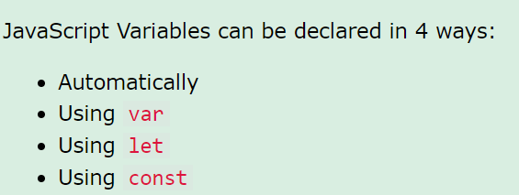

- It is considered good programming practice to always declare variables before use.

