CreateChange_intro
1
var newP = $("<p>");
newP.append("<em>Hello There</em>");
$("#example").html(newP);
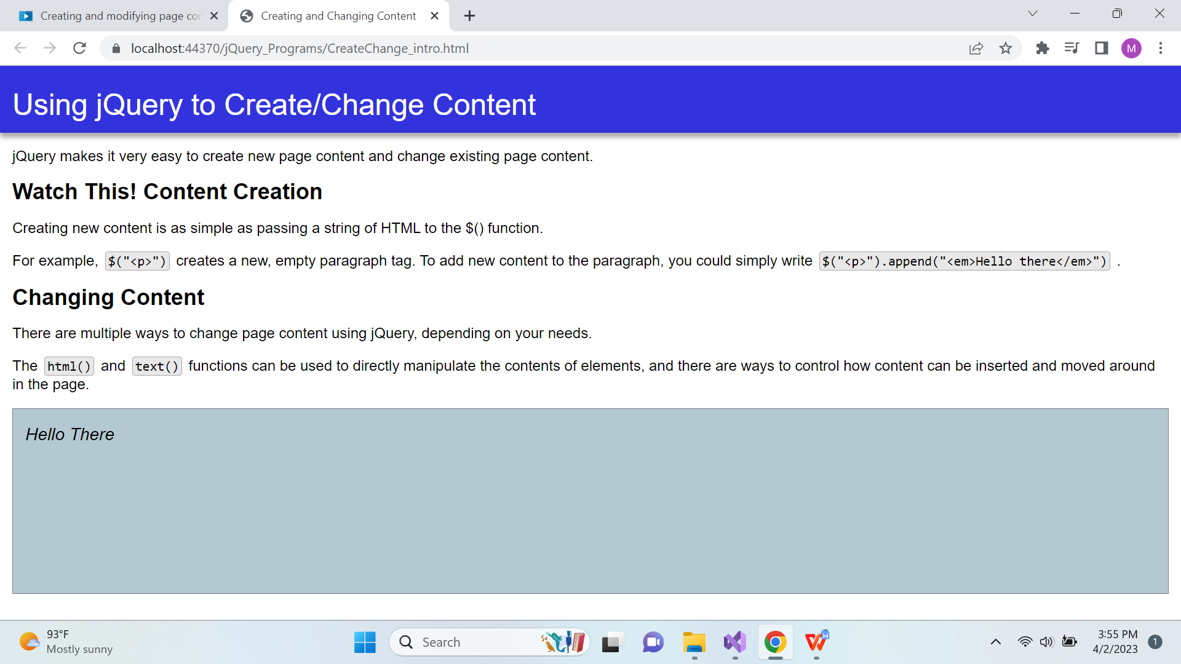
2
$("#creation").prepend("Watch This! ");
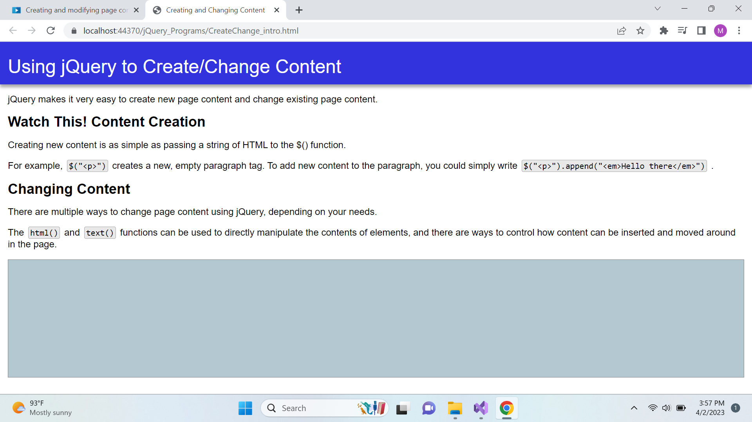
3
$("#example").html("<h2>This is a new H2</h2>");
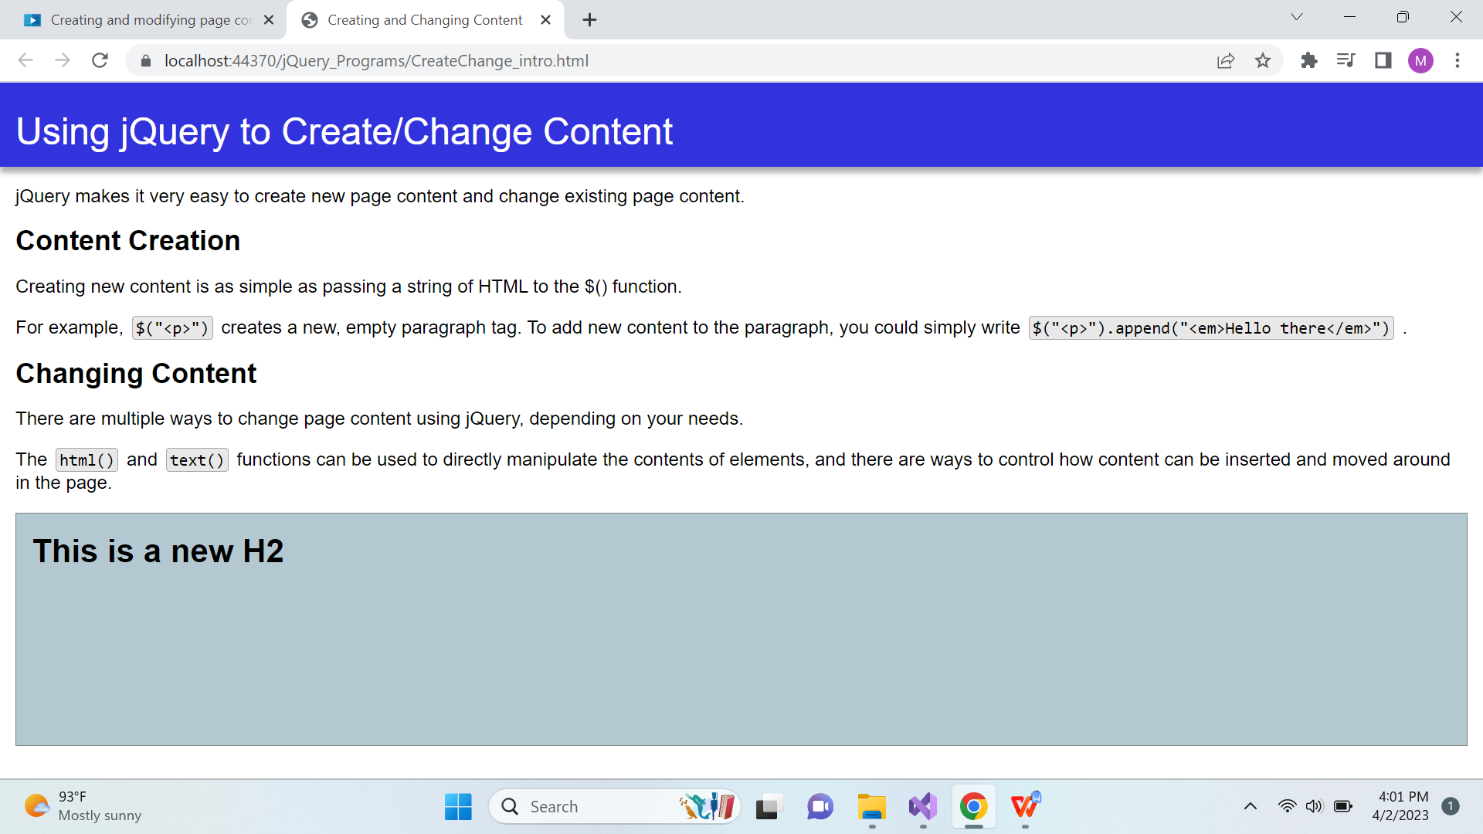

4.
$("#example").text("<h2>This is a new H2</h2>");
