SelectFilter_intro
1: $("p").css("border", "3px solid red");
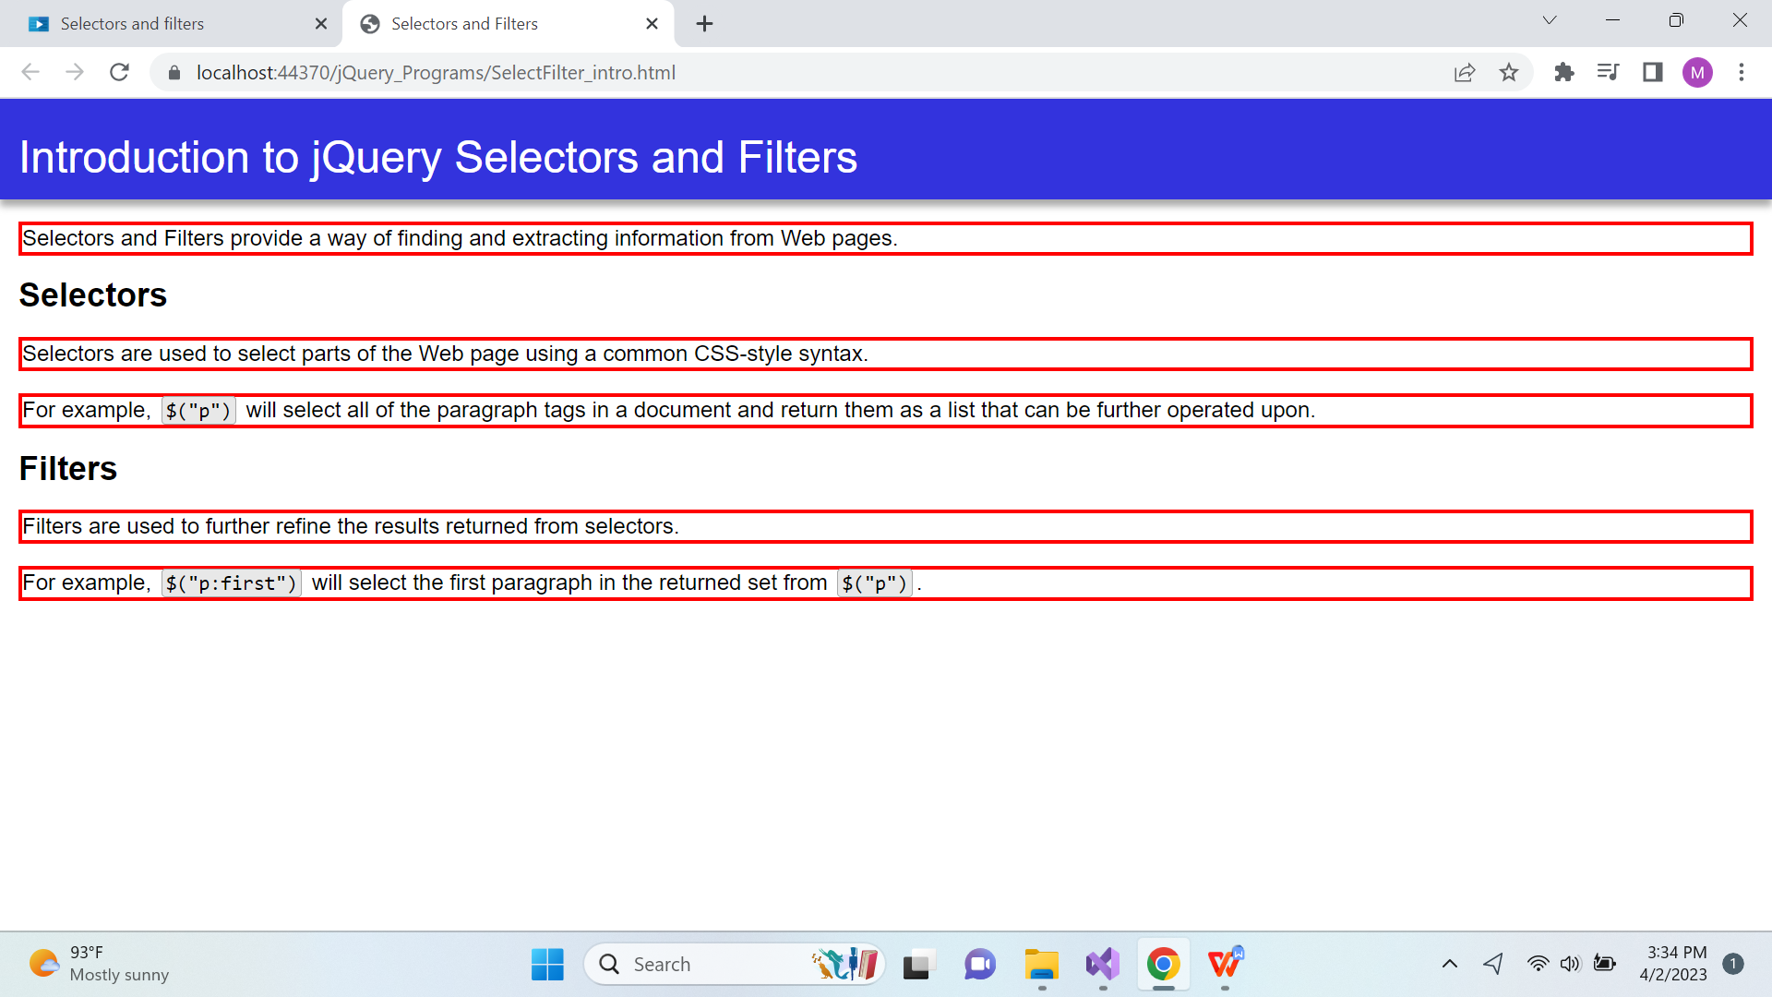

2: $(".selectors").css("border", "3px solid red")
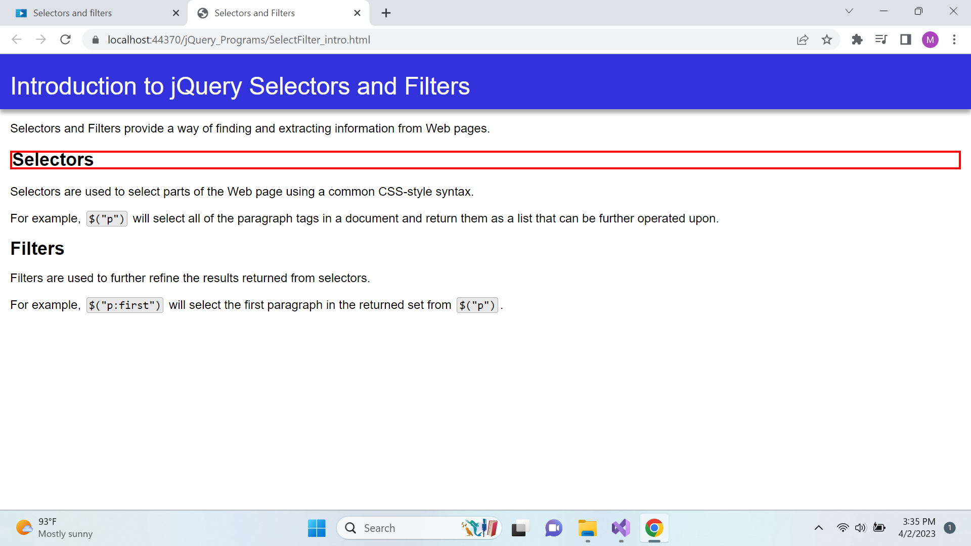

3: $("#intro").css("border", "3px solid red");

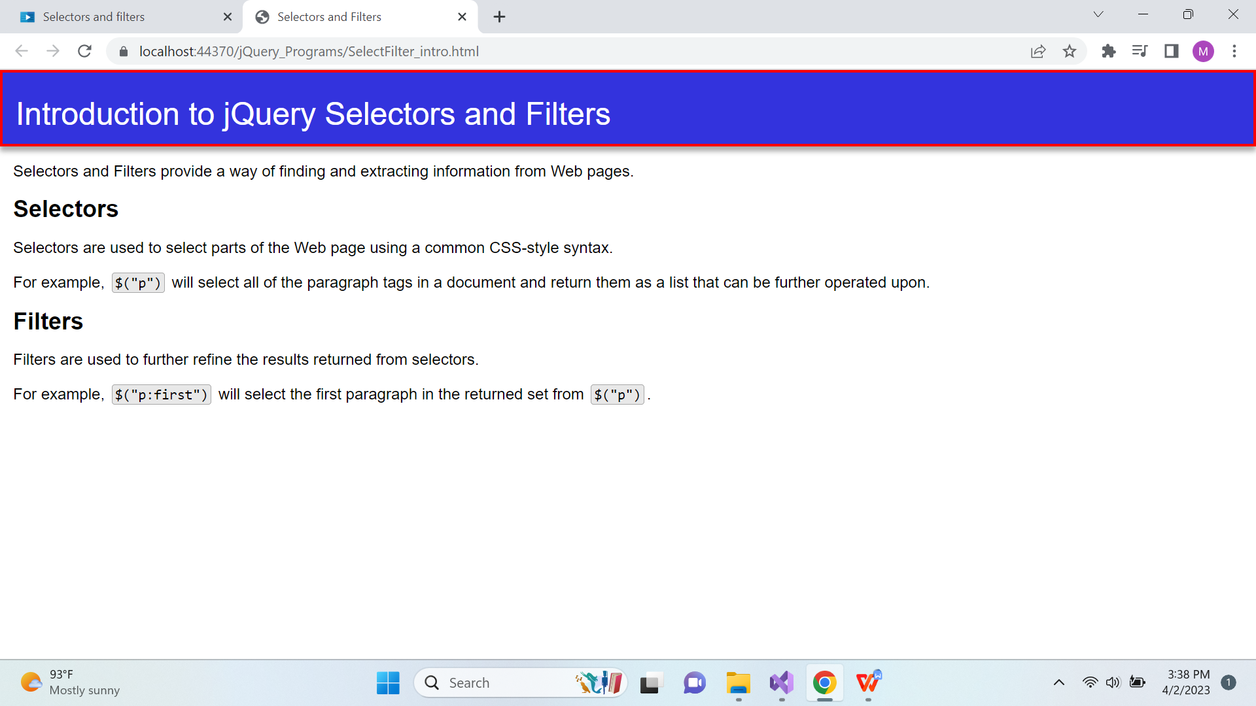

4: $("p:first").css("border", "3px solid red");
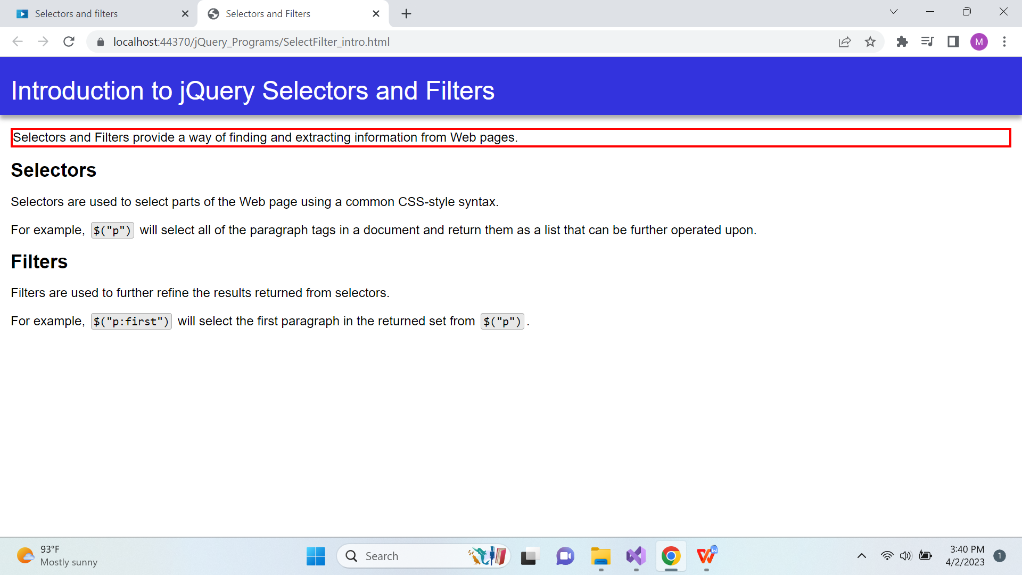
5: $("h2:not(.selectors)").css("border", "3px solid red");
