ENUMS IN JAVA

Enum is a special type of variable or a special datatype.

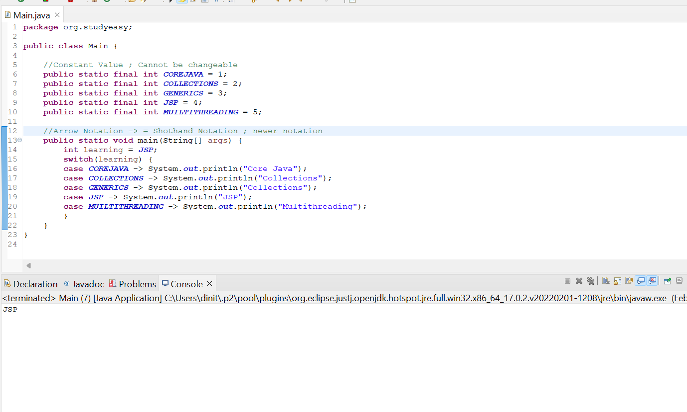

Let us try to change the value. You get output nothing.The value learning changed to 10, but you get no output. So if you want to restrict the values in variable, Enum is a good way.
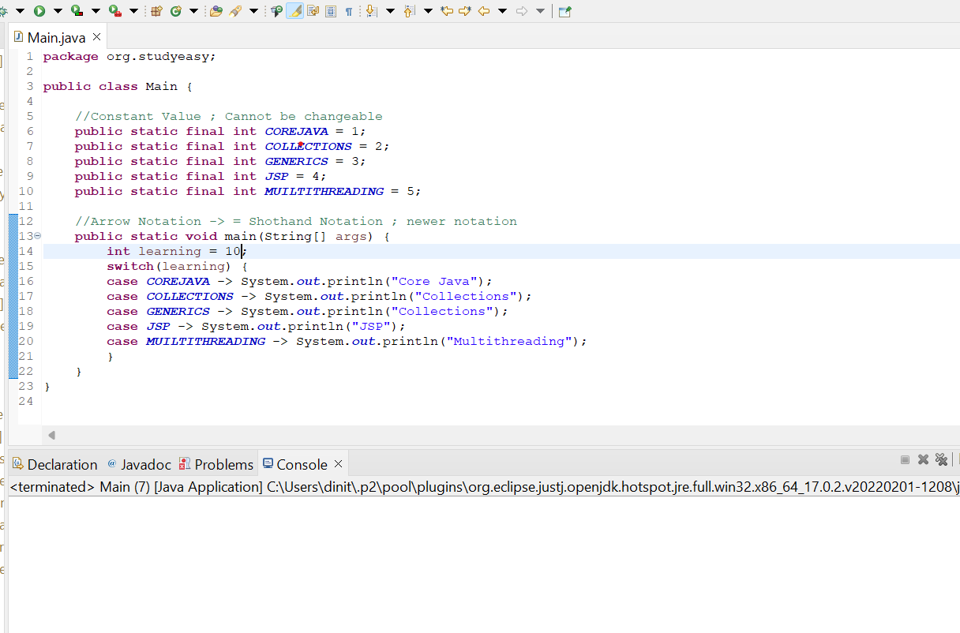

So let us try to create a Enum ‘Learning’.

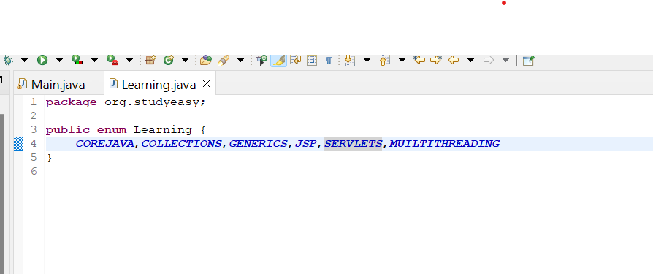

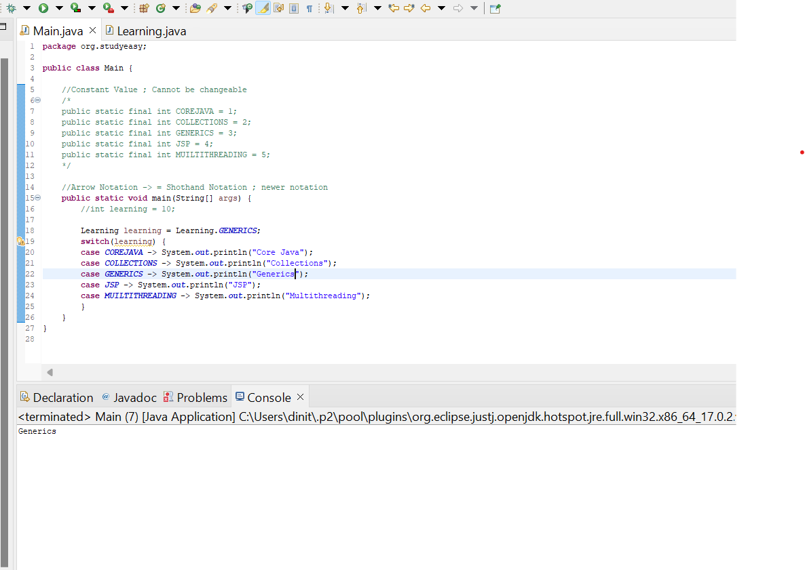

Now we want to know what is the expected value? It will contain the value as the name of the variable itself.
No getters
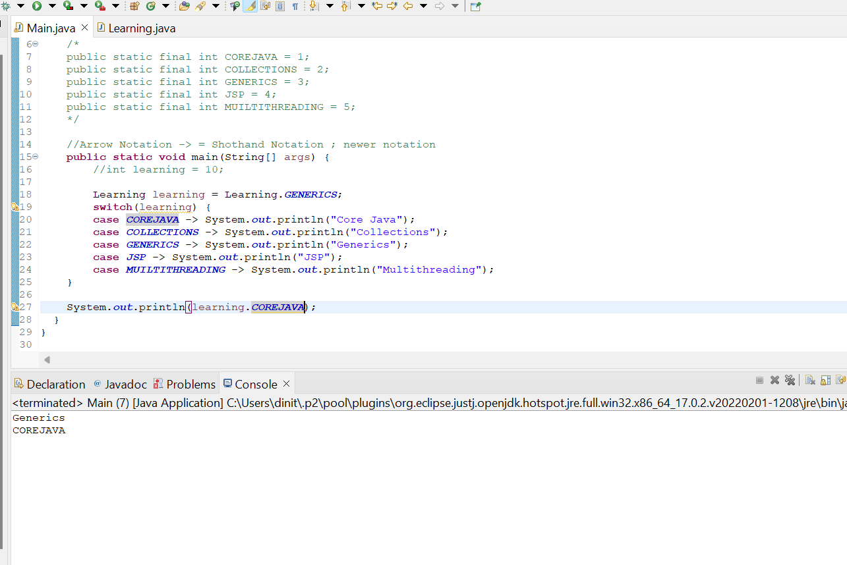

Defining Enums with value for each variable and a few snpashots which will tell you in detail.
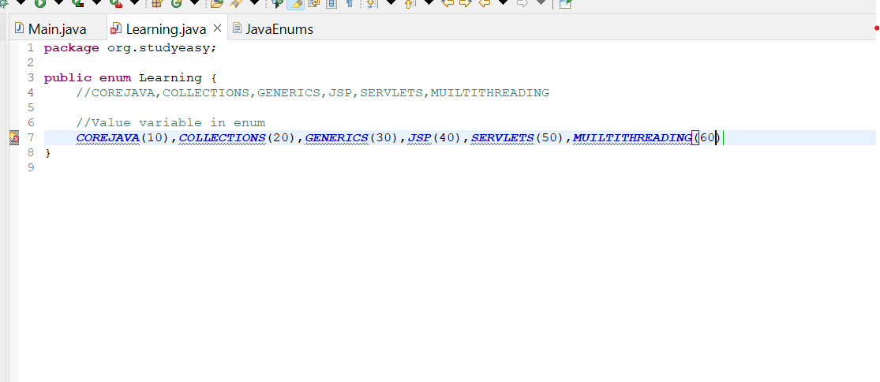

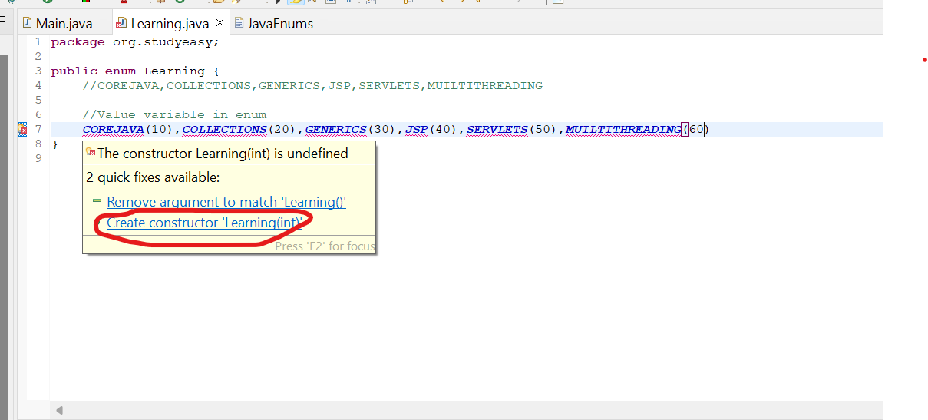

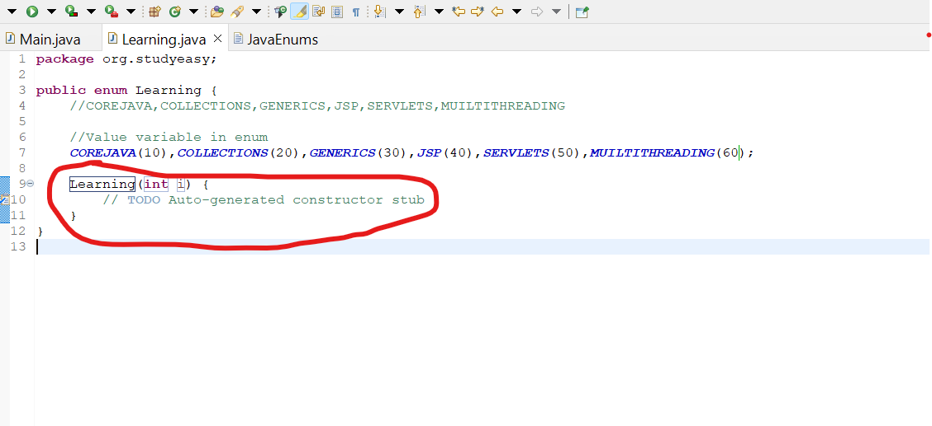
Try to run the main program. You get the same output.Constructor above is not properly constructed.

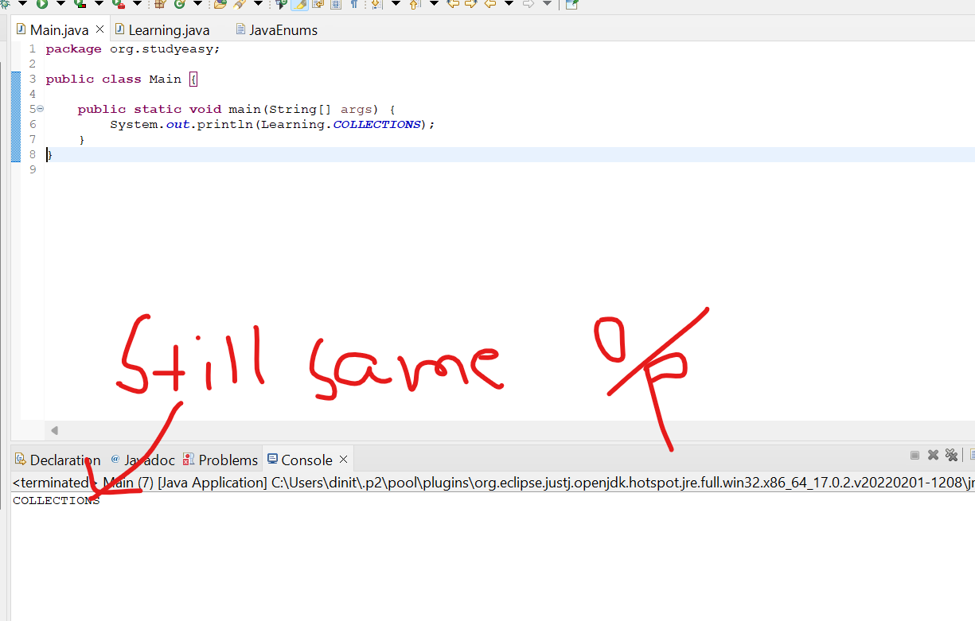

Scenario 2 - Adding getter but still we get the same output.

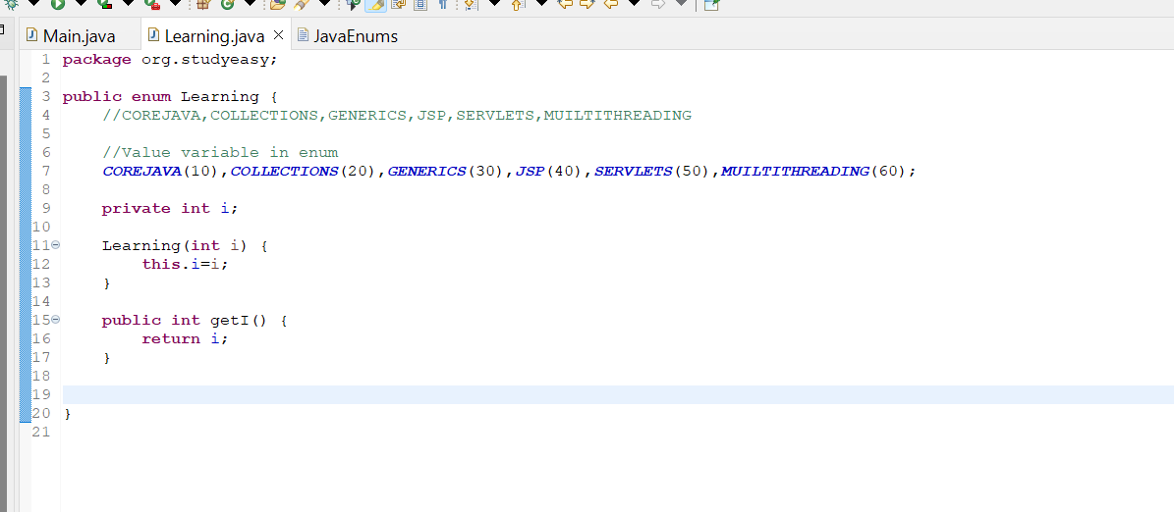

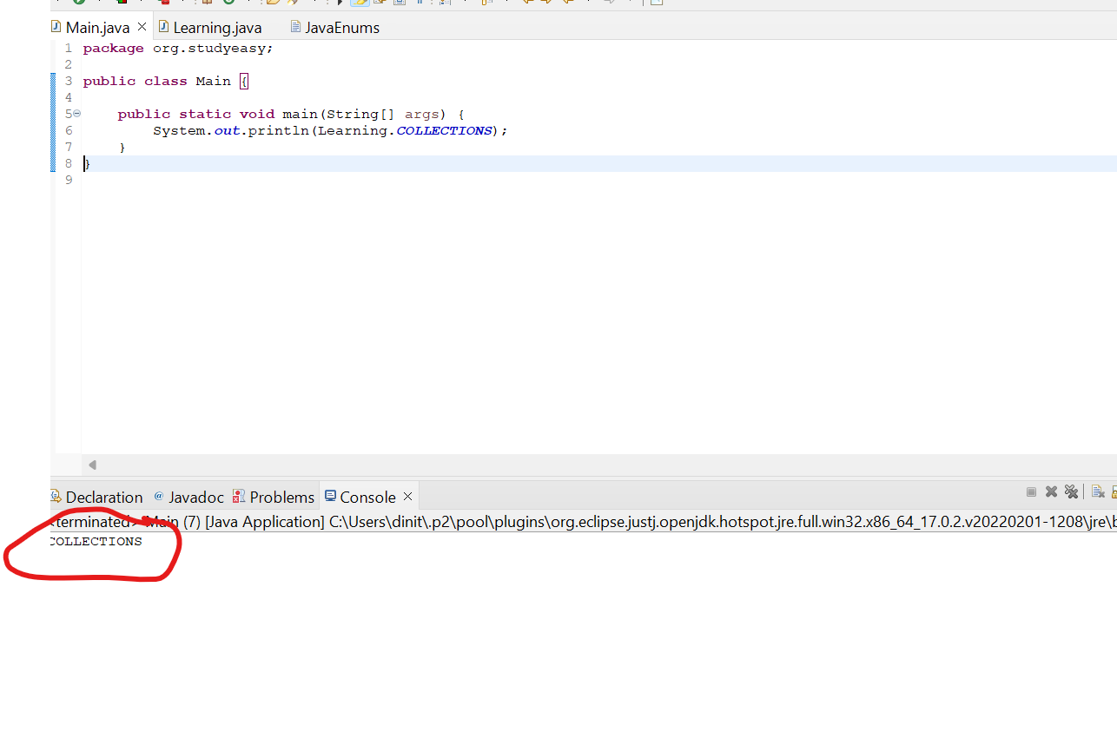
Solution Is we add a line like below pic. We get the output as expected.

