ACCESS SPECIFIORS/ACCESS MODIFIERS/SCOPE SPECIFIORS

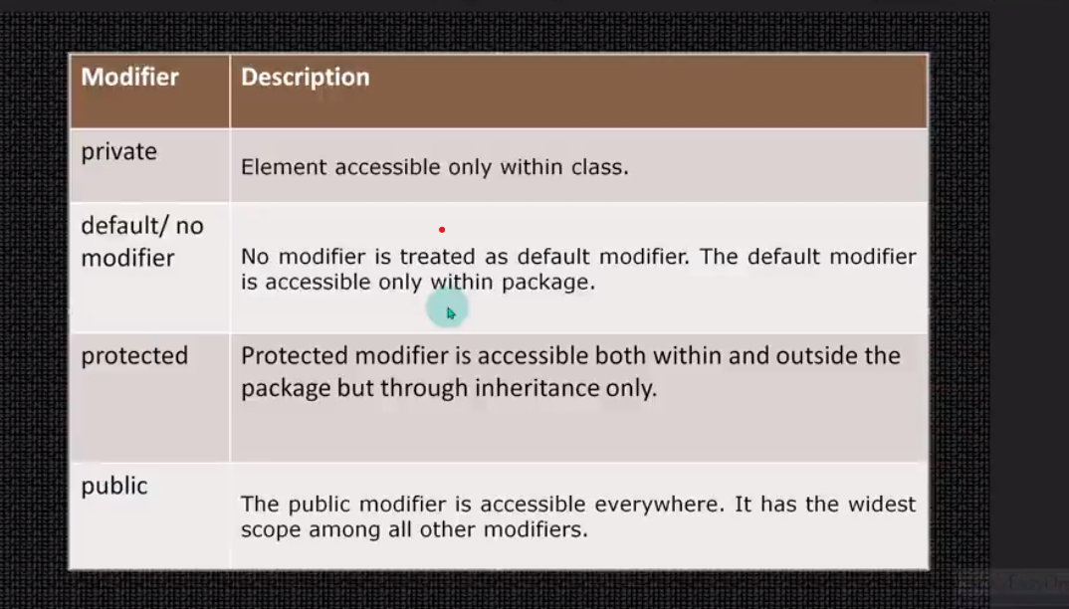

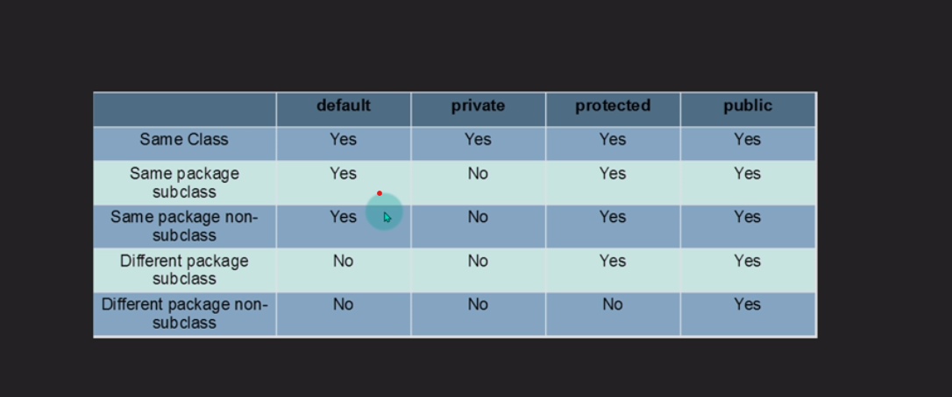

Access modifiers in Java without inheritance

OtherClass.java

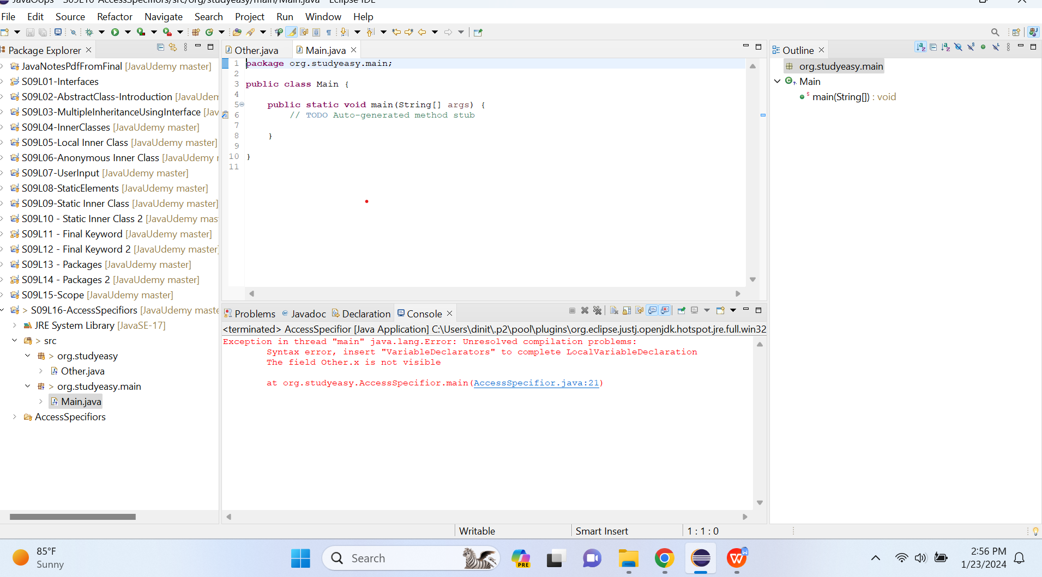

Unresolved Compilation Error - Different Package

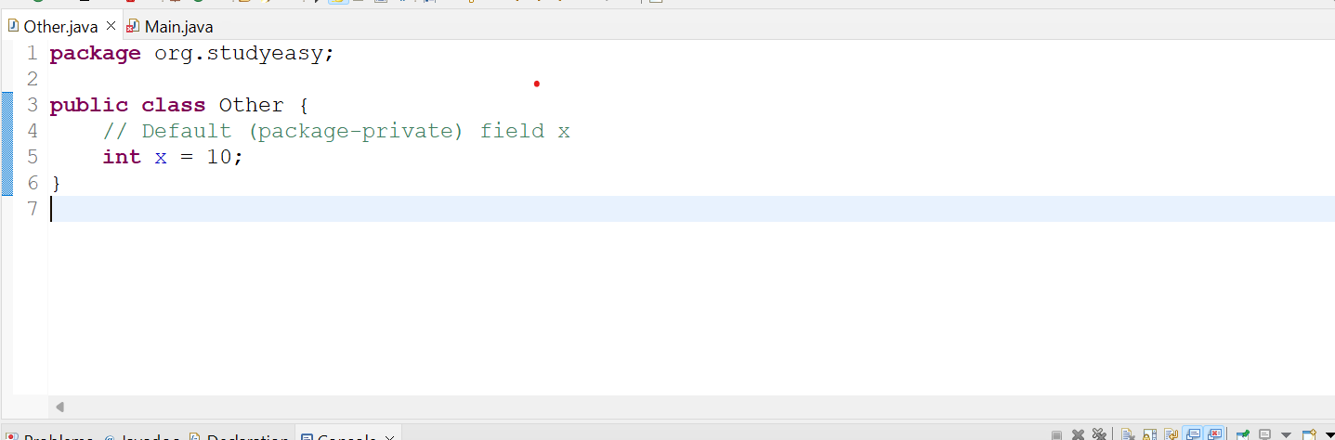

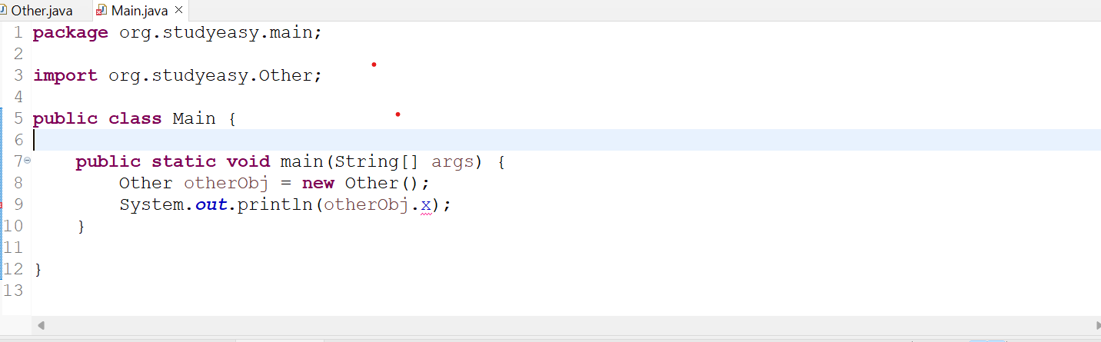

Solution:

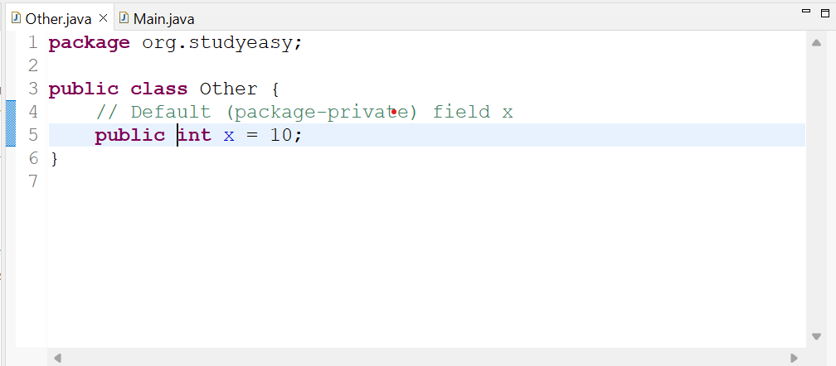

Make the variable as public, then you get output as 10.

Unresolved Compilation Error - Same Package
You get output as 10.

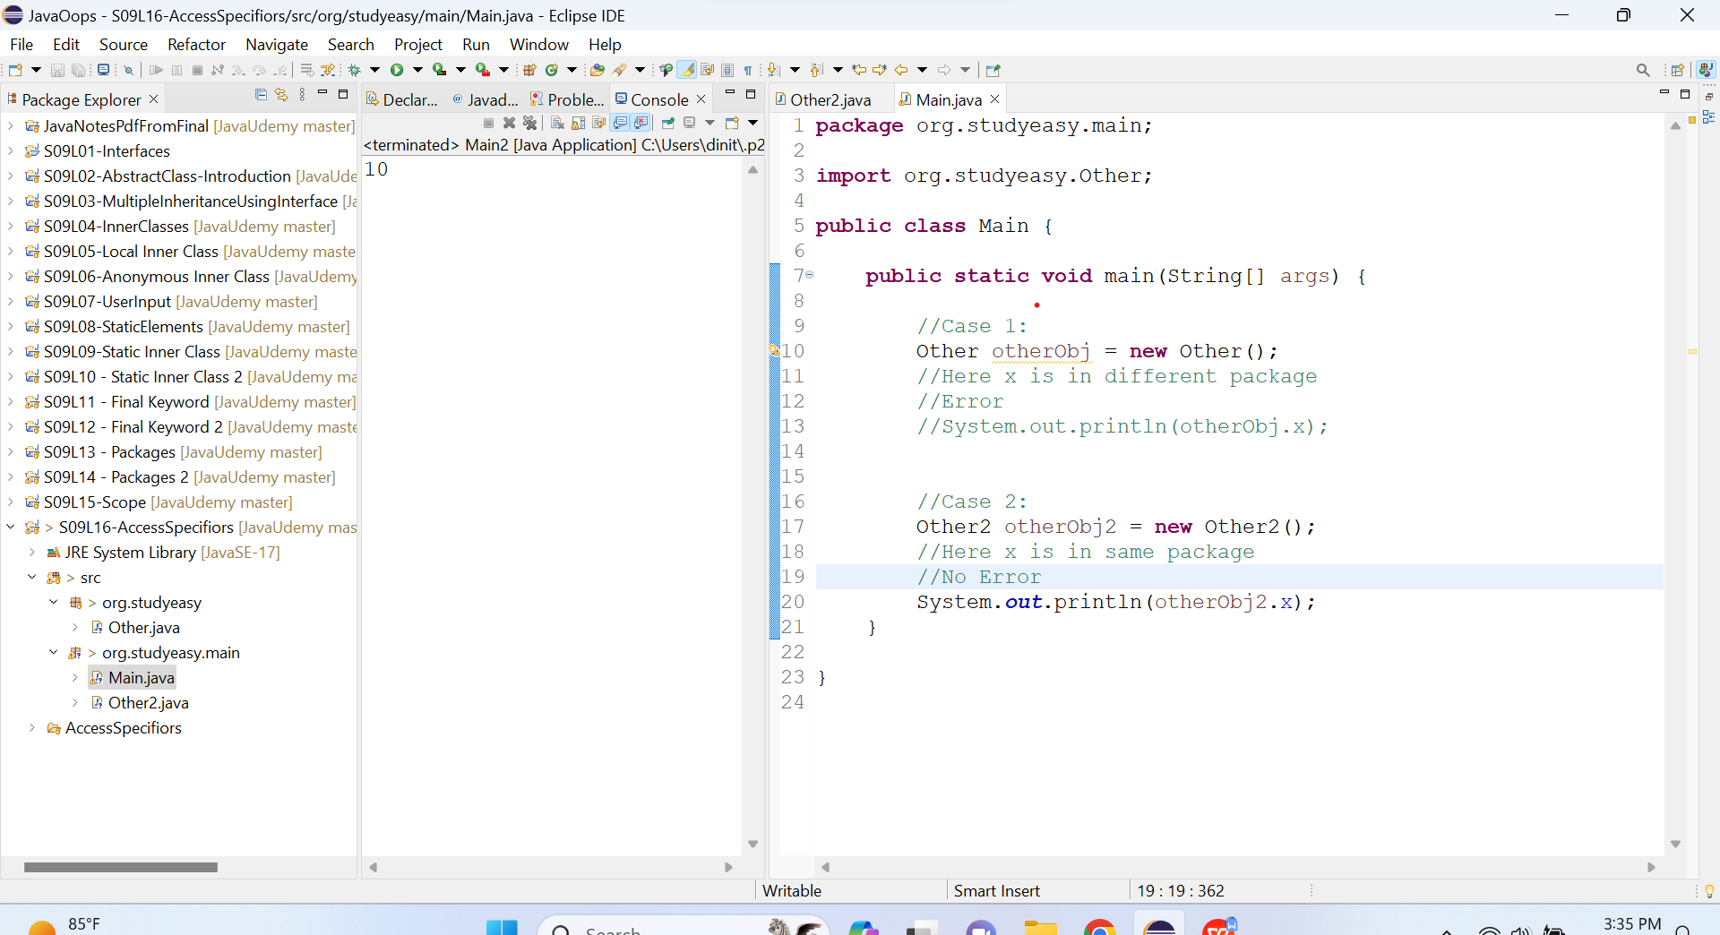

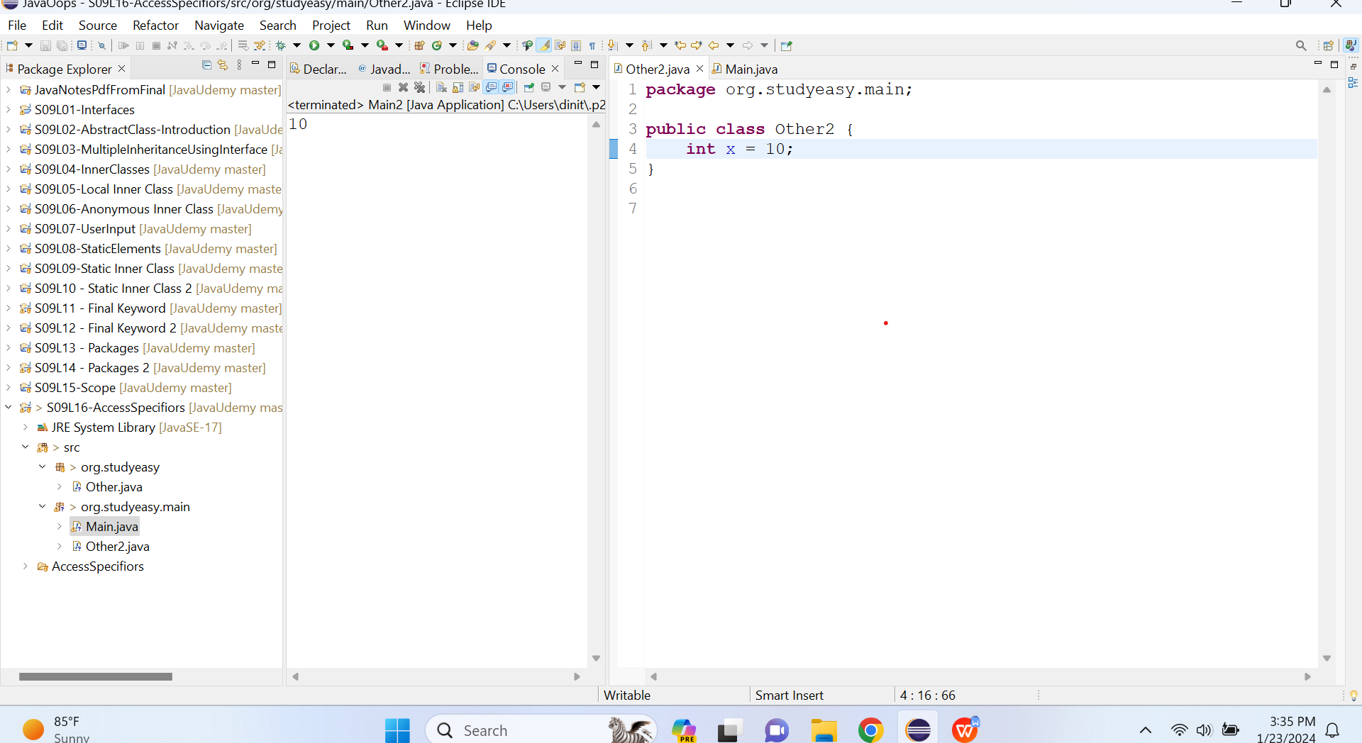

Unresolved Compilation Error - Same Package- Using Protected Access Specifior:

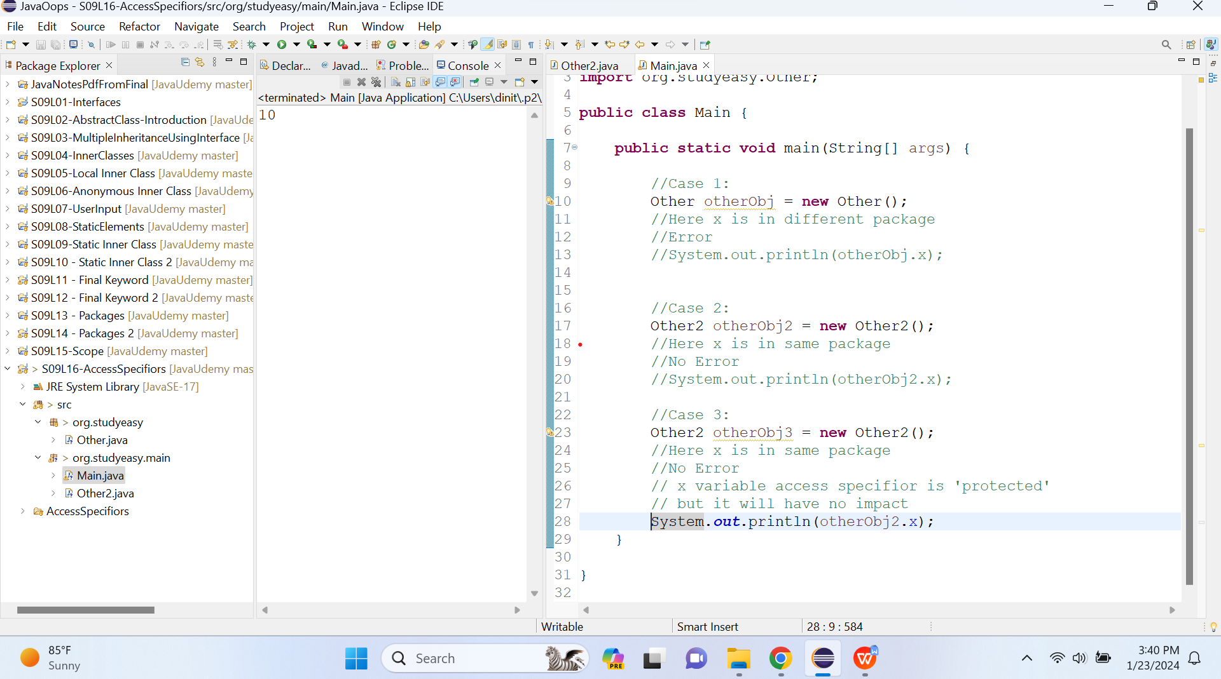

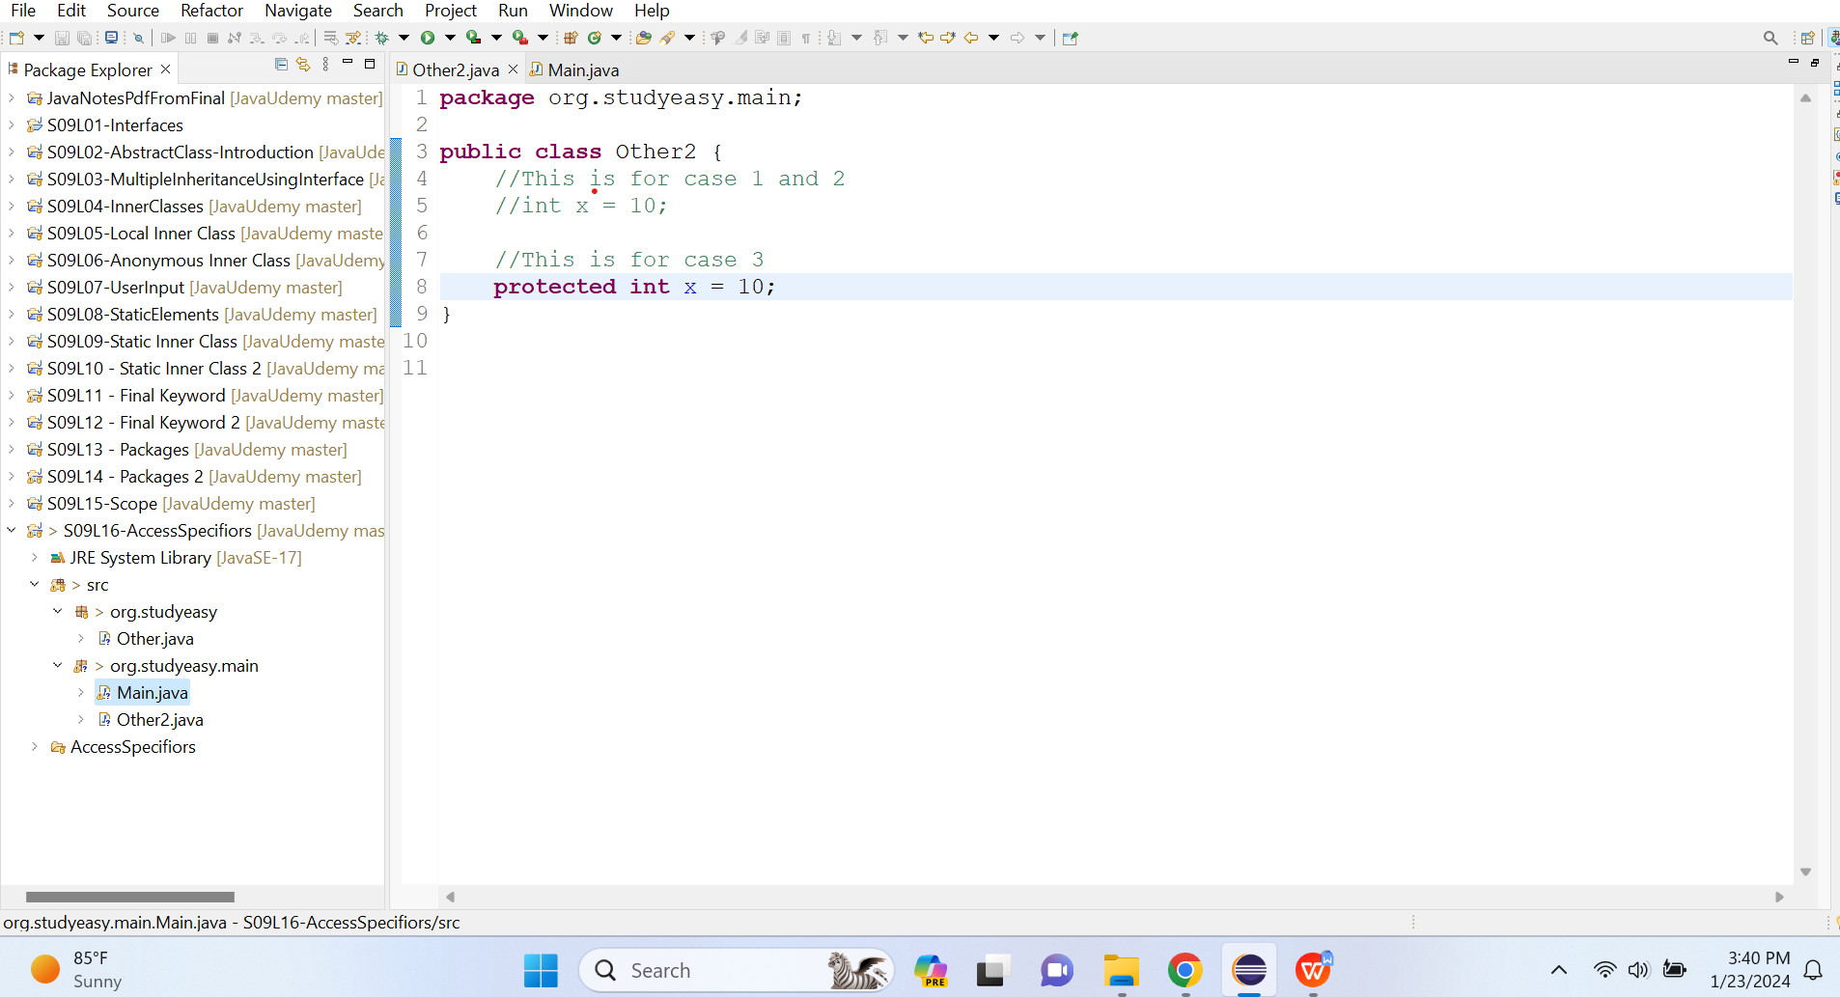

Unresolved Compilation Error - Same Package- Using Private Access Specifior:

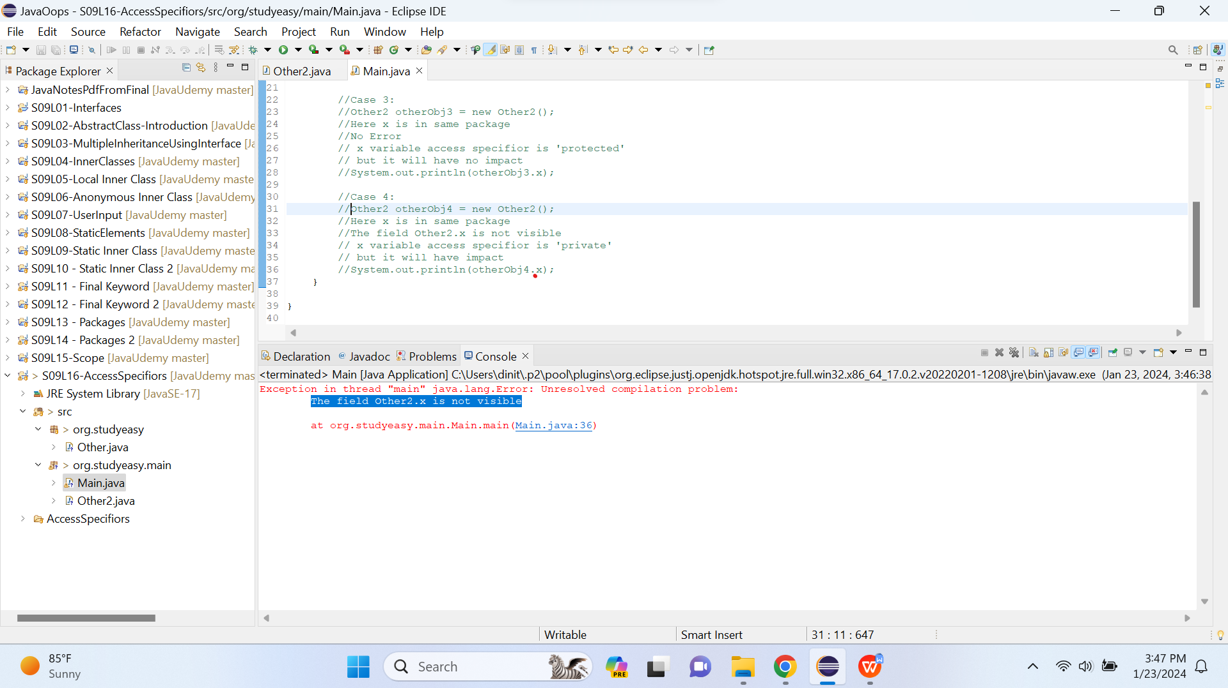

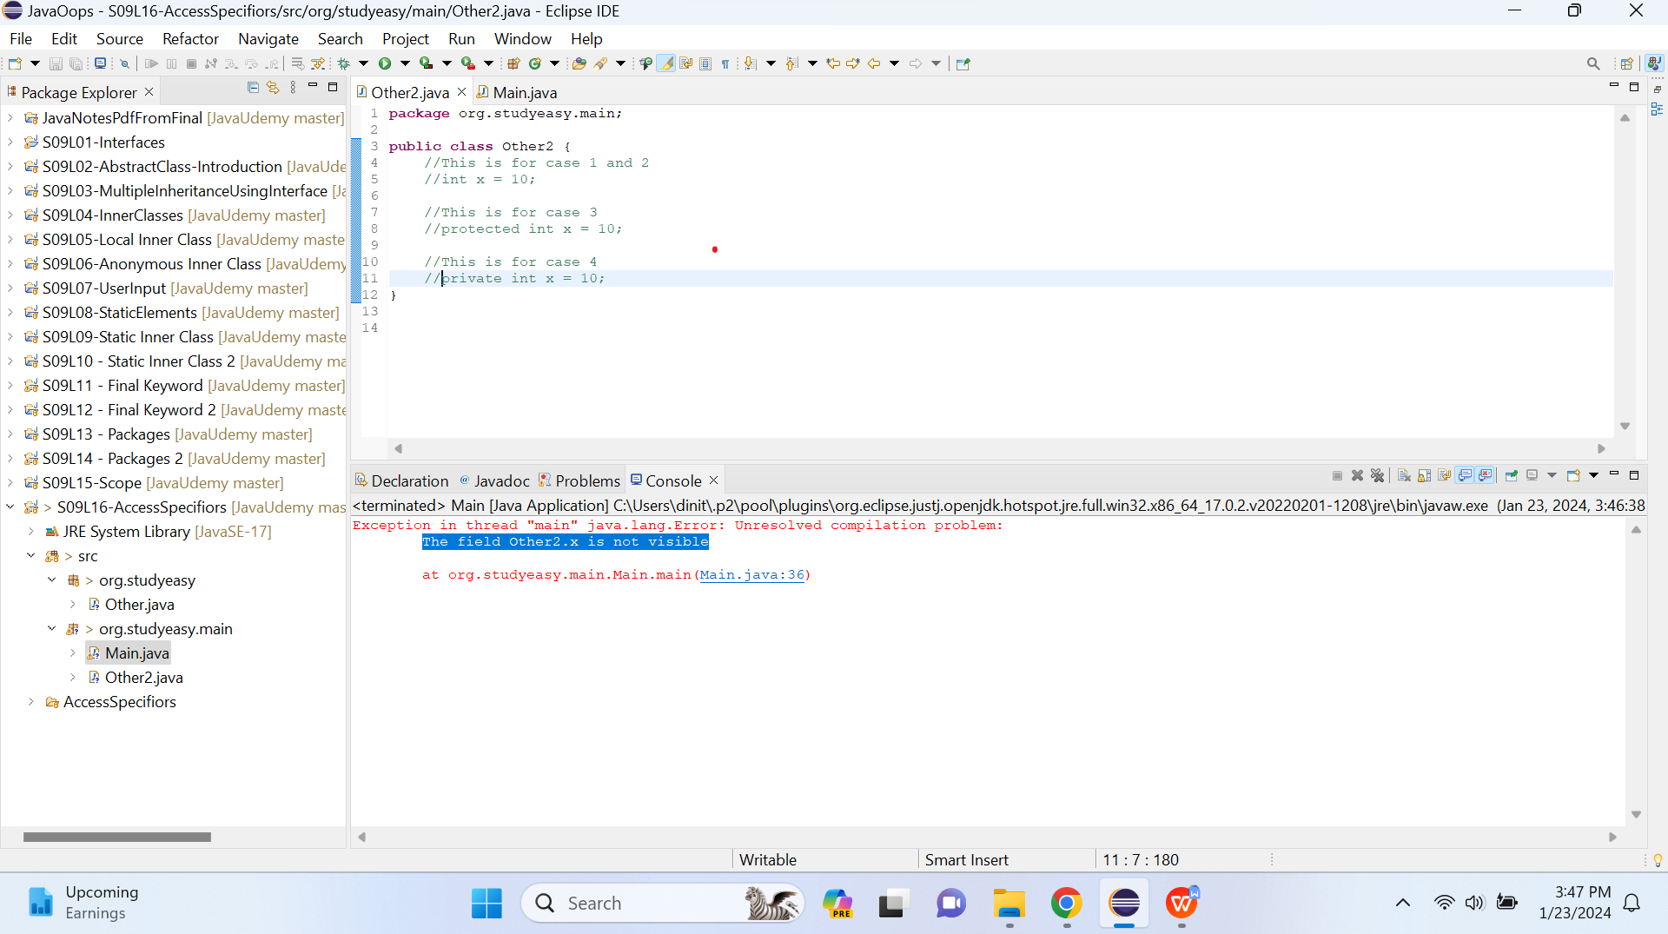

Unresolved Compilation Error - Same Package- Using Private Access Specifior - Calling Through a Method:

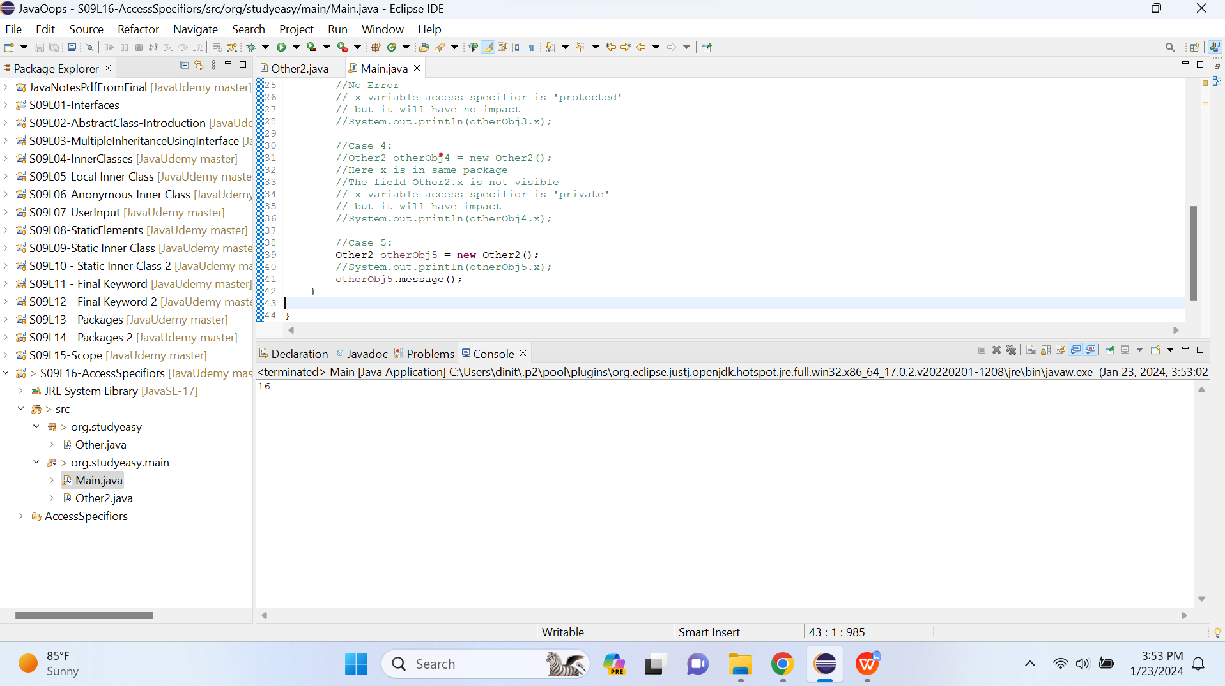

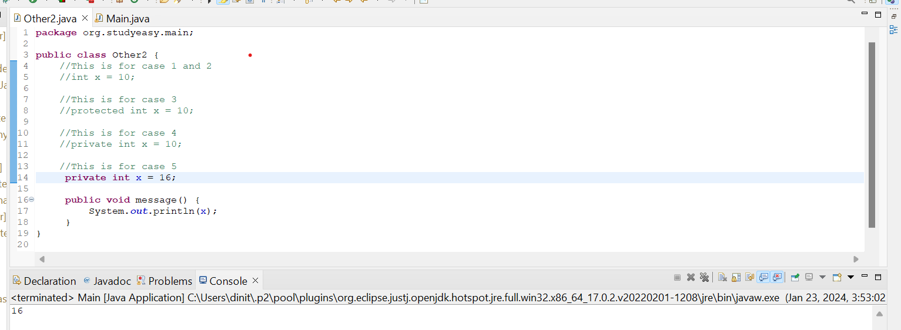

Unresolved Compilation Error - Inheritance Approach

Base.java Sub.java

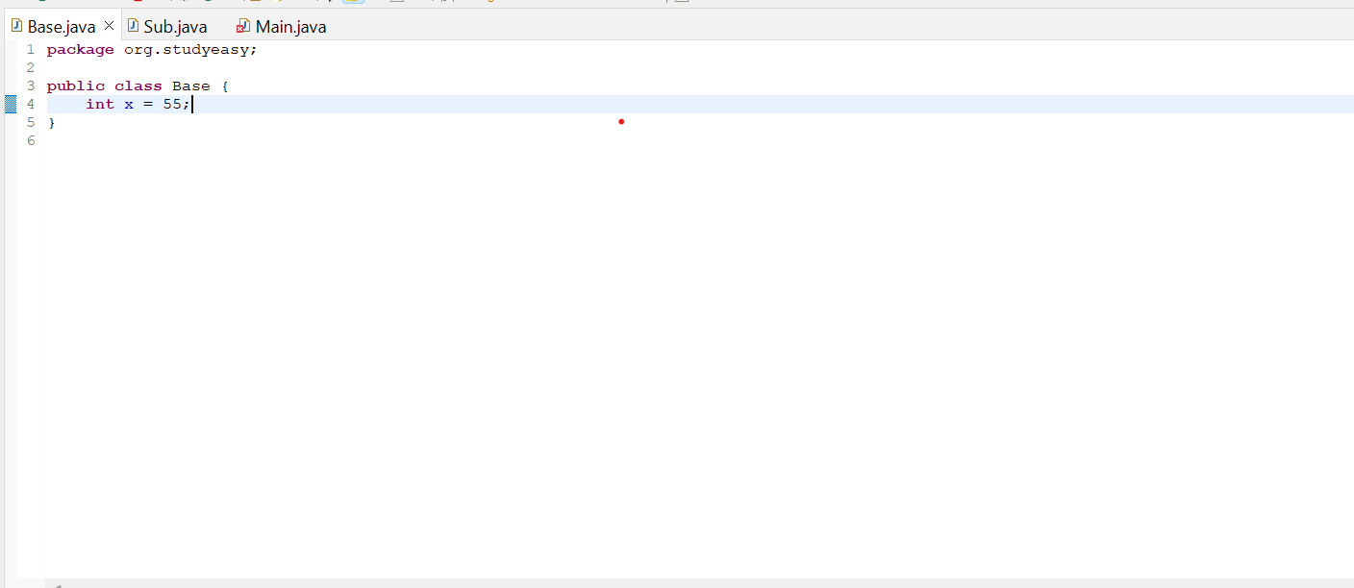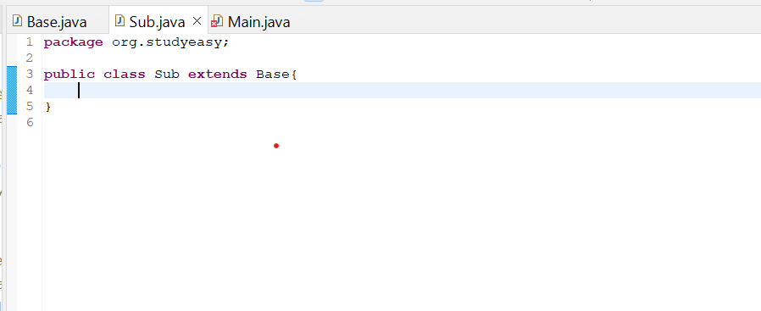

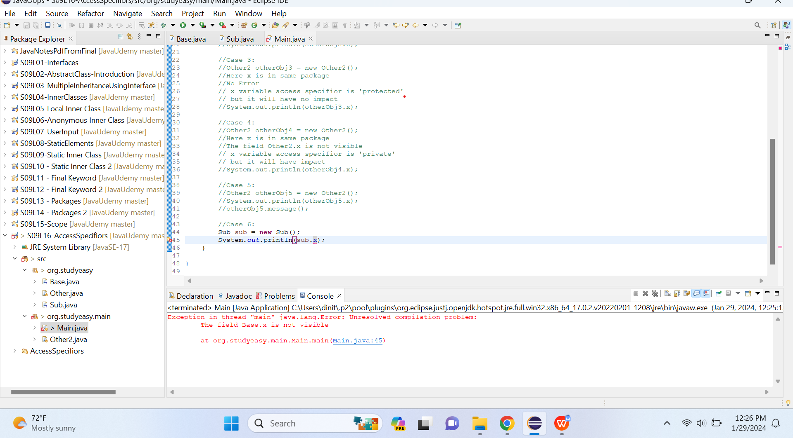

This is the Base Class This is the Parent Class Trying to access variable x from Parent Class
Gives you error. So to access it make the
Variable as public.

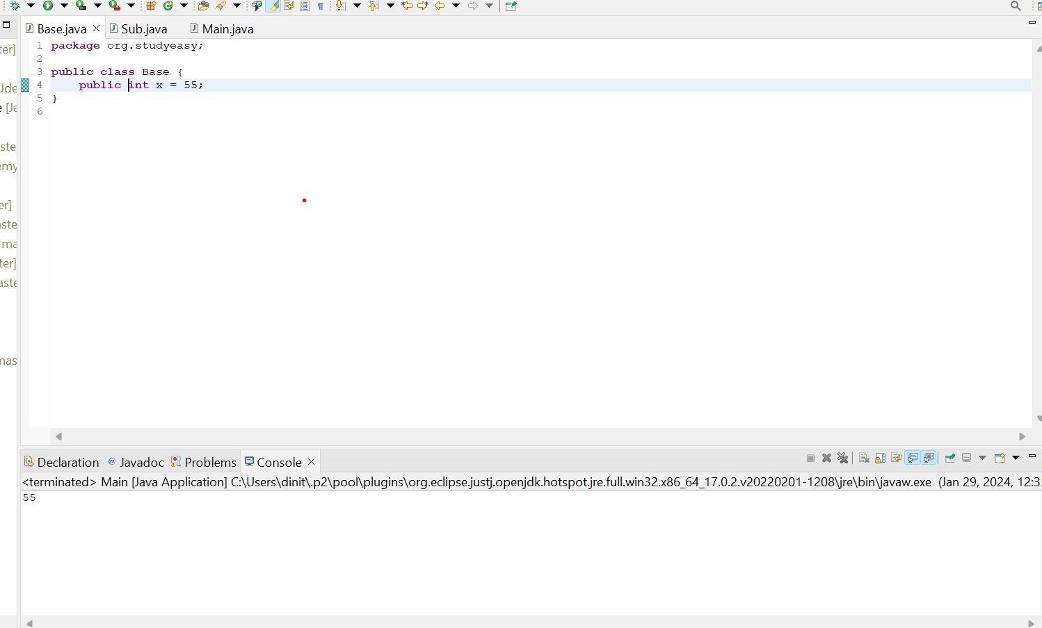

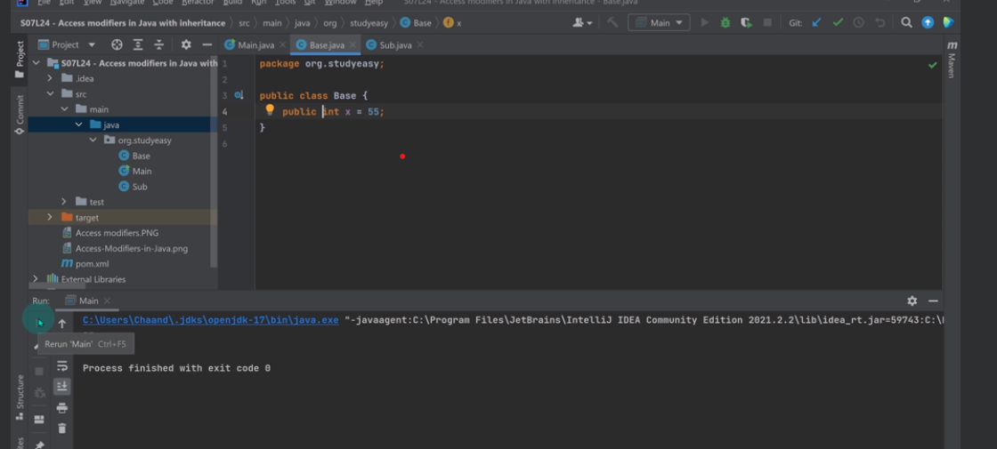
You can also bring Main.java in same package to get rid of the error.(Different IDE but same concept).
For both private and protected access specifiors.

