Call By Value

CallByValueDemo.java
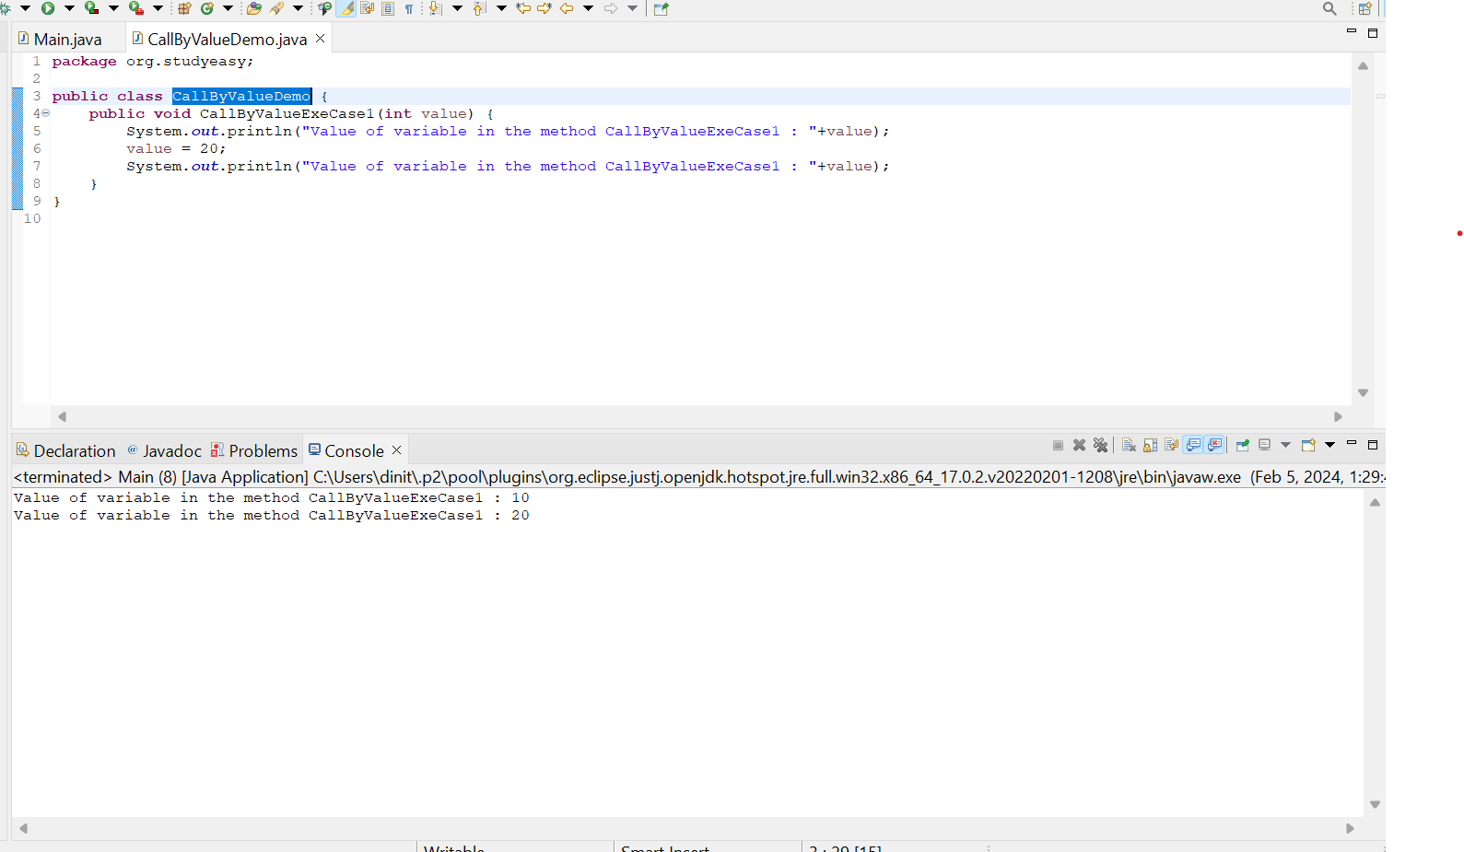
Main.java
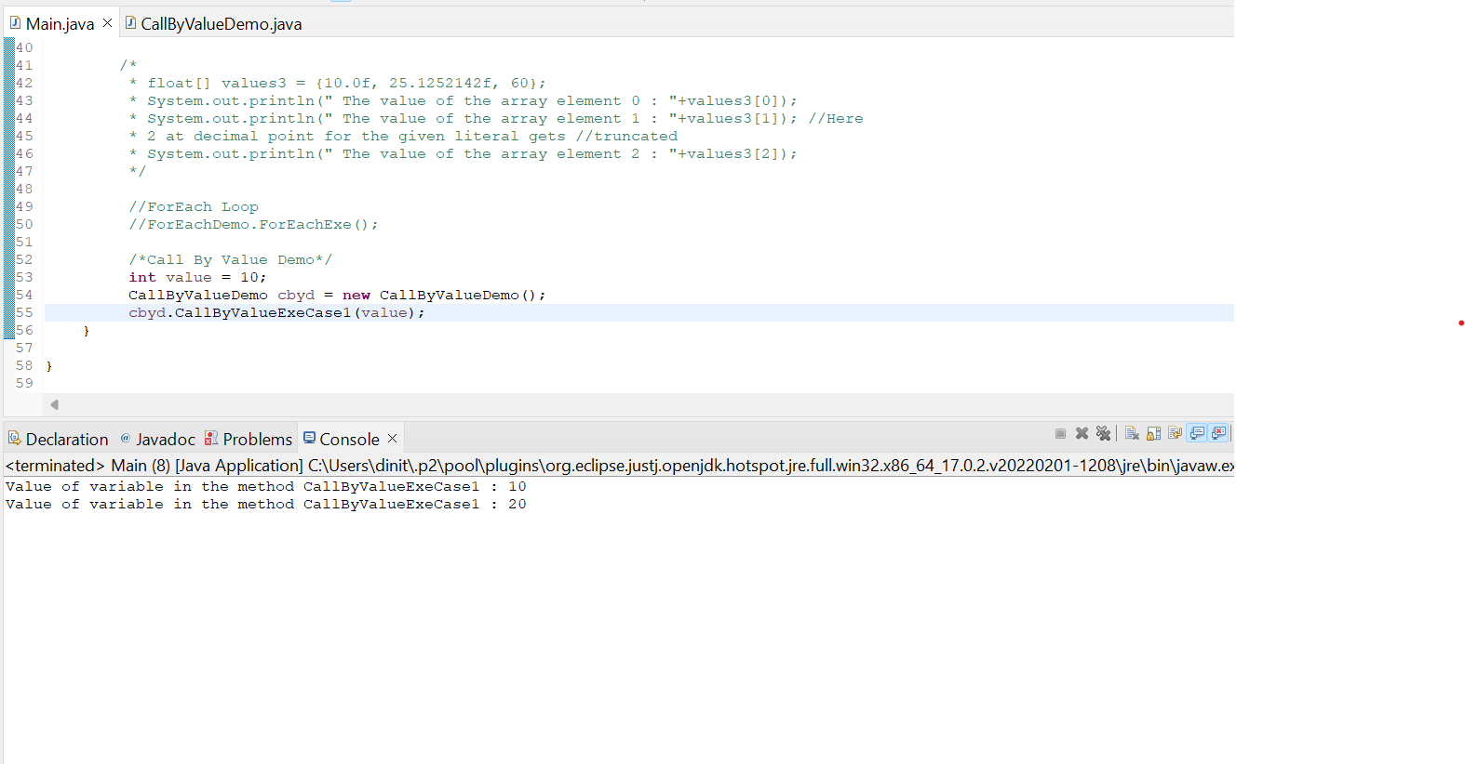

Whenever we pass a value, the variable reference is never passed only the value is passed. Refer below example. There is no change in CallByValueDemo.java, but there is change in Main.java(The value = 20; will be destroyed after the method is done executing)
