- THROWS

- Throws Example , And when you hover over the error you get options like below.
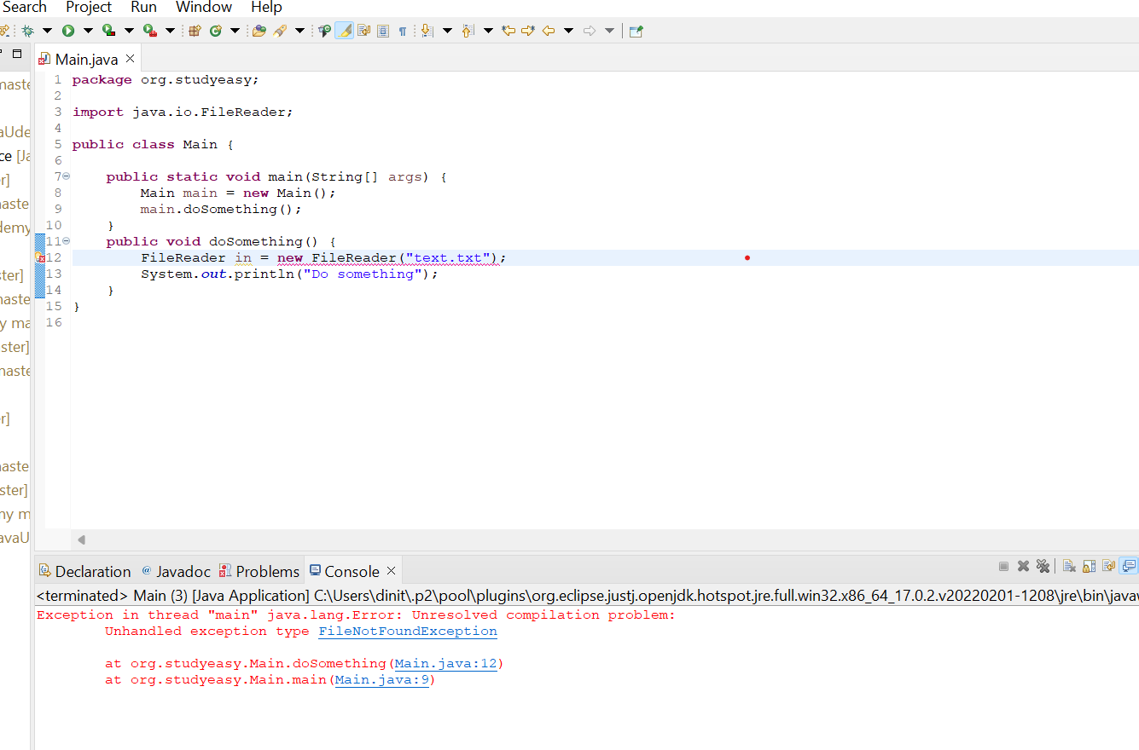

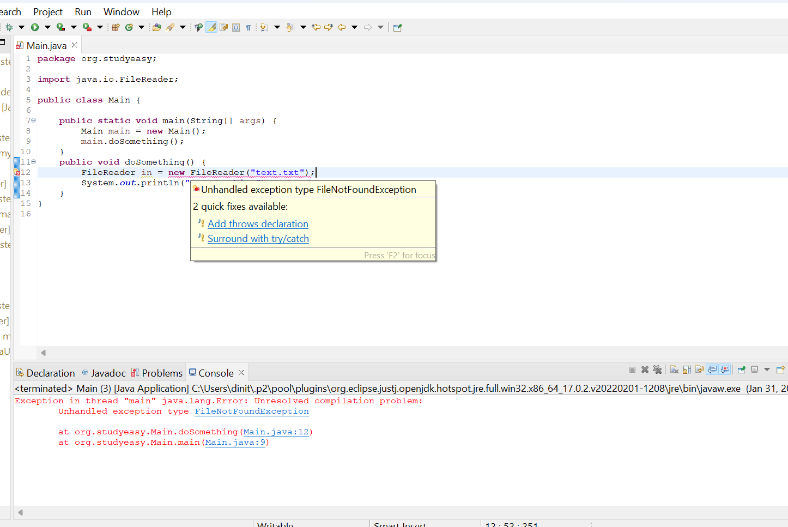

Case 1: Surround with try/catch

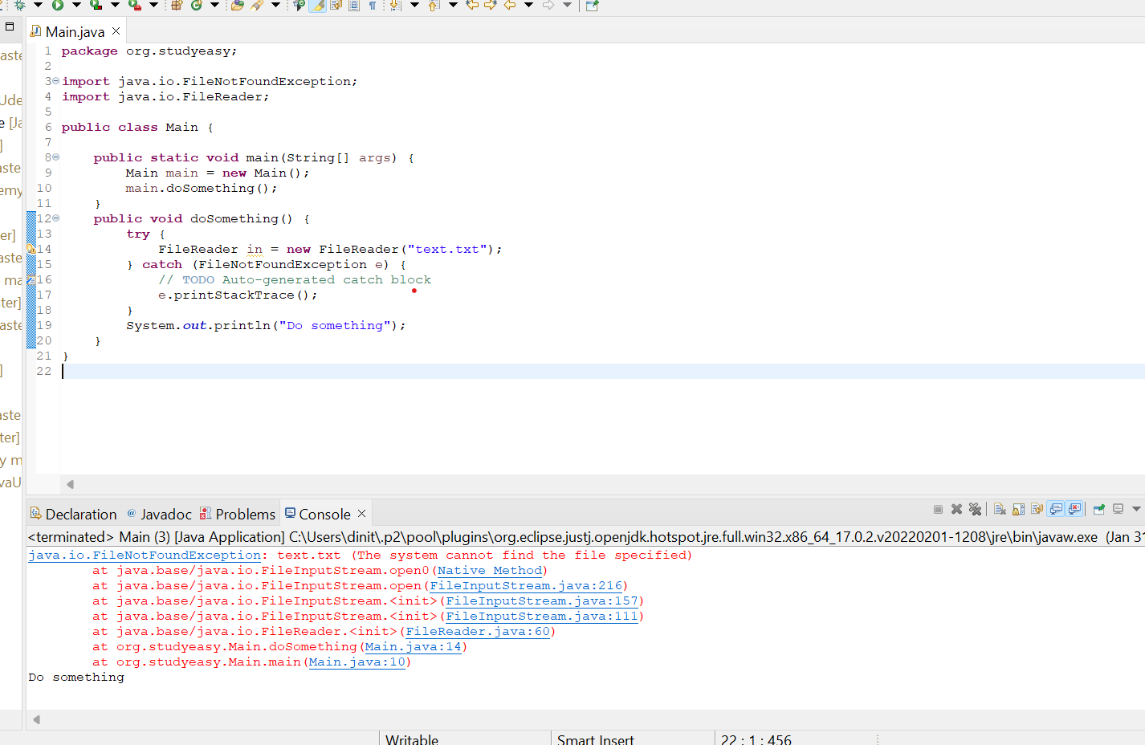

Case 2 : Add throws declaration

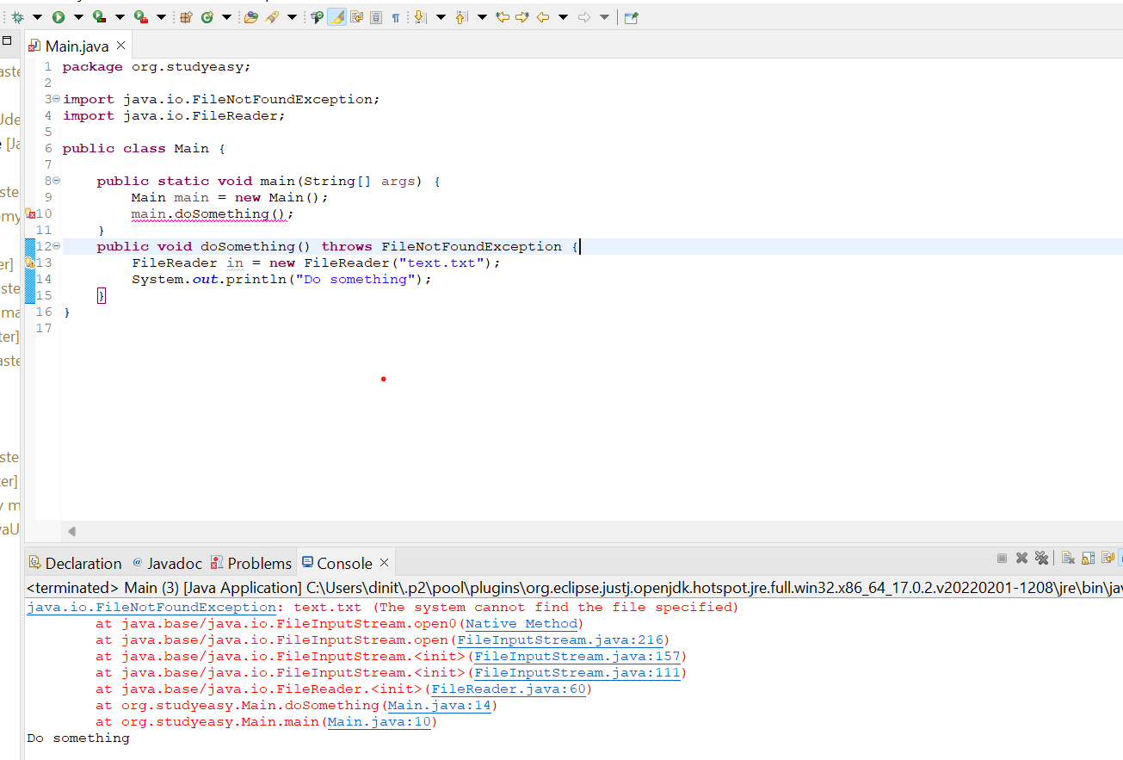

In Java, the throws keyword is used in the method signature to declare that a method may throw certain exceptions. This keyword is part of the method declaration and is used to indicate that the method might generate exceptions of a particular type during its execution.

public void exampleMethod() throws SomeException {
// Method implementation that may throw SomeException
}

- Throws keyword is used in order to throw an exception.

- If we you try catch statement - in another block like below, then we get output like below.
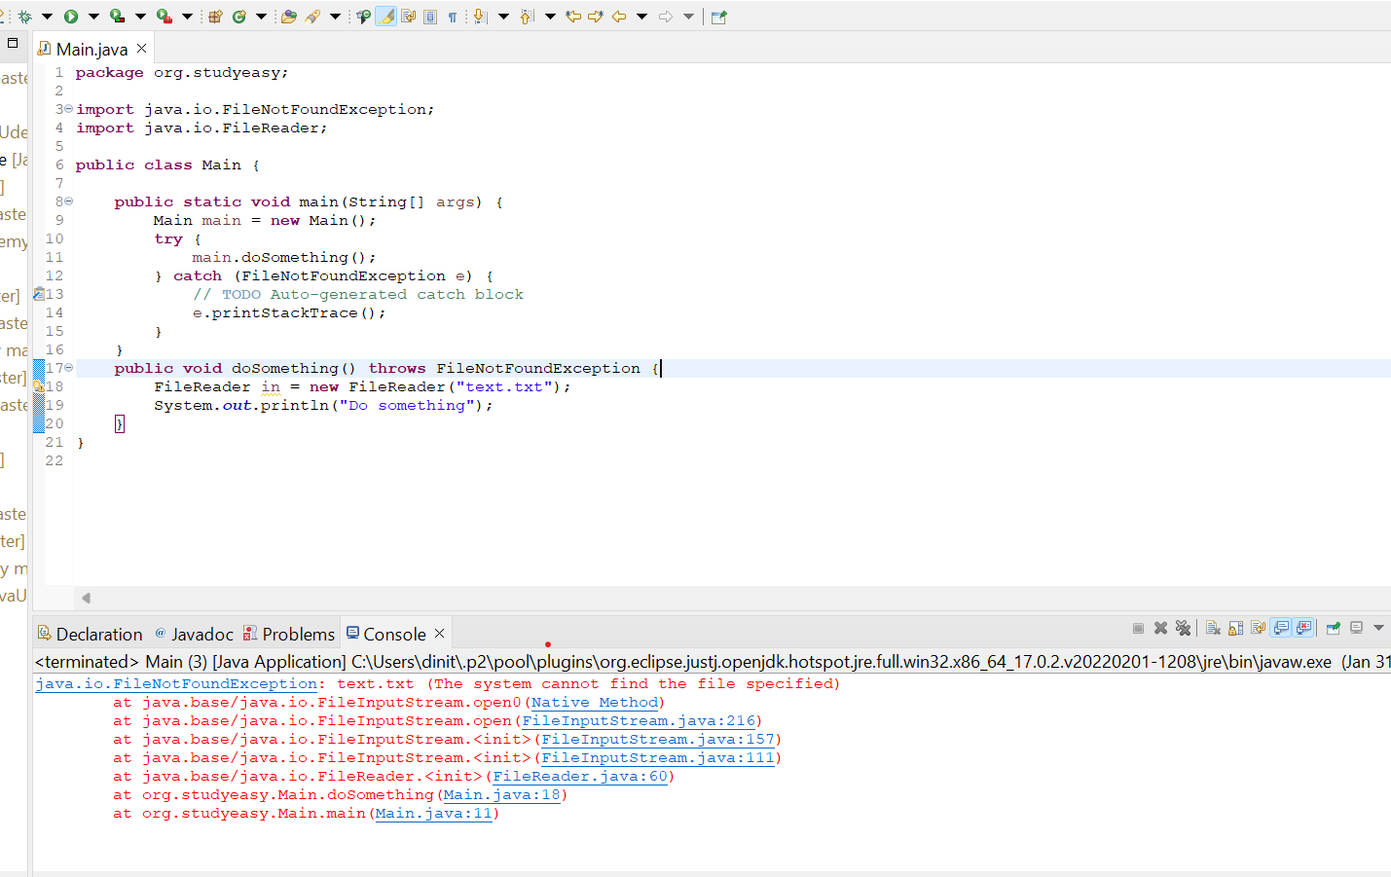

You won’t get the output “Do something”

- If you don’t know how to handle the exception by yourself and the exception handling will be unique for every case. It is better idea to throw the exception, so whenever the user will use the method, the user have to handle the exception according to the situation.

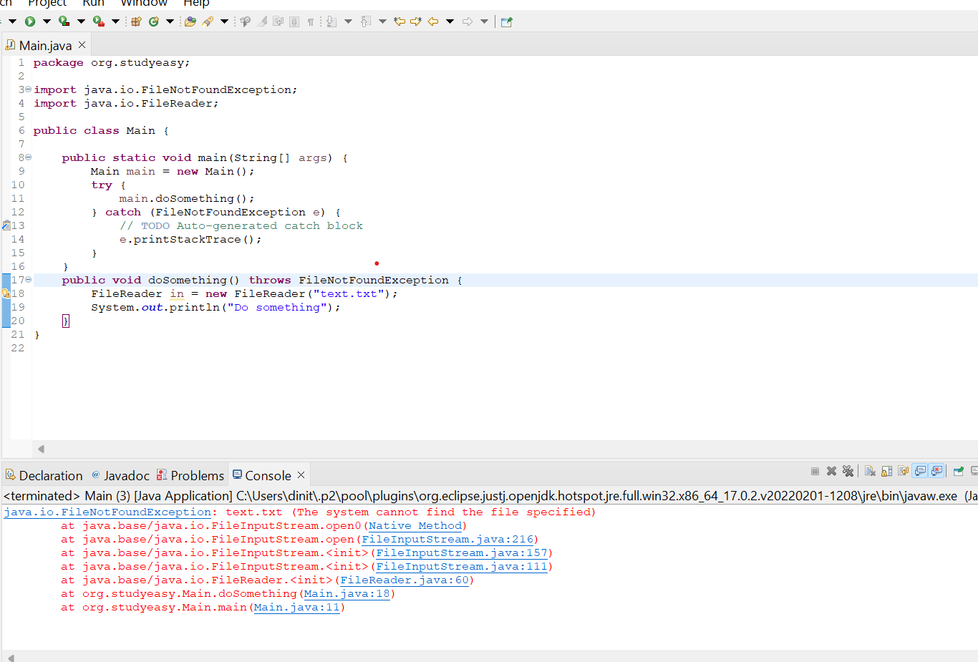

User is forced to handle the exception as the throws keyword forces it.

- JAVA THROW KEYWORD

- Imagine a scenario where we want to throw an exception, based on our own custom logic.So we have throw keyword.

Willing to throw an exception manually, we will use this keyword - throw.

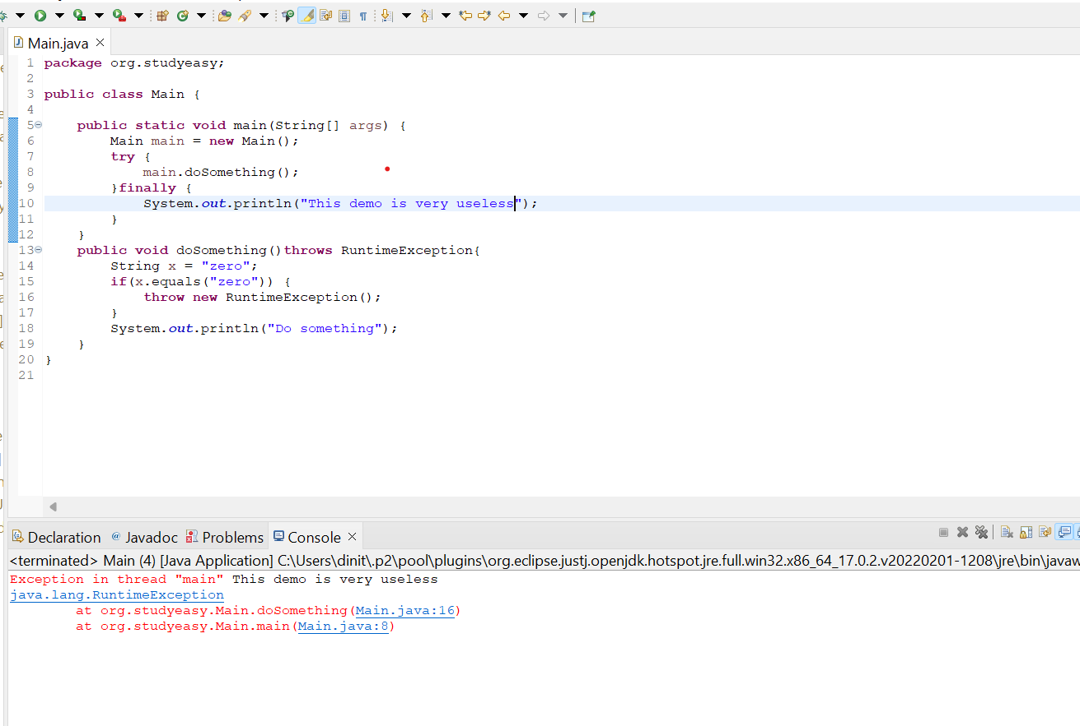

- In the above example, String x = “one”

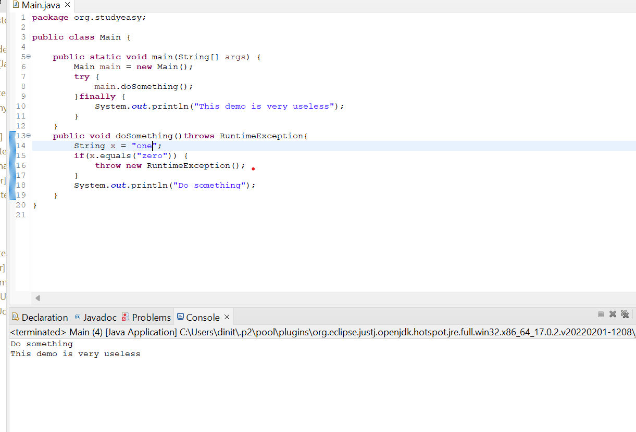

- User defined Exception

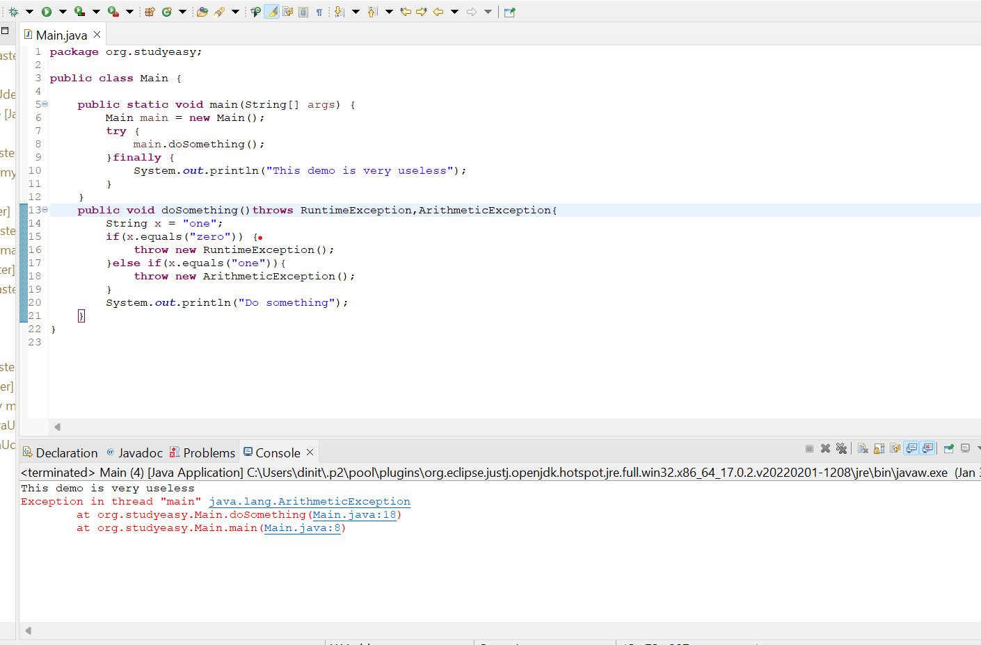

When we use Exception instead of ArthimeticException.Solution is below also.

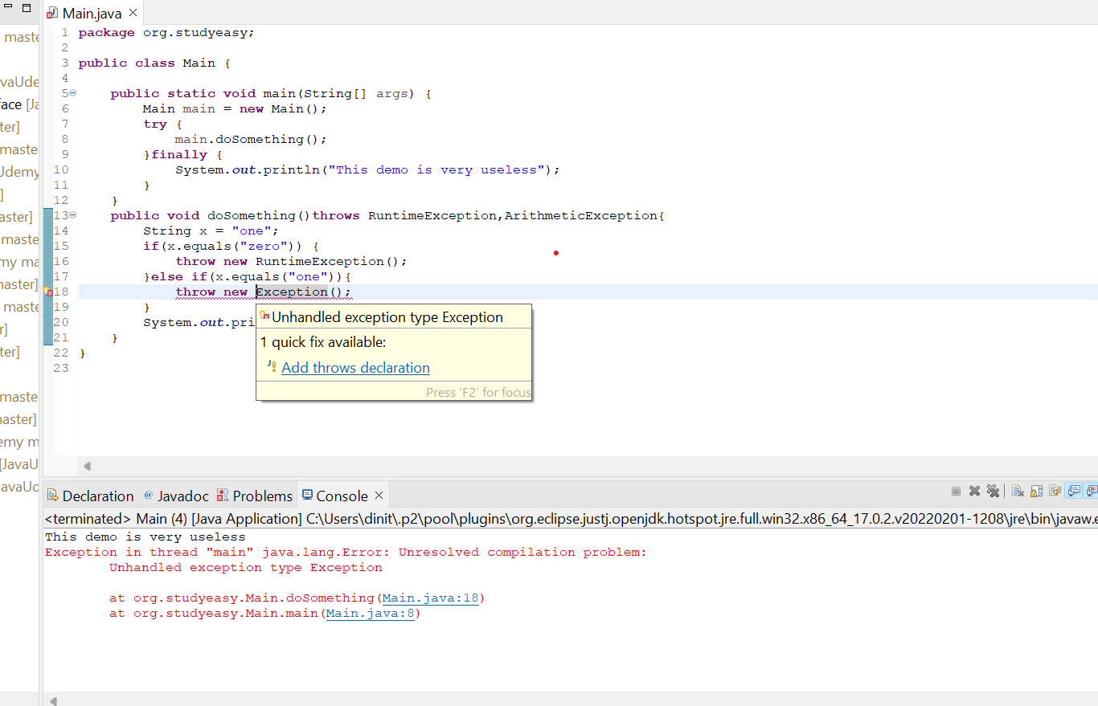

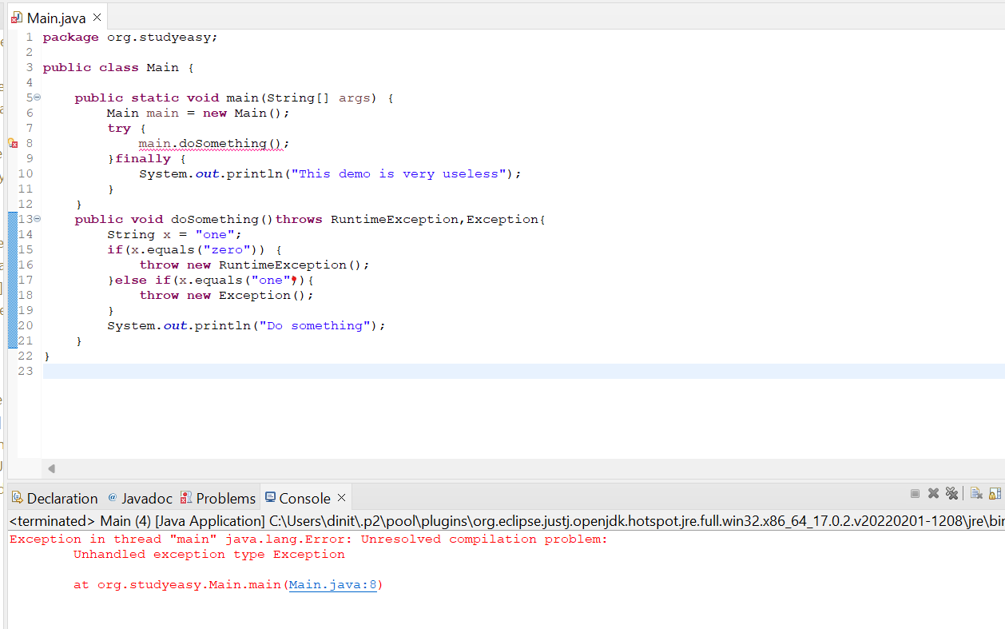

But Exception does not make any sense. So we can create a custom Exception, like Zero Exception.

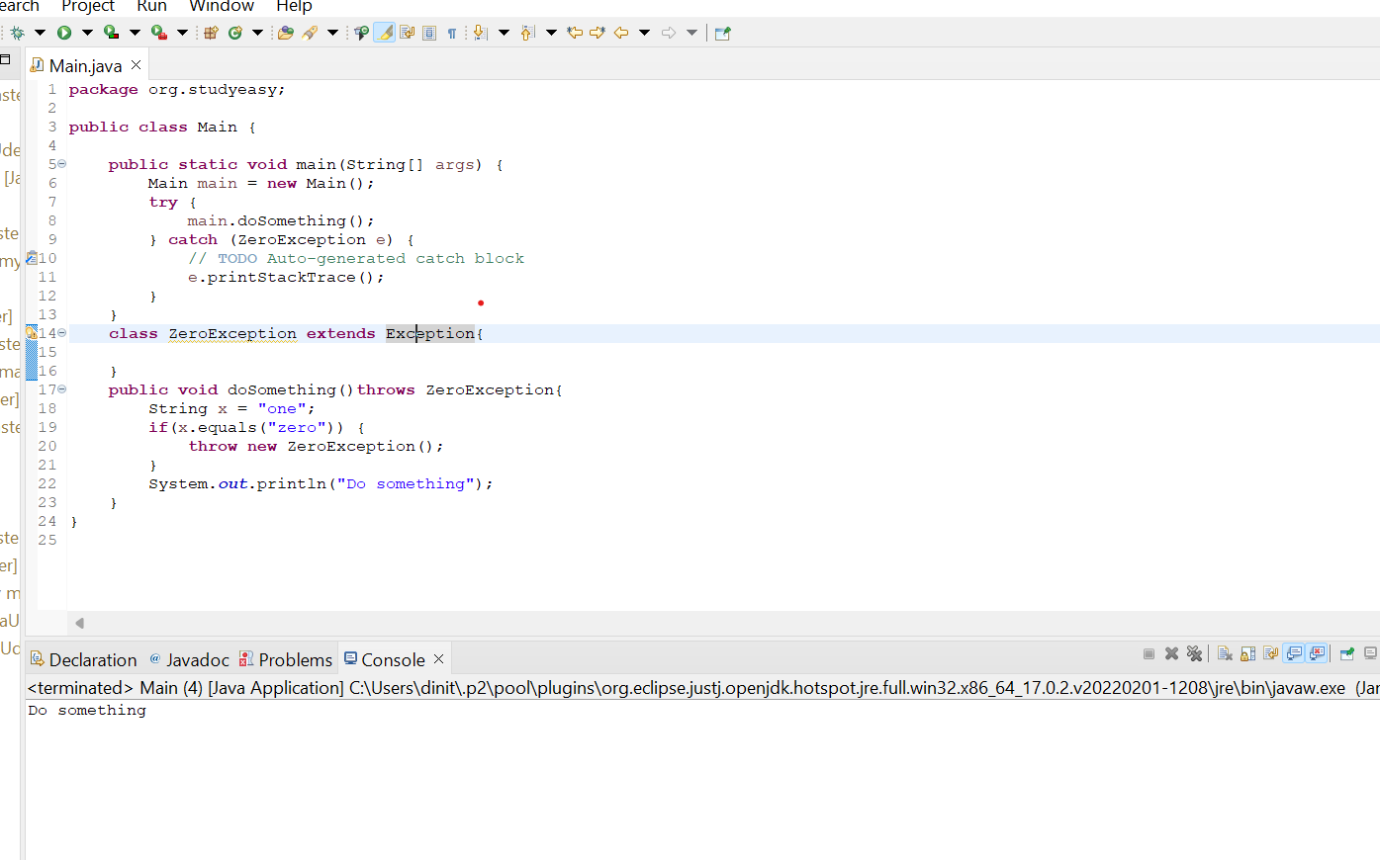

If String x = "zero"; you get the below output.

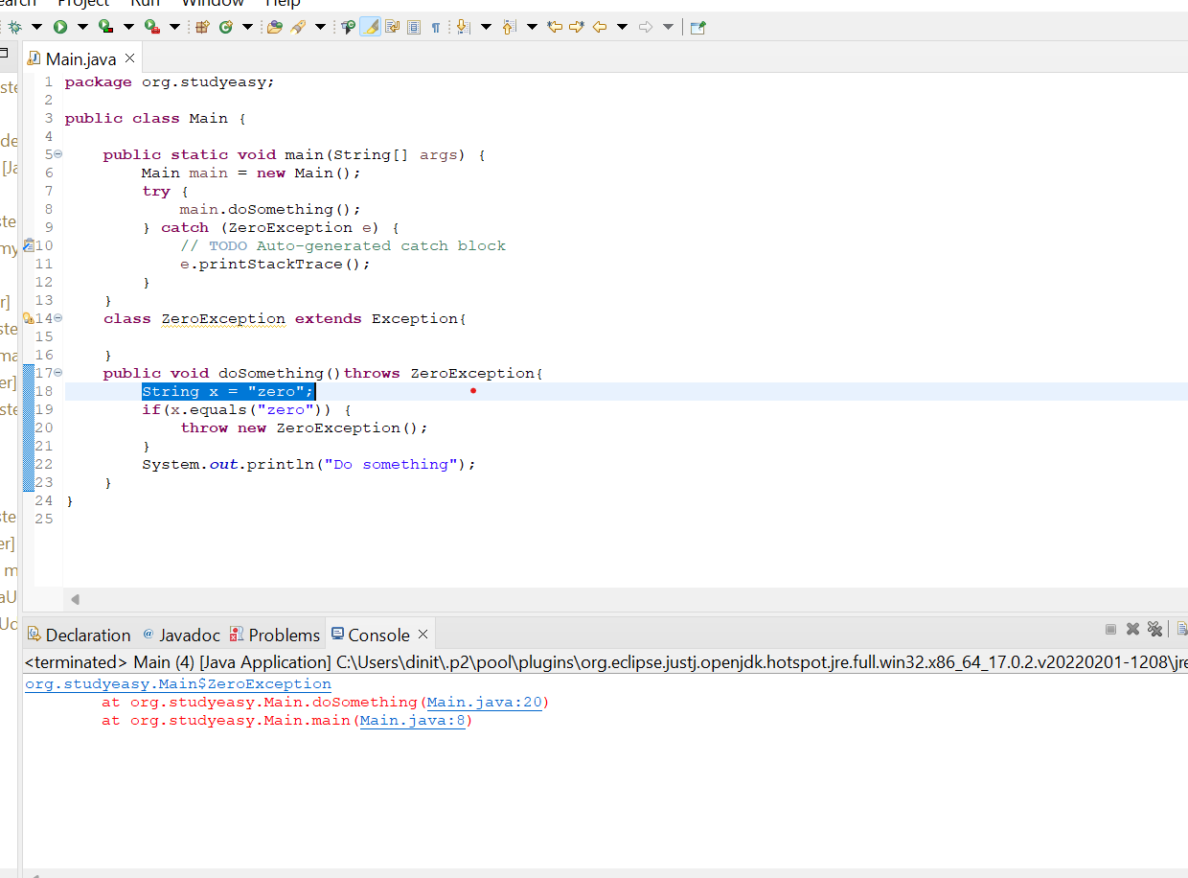

This is the how Standard Custom Exception structure looks like below.

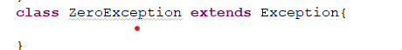

Custom exception is not widely used.

- CHECKED AND UNCHECKED EXCEPTIONS JAVA

- Unchecked Exception are casual or less serious exception. Runtime Error is not seriously error. So it is unchecked.

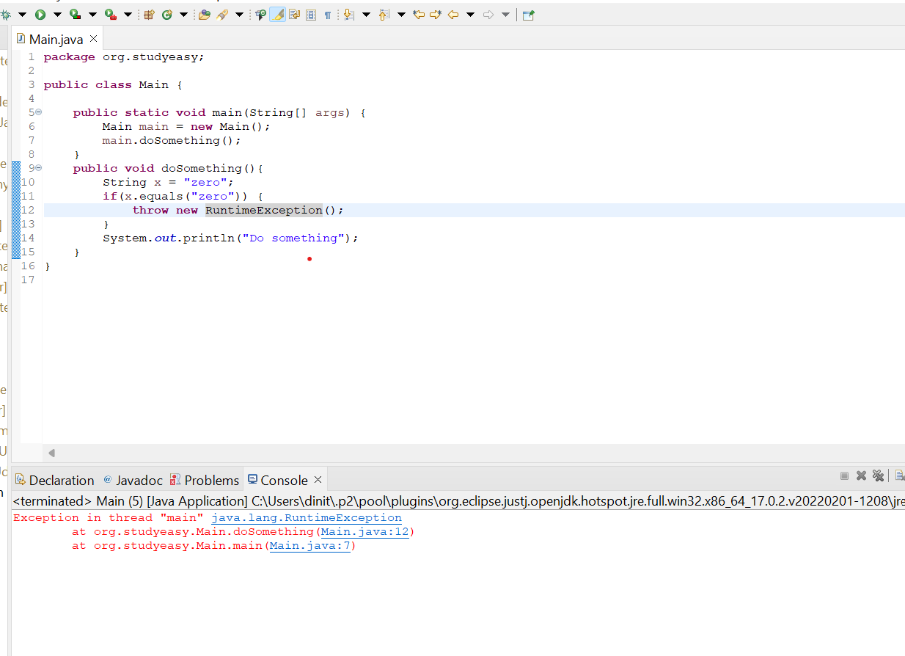

- Checked Exception - Not serious type exceptions - Example : FileNotFound Exception

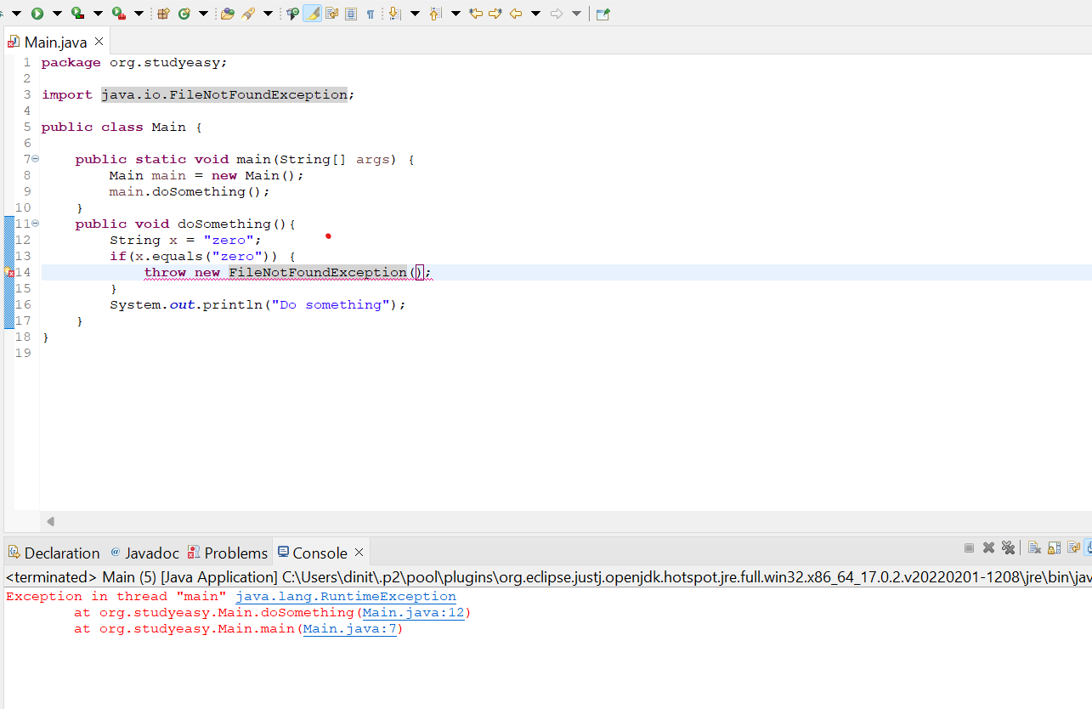

- Custom Exceptions by default are Checked or Serious Exceptions.

