- Strings

- int is a keyword and has a different syntax highlighting

- Every Datatype in Java except String is implemented as a primitive datatype.
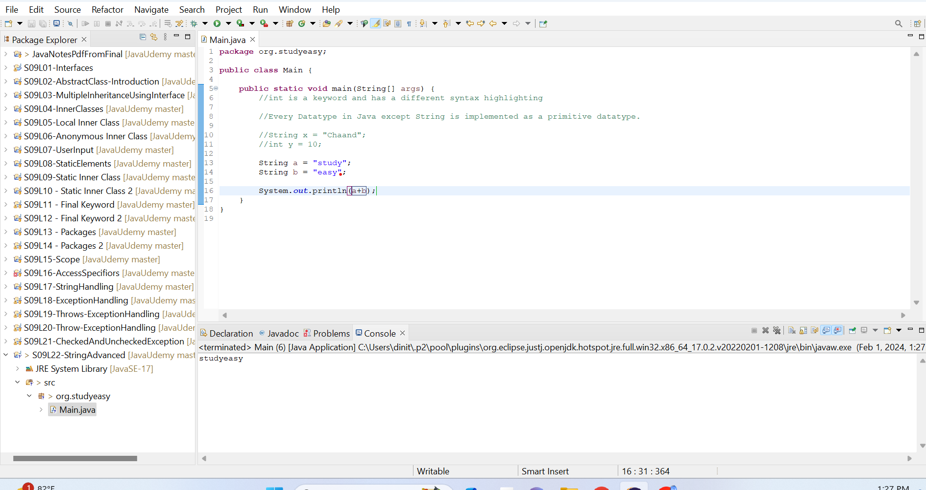

- String is character array.

- A Confusion with the strings.See below where the if condition; and still confusing output.Instead of getting output as Great you get What just happened.

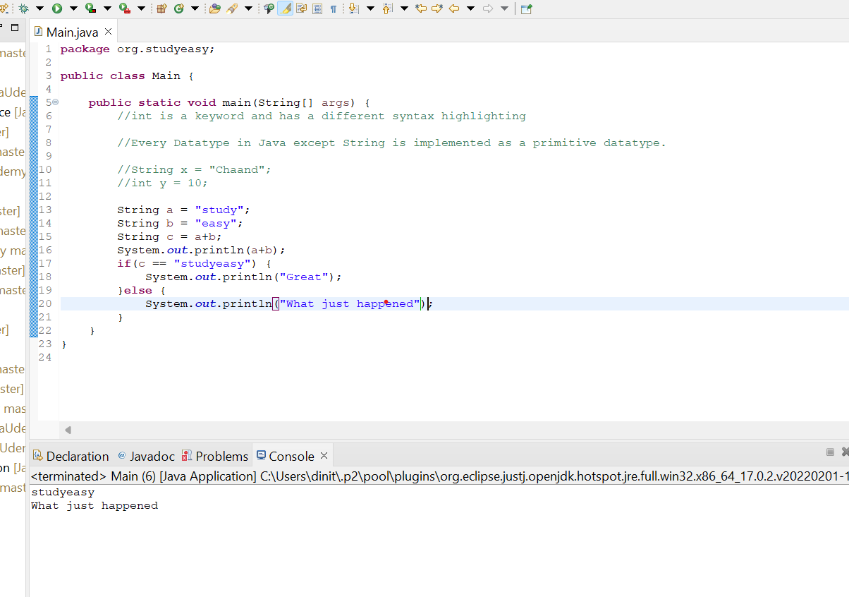

- Trying in another way, where you might think == is not capable of handling string operations.See below pic.

