- Strings

Let us try to use String Methods and see if we can fix the error. Actually it still doesn’t get fixed.
The difference between == and String.equals()
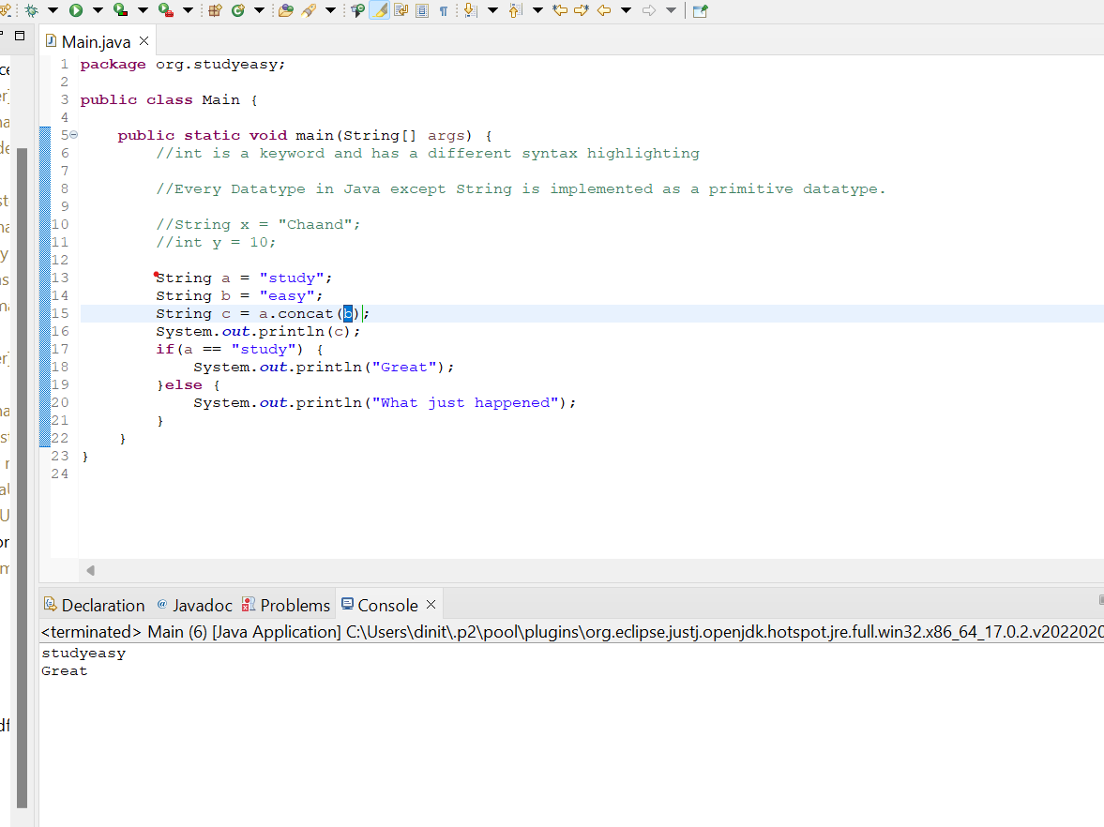

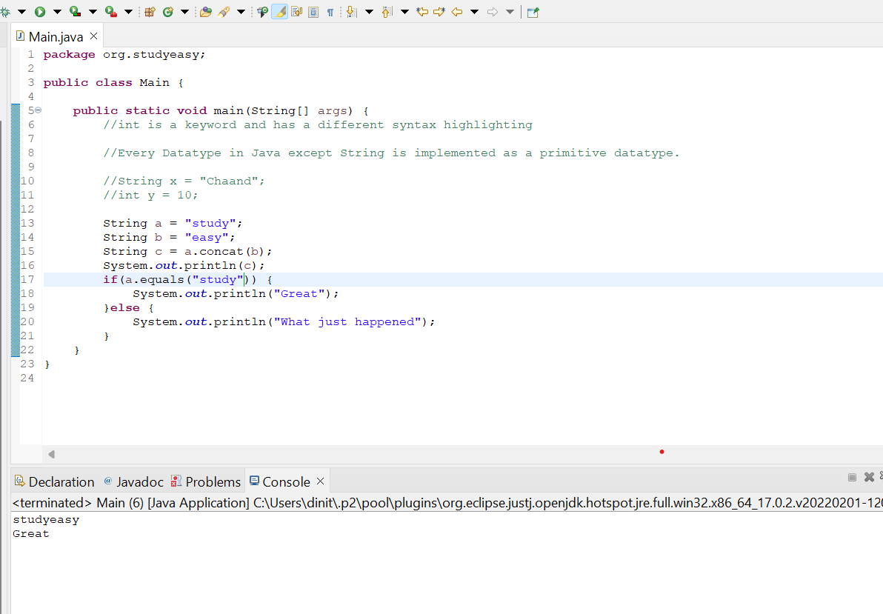

Trying to use other method like replace(). Below is the output how we get it.
