JAVA TYPES OF SETS IN COLLECTION FRAMEWORK

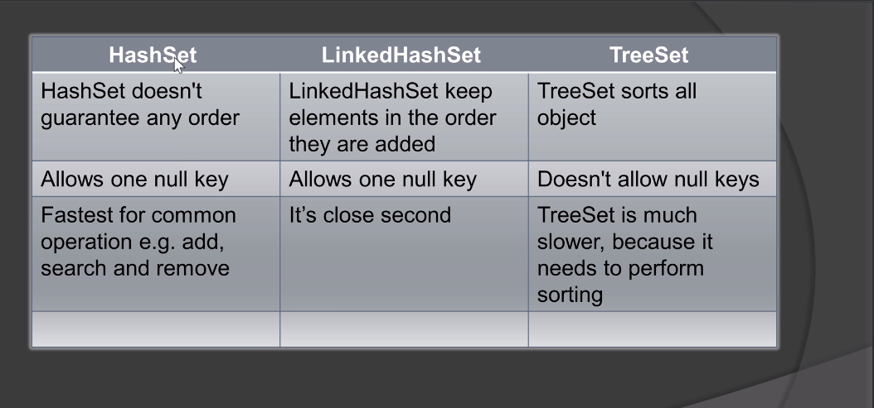

HashSet is the fastest one.

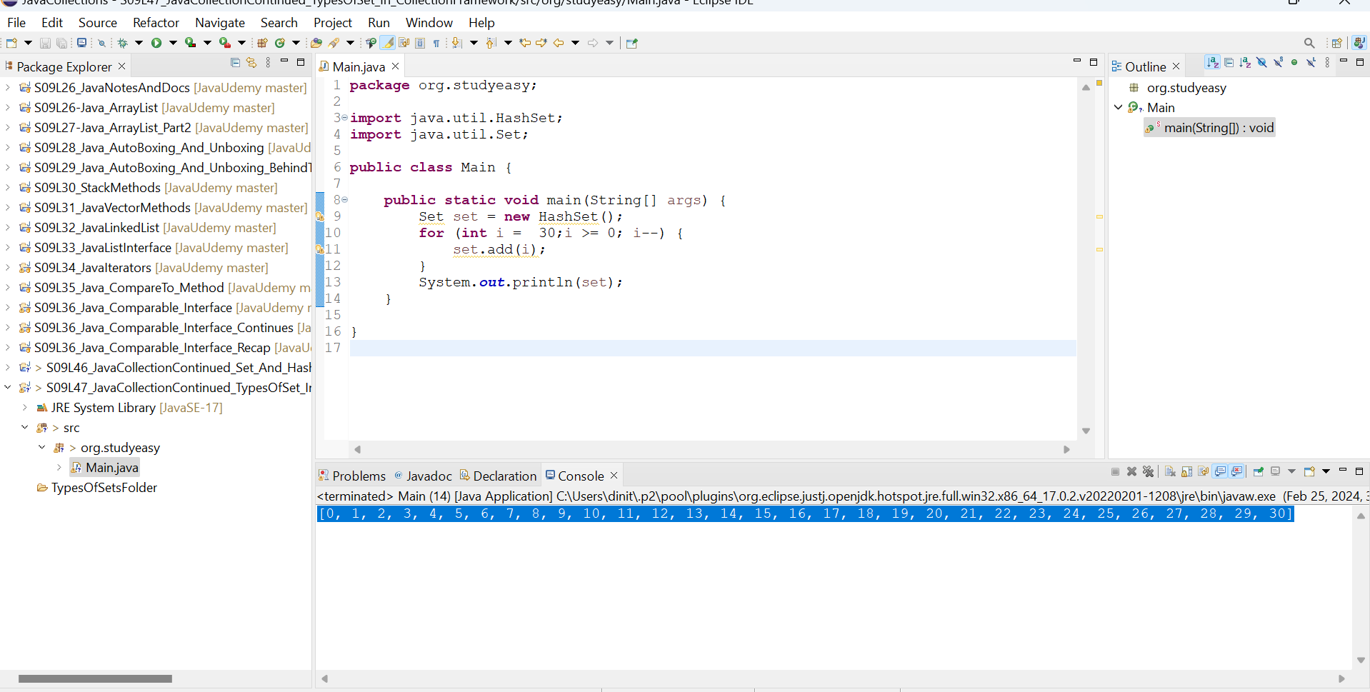
Here the sequence is not maintained, but the solution is below. Here the order is guaranteed.

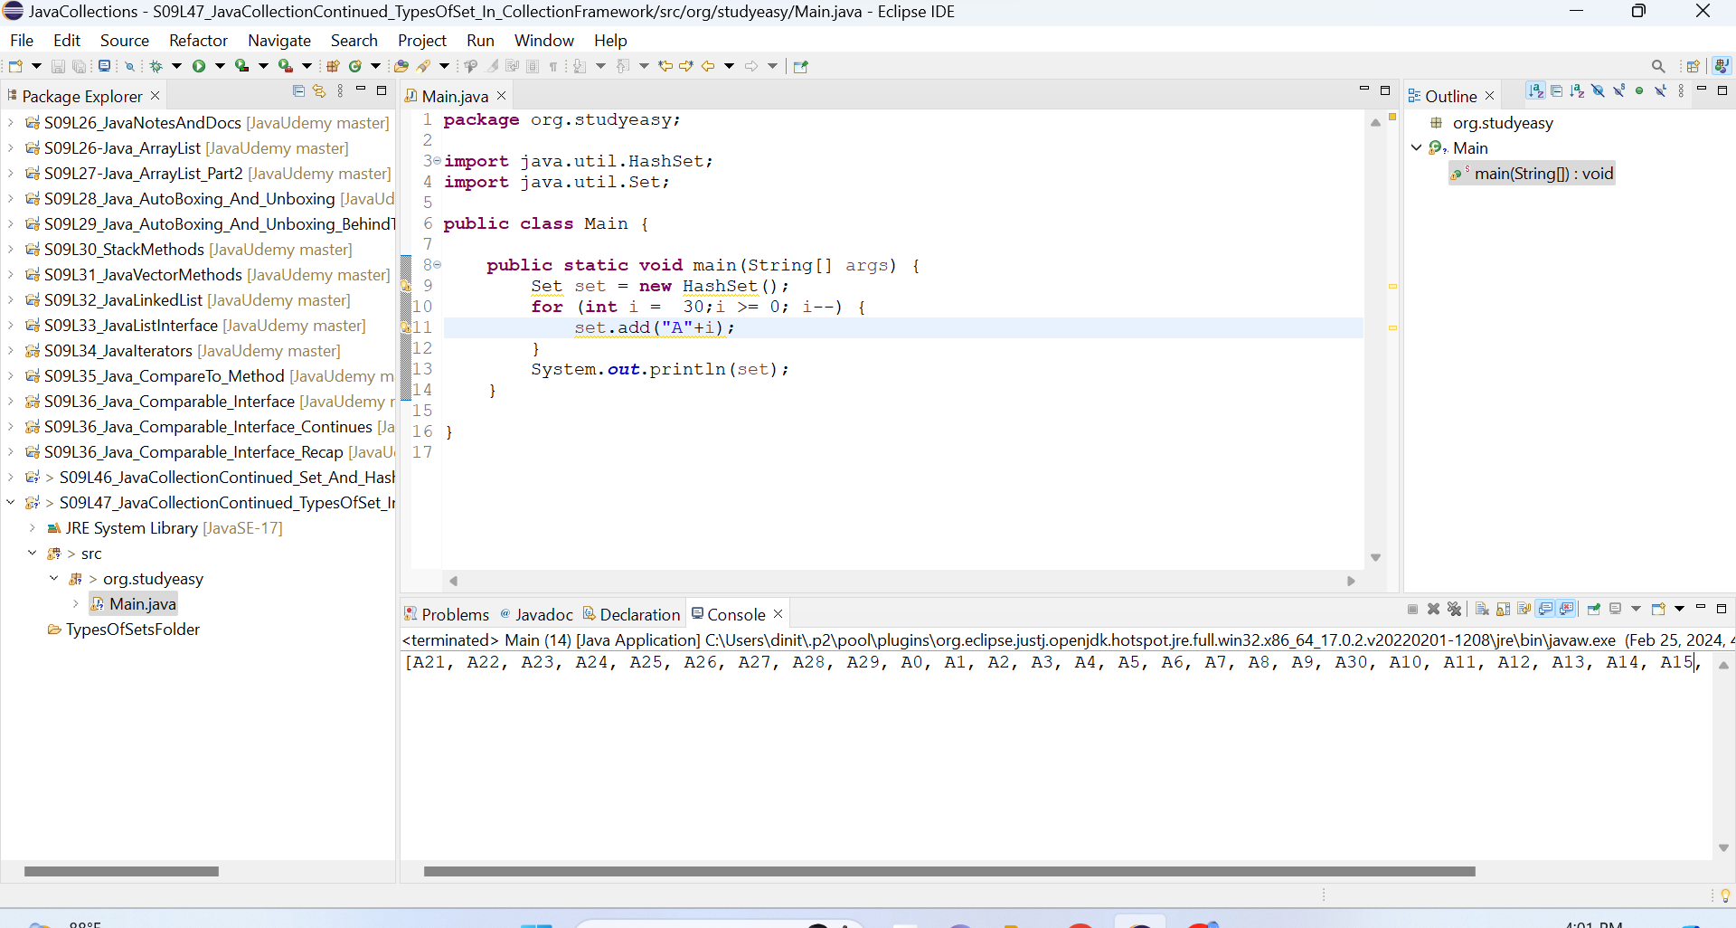

LinkedHashSet

