JAVA SESSION MANAGEMENT

When you firstly log in, session pool is created in the server. A new column will be added. A server will know an additional new user has been logged in. Session Id will be kept in the browser, so that it can send seesion id with your request whenever it request.

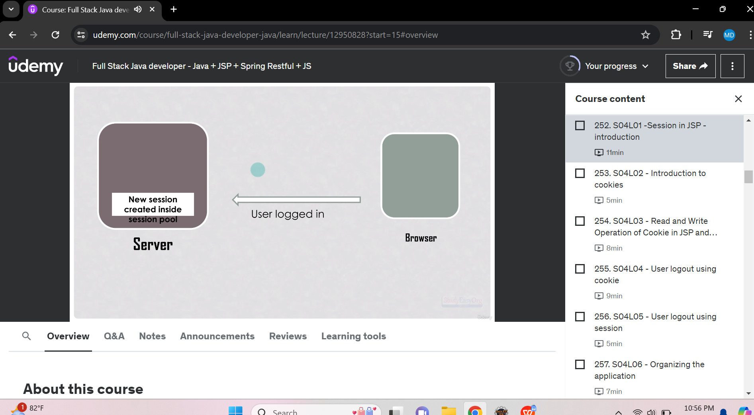

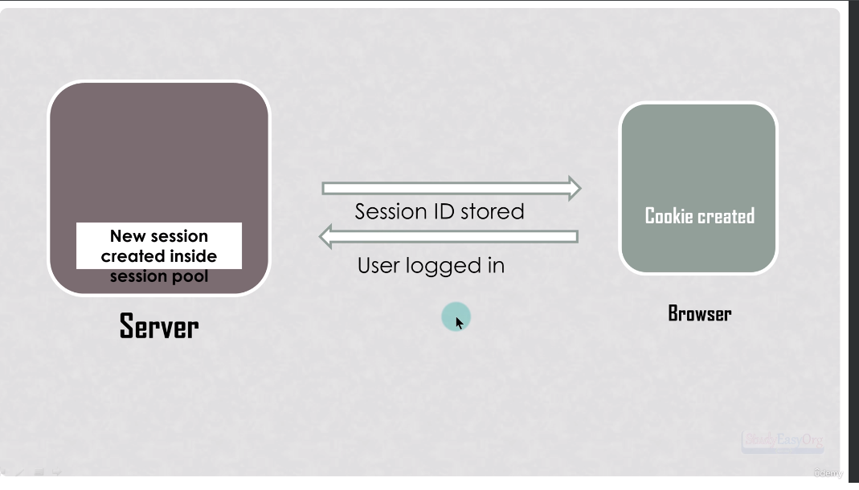

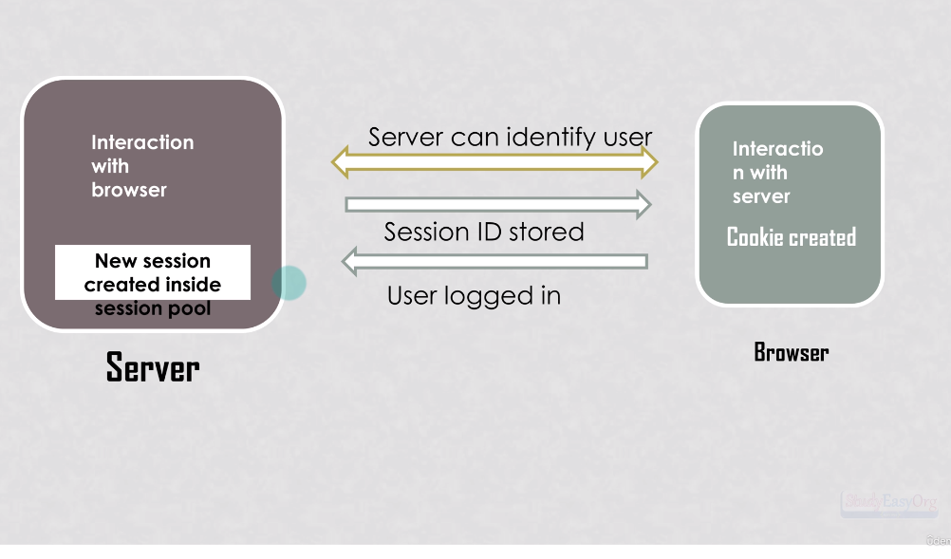

JAVA SESSION MANAGEMENT QUIZ

Question 1:
Which of the following is used to invalidate a session ?
Request.getSession().invalidate();

窗体顶端
Question 2:
what happens if we set request.getSession(true)?

returns null, if no session is associated with the request

returns new session

destroys the existing session and returns new session

returns current session, if no session is associated with the request then returns new session. <- Answer

窗体底端

窗体顶端
Question 3:
Define cookie?

Cookie is a chunk of memory in the computer RAM

Cookie is a chunk of memory in the browser for the specific website <- Answer

Cookie is a chunk of memory in the browser and it is common to all website.

None of the above

窗体底端

Question 4:which of the following code retrieves all the cookies for the application/website?Request.getCookies()

Question 5:What happens when we invalidate a session?
New session id is generated and my attribute associated with old session is destroyed.

-------------------------------------------------------------------------------------------------------
窗体顶端
Question 6:
______________________ method is used to get the baseURL.

response.getContextPath()

response.getBaseURL()

request.getBaseURL()

request.getContextPath() <- Answer

窗体底端

窗体顶端
Question 7:
_____________________ method is used to get the encoded URL.

request.getEncodedURL();

response.encodeURL(); <- Answer

request.encodeURL();

request.getEncodeURL();

窗体底端
-------------------------------------------------------------------------------------------------------

