-------------------------------------------------------------------------------------
Java Hibernate - Setting Up Hibernate Configuration file
-------------------------------------------------------------------------------------
Create a Package inside the java folder which is inside main folder. -> org.studyeasy

Inside java folder create a XML file. -> hibernate.cfg.xml

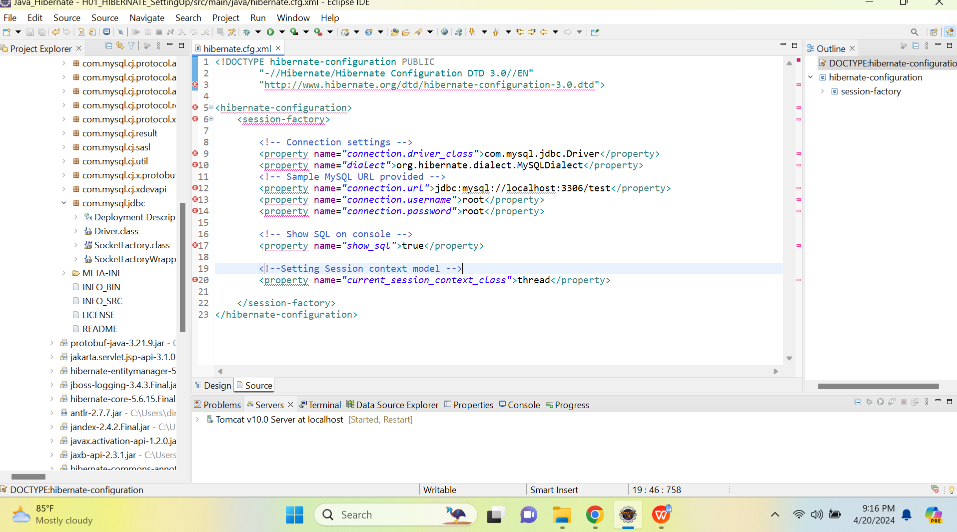

This is your Driver class.

Below is the updated Source code of hibernate.cfg.xml

<!DOCTYPE hibernate-configuration PUBLIC
"-//Hibernate/Hibernate Configuration DTD 3.0//EN"
"http://www.hibernate.org/dtd/hibernate-configuration-3.0.dtd">
<hibernate-configuration>
<session-factory>
<!-- Connection settings -->
<property name="connection.driver_class">com.mysql.jdbc.Driver</property>
<property name="dialect">org.hibernate.dialect.MySQLDialect</property>
<!-- Sample MySQL URL provided -->
<property name="connection.url">jdbc:mysql://localhost:3306/hibernateproj</property>
<property name="connection.username">root</property>
<property name="connection.password">wizardMDFC30$</property>
<!-- Show SQL on console -->
<property name="show_sql">true</property>
<!--Setting Session context model -->
<property name="current_session_context_class">thread</property>
</session-factory>
</hibernate-configuration>

