-------------------------------------------------------------------------------------
Java Hibernate - CRUD Operation - Create
-------------------------------------------------------------------------------------
Package :-> org.studyeasy
Class :-> App
Source Code :-

- SessionFactory

//Session Factory
SessionFactory factory = new Configuration()
.configure("hibernate.cfg.xml")
.addAnnotatedClass(Users.class)
.buildSessionFactory();

- Session

//Session
Session session = factory.getCurrentSession();

- Close the session

//Close the session
try {
//Create Object of Entity Class Type
Users user = new Users("username", "password", "first_name", "last_name");
//Start Transaction
session.beginTransaction();
//Perform operation
session.save(user); -> save has been deprecated, but can use persist().
//Commit Transaction
session.getTransaction().commit();
System.out.println("Row added!..");
}finally {
session.close();
factory.close();
}

Full Source Code:

package org.studyeasy;

import org.hibernate.Session;
import org.hibernate.SessionFactory;
import org.hibernate.cfg.Configuration;
import org.studyeasy.entity.Users;

public class App {

public static void main(String[] args) {

//Session Factory
SessionFactory factory = new Configuration()
.configure("hibernate.cfg.xml")
.addAnnotatedClass(Users.class)
.buildSessionFactory();

//Session
Session session = factory.getCurrentSession();

//Close the session
try {
//Create Object of Entity Class Type
Users user = new Users("username", "password", "first_name", "last_name");
//Start Transaction
session.beginTransaction();
//Perform operation
session.save(user);
//Commit Transaction
session.getTransaction().commit();
System.out.println("Row added!..");

}finally {
session.close();
factory.close();
}
}
}

THIS IS THE FINAL CODE (App.java) FOR THE CRUD OPERATION WITH THE DEPENDANCIES

App.java

package org.studyeasy;

import org.hibernate.Session;
import org.hibernate.SessionFactory;
import org.hibernate.cfg.Configuration;
import org.studyeasy.entity.Users;

public class App {

public static void main(String[] args) {
//Session Factory
SessionFactory factory = new Configuration()
.configure("hibernate.cfg.xml")
.addAnnotatedClass(Users.class)
.buildSessionFactory();

//Session
Session session = factory.getCurrentSession();

//Close the session
try {
//Create Object of Entity Class Type
Users user = new Users("username", "password", "first_name", "last_name");

//Start Transaction
session.beginTransaction();

//Perform operation
session.persist(user);

//Commit Transaction
session.getTransaction().commit();
System.out.println("Row added!..");

}finally {
session.close();
factory.close();
}
}
}

Hibernate.cfg.xml

<?xml version="1.0" encoding="UTF-8"?>

<project xmlns="http://maven.apache.org/POM/4.0.0"
xmlns:xsi="http://www.w3.org/2001/XMLSchema-instance"
xsi:schemaLocation="http://maven.apache.org/POM/4.0.0 http://maven.apache.org/xsd/maven-4.0.0.xsd">
<modelVersion>4.0.0</modelVersion>

<groupId>org.studyeasy</groupId>
<artifactId>H03_HIBERNATE_CrudOperationCreate</artifactId>
<version>0.0.1-SNAPSHOT</version>
<packaging>war</packaging>

<name>H03_HIBERNATE_CrudOperationCreate Maven Webapp</name>
<!-- FIXME change it to the project's website -->
<url>http://www.example.com</url>

<properties>
<project.build.sourceEncoding>UTF-8</project.build.sourceEncoding>
<maven.compiler.source>1.7</maven.compiler.source>
<maven.compiler.target>1.7</maven.compiler.target>
</properties>

<dependencies>

<dependency>
<groupId>junit</groupId>
<artifactId>junit</artifactId>
<version>4.11</version>
<scope>test</scope>
</dependency>

<dependency>
<groupId>javax.servlet</groupId>
<artifactId>servlet-api</artifactId>
<version>2.5</version>
<scope>provided</scope>
</dependency>

<!--
https://mvnrepository.com/artifact/jakarta.servlet/jakarta.servlet-api -->
<dependency>
<groupId>jakarta.servlet</groupId>
<artifactId>jakarta.servlet-api</artifactId>
<version>5.0.0</version>
<scope>provided</scope>
</dependency>

<!-- https://mvnrepository.com/artifact/mysql/mysql-connector-java -->
<dependency>
<groupId>mysql</groupId>
<artifactId>mysql-connector-java</artifactId>
<version>8.0.33</version>
</dependency>

<!--
https://mvnrepository.com/artifact/jakarta.servlet.jsp/jakarta.servlet.jsp-api -->
<dependency>
<groupId>jakarta.servlet.jsp</groupId>
<artifactId>jakarta.servlet.jsp-api</artifactId>
<version>3.1.0</version>
<scope>provided</scope>
</dependency>

<!-- https://mvnrepository.com/artifact/org.hibernate.orm/hibernate-core -->
<dependency>
<groupId>org.hibernate.orm</groupId>
<artifactId>hibernate-core</artifactId>
<version>6.4.4.Final</version>
</dependency>
</dependencies>

<build>
<finalName>H03_HIBERNATE_CrudOperationCreate</finalName>
<pluginManagement><!-- lock down plugins versions to avoid using Maven
defaults (may be moved to parent pom) -->
<plugins>
<plugin>
<artifactId>maven-clean-plugin</artifactId>
<version>3.1.0</version>
</plugin>
<!-- see
http://maven.apache.org/ref/current/maven-core/default-bindings.html#Plugin_bindings_for_war_packaging -->
<plugin>
<artifactId>maven-resources-plugin</artifactId>
<version>3.0.2</version>
</plugin>
<plugin>
<artifactId>maven-compiler-plugin</artifactId>
<version>3.8.0</version>
</plugin>
<plugin>
<artifactId>maven-surefire-plugin</artifactId>
<version>2.22.1</version>
</plugin>
<plugin>
<artifactId>maven-war-plugin</artifactId>
<version>3.2.2</version>
</plugin>
<plugin>
<artifactId>maven-install-plugin</artifactId>

<version>2.5.2</version>
</plugin>
<plugin>
<artifactId>maven-deploy-plugin</artifactId>
<version>2.8.2</version>
</plugin>
</plugins>
</pluginManagement>
</build>
</project>

Dependancies to be installed
<dependency>
<groupId>javax.servlet</groupId>
<artifactId>servlet-api</artifactId>
<version>2.5</version>
<scope>provided</scope>
</dependency>

<!--
https://mvnrepository.com/artifact/jakarta.servlet/jakarta.servlet-api -->
<dependency>
<groupId>jakarta.servlet</groupId>
<artifactId>jakarta.servlet-api</artifactId>
<version>5.0.0</version>
<scope>provided</scope>
</dependency>

<!-- https://mvnrepository.com/artifact/mysql/mysql-connector-java -->
<dependency>
<groupId>mysql</groupId>
<artifactId>mysql-connector-java</artifactId>
<version>8.0.33</version>
</dependency>

<!--
https://mvnrepository.com/artifact/jakarta.servlet.jsp/jakarta.servlet.jsp-api -->
<dependency>
<groupId>jakarta.servlet.jsp</groupId>
<artifactId>jakarta.servlet.jsp-api</artifactId>
<version>3.1.0</version>
<scope>provided</scope>
</dependency>

<!-- https://mvnrepository.com/artifact/org.hibernate.orm/hibernate-core -->
<dependency>
<groupId>org.hibernate.orm</groupId>
<artifactId>hibernate-core</artifactId>
<version>6.4.4.Final</version>
</dependency>
</dependencies>

Log Report looks like below

Apr 21, 2024 12:23:27 PM org.hibernate.Version logVersion
INFO: HHH000412: Hibernate ORM core version 6.4.4.Final
Apr 21, 2024 12:23:27 PM org.hibernate.cache.internal.RegionFactoryInitiator initiateService
INFO: HHH000026: Second-level cache disabled
Apr 21, 2024 12:23:27 PM org.hibernate.engine.jdbc.connections.internal.DriverManagerConnectionProviderImpl configure
WARN: HHH10001002: Using built-in connection pool (not intended for production use)
Loading class `com.mysql.jdbc.Driver'. This is deprecated. The new driver class is `com.mysql.cj.jdbc.Driver'. The driver is automatically registered via the SPI and manual loading of the driver class is generally unnecessary.
Apr 21, 2024 12:23:27 PM org.hibernate.engine.jdbc.connections.internal.DriverManagerConnectionProviderImpl buildCreator
INFO: HHH10001005: Loaded JDBC driver class: com.mysql.jdbc.Driver
Apr 21, 2024 12:23:27 PM org.hibernate.engine.jdbc.connections.internal.DriverManagerConnectionProviderImpl buildCreator
INFO: HHH10001012: Connecting with JDBC URL [jdbc:mysql://localhost:3306/hibernateproj]
Apr 21, 2024 12:23:27 PM org.hibernate.engine.jdbc.connections.internal.DriverManagerConnectionProviderImpl buildCreator
INFO: HHH10001001: Connection properties: {password=****, user=root}
Apr 21, 2024 12:23:27 PM org.hibernate.engine.jdbc.connections.internal.DriverManagerConnectionProviderImpl buildCreator
INFO: HHH10001003: Autocommit mode: false
Apr 21, 2024 12:23:27 PM org.hibernate.engine.jdbc.connections.internal.DriverManagerConnectionProviderImpl$PooledConnections <init>
INFO: HHH10001115: Connection pool size: 20 (min=1)
Apr 21, 2024 12:23:28 PM org.hibernate.engine.jdbc.dialect.internal.DialectFactoryImpl constructDialect
WARN: HHH90000025: MySQLDialect does not need to be specified explicitly using 'hibernate.dialect' (remove the property setting and it will be selected by default)
Apr 21, 2024 12:23:29 PM org.hibernate.metamodel.internal.EntityInstantiatorPojoStandard resolveConstructor
INFO: HHH000182: No default (no-argument) constructor for class: org.studyeasy.entity.Users (class must be instantiated by Interceptor)
Hibernate: insert into hibusers (first_name,last_name,password,username,user_id) values (?,?,?,?,?)
Row added!..
Apr 21, 2024 12:23:29 PM org.hibernate.engine.jdbc.connections.internal.DriverManagerConnectionProviderImpl$PoolState stop
INFO: HHH10001008: Cleaning up connection pool [jdbc:mysql://localhost:3306/hibernateproj]

Final Output in MYSQL Database

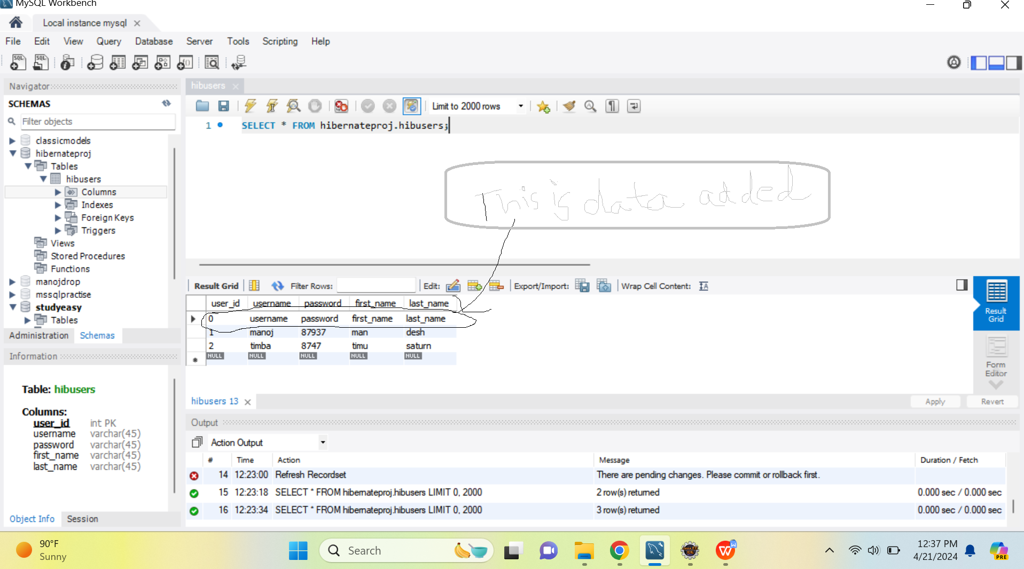

You will get error if you try to execute or run App.java again.
You have dependencies for both Hibernate Core and Hibernate EntityManager.
Since Hibernate EntityManager is part of Hibernate Core in version 5 and later, you typically don't need to include both dependencies explicitly.
However, it's harmless to have both included.

