-------------------------------------------------------------------------------------
Java Hibernate - HQL Opeartion - Listing
-------------------------------------------------------------------------------------
Package :-> org.studyeasy
Class :-> App
Source Code :-

- SessionFactory

//Session Factory
SessionFactory factory = new Configuration()
.configure("hibernate.cfg.xml")
.addAnnotatedClass(Users.class)
.buildSessionFactory();

- Session

//Session
Session session = factory.getCurrentSession();

- Close the session

//Close the session
try {
//Start Transaction
session.beginTransaction();
//Listing
//hibusers is entity name
List<Users> users = session.createQuery("from hibusers").getResultList();
for(Users temp : users) {
System.out.println(temp);
}

}finally {
session.close();
factory.close();
}

Full Source Code:

package org.studyeasy;import java.util.List;import org.hibernate.Session;import org.hibernate.SessionFactory;import org.hibernate.cfg.Configuration;import org.studyeasy.entity.Users;public class App {public static void main(String[] args) {//Session FactorySessionFactory factory = new Configuration().configure("hibernate.cfg.xml").addAnnotatedClass(Users.class).buildSessionFactory();//SessionSession session = factory.getCurrentSession();//Close the sessiontry {//Start Transactionsession.beginTransaction();
//Listing//hibusers is entity nameList<Users> users = session.createQuery("from hibusers").getResultList();
for(Users temp : users) {System.out.println(temp);}}finally {session.close();factory.close();}}}

THIS IS THE FINAL CODE (App.java) FOR THE CRUD OPERATION WITH THE DEPENDANCIES

App.java

package org.studyeasy;import java.util.List;import org.hibernate.Session;import org.hibernate.SessionFactory;import org.hibernate.cfg.Configuration;import org.studyeasy.entity.Users;public class App {public static void main(String[] args) {//Session FactorySessionFactory factory = new Configuration().configure("hibernate.cfg.xml").addAnnotatedClass(Users.class).buildSessionFactory();//SessionSession session = factory.getCurrentSession();//Close the sessiontry {//Start Transactionsession.beginTransaction();
//Listing//hibusers is entity nameList<Users> users = session.createQuery("from hibusers").getResultList();
for(Users temp : users) {System.out.println(temp);}}finally {session.close();factory.close();}}}

Hibernate.cfg.xml

<?xml version="1.0" encoding="UTF-8"?>

<project xmlns="http://maven.apache.org/POM/4.0.0"
xmlns:xsi="http://www.w3.org/2001/XMLSchema-instance"
xsi:schemaLocation="http://maven.apache.org/POM/4.0.0 http://maven.apache.org/xsd/maven-4.0.0.xsd">
<modelVersion>4.0.0</modelVersion>

<groupId>org.studyeasy</groupId>
<artifactId>H03_HIBERNATE_CrudOperationCreate</artifactId>
<version>0.0.1-SNAPSHOT</version>
<packaging>war</packaging>

<name>H03_HIBERNATE_CrudOperationCreate Maven Webapp</name>
<!-- FIXME change it to the project's website -->
<url>http://www.example.com</url>

<properties>
<project.build.sourceEncoding>UTF-8</project.build.sourceEncoding>
<maven.compiler.source>1.7</maven.compiler.source>
<maven.compiler.target>1.7</maven.compiler.target>
</properties>

<dependencies>

<dependency>
<groupId>junit</groupId>
<artifactId>junit</artifactId>
<version>4.11</version>
<scope>test</scope>
</dependency>

<dependency>
<groupId>javax.servlet</groupId>
<artifactId>servlet-api</artifactId>
<version>2.5</version>
<scope>provided</scope>
</dependency>

<!--
https://mvnrepository.com/artifact/jakarta.servlet/jakarta.servlet-api -->
<dependency>
<groupId>jakarta.servlet</groupId>
<artifactId>jakarta.servlet-api</artifactId>
<version>5.0.0</version>
<scope>provided</scope>
</dependency>

<!-- https://mvnrepository.com/artifact/mysql/mysql-connector-java -->
<dependency>
<groupId>mysql</groupId>
<artifactId>mysql-connector-java</artifactId>
<version>8.0.33</version>
</dependency>

<!--
https://mvnrepository.com/artifact/jakarta.servlet.jsp/jakarta.servlet.jsp-api -->
<dependency>
<groupId>jakarta.servlet.jsp</groupId>
<artifactId>jakarta.servlet.jsp-api</artifactId>
<version>3.1.0</version>
<scope>provided</scope>
</dependency>

<!--
https://mvnrepository.com/artifact/jakarta.servlet.jsp/jakarta.servlet.jsp-api -->
<dependency>
<groupId>jakarta.servlet.jsp</groupId>
<artifactId>jakarta.servlet.jsp-api</artifactId>
<version>3.1.0</version>
<scope>provided</scope>
</dependency>

<!-- https://mvnrepository.com/artifact/org.hibernate.orm/hibernate-core -->
<dependency>
<groupId>org.hibernate.orm</groupId>
<artifactId>hibernate-core</artifactId>
<version>6.4.4.Final</version>
</dependency>
</dependencies>

<build>
<finalName>H03_HIBERNATE_CrudOperationCreate</finalName>
<pluginManagement><!-- lock down plugins versions to avoid using Maven
defaults (may be moved to parent pom) -->
<plugins>
<plugin>
<artifactId>maven-clean-plugin</artifactId>
<version>3.1.0</version>
</plugin>
<!-- see
http://maven.apache.org/ref/current/maven-core/default-bindings.html#Plugin_bindings_for_war_packaging -->
<plugin>
<artifactId>maven-resources-plugin</artifactId>
<version>3.0.2</version>
</plugin>
<plugin>
<artifactId>maven-compiler-plugin</artifactId>
<version>3.8.0</version>
</plugin>
<plugin>
<artifactId>maven-surefire-plugin</artifactId>

<version>2.22.1</version>
</plugin>
<plugin>
<artifactId>maven-war-plugin</artifactId>
<version>3.2.2</version>
</plugin>
<plugin>
<artifactId>maven-install-plugin</artifactId>
<version>2.5.2</version>
</plugin>
<plugin>
<artifactId>maven-deploy-plugin</artifactId>
<version>2.8.2</version>
</plugin>
</plugins>
</pluginManagement>
</build>
</project>

Dependancies to be installed
<dependency>
<groupId>javax.servlet</groupId>
<artifactId>servlet-api</artifactId>
<version>2.5</version>
<scope>provided</scope>
</dependency>

<!--
https://mvnrepository.com/artifact/jakarta.servlet/jakarta.servlet-api -->
<dependency>
<groupId>jakarta.servlet</groupId>
<artifactId>jakarta.servlet-api</artifactId>
<version>5.0.0</version>
<scope>provided</scope>
</dependency>

<!-- https://mvnrepository.com/artifact/mysql/mysql-connector-java -->
<dependency>
<groupId>mysql</groupId>
<artifactId>mysql-connector-java</artifactId>
<version>8.0.33</version>
</dependency>

<!--
https://mvnrepository.com/artifact/jakarta.servlet.jsp/jakarta.servlet.jsp-api -->
<dependency>
<groupId>jakarta.servlet.jsp</groupId>
<artifactId>jakarta.servlet.jsp-api</artifactId>
<version>3.1.0</version>
<scope>provided</scope>
</dependency>

<!-- https://mvnrepository.com/artifact/org.hibernate.orm/hibernate-core -->
<dependency>
<groupId>org.hibernate.orm</groupId>
<artifactId>hibernate-core</artifactId>
<version>6.4.4.Final</version>
</dependency>
</dependencies>

Log Report looks like below

Apr 21, 2024 4:12:57 PM org.hibernate.Version logVersion
INFO: HHH000412: Hibernate ORM core version 6.4.4.Final
Apr 21, 2024 4:12:58 PM org.hibernate.cache.internal.RegionFactoryInitiator initiateService
INFO: HHH000026: Second-level cache disabled
Apr 21, 2024 4:12:58 PM org.hibernate.engine.jdbc.connections.internal.DriverManagerConnectionProviderImpl configure
WARN: HHH10001002: Using built-in connection pool (not intended for production use)
Loading class `com.mysql.jdbc.Driver'. This is deprecated. The new driver class is `com.mysql.cj.jdbc.Driver'. The driver is automatically registered via the SPI and manual loading of the driver class is generally unnecessary.
Apr 21, 2024 4:12:58 PM org.hibernate.engine.jdbc.connections.internal.DriverManagerConnectionProviderImpl buildCreator
INFO: HHH10001005: Loaded JDBC driver class: com.mysql.jdbc.Driver
Apr 21, 2024 4:12:58 PM org.hibernate.engine.jdbc.connections.internal.DriverManagerConnectionProviderImpl buildCreator
INFO: HHH10001012: Connecting with JDBC URL [jdbc:mysql://localhost:3306/hibernateproj]
Apr 21, 2024 4:12:58 PM org.hibernate.engine.jdbc.connections.internal.DriverManagerConnectionProviderImpl buildCreator
INFO: HHH10001001: Connection properties: {password=****, user=root}
Apr 21, 2024 4:12:58 PM org.hibernate.engine.jdbc.connections.internal.DriverManagerConnectionProviderImpl buildCreator
INFO: HHH10001003: Autocommit mode: false
Apr 21, 2024 4:12:58 PM org.hibernate.engine.jdbc.connections.internal.DriverManagerConnectionProviderImpl$PooledConnections <init>
INFO: HHH10001115: Connection pool size: 20 (min=1)
Apr 21, 2024 4:12:58 PM org.hibernate.engine.jdbc.dialect.internal.DialectFactoryImpl constructDialect
WARN: HHH90000025: MySQLDialect does not need to be specified explicitly using 'hibernate.dialect' (remove the property setting and it will be selected by default)
Hibernate: select u1_0.user_id,u1_0.first_name,u1_0.last_name,u1_0.password,u1_0.username from hibusers u1_0
Users [userId=1, username=manoj, password=87937, firstname=man, lastname=desh]
Users [userId=2, username=timba, password=8747, firstname=timu, lastname=saturn]
Users [userId=3, username=sinduyf, password=8738, firstname=timur, lastname=uranus]
Users [userId=4, username=ash, password=8981, firstname=ketchum, lastname=triloki]
Apr 21, 2024 4:13:00 PM org.hibernate.engine.jdbc.connections.internal.DriverManagerConnectionProviderImpl$PoolState stop
INFO: HHH10001008: Cleaning up connection pool [jdbc:mysql://localhost:3306/hibernateproj]

Final Output in MYSQL Database

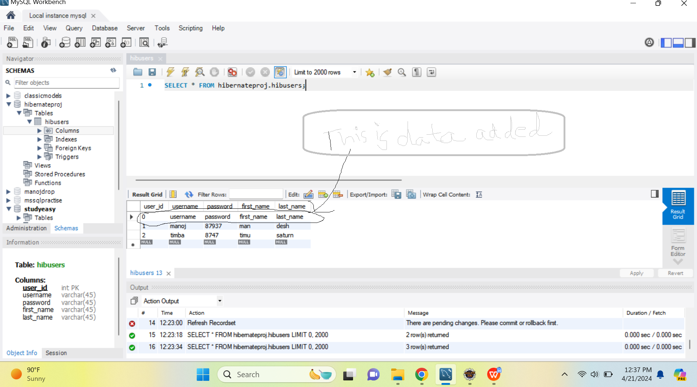

You will get error if you try to execute or run App.java again.

You have dependencies for both Hibernate Core and Hibernate EntityManager.
Since Hibernate EntityManager is part of Hibernate Core in version 5 and later, you typically don't need to include both dependencies explicitly.
However, it's harmless to have both included.

What happens if we remove the annotations in Users class? Then we get crashed.
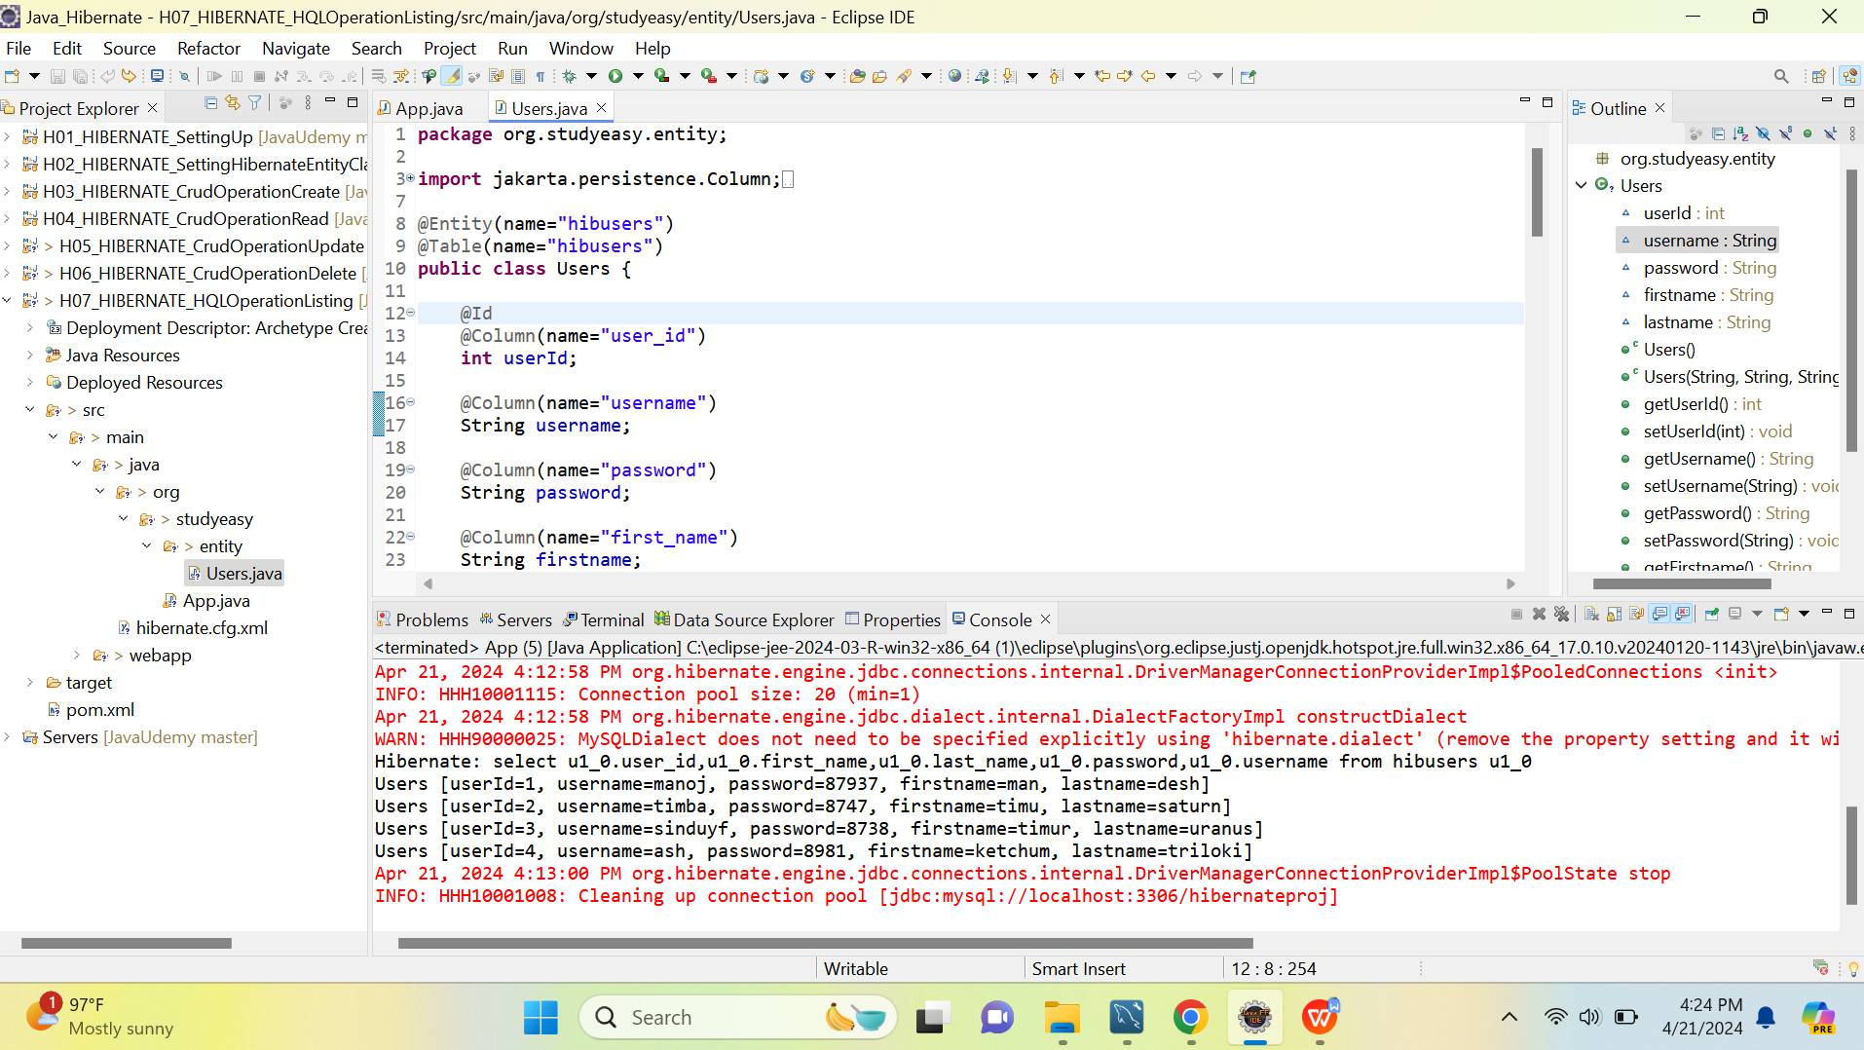
Removing the name and then next below diagram and run the App.java
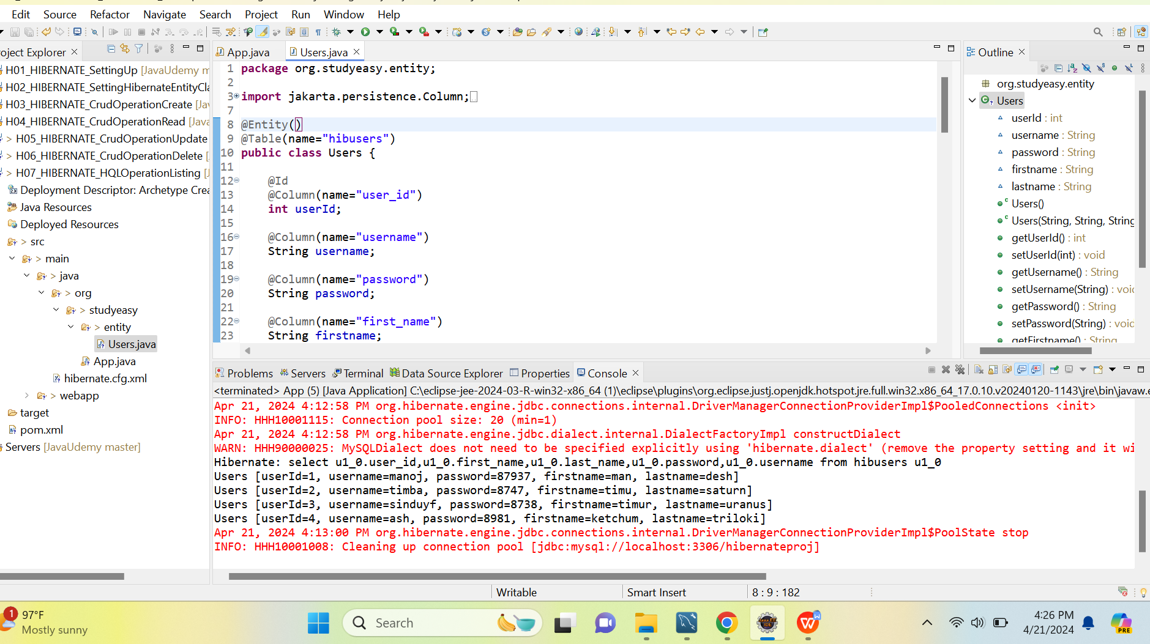

You system gets crashed and you get below log output in console like below.
Apr 21, 2024 4:27:49 PM org.hibernate.Version logVersion
INFO: HHH000412: Hibernate ORM core version 6.4.4.Final
Apr 21, 2024 4:27:49 PM org.hibernate.cache.internal.RegionFactoryInitiator initiateService
INFO: HHH000026: Second-level cache disabled
Apr 21, 2024 4:27:49 PM org.hibernate.engine.jdbc.connections.internal.DriverManagerConnectionProviderImpl configure
WARN: HHH10001002: Using built-in connection pool (not intended for production use)
Loading class `com.mysql.jdbc.Driver'. This is deprecated. The new driver class is `com.mysql.cj.jdbc.Driver'. The driver is automatically registered via the SPI and manual loading of the driver class is generally unnecessary.
Apr 21, 2024 4:27:49 PM org.hibernate.engine.jdbc.connections.internal.DriverManagerConnectionProviderImpl buildCreator
INFO: HHH10001005: Loaded JDBC driver class: com.mysql.jdbc.Driver
Apr 21, 2024 4:27:49 PM org.hibernate.engine.jdbc.connections.internal.DriverManagerConnectionProviderImpl buildCreator
INFO: HHH10001012: Connecting with JDBC URL [jdbc:mysql://localhost:3306/hibernateproj]
Apr 21, 2024 4:27:49 PM org.hibernate.engine.jdbc.connections.internal.DriverManagerConnectionProviderImpl buildCreator
INFO: HHH10001001: Connection properties: {password=****, user=root}
Apr 21, 2024 4:27:49 PM org.hibernate.engine.jdbc.connections.internal.DriverManagerConnectionProviderImpl buildCreator
INFO: HHH10001003: Autocommit mode: false
Apr 21, 2024 4:27:49 PM org.hibernate.engine.jdbc.connections.internal.DriverManagerConnectionProviderImpl$PooledConnections <init>
INFO: HHH10001115: Connection pool size: 20 (min=1)
Apr 21, 2024 4:27:50 PM org.hibernate.engine.jdbc.dialect.internal.DialectFactoryImpl constructDialect
WARN: HHH90000025: MySQLDialect does not need to be specified explicitly using 'hibernate.dialect' (remove the property setting and it will be selected by default)
Apr 21, 2024 4:27:52 PM org.hibernate.engine.jdbc.connections.internal.DriverManagerConnectionProviderImpl$PoolState stop
INFO: HHH10001008: Cleaning up connection pool [jdbc:mysql://localhost:3306/hibernateproj]
Exception in thread "main" java.lang.IllegalArgumentException: org.hibernate.query.sqm.UnknownEntityException: Could not resolve root entity 'hibusers'
at org.hibernate.internal.ExceptionConverterImpl.convert(ExceptionConverterImpl.java:143)
at org.hibernate.internal.ExceptionConverterImpl.convert(ExceptionConverterImpl.java:167)
at org.hibernate.internal.ExceptionConverterImpl.convert(ExceptionConverterImpl.java:173)
at org.hibernate.internal.AbstractSharedSessionContract.createQuery(AbstractSharedSessionContract.java:848)
at org.hibernate.internal.AbstractSharedSessionContract.createQuery(AbstractSharedSessionContract.java:753)
at org.hibernate.internal.AbstractSharedSessionContract.createQuery(AbstractSharedSessionContract.java:136)
at java.base/jdk.internal.reflect.NativeMethodAccessorImpl.invoke0(Native Method)
at java.base/jdk.internal.reflect.NativeMethodAccessorImpl.invoke(NativeMethodAccessorImpl.java:77)
at java.base/jdk.internal.reflect.DelegatingMethodAccessorImpl.invoke(DelegatingMethodAccessorImpl.java:43)
at java.base/java.lang.reflect.Method.invoke(Method.java:568)
at org.hibernate.context.internal.ThreadLocalSessionContext$TransactionProtectionWrapper.invoke(ThreadLocalSessionContext.java:343)
at jdk.proxy2/jdk.proxy2.$Proxy51.createQuery(Unknown Source)
at org.studyeasy.App.main(App.java:30)
Caused by: org.hibernate.query.sqm.UnknownEntityException: Could not resolve root entity 'hibusers'
at org.hibernate.query.hql.internal.SemanticQueryBuilder.resolveRootEntity(SemanticQueryBuilder.java:2013)
at org.hibernate.query.hql.internal.SemanticQueryBuilder.visitRootEntity(SemanticQueryBuilder.java:1944)
at org.hibernate.query.hql.internal.SemanticQueryBuilder.visitRootEntity(SemanticQueryBuilder.java:269)
at org.hibernate.grammars.hql.HqlParser$RootEntityContext.accept(HqlParser.java:2549)
at org.hibernate.query.hql.internal.SemanticQueryBuilder.visitEntityWithJoins(SemanticQueryBuilder.java:1914)
at org.hibernate.query.hql.internal.SemanticQueryBuilder.visitFromClause(SemanticQueryBuilder.java:1901)
at org.hibernate.query.hql.internal.SemanticQueryBuilder.visitQuery(SemanticQueryBuilder.java:1148)
at org.hibernate.query.hql.internal.SemanticQueryBuilder.visitQuerySpecExpression(SemanticQueryBuilder.java:941)
at org.hibernate.query.hql.internal.SemanticQueryBuilder.visitQuerySpecExpression(SemanticQueryBuilder.java:269)
at org.hibernate.grammars.hql.HqlParser$QuerySpecExpressionContext.accept(HqlParser.java:1869)
at org.hibernate.query.hql.internal.SemanticQueryBuilder.visitSimpleQueryGroup(SemanticQueryBuilder.java:926)
at org.hibernate.query.hql.internal.SemanticQueryBuilder.visitSimpleQueryGroup(SemanticQueryBuilder.java:269)
at org.hibernate.grammars.hql.HqlParser$SimpleQueryGroupContext.accept(HqlParser.java:1740)
at org.hibernate.query.hql.internal.SemanticQueryBuilder.visitSelectStatement(SemanticQueryBuilder.java:443)
at org.hibernate.query.hql.internal.SemanticQueryBuilder.visitStatement(SemanticQueryBuilder.java:402)
at org.hibernate.query.hql.internal.SemanticQueryBuilder.buildSemanticModel(SemanticQueryBuilder.java:311)
at org.hibernate.query.hql.internal.StandardHqlTranslator.translate(StandardHqlTranslator.java:71)
at org.hibernate.query.internal.QueryInterpretationCacheStandardImpl.createHqlInterpretation(QueryInterpretationCacheStandardImpl.java:165)
at org.hibernate.query.internal.QueryInterpretationCacheStandardImpl.resolveHqlInterpretation(QueryInterpretationCacheStandardImpl.java:147)
at org.hibernate.internal.AbstractSharedSessionContract.interpretHql(AbstractSharedSessionContract.java:790)
at org.hibernate.internal.AbstractSharedSessionContract.createQuery(AbstractSharedSessionContract.java:840)
... 9 more

