FRAGMENT TAG

<head th:replace="/fragments/head :: head">

<header th:replace="/fragments/header :: header">

<footer th:replace="/fragments/footer :: footer">

FILE BASED DATABASE - application.properties

# File Based Database

# Server port
server.port=8081

# Database config
spring.datasource.url=jdbc:h2:file:./db/blogdb
spring.datasource.driverClassName=org.h2.Driver
spring.datasource.username=admin
spring.datasource.password=password
spring.jpa.database-platform=org.hibernate.dialect.H2Dialect

# setup local h2 database console
spring.h2.console.enabled=true
spring.h2.console.path=/db-console
spring.h2.console.settings.web-allow-others=false

# local h2 tables setup on startup; use the value "none" in production!
spring.jpa.hibernate.ddl-auto=create-drop

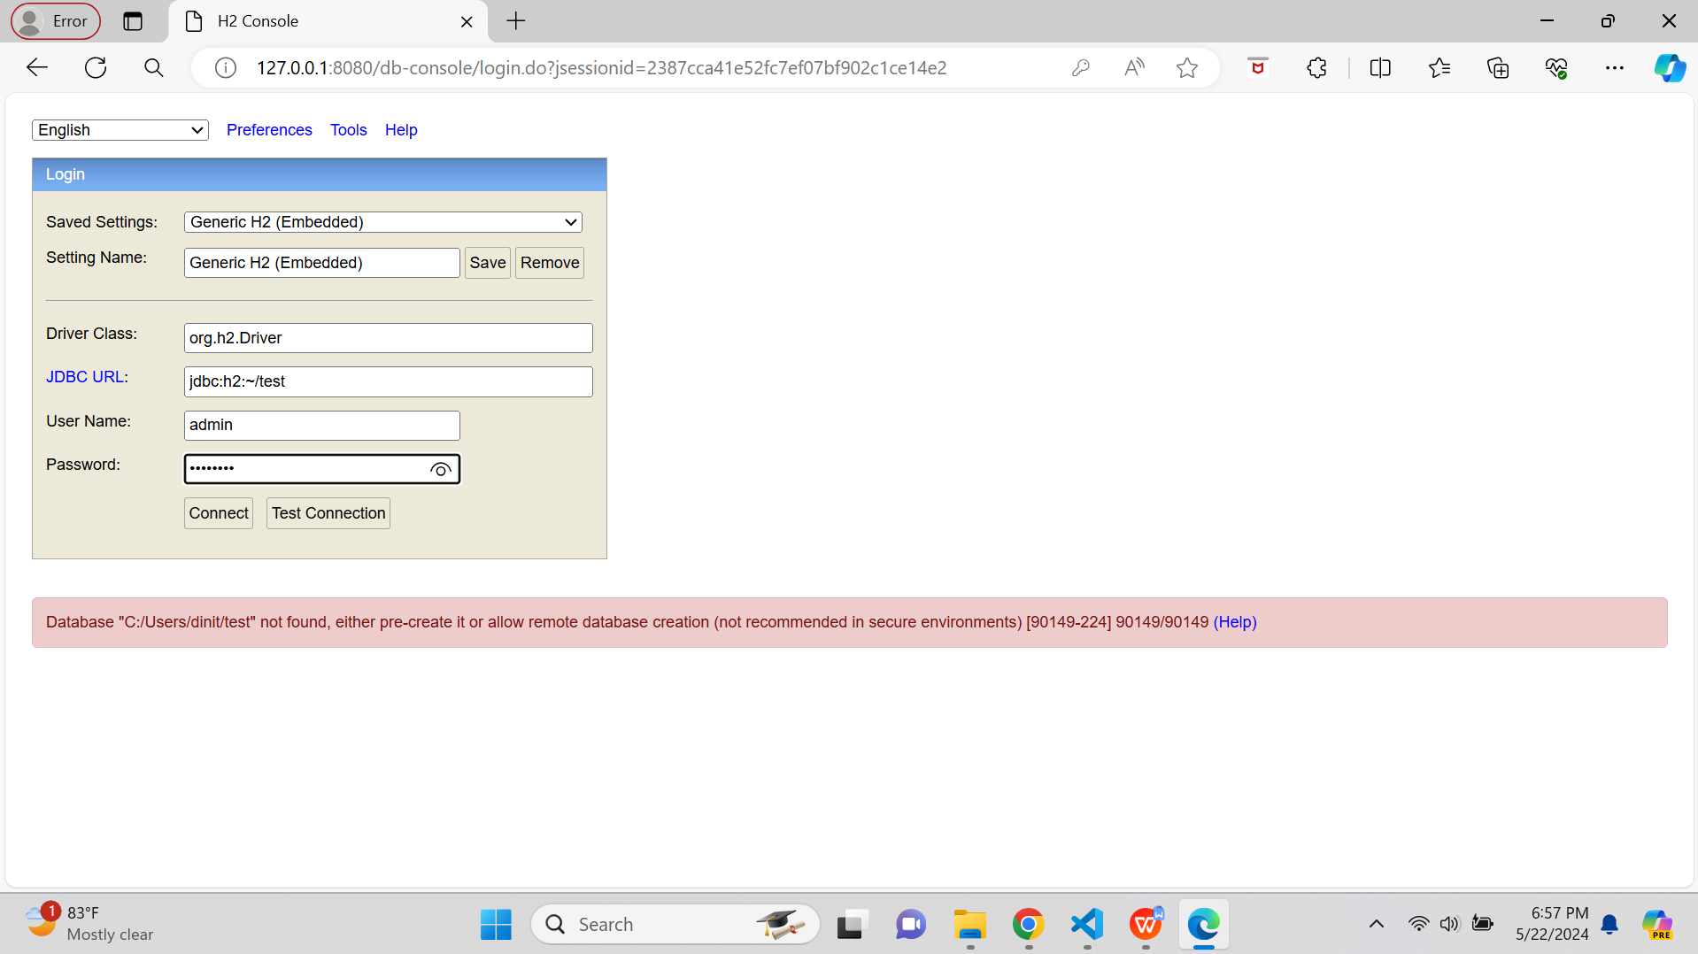

URL of the File System Database

jdbc:h2:file:C:/Users/dinit/db/blogdb

