LINK FOR THE SPRING BOOT - SPRING TOOL SUITE

https://spring.io/tools

LINK FOR THE SPRING BOOT - SPRING BOOT EXTENSION PACK

https://marketplace.visualstudio.com/items?itemName=vmware.vscode-boot-dev-pack

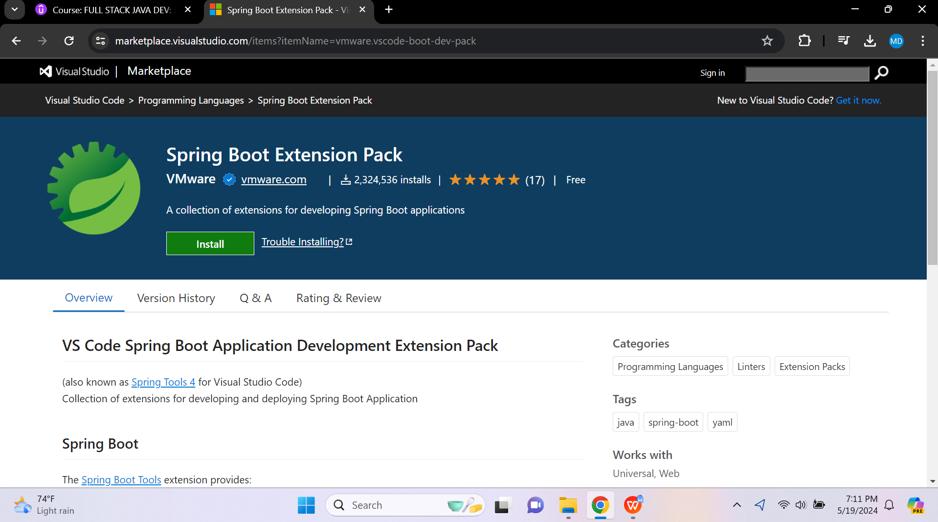

LINK FOR THE JAVA VSCODE PACK - VISUAL STUDIO CODE

https://code.visualstudio.com/docs/languages/java

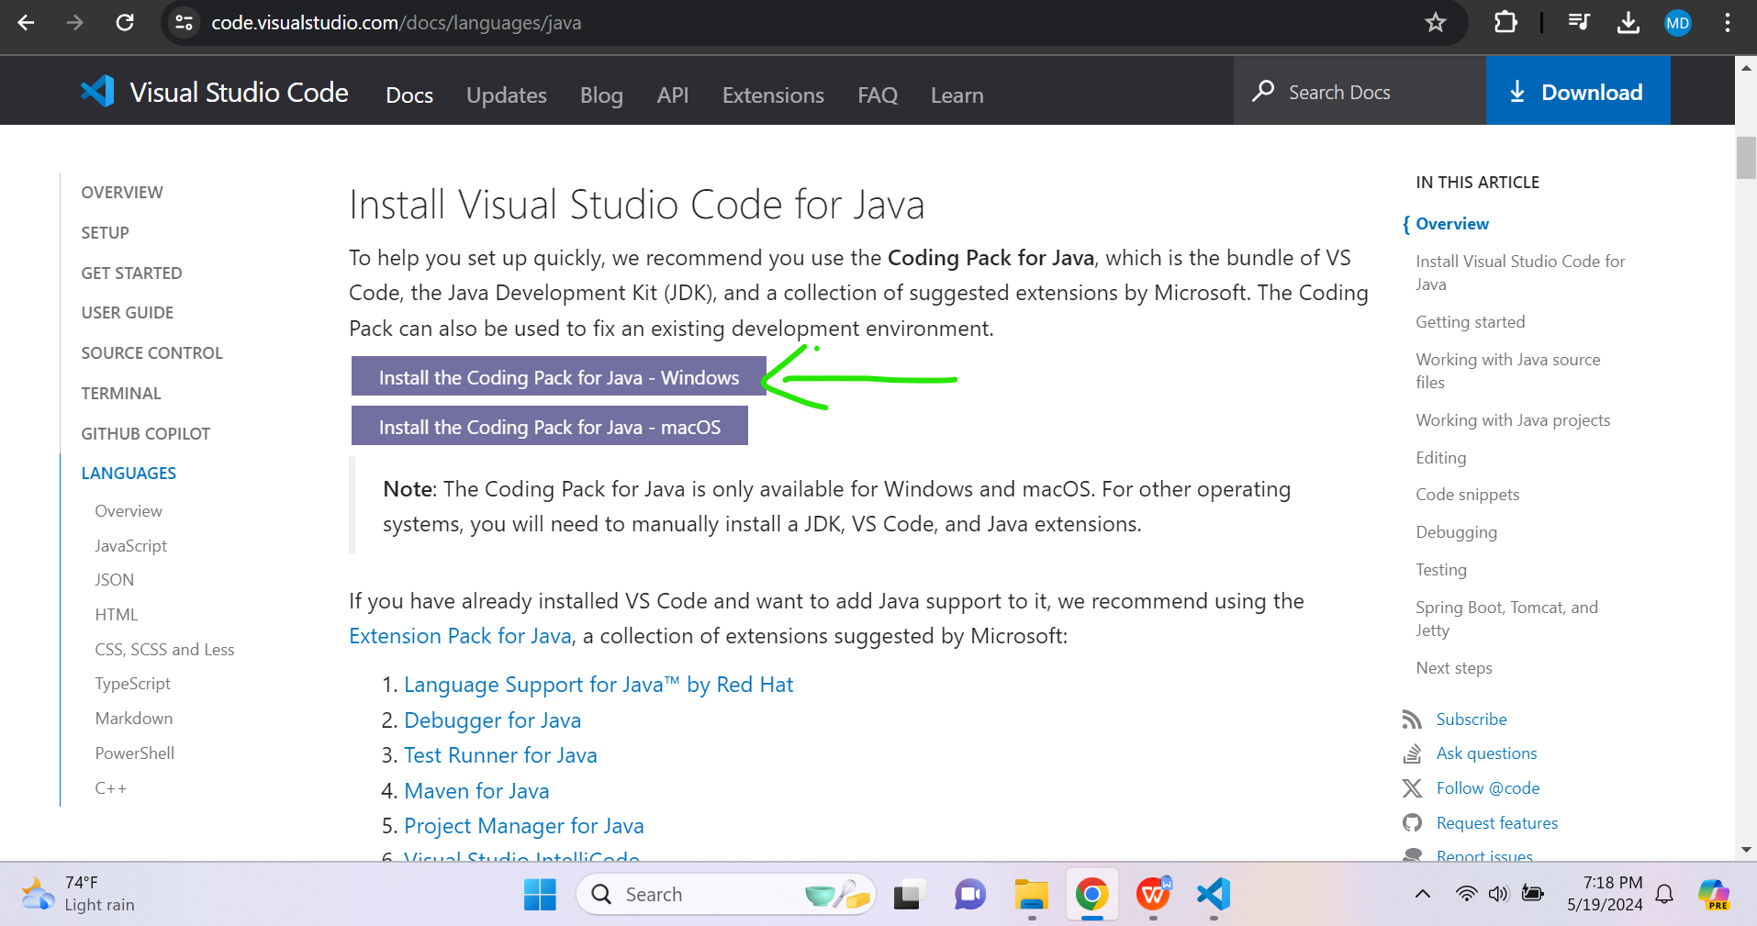

LINK FOR THE SPRING - SPRING BOOT JAVA - SPRING STARTER /INITIALIZR

https://start.spring.io/

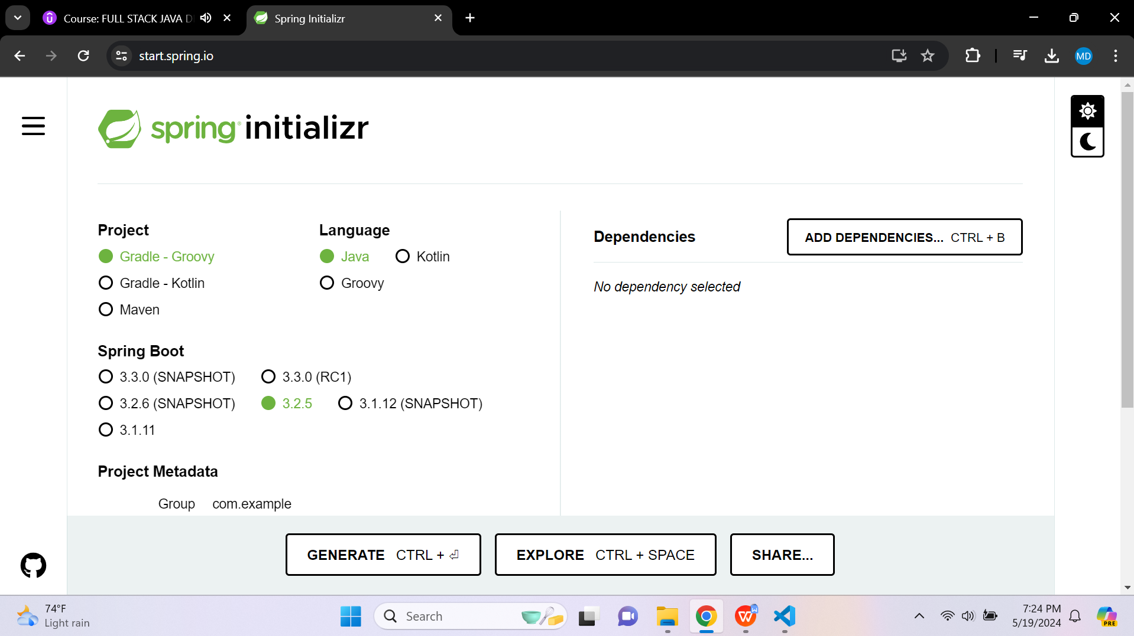

LINK FOR THE THYMELEAF

<head lang="en" xmlns:th="http://www.thymeleaf.org">

This portion will let know the Spring that this is the ThymeLeaf.

LINK FOR THE HEADER - WITH - SPRING SECURITY

<html lang="en"
xmlns:th="http://www.thymeleaf.org"
xmlns:sec="http://www.thymeleaf.org/extras/spring-security">

This portion will Manipulating the navigation links.

