SPRING BOOT - SPRING BOOT INTIALIZER

To add dependancies click this button

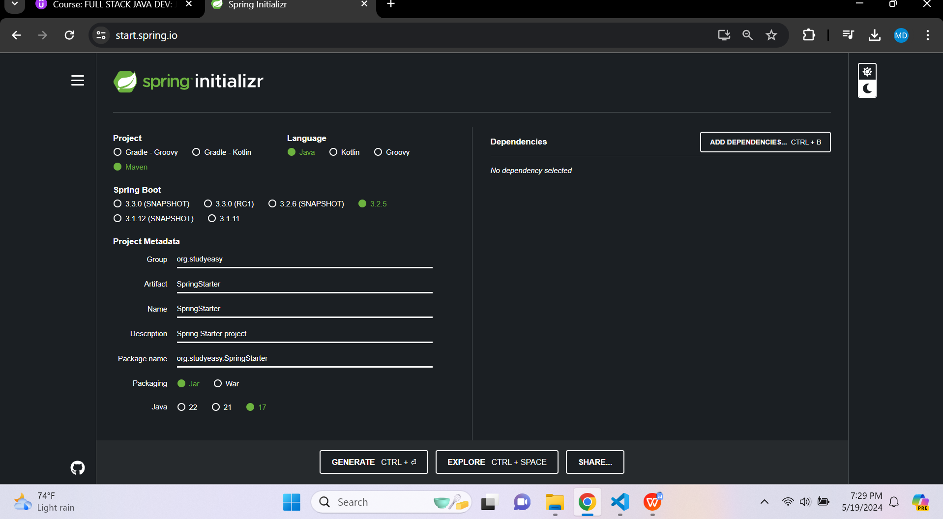

Please fill in these fields to complete Spring Boot Project Details.

SPRING BOOT - SPRING BOOT - ADD DEPENDANCIES
- Spring Boot Dev Tools
- Lombok
- Spring Web
- Thymeleaf
- Spring Data JPA
- H2 Database

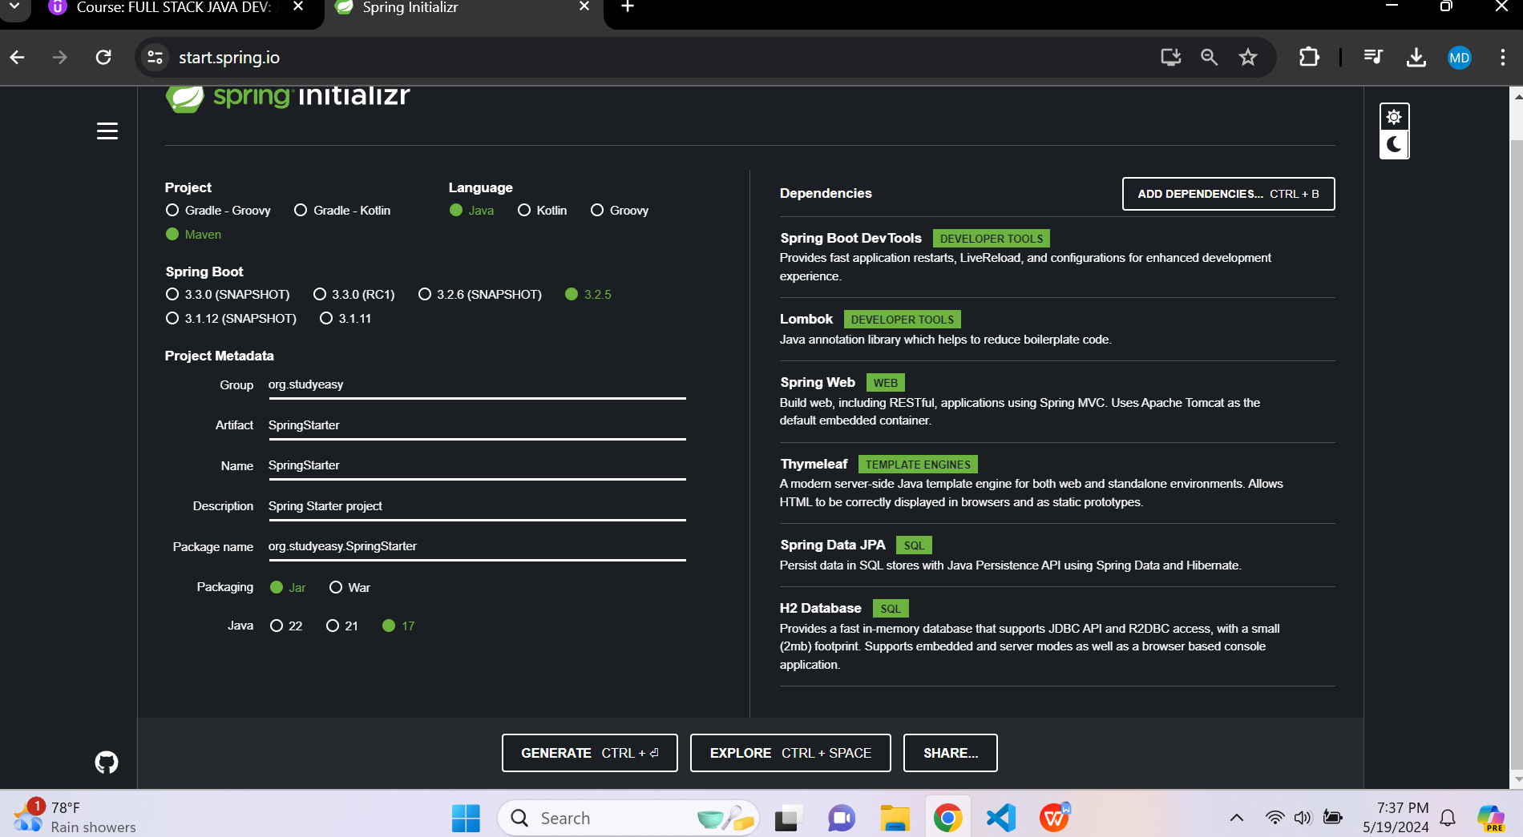

Click Generate Button to generate the project and extract the file to your local file system.

