Spring Boot - Adding Models

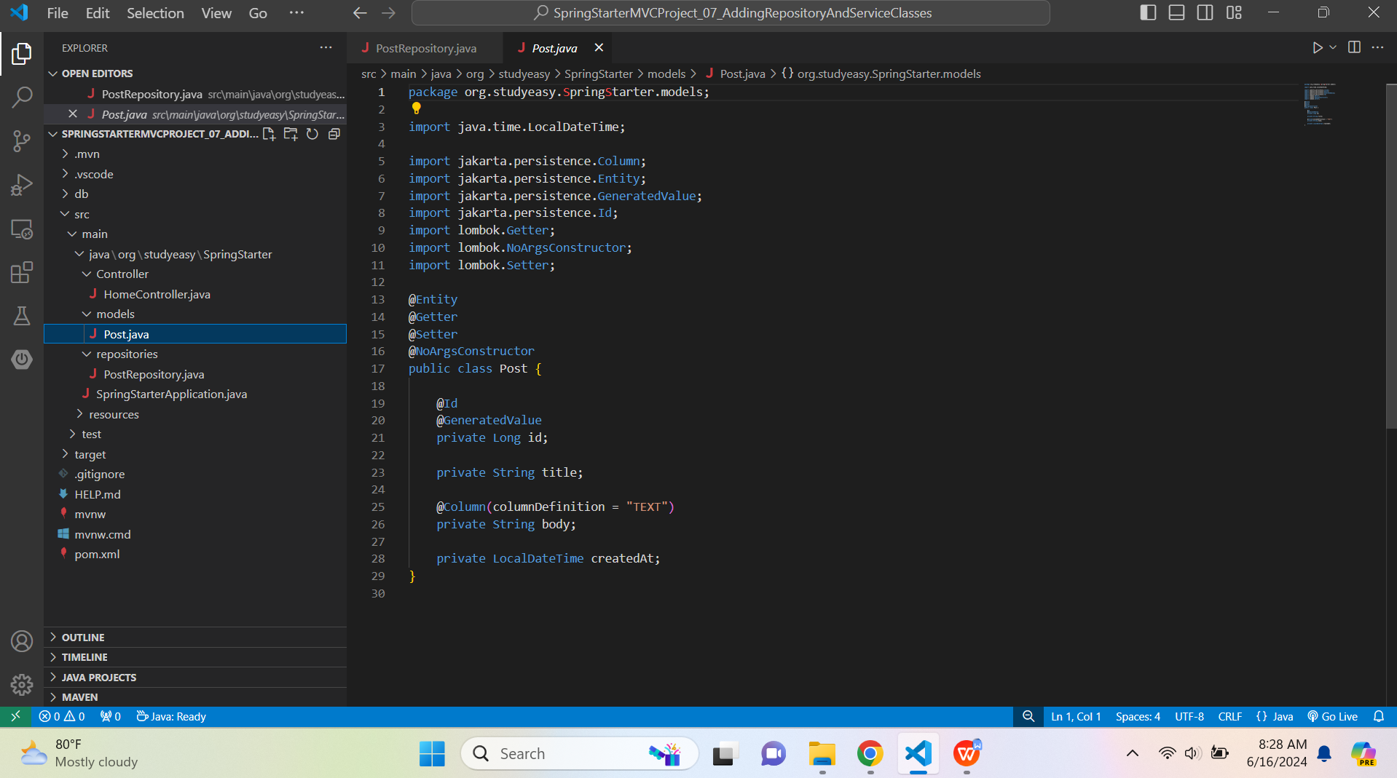

package org.studyeasy.SpringStarter.models;

import java.time.LocalDateTime;
import jakarta.persistence.Column;
import jakarta.persistence.Entity;
import jakarta.persistence.GeneratedValue;
import jakarta.persistence.Id;
import lombok.Getter;
import lombok.NoArgsConstructor;
import lombok.Setter;

@Entity
@Getter
@Setter
@NoArgsConstructor
public class Post {

@Id
@GeneratedValue
private Long id;

private String title;

@Column(columnDefinition = "TEXT")
private String body;

private LocalDateTime createdAt;
}

