Spring Boot - Add Services And Repositories

@Repository
public interface PostRepository extends JpaRepository<Post, Long>{
}

Type Of Model Datatype Of Primary Key

Services:-

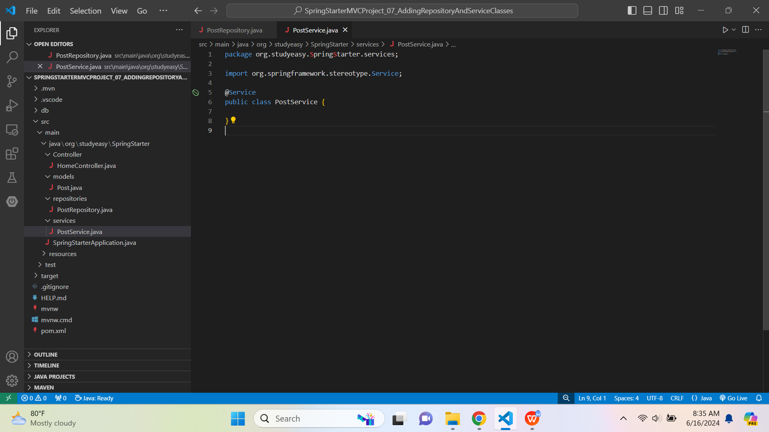

package org.studyeasy.SpringStarter.services;

import org.springframework.stereotype.Service;

@Service
public class PostService {

}

- @Service - Annotation for the service layer.

- Service Layer is the backbone for interaction or adding any functionality given the controller interact with service layer.

Repositories -> PostRepository.java

package org.studyeasy.SpringStarter.repositories;

import org.springframework.data.jpa.repository.JpaRepository;
import org.springframework.stereotype.Repository;
import org.studyeasy.SpringStarter.models.Post;

@Repository
public interface PostRepository extends JpaRepository<Post, Long>{

}

Services-> PostService.java

package org.studyeasy.SpringStarter.services;

import java.time.LocalDateTime;
import java.util.List;
import java.util.Optional;
import org.springframework.beans.factory.annotation.Autowired;
import org.springframework.stereotype.Service;
import org.studyeasy.SpringStarter.models.Post;
import org.studyeasy.SpringStarter.repositories.PostRepository;

@Service
public class PostService {
@Autowired
private PostRepository postRepository;

//Method which will get us a specific record based on the primary key.
//Optional is a return Object of Post Type ; If we do not get this, we get null.
public Optional<Post> getById(Long id){
return postRepository.findById(id);
}

//Listing All the data
public List<Post> getAll(){
return postRepository.findAll();
}

//Delete
public void delete(Post post){
postRepository.delete(post);
}

//Saving the data
//It will be null, if we are adding new record.
public Post save(Post post){
if(post.getId() == null){
post.setCreatedAt(LocalDateTime.now());
}
return postRepository.save(post);
}
}

