Spring Boot - Add Seeding to DB

Seed Folder -> SeedData.java

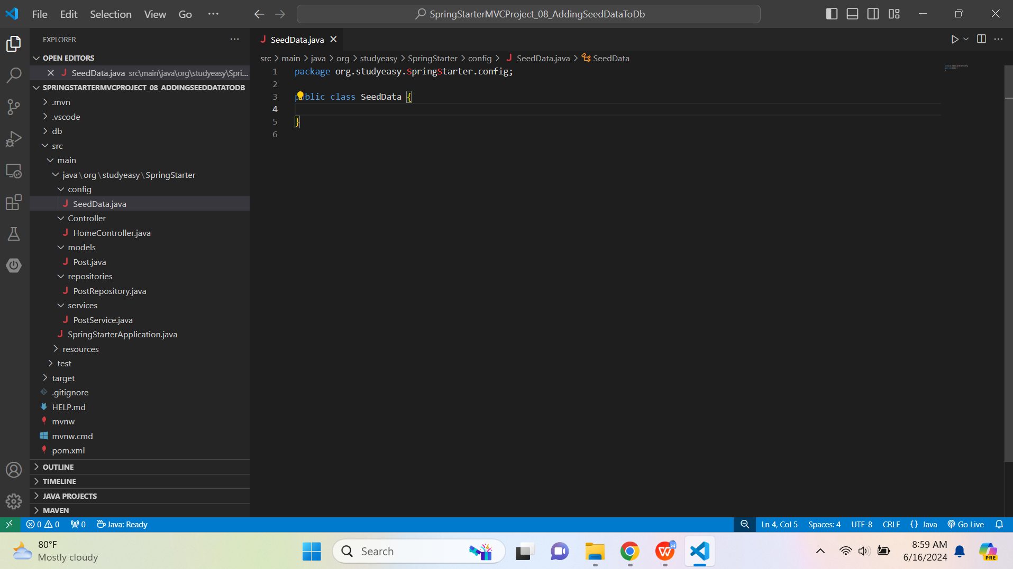

Code:-

package org.studyeasy.SpringStarter.config;

import java.util.List;
import org.springframework.beans.factory.annotation.Autowired;
import org.springframework.boot.CommandLineRunner;
import org.springframework.stereotype.Component;
import org.studyeasy.SpringStarter.models.Post;
import org.studyeasy.SpringStarter.services.PostService;

@Component
public class SeedData implements CommandLineRunner{
@Autowired
private PostService postService;

@Override
public void run(String... args) throws Exception {
List<Post> posts = postService.getAll();
if(posts.size() == 0){
Post post01 = new Post();
post01.setTitle("Post01");
post01.setBody("Post 01 Body ..........................");
postService.save(post01);

Post post02 = new Post();
post02.setTitle("Post02");
post02.setBody("Post 02 Body ..........................");
postService.save(post02);
}
}
}

Output:-

