JAVA SPRING DEPENDANCY INJECTION

Steps :

- Create a Interface
Package - org.studyeasy.interfaces

Interface - Car

Code :

package org.studyeasy.interfaces;

public interface Car {
void specs();
}

- Create a Class

Package - org.studyeasy.cars

Class - Swift

Swift Class implements Car interface

Code :

package org.studyeasy.cars;

import org.studyeasy.interfaces.Car;

public class Swift implements Car{

@Override
public void specs() {
// TODO Auto-generated method stub
}
}

- Create a Class

Package - org.studyeasy.cars

Class - Corolla

Corolla Class implements Car interface

Code :
package org.studyeasy.interfaces;

public class Corolla implements Car {
@Override
public void specs() {
}
}

- Create a Class

Package - org.studyeasy

Class - App

Code :
package org.studyeasy;

public class App {
public static void main(String[] args) {
}
}

- Create a Class

Package - org.studyeasy

Class - AppConfig -

Telling Spring that it is configuration class and which particular package to scan for components

Code :
package org.studyeasy;

// Telling Spring that it is configuration class and which particular package // to scan for components

public class AppConfig {
}
}

Final Code

App.java
package org.studyeasy;

import org.springframework.context.annotation.AnnotationConfigApplicationContext;
import org.studyeasy.interfaces.Car;

public class App_Modified_SolutionForAmbiguityOfClasses {

public static void main(String[] args) {

/*
* Car o1 = new Swift(); o1.specs();
*
* Car o2 = new Swift(); o2.specs();
*/

//---------------------------------------------------------------------

//Outsourcing Object Creation process
AnnotationConfigApplicationContext context = new AnnotationConfigApplicationContext(AppConfig.class);

//Outsource the work to Spring.
Car myCar = context.getBean("swift" , Car.class);
myCar.specs();

//Closing the context also
context.close();
}
}
Corolla.java
package org.studyeasy.cars;

import org.springframework.stereotype.Component;
import org.studyeasy.interfaces.Car;

@Component("corolla")
public class Corolla implements Car {

@Override
public void specs() {
System.out.println("Sedan from Toyota");
}

}
Swift.java
package org.studyeasy.cars;

import org.springframework.stereotype.Component;
import org.studyeasy.interfaces.Car;

@Component("swift")
public class Swift implements Car{

@Override
public void specs() {
System.out.println("Hatchback from Suzuki");
}
}

Car.java -> Interface
package org.studyeasy.interfaces;

public interface Car {
void specs();
}

AppConfig.java

package org.studyeasy;

import org.springframework.context.annotation.ComponentScan;
import org.springframework.context.annotation.Configuration;

// Telling Spring that it is configuration class and which particular package to scan for components

@Configuration
@ComponentScan("org.studyeasy")
public class AppConfig {
}
}

INVERSION OF CONTROL

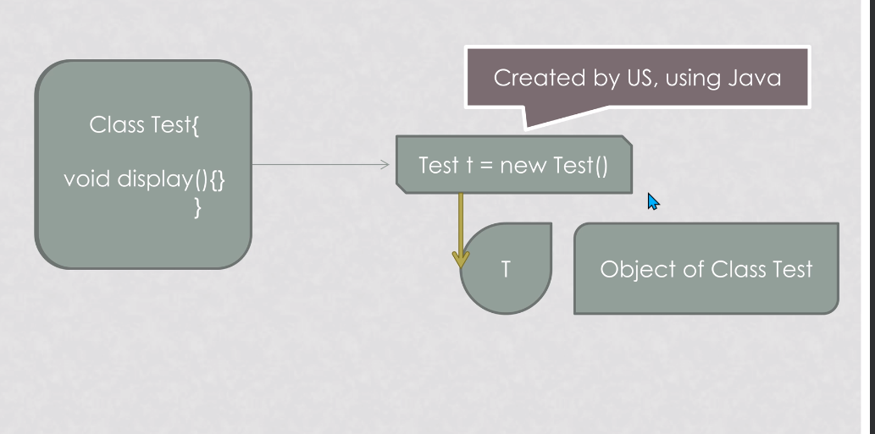

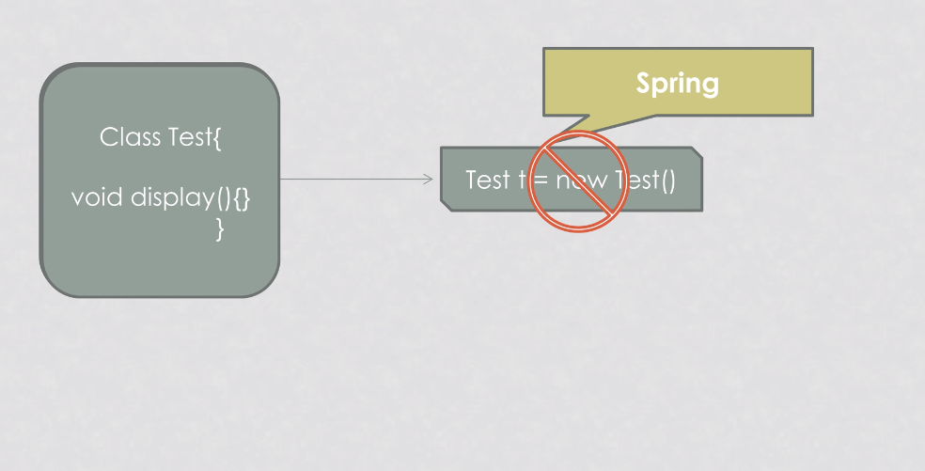

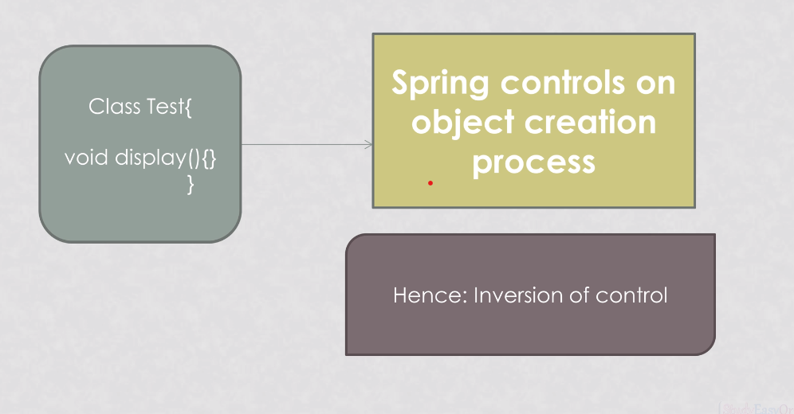

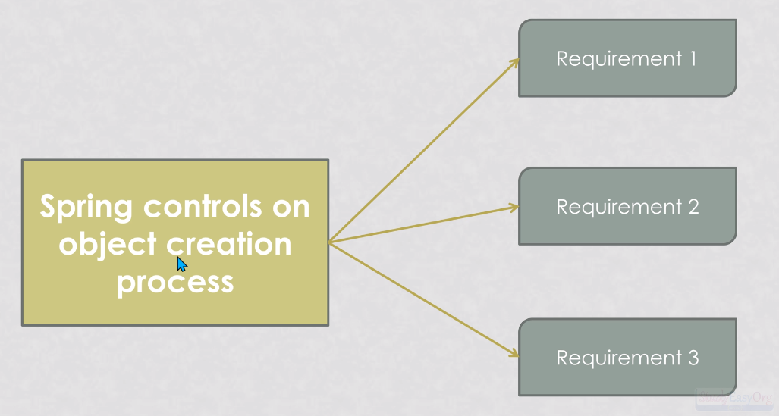

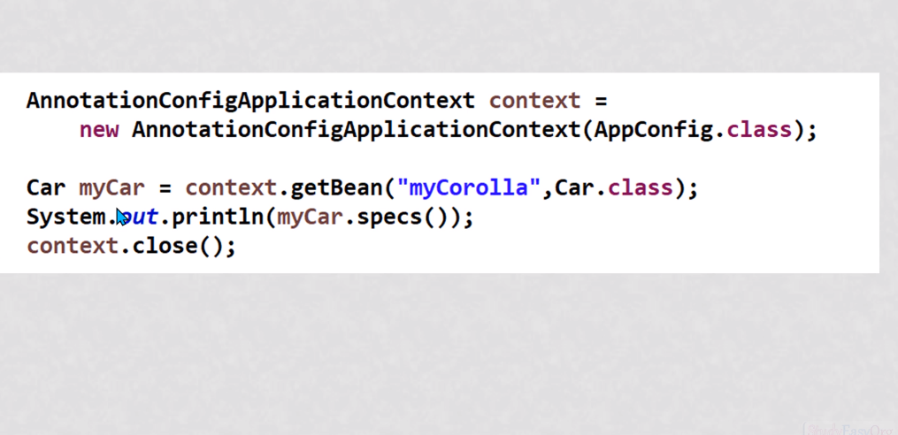

We are just creating a context.And then we are assigning or we are making use of a bean for creation of a object and that is it.

