JAVA SPRING - MVC MINIMAL PROJECT

Create a Maven Project -> Click Next -> Filter By typing in serach box -> apache.maven
Select like below-> Click Next -> Setup the project.

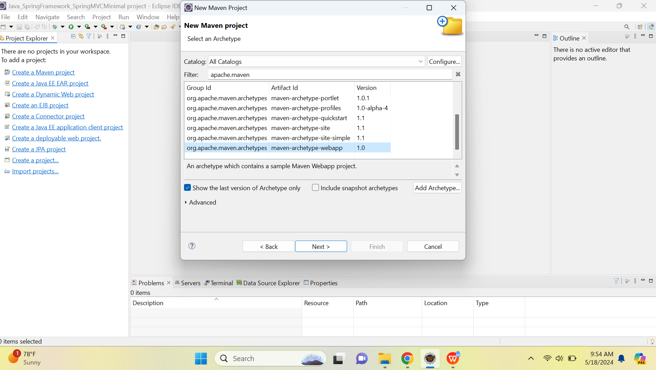

Group Id : org.studyeasy

Artifcat Id : SpringMVC_01_SpringMinimalProjectSetup

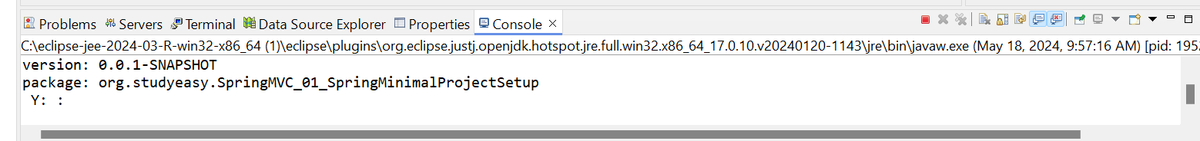

Click Y or Enter -> which means yes -> It will create the maven project for you.

Following script will be produced in console.
[INFO] Scanning for projects...
[90mDownloading from [0mcentral[90m: https://repo.maven.apache.org/maven2/[0morg/codehaus/mojo/maven-metadata.xml
[90mDownloading from [0mcentral[90m: https://repo.maven.apache.org/maven2/[0morg/apache/maven/plugins/maven-metadata.xml
Progress (1): 1.4/21 kB
Progress (2): 1.4/21 kB | 1.4/14 kB
Progress (2): 2.8/21 kB | 1.4/14 kB
Progress (2): 2.8/21 kB | 2.8/14 kB
Progress (2): 4.1/21 kB | 2.8/14 kB
Progress (2): 4.1/21 kB | 4.1/14 kB
Progress (2): 5.5/21 kB | 4.1/14 kB
Progress (2): 5.5/21 kB | 5.5/14 kB
Progress (2): 5.5/21 kB | 6.9/14 kB
Progress (2): 5.5/21 kB | 8.3/14 kB
Progress (2): 6.9/21 kB | 8.3/14 kB
Progress (2): 6.9/21 kB | 9.7/14 kB
Progress (2): 8.3/21 kB | 9.7/14 kB
Progress (2): 8.3/21 kB | 11/14 kB
Progress (2): 8.3/21 kB | 12/14 kB
Progress (2): 8.3/21 kB | 14/14 kB
Progress (2): 8.3/21 kB | 14 kB
Progress (2): 9.7/21 kB | 14 kB
Progress (2): 11/21 kB | 14 kB

Progress (2): 12/21 kB | 14 kB
Progress (2): 14/21 kB | 14 kB
Progress (2): 15/21 kB | 14 kB
Progress (2): 17/21 kB | 14 kB
Progress (2): 18/21 kB | 14 kB
Progress (2): 19/21 kB | 14 kB
Progress (2): 21 kB | 14 kB
Downloaded[90m from [0mcentral[90m: https://repo.maven.apache.org/maven2/[0morg/codehaus/mojo/maven-metadata.xml[90m (21 kB at 47 kB/s)[0m
Downloaded[90m from [0mcentral[90m: https://repo.maven.apache.org/maven2/[0morg/apache/maven/plugins/maven-metadata.xml[90m (14 kB at 31 kB/s)[0m
[90mDownloading from [0mcentral[90m: https://repo.maven.apache.org/maven2/[0morg/apache/maven/plugins/maven-archetype-plugin/maven-metadata.xml
Progress (1): 980 B
Downloaded[90m from [0mcentral[90m: https://repo.maven.apache.org/maven2/[0morg/apache/maven/plugins/maven-archetype-plugin/maven-metadata.xml[90m (980 B at 21 kB/s)[0m
[INFO]
[INFO] [1m------------------< [0;36morg.apache.maven:standalone-pom[0;1m >-------------------[m
[INFO] [1mBuilding Maven Stub Project (No POM) 1[m
[INFO] [1m--------------------------------[ pom ]---------------------------------[m
[INFO]
[INFO] [1m>>> [0;32marchetype:3.2.1:generate[m [1m(default-cli)[0;1m > [0;1mgenerate-sources[m @ [36mstandalone-pom[0;1m >>>[m
[INFO]
[INFO] [1m<<< [0;32marchetype:3.2.1:generate[m [1m(default-cli)[0;1m < [0;1mgenerate-sources[m @ [36mstandalone-pom[0;1m <<<[m
[INFO]
[INFO]
[INFO] [1m--- [0;32marchetype:3.2.1:generate[m [1m(default-cli)[m @ [36mstandalone-pom[0;1m ---[m
[INFO] Generating project in Interactive mode
[INFO] Archetype repository not defined. Using the one from [org.apache.maven.archetypes:maven-archetype-webapp:1.4] found in catalog remote
[INFO] Using property: groupId = org.studyeasy
[INFO] Using property: artifactId = SpringMVC_01_SpringMinimalProjectSetup
[INFO] Using property: version = 0.0.1-SNAPSHOT
[INFO] Using property: package = org.studyeasy.SpringMVC_01_SpringMinimalProjectSetup
Confirm properties configuration:
groupId: org.studyeasy
artifactId: SpringMVC_01_SpringMinimalProjectSetup
version: 0.0.1-SNAPSHOT
package: org.studyeasy.SpringMVC_01_SpringMinimalProjectSetup
Y: :
[INFO] ----------------------------------------------------------------------------
[INFO] Using following parameters for creating project from Old (1.x) Archetype: maven-archetype-webapp:1.0
[INFO] ----------------------------------------------------------------------------
[INFO] Parameter: basedir, Value: D:\RECYCLE BIN EXTRAS\ONLY_DOCS\JavaUdemy\Java_SpringFramework_SpringMVCMinimal project
[INFO] Parameter: package, Value: org.studyeasy.SpringMVC_01_SpringMinimalProjectSetup
[INFO] Parameter: groupId, Value: org.studyeasy
[INFO] Parameter: artifactId, Value: SpringMVC_01_SpringMinimalProjectSetup
[INFO] Parameter: packageName, Value: org.studyeasy.SpringMVC_01_SpringMinimalProjectSetup
[INFO] Parameter: version, Value: 0.0.1-SNAPSHOT
[INFO] project created from Old (1.x) Archetype in dir: D:\RECYCLE BIN EXTRAS\ONLY_DOCS\JavaUdemy\Java_SpringFramework_SpringMVCMinimal project\SpringMVC_01_SpringMinimalProjectSetup
[INFO] [1m------------------------------------------------------------------------[m
[INFO] [1;32mBUILD SUCCESS[m
[INFO] [1m------------------------------------------------------------------------[m
[INFO] Total time: 04:40 min
[INFO] Finished at: 2024-05-18T10:01:58+05:30
[INFO] [1m------------------------------------------------------------------------[m

After Project Installation -> Go to pom.xml -> Add Below dependancies.

Below is JUnit dependancies -> It can be removed currently and also optional.
<dependency>
<groupId>junit</groupId>
<artifactId>junit</artifactId>
<version>3.8.1</version>
<scope>test</scope>
</dependency>

Install Below dependancies
<!-- Dependancy added also-->
<dependency>
<groupId>javax.servlet</groupId>
<artifactId>servlet-api</artifactId>
<version>2.3</version>
<scope>provided</scope>
</dependency>

<!--
https://mvnrepository.com/artifact/jakarta.servlet/jakarta.servlet-api -->
<dependency>
<groupId>jakarta.servlet</groupId>
<artifactId>jakarta.servlet-api</artifactId>
<version>5.0.0</version>
<scope>provided</scope>
</dependency>

<!-- https://mvnrepository.com/artifact/org.springframework/spring-core -->
<dependency>
<groupId>org.springframework</groupId>
<artifactId>spring-core</artifactId>
<version>6.1.6</version>
</dependency>

<!--
https://mvnrepository.com/artifact/org.springframework/spring-context -->
<dependency>
<groupId>org.springframework</groupId>
<artifactId>spring-context</artifactId>
<version>6.1.6</version>
</dependency>

<!-- https://mvnrepository.com/artifact/org.springframework/spring-webmvc -->
<dependency>
<groupId>org.springframework</groupId>
<artifactId>spring-webmvc</artifactId>
<version>6.1.7</version>
</dependency>

<!-- https://mvnrepository.com/artifact/org.springframework/spring-web -->
<dependency>
<groupId>org.springframework</groupId>
<artifactId>spring-web</artifactId>
<version>6.1.7</version>
</dependency>

<!-- https://mvnrepository.com/artifact/org.springframework/spring-beans -->
<dependency>
<groupId>org.springframework</groupId>
<artifactId>spring-beans</artifactId>
<version>6.1.7</version>
</dependency>

Update the Maven project . This is how pom.xml looks like.
<project xmlns="http://maven.apache.org/POM/4.0.0"
xmlns:xsi="http://www.w3.org/2001/XMLSchema-instance"
xsi:schemaLocation="http://maven.apache.org/POM/4.0.0 http://maven.apache.org/maven-v4_0_0.xsd">
<modelVersion>4.0.0</modelVersion>
<groupId>org.studyeasy</groupId>
<artifactId>SpringMVC_01_SpringMinimalProjectSetup</artifactId>
<packaging>war</packaging>
<version>0.0.1-SNAPSHOT</version>
<name>SpringMVC_01_SpringMinimalProjectSetup Maven Webapp</name>
<url>http://maven.apache.org</url>

<dependencies>

<!-- Dependancy added also-->
<dependency>
<groupId>javax.servlet</groupId>
<artifactId>servlet-api</artifactId>
<version>2.3</version>
<scope>provided</scope>
</dependency>

<!--
https://mvnrepository.com/artifact/jakarta.servlet/jakarta.servlet-api -->
<dependency>
<groupId>jakarta.servlet</groupId>
<artifactId>jakarta.servlet-api</artifactId>
<version>5.0.0</version>
<scope>provided</scope>
</dependency>

<!-- https://mvnrepository.com/artifact/org.springframework/spring-core -->
<dependency>
<groupId>org.springframework</groupId>
<artifactId>spring-core</artifactId>
<version>6.1.6</version>
</dependency>

<!--
https://mvnrepository.com/artifact/org.springframework/spring-context -->
<dependency>
<groupId>org.springframework</groupId>
<artifactId>spring-context</artifactId>
<version>6.1.6</version>
</dependency>

<!--
https://mvnrepository.com/artifact/org.springframework/spring-webmvc -->
<dependency>
<groupId>org.springframework</groupId>
<artifactId>spring-webmvc</artifactId>
<version>6.1.7</version>
</dependency>

<!-- https://mvnrepository.com/artifact/org.springframework/spring-web -->
<dependency>
<groupId>org.springframework</groupId>
<artifactId>spring-web</artifactId>
<version>6.1.7</version>
</dependency>

<!-- https://mvnrepository.com/artifact/org.springframework/spring-beans -->
<dependency>
<groupId>org.springframework</groupId>
<artifactId>spring-beans</artifactId>
<version>6.1.7</version>
</dependency>

</dependencies>
<build>
<finalName>SpringMVC_01_SpringMinimalProjectSetup</finalName>
</build>
</project>

For the web.xml in project update to the below program.
https://studyeasy.org/spring/spring-mvc-minimal/ -> Use this link to copy web.xml code.
<?xml version="1.0" encoding="UTF-8"?>
<web-app xmlns:xsi="http://www.w3.org/2001/XMLSchema-instance" xmlns="http://java.sun.com/xml/ns/j2ee" xmlns:web="http://xmlns.jcp.org/xml/ns/javaee" xsi:schemaLocation="http://java.sun.com/xml/ns/j2ee http://java.sun.com/xml/ns/j2ee/web-app_2_4.xsd" id="WebApp_ID" version="2.4">
<servlet>
<servlet-name>SpringSample</servlet-name>
<servlet-class>
org.springframework.web.servlet.DispatcherServlet
</servlet-class>
<init-param>
<param-name>contextConfigLocation</param-name>
<param-value>/WEB-INF/SpringSample-servlet.xml</param-value>
</init-param>
<load-on-startup>1</load-on-startup>
</servlet>

<servlet-mapping>
<servlet-name>SpringSample</servlet-name>
<url-pattern>/</url-pattern>
</servlet-mapping>
</web-app>
Create a new XML file. -> SpringSample-servlet.xml
Inside web-INF folder. This is the config for Spring.
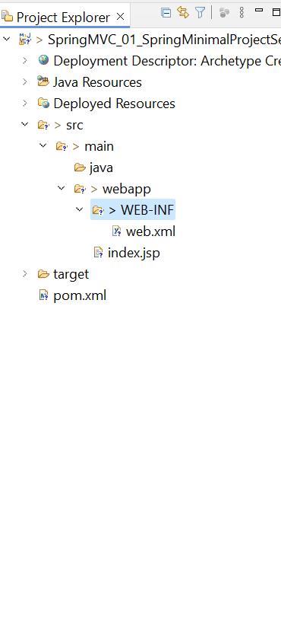
Inside this add below code. Refer to the same URL like above and copy the below code and code from -> SpringSample-servlet.xml
<beans xmlns="http://www.springframework.org/schema/beans"
xmlns:context="http://www.springframework.org/schema/context"
xmlns:xsi="http://www.w3.org/2001/XMLSchema-instance"
xsi:schemaLocation="
http://www.springframework.org/schema/beans
http://www.springframework.org/schema/beans/spring-beans.xsd
http://www.springframework.org/schema/context
http://www.springframework.org/schema/context/spring-context.xsd">

<!-- Adding Support for Component Scan -->
<context:component-scan base-package="org.studyeasy" />

<!-- Configure View Resolver -->
<bean class="org.springframework.web.servlet.view.InternalResourceViewResolver">
<property name="prefix" value="/WEB-INF/" />
<property name="suffix" value=".jsp" />
</bean>
</beans>

It seems there is an error -> Element type "beans" must be followed by either attribute specifications, ">" or "/>". -> So this is the cleaner code of above XML file.

<?xml version="1.0" encoding="UTF-8"?>
<beans xmlns="http://www.springframework.org/schema/beans"
xmlns:context="http://www.springframework.org/schema/context"
xmlns:xsi="http://www.w3.org/2001/XMLSchema-instance"
xsi:schemaLocation="http://www.springframework.org/schema/beans
http://www.springframework.org/schema/beans/spring-beans.xsd
http://www.springframework.org/schema/context
http://www.springframework.org/schema/context/spring-context.xsd">

<!-- Adding Support for Component Scan -->
<context:component-scan base-package="org.studyeasy" />

<!-- Configure View Resolver -->
<bean class="org.springframework.web.servlet.view.InternalResourceViewResolver">
<property name="prefix" value="/WEB-INF/" />
<property name="suffix" value=".jsp" />
</bean>
</beans>

This configuration is nothing but some syntatical sugar.
<?xml version="1.0" encoding="UTF-8"?>
<beans xmlns="http://www.springframework.org/schema/beans"
xmlns:context="http://www.springframework.org/schema/context"
xmlns:xsi="http://www.w3.org/2001/XMLSchema-instance"
xsi:schemaLocation="http://www.springframework.org/schema/beans
http://www.springframework.org/schema/beans/spring-beans.xsd
http://www.springframework.org/schema/context
http://www.springframework.org/schema/context/spring-context.xsd">

Then we have this main configuration which is important. This symbolizes that which is our base package. In our case it is org.studyeasy.

You can use any package based on your preferences.

<context:component-scan base-package="org.studyeasy" />

View Resolver - Where we will be keeping our HTML or JSP files.

<!-- Configure View Resolver -->
<bean class="org.springframework.web.servlet.view.InternalResourceViewResolver">
<property name="prefix" value="/WEB-INF/" />
<property name="suffix" value=".jsp" />
</bean>

Creating Controllers:-

Inside the folder -> java -> Create a new class -> MainController.java
Package : org.studyeasy -> Because it is base package.

Add @Controller Annotation to this class and add some public methods.

package org.studyeasy;

import org.springframework.stereotype.Controller;

@Controller
public class MainController {

public String home() {
return "home";
}

}

WEB-INF -> Where we keep all the Views. -> Create folder-> views
Make few changes in SpringSample-servlet.xml.

<!-- Configure View Resolver -->
<bean class="org.springframework.web.servlet.view.InternalResourceViewResolver">

<property name="prefix" value="/WEB-INF/" /> <- Need to modify this line

<property name="suffix" value=".jsp" />

</bean>

To

<!-- Configure View Resolver -->
<bean class="org.springframework.web.servlet.view.InternalResourceViewResolver">

<property name="prefix" value="/views/" />

<property name="suffix" value=".jsp" />

</bean>

Creating Views:-

Inside folder -> views -> We will create new JSP file -> home.jsp

Take a note of it that because we already given the suffix as JSP, we need not to worry about sending the entire name inside our controller. Just home is good enough and home.jsp will be used here.

We will be giving the title as a home page rather.

Home.jsp

<%@ page language="java" contentType="text/html; charset=ISO-8859-1"
pageEncoding="ISO-8859-1"%>
<!DOCTYPE html>
<html>
<head>
<meta charset="ISO-8859-1">
<title>Home</title>
</head>
<body>
<h3>Welcome to the world of Spring-MVC</h3>
</body>
</html>

Index.jsp

<%@ page language="java" contentType="text/html; charset=ISO-8859-1"
pageEncoding="ISO-8859-1"%>
<!DOCTYPE html>
<html>
<head>
<meta charset="ISO-8859-1">
<title>Index</title>
</head>
<body>
<h1>Hello World!...</h1>
</body>
</html>

MainController.java

public String home() {
return "home"; <- No need “home.jsp”
}

