There are 2 parts in the LinkedList. Data Part And Address Part

White Part - Address
Blue Part - Blue

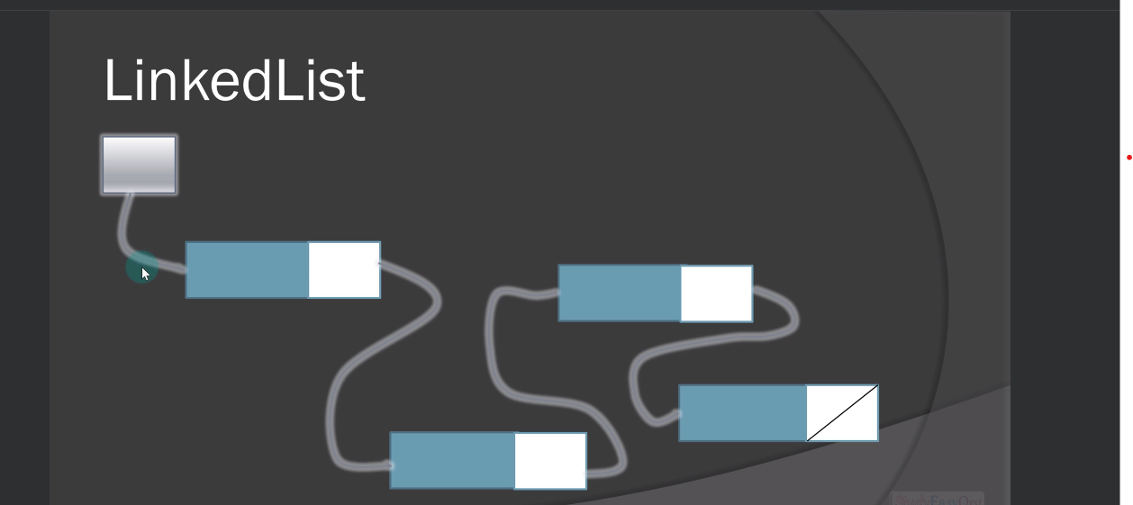

First Node is special node where we just have an address.
Last Node is special node where address is null.

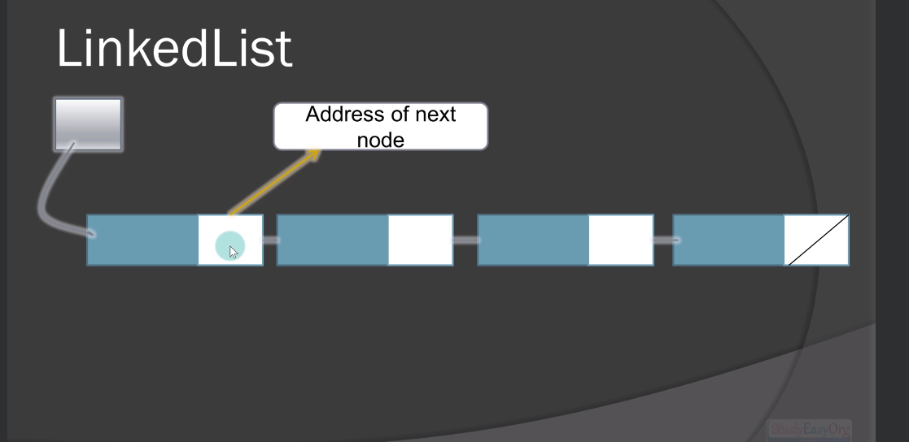

Delete A Node

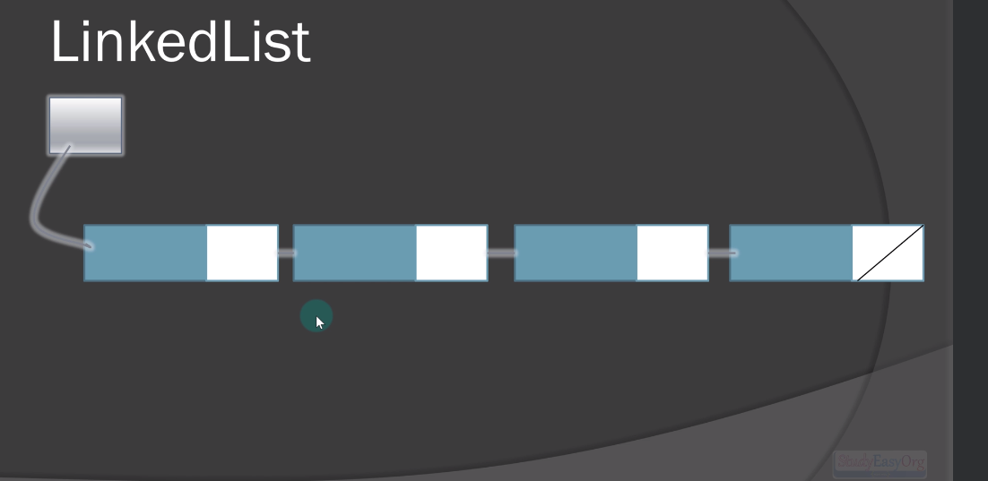

Remove The Node.

Update the address of the previous node with the address of next node.

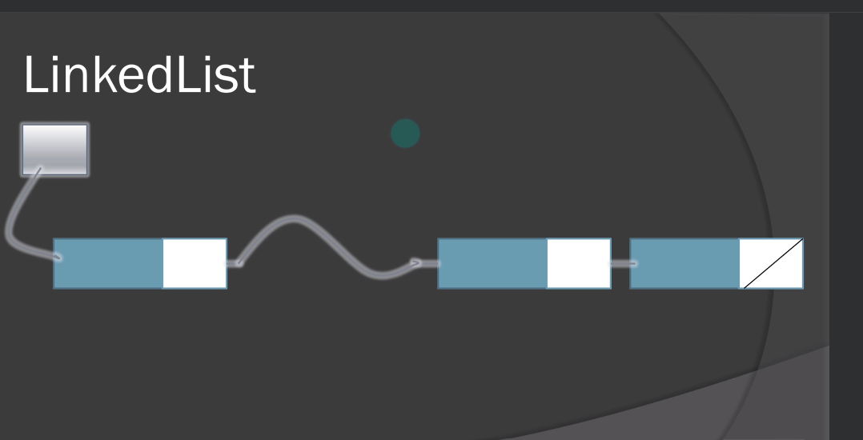

Add Node
