JSP SCRIPTING ELEMENTS
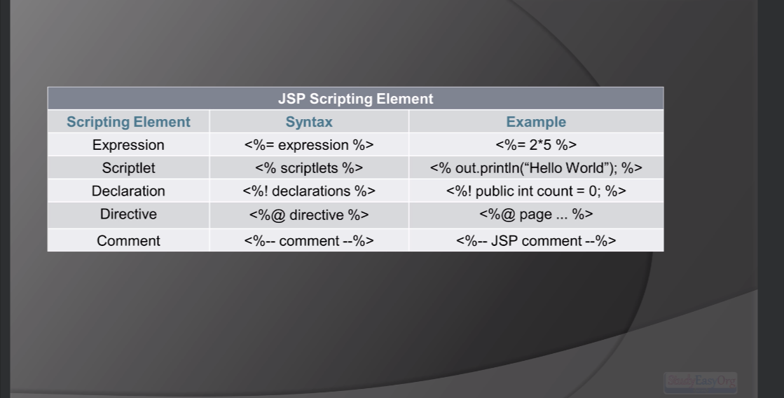
When it comes to expression, it only comes with single statement.

