Java Scope

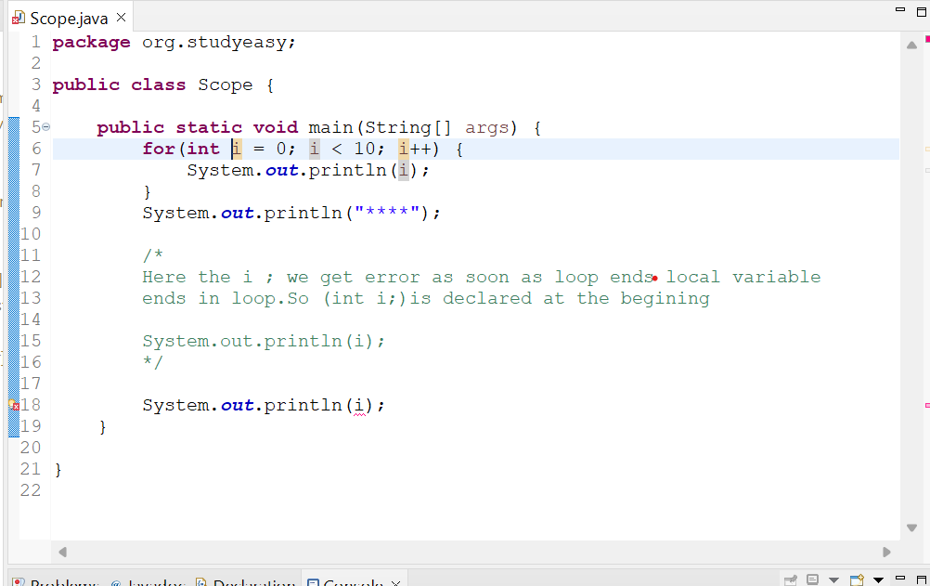
Here I gives an error and explaination is given in comments.Sol is below.

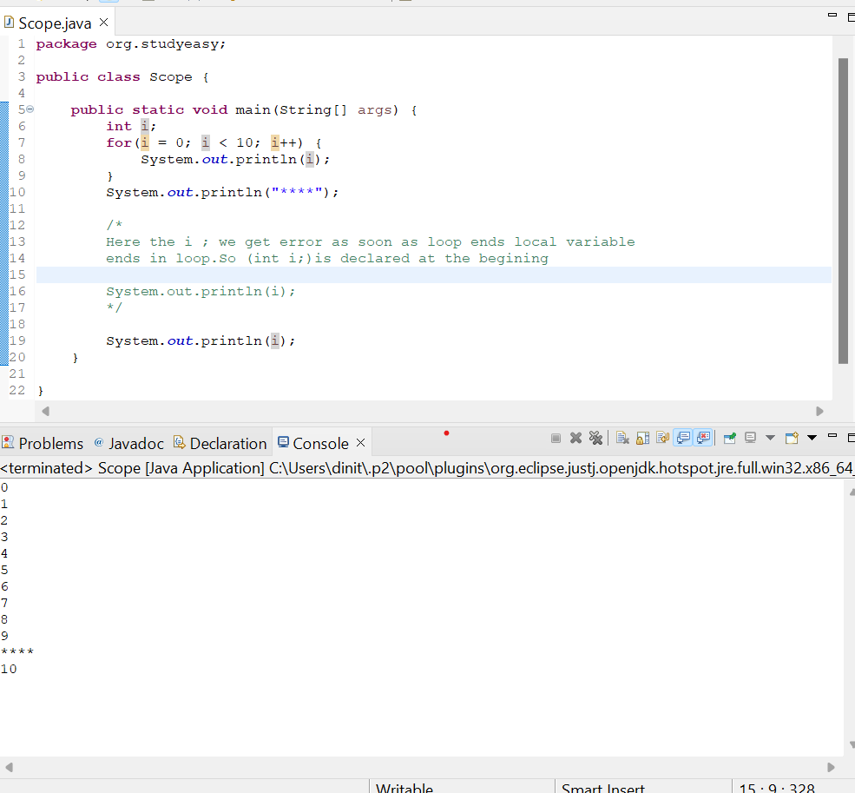
Now the outer variable will be accessed by the inner scopes, but the inner scope variable can't be accessed from the outside world.

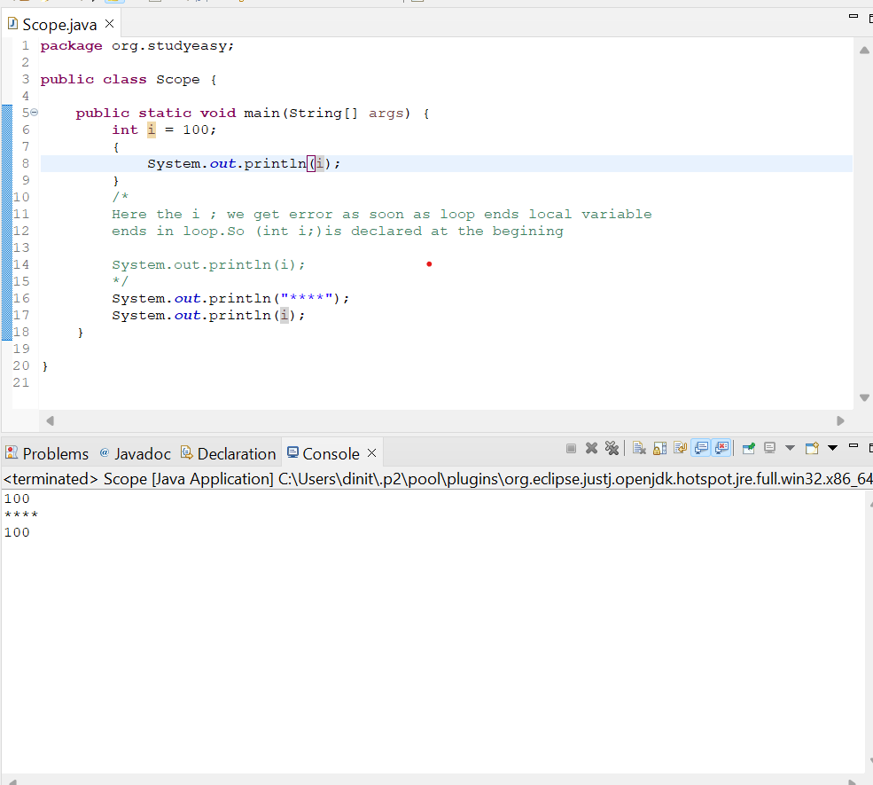

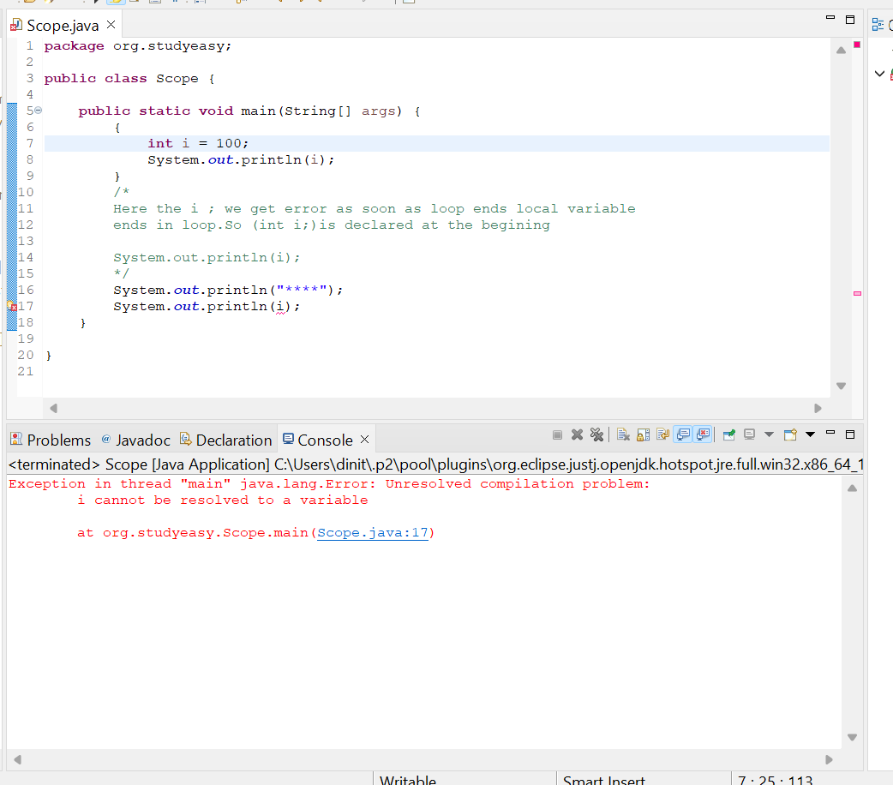
Global Variable or Class Level Variable
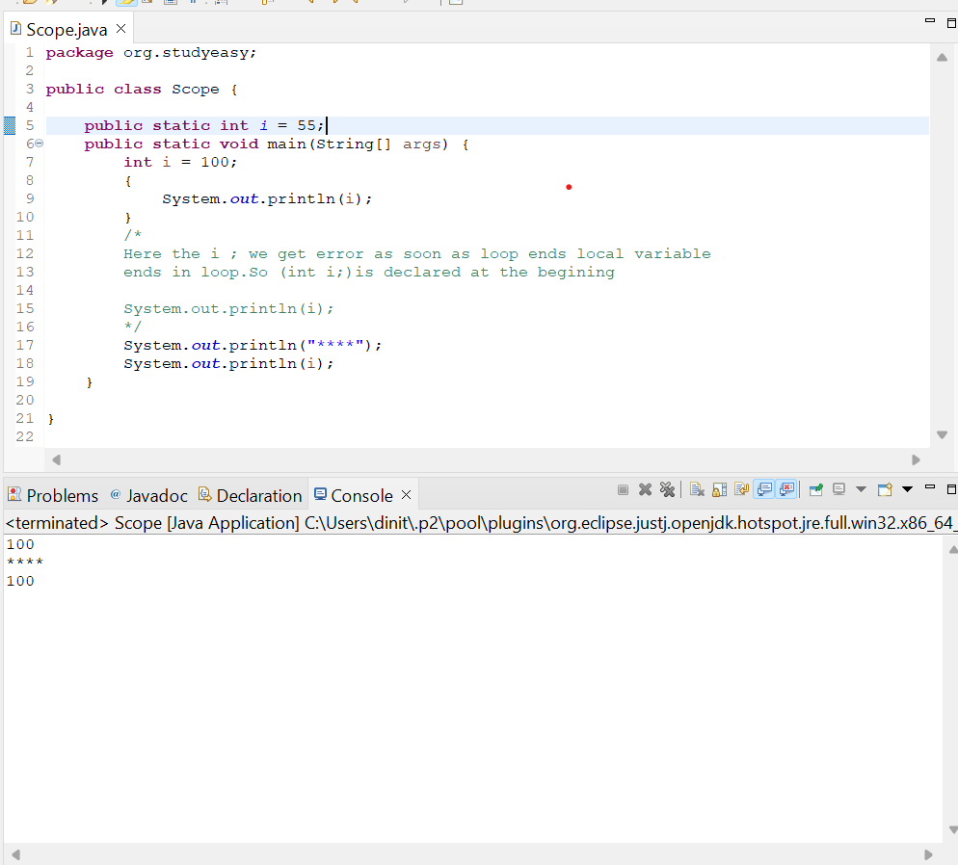
We have a method inside a method, we cannot repeat the name of the variable, which is a generic rule.Okay, but a class level variable or a global variable can have a same name.A global variable and a local variable.A method level variable and a class level variable can have same name.But in a method we cannot have duplicate variable names.

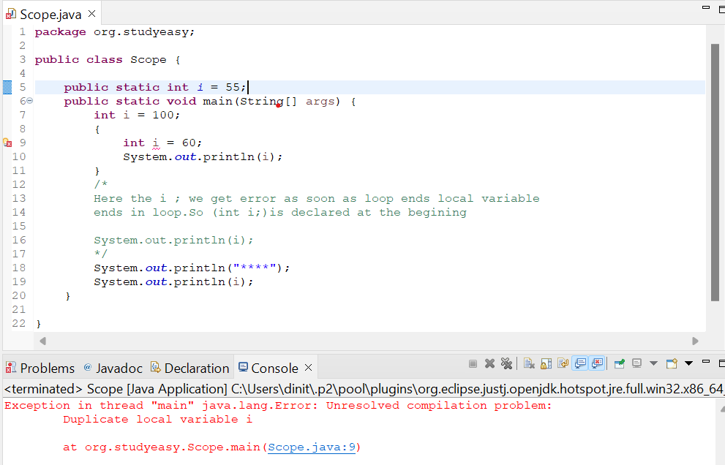

If we have the local variable, the method will actually prefer the local variable.
But if there is a global variable and there is no local variable with that name, then the global or
the method level.

Pardon me.

Class level variable will be used.

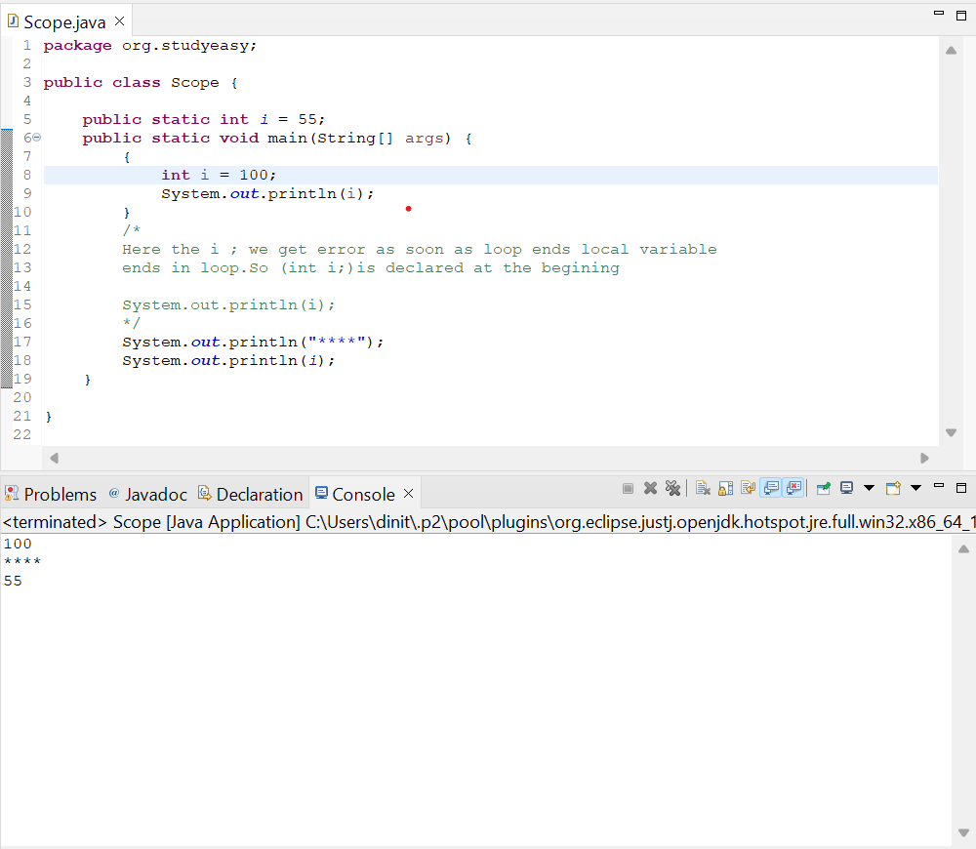
To access a variable, a class level variable where we don't have the static keyword or a variable is non static. Class level variable.In this case, as the name suggests it's a non static class level variable.
So we will do new main.
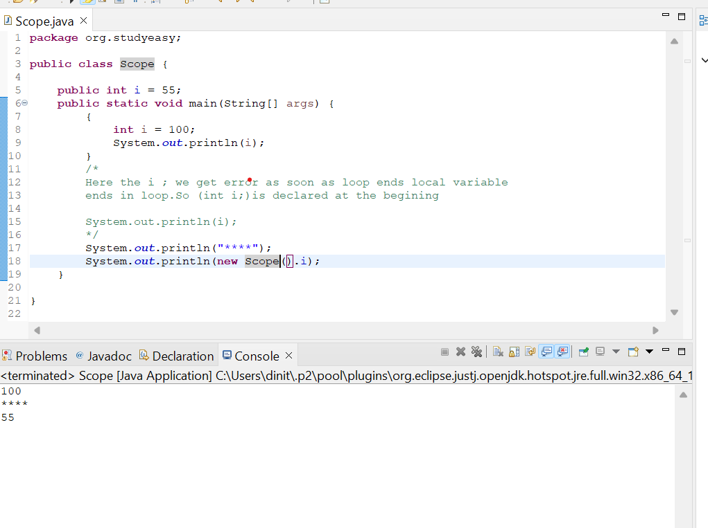
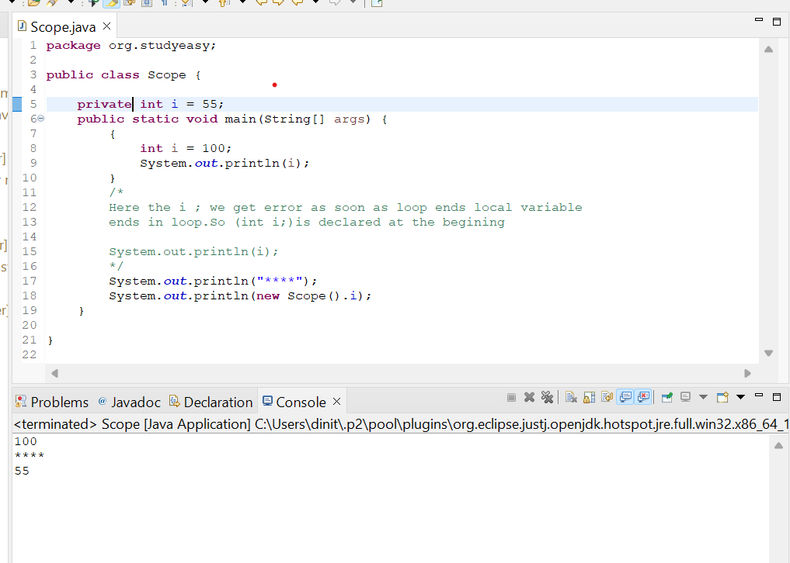
- Int i = 100;
- public static int I =100;
- Private int I = 100; (Within Class itself)

