- STRING HANDLING

- String is a special variable or special datatype.

- Example : Hover over the String, you get popover.
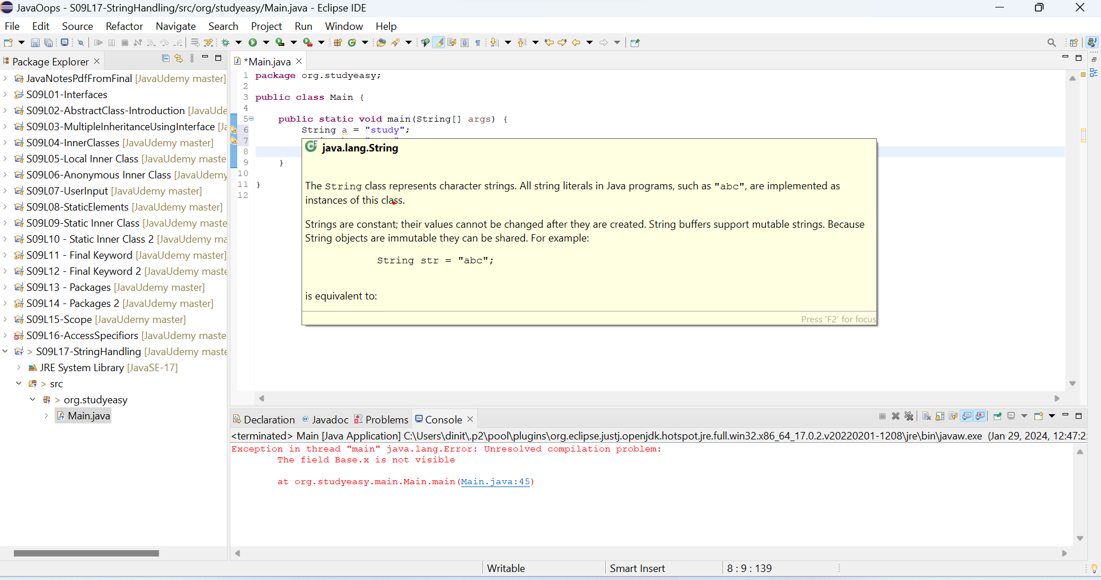

- Why Java String is a Class (Difference between primitive and non primitive datatype)?

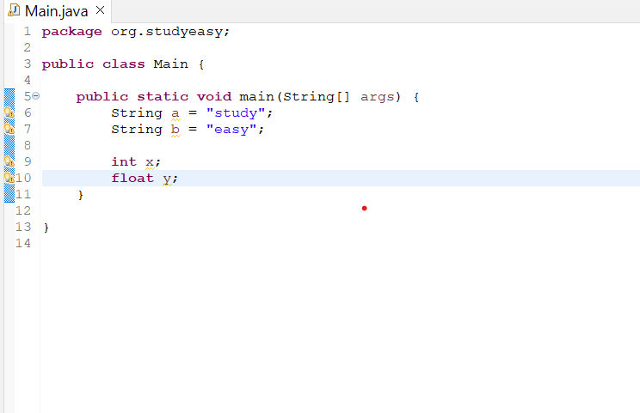

The above pic is the difference between primitive datatype and non primitive datatype.

- Why Java String is a Class? ‘+’ as Overloaded operator - Can add both primitive and objects.

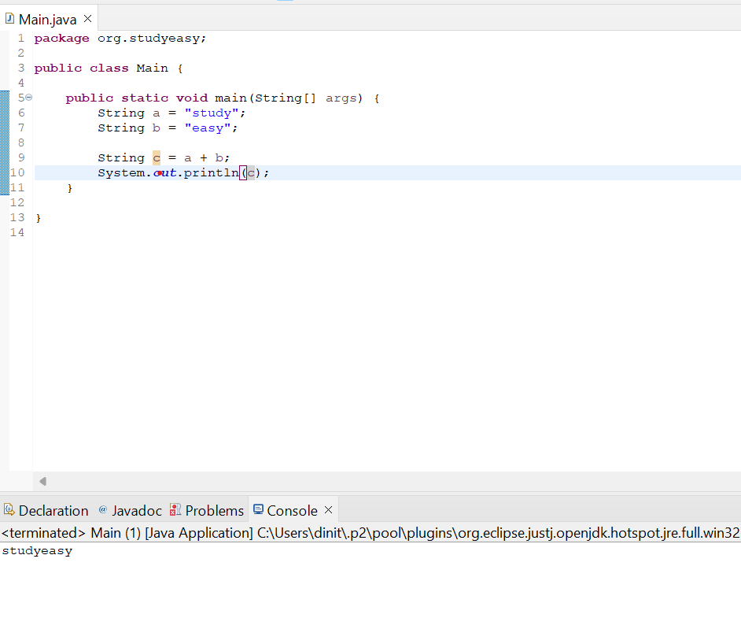

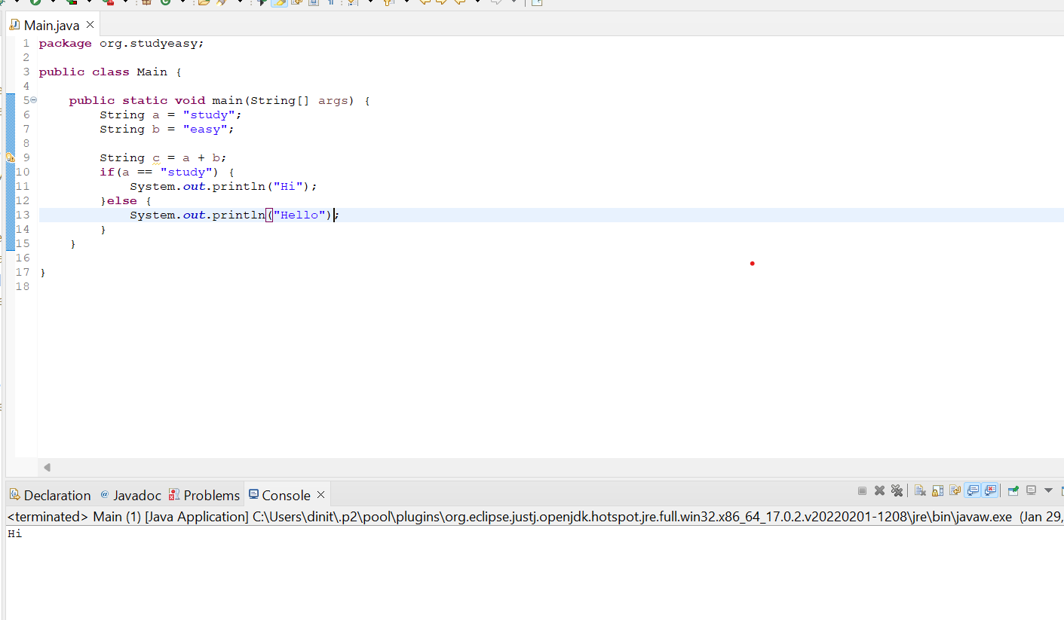

- Unexpected Output - String Example

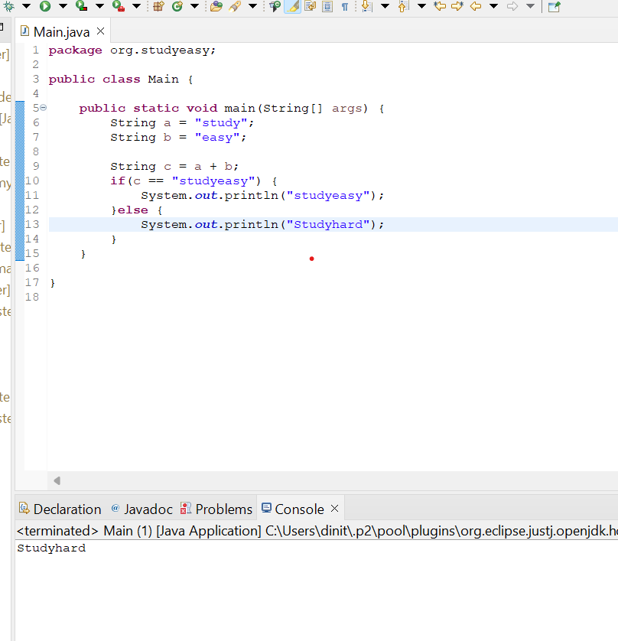

- URL link for the Java String Class documentation

https://docs.oracle.com/javase/8/docs/api/java/lang/String.html

- Solution for the above example

Can use String Manipulation Methods . Also refer to the above URL for more details.

