ForEach Loop Refresher

Syntax: - foreach(datatype <var_name> : <array_name>){}

ForEachDemo.java
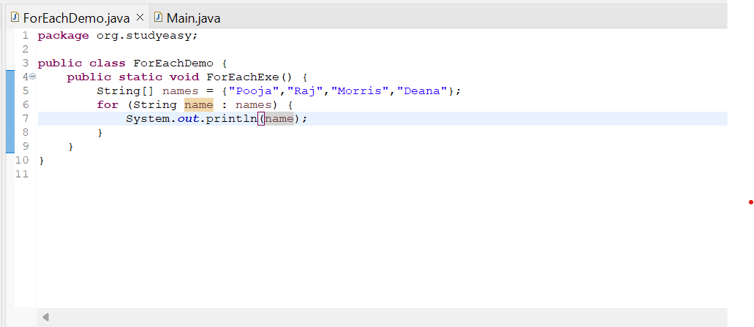
Main.java
