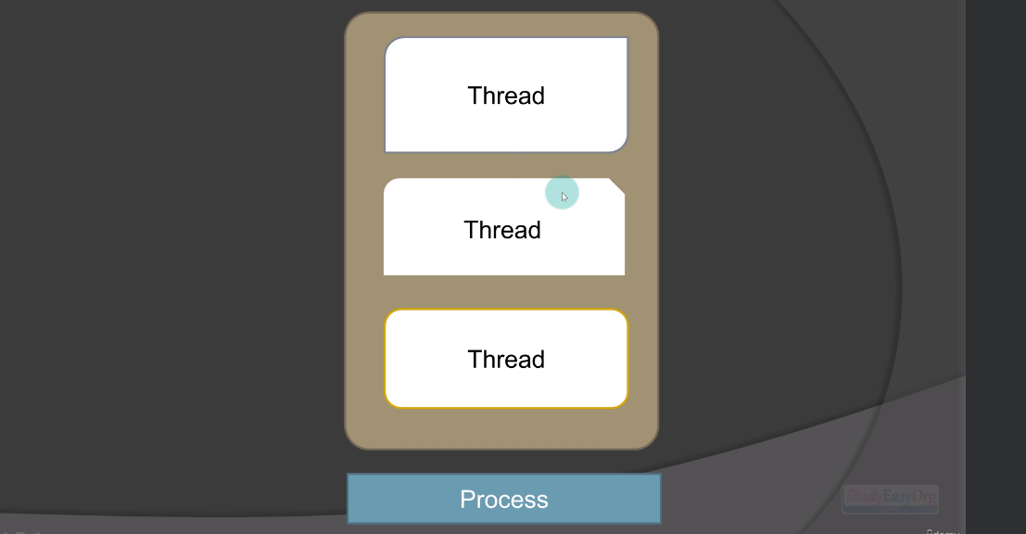

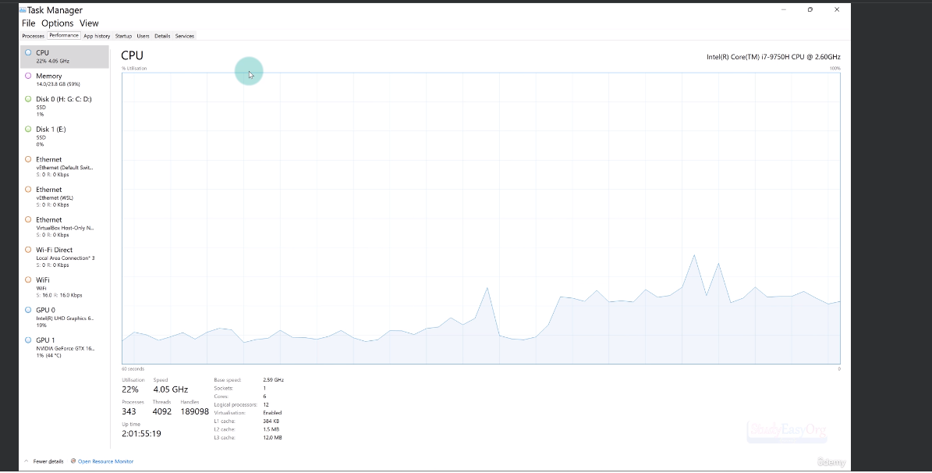

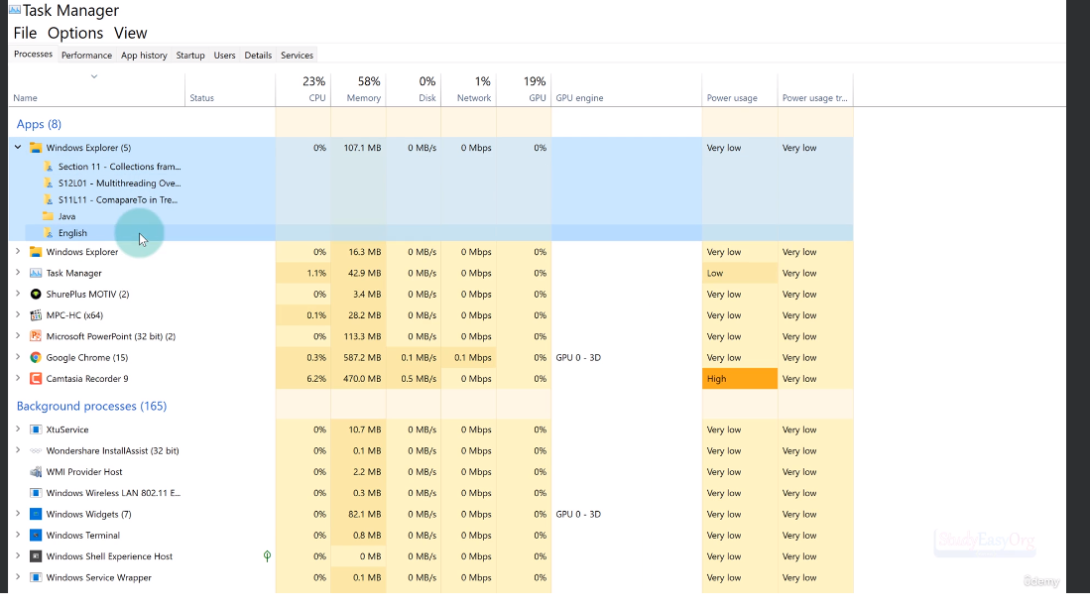

Few Applications are running currently. These are Sub Processes.

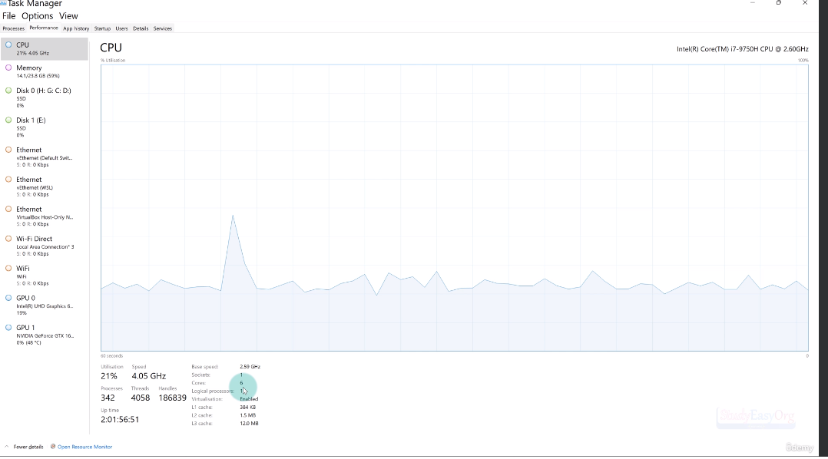

It physically has one processor. But inside the processor, if you check there are 6 cores. This means there are 6 simultaneous processors and these are like tiny processors inside an entire big processor. So we can simply say, there are 6 processor inside this.

But we see Logical processor(12), These are Threads. These 6 cores have additional threads. These threads have capability to run multiple processors simultaneously. As a result, based on the logical processors can actually run 12 simultaneous processors on this hardware.

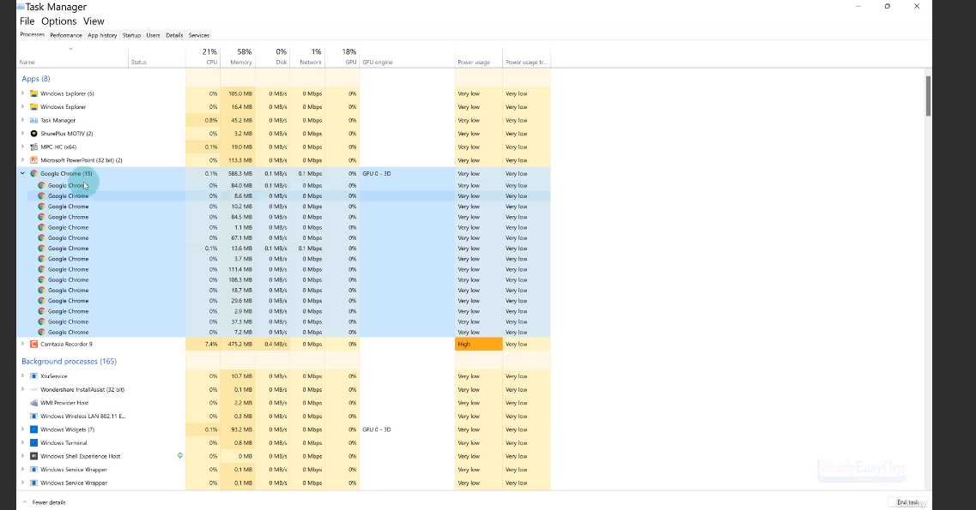

There are (Google chrome) 15 Threads. How we are running 15 threads on a processor where we only have 12 Logical processors?

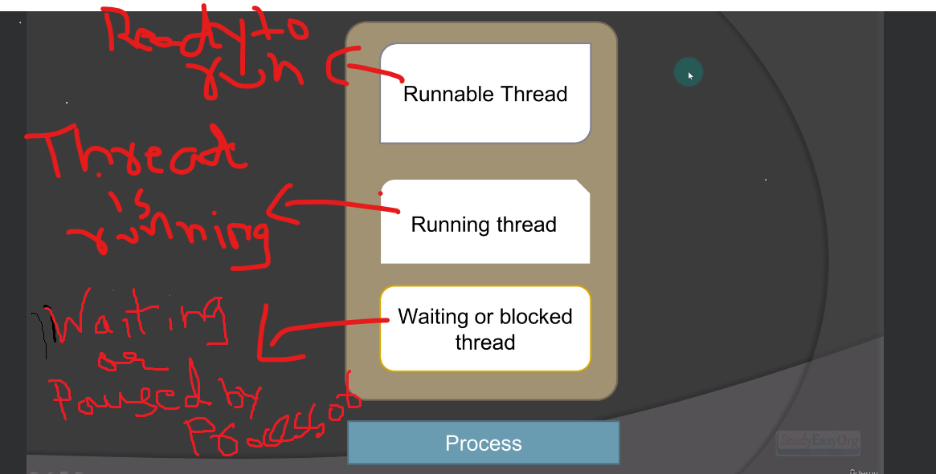

Life Cycle of a Thread

