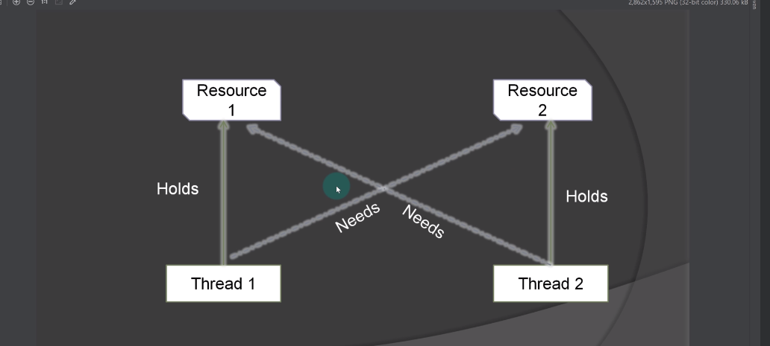

Deadlock is a scenario where thread is holding a resource, but resource is required by some other thread and vice versa. If there is a intersection or holding of resources, then there will be a Deadlock.

