MYSQL WORKBENCH
Step 1: https://dev.mysql.com/downloads/installer/

Step 2: Configure

Step 3: Execute

Step 4: Welcome Page -> It looks like this below picture.

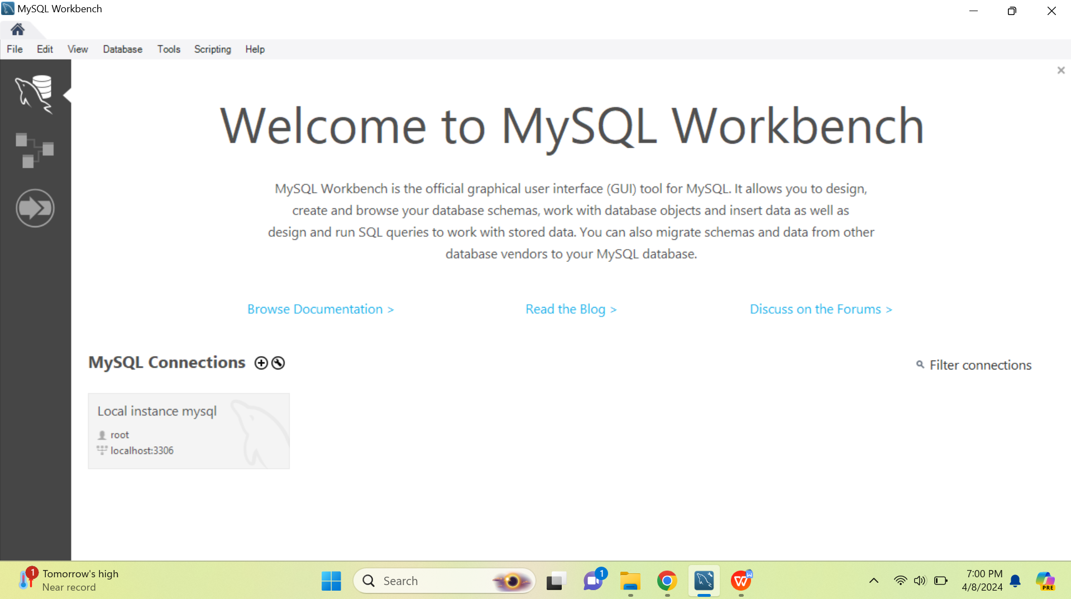

Step 5: Click on this.

Step 6: It will ask the password. Enter the password. Click OK.

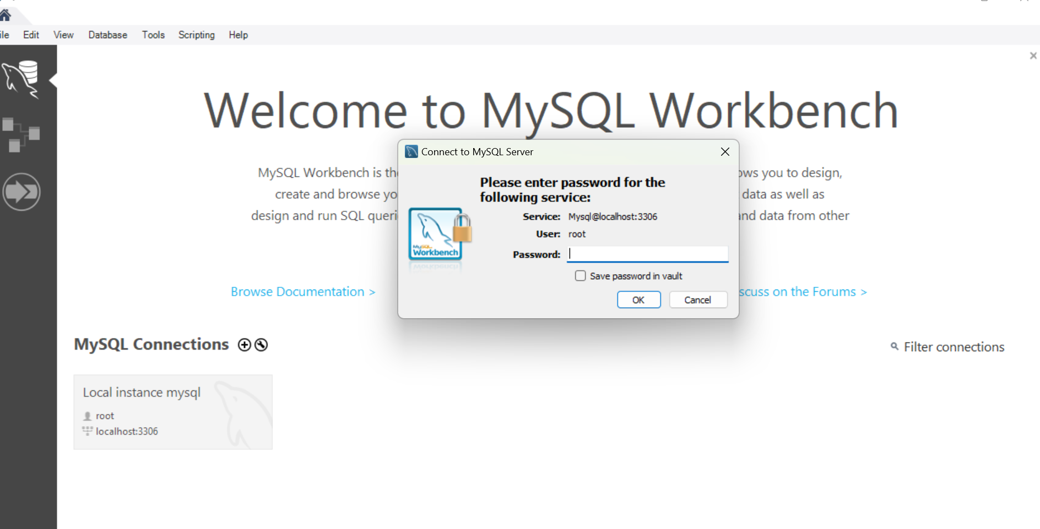

Step 7: After entering, the window page might look like this.

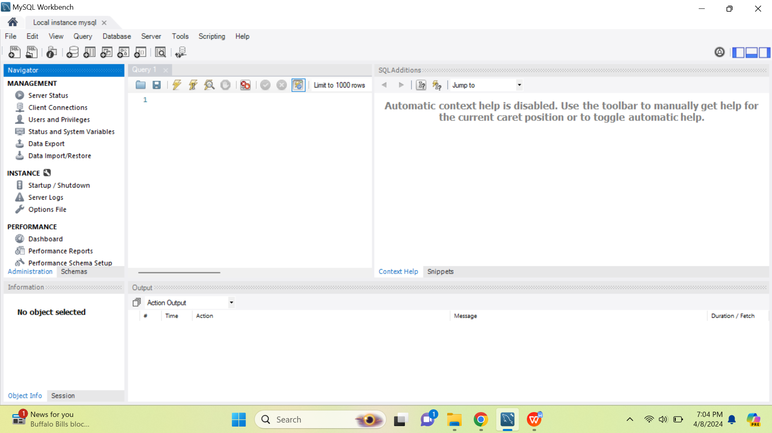

Step 8: If you do not have connection, please click below and following dialog box will appear.

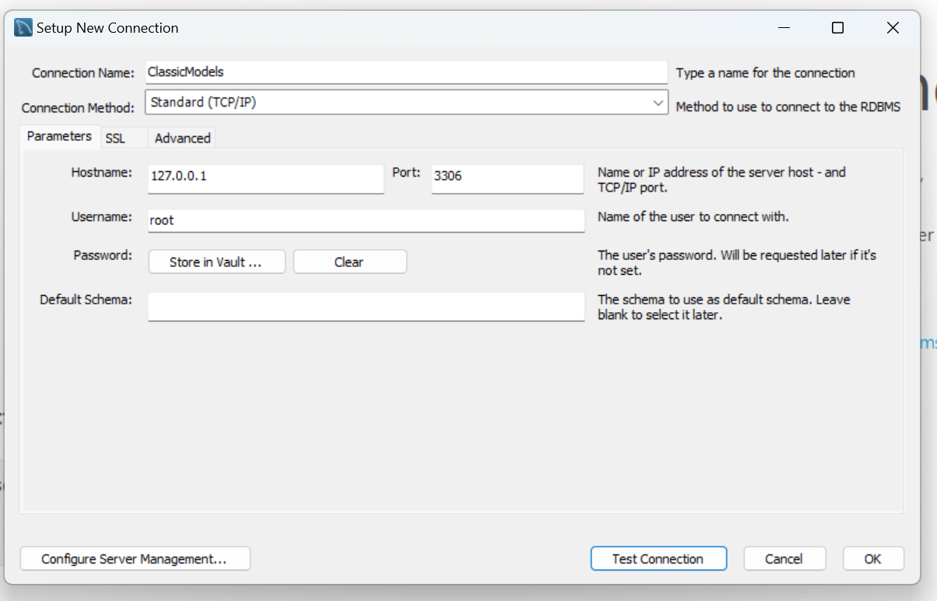

Step 9: After entering connection name, Click on test connection. Enter password and you will get the dialog box like below.
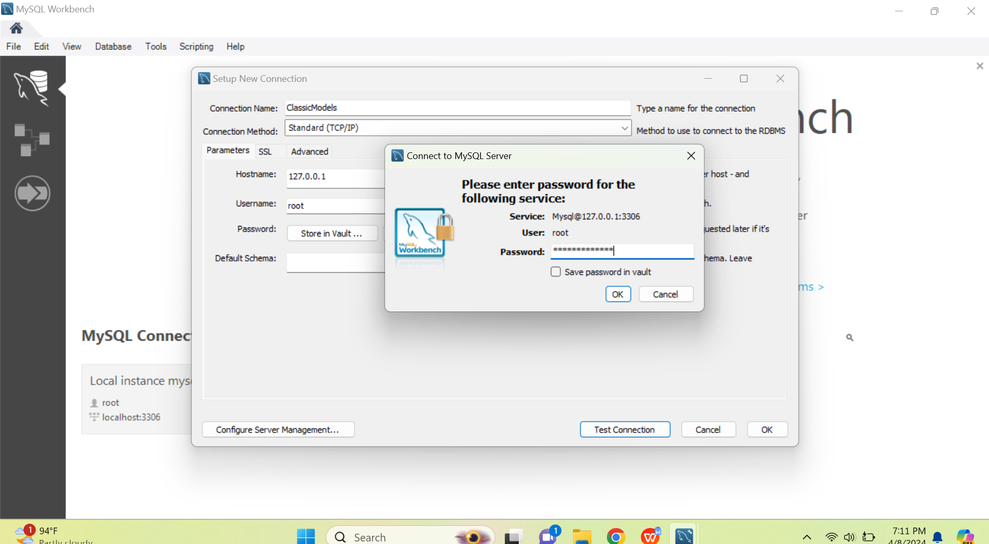

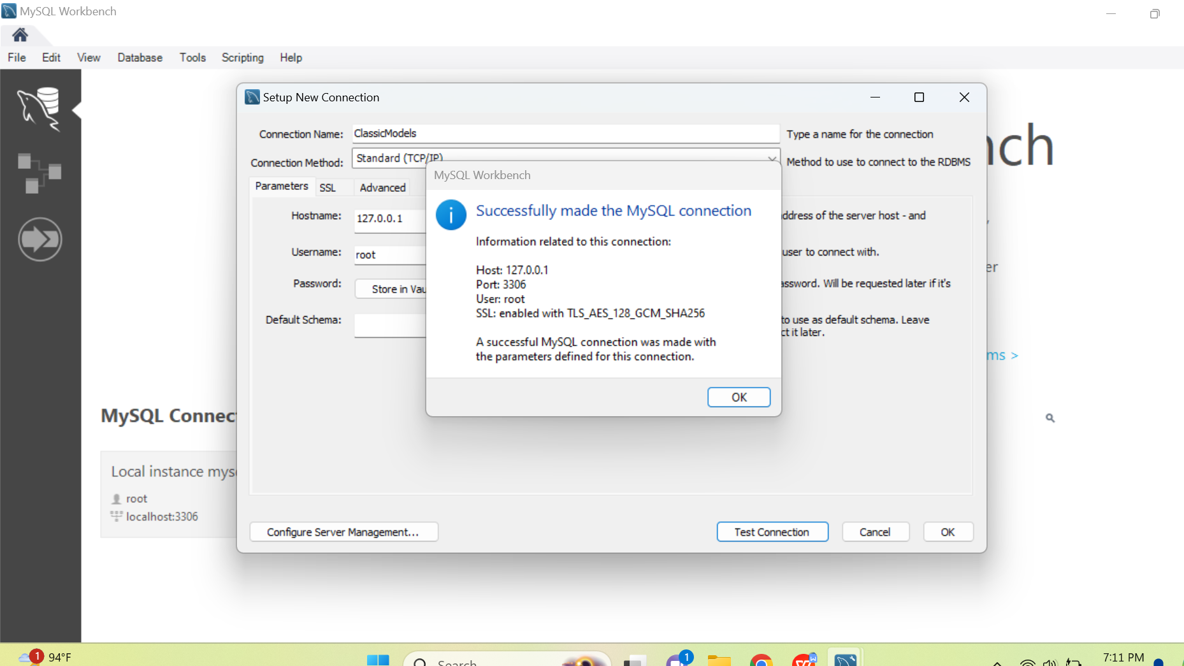

Step 10: You will get your connection displayed like below.
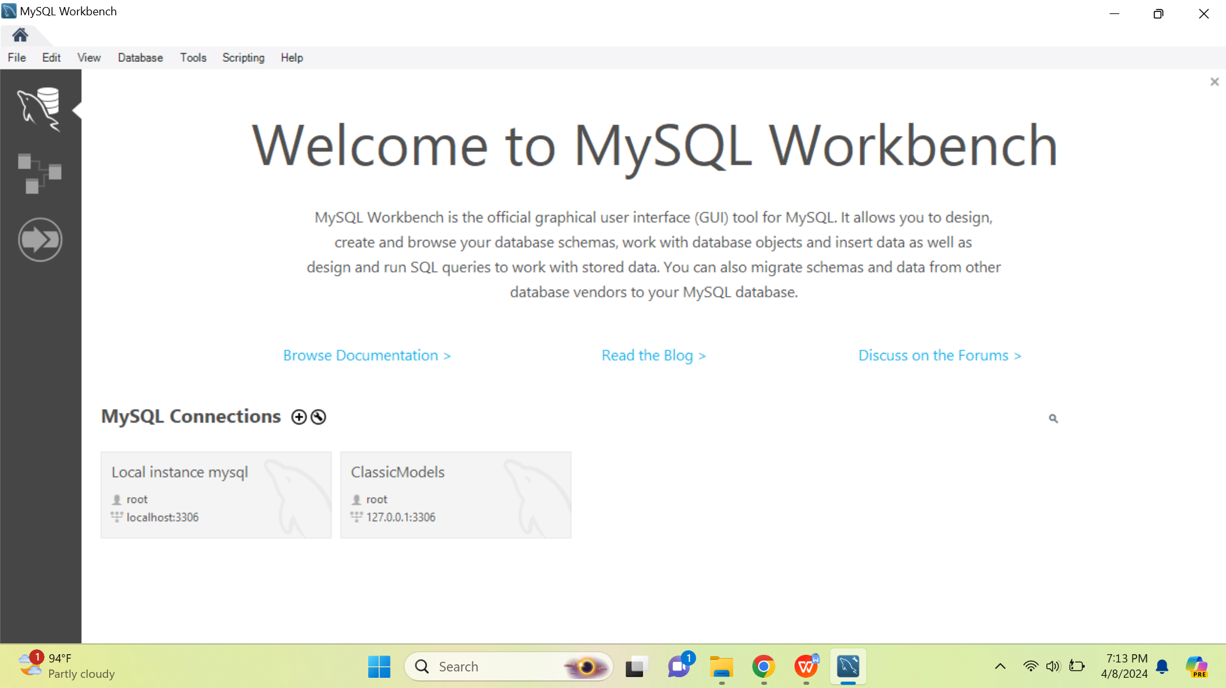
Step 11: Right click on the connection -> Open Connection -> Enter Password(if asked) -> You will get like below page.

