**SpringBoot – Roles and Authorities**

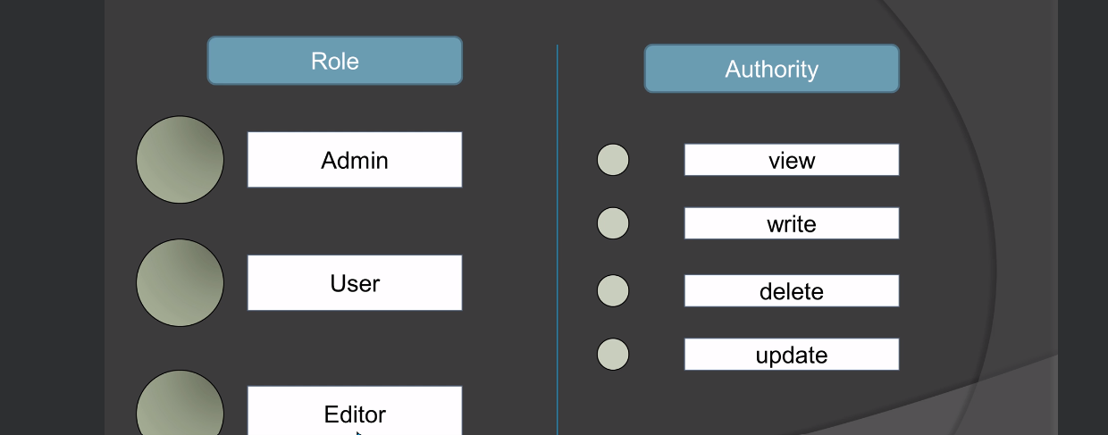

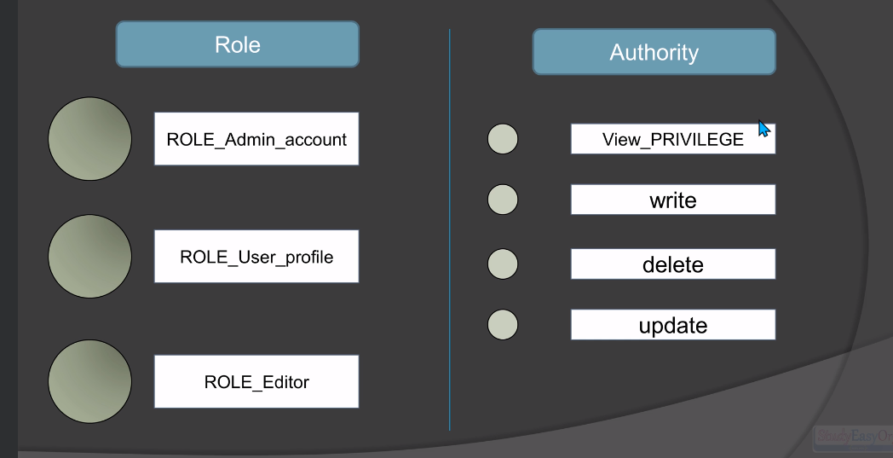

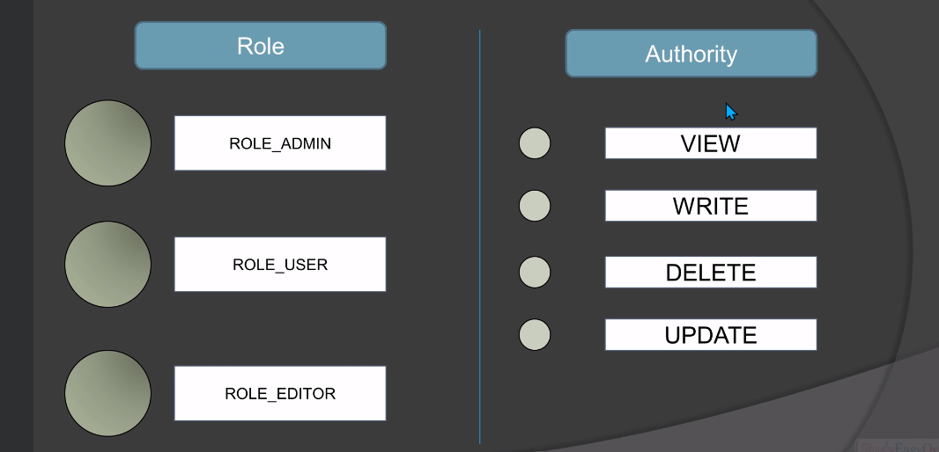

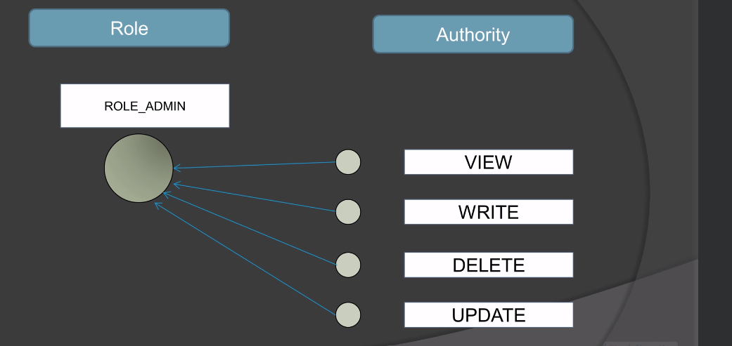

**Role:- It means the collection of authrorities.**

**Authorities:- Based on the operation specific entities.**

**They can be applied on endpoint or the view.**