**Spring Boot - Update Homepage With Post Links**

<section class="about_section layout_padding">

    <div class="container  ">

      <div class="posts" th:each="post : ${posts}">

        <h3<a th:href="@{'/posts/' + ${post.id}}" th:text="${post.title}">Title</a></h3>

        <h5 th:text="'Author : '+ ${post.account.firstname} + ' | Created At : '+ ${post.createdAt}"></h5>

        <p th:text="${post.body}">body</p>

        <hr color="gray"/>

      </div>

    </div>

  </section>

**Changes made – Below code applied and output coming**

 <section class="about_section layout_padding">

    <div class="container  ">

      <div class="posts" th:each="post : ${posts}">

        <h3><a th:href="@{'/posts/' + ${post.id}}" th:text="${post.title}">Title</a></h3>

        <h5 th:text="'Author: '+ ${post.account.firstname} + ' | Created at: '+ ${post.createdAt}"></h5>

        <p th:text="${post.body}">body</p>

        <hr color="grey"/>

      </div>

    </div>

  </section>

**Output**

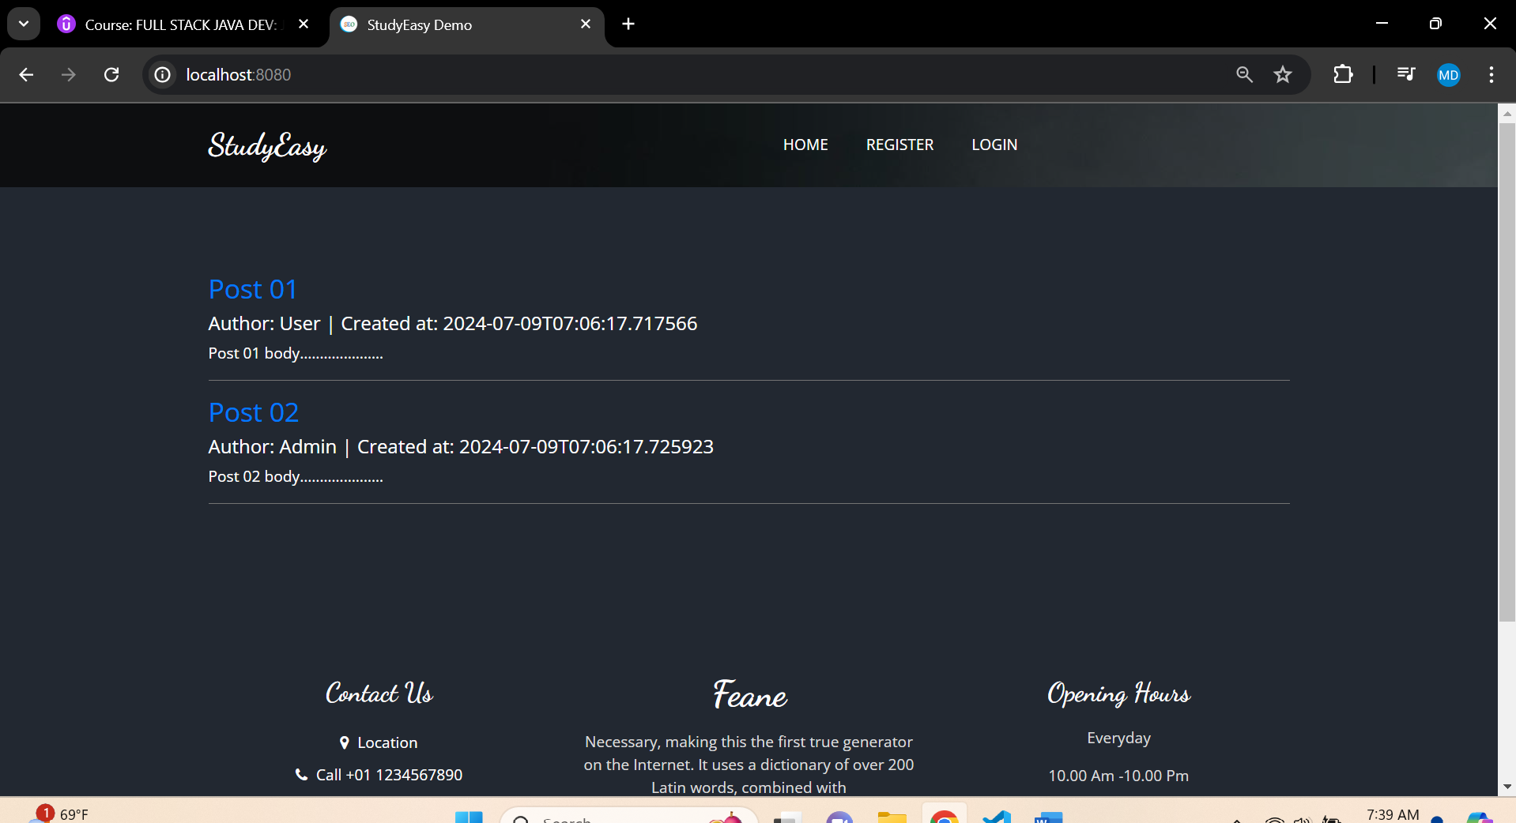

**If you click on the link of the Post name eg:- (Post1), you get like below output.**



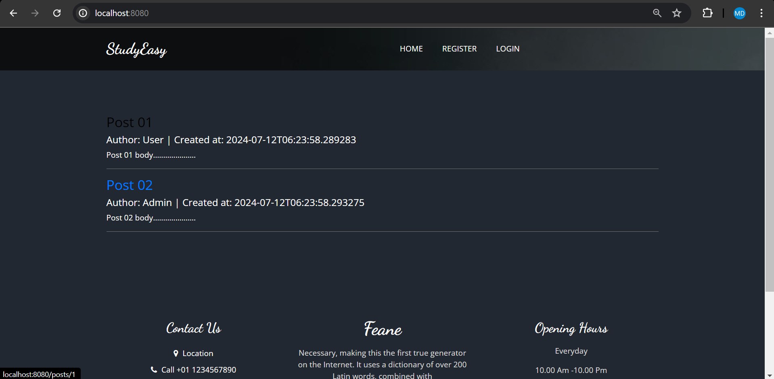



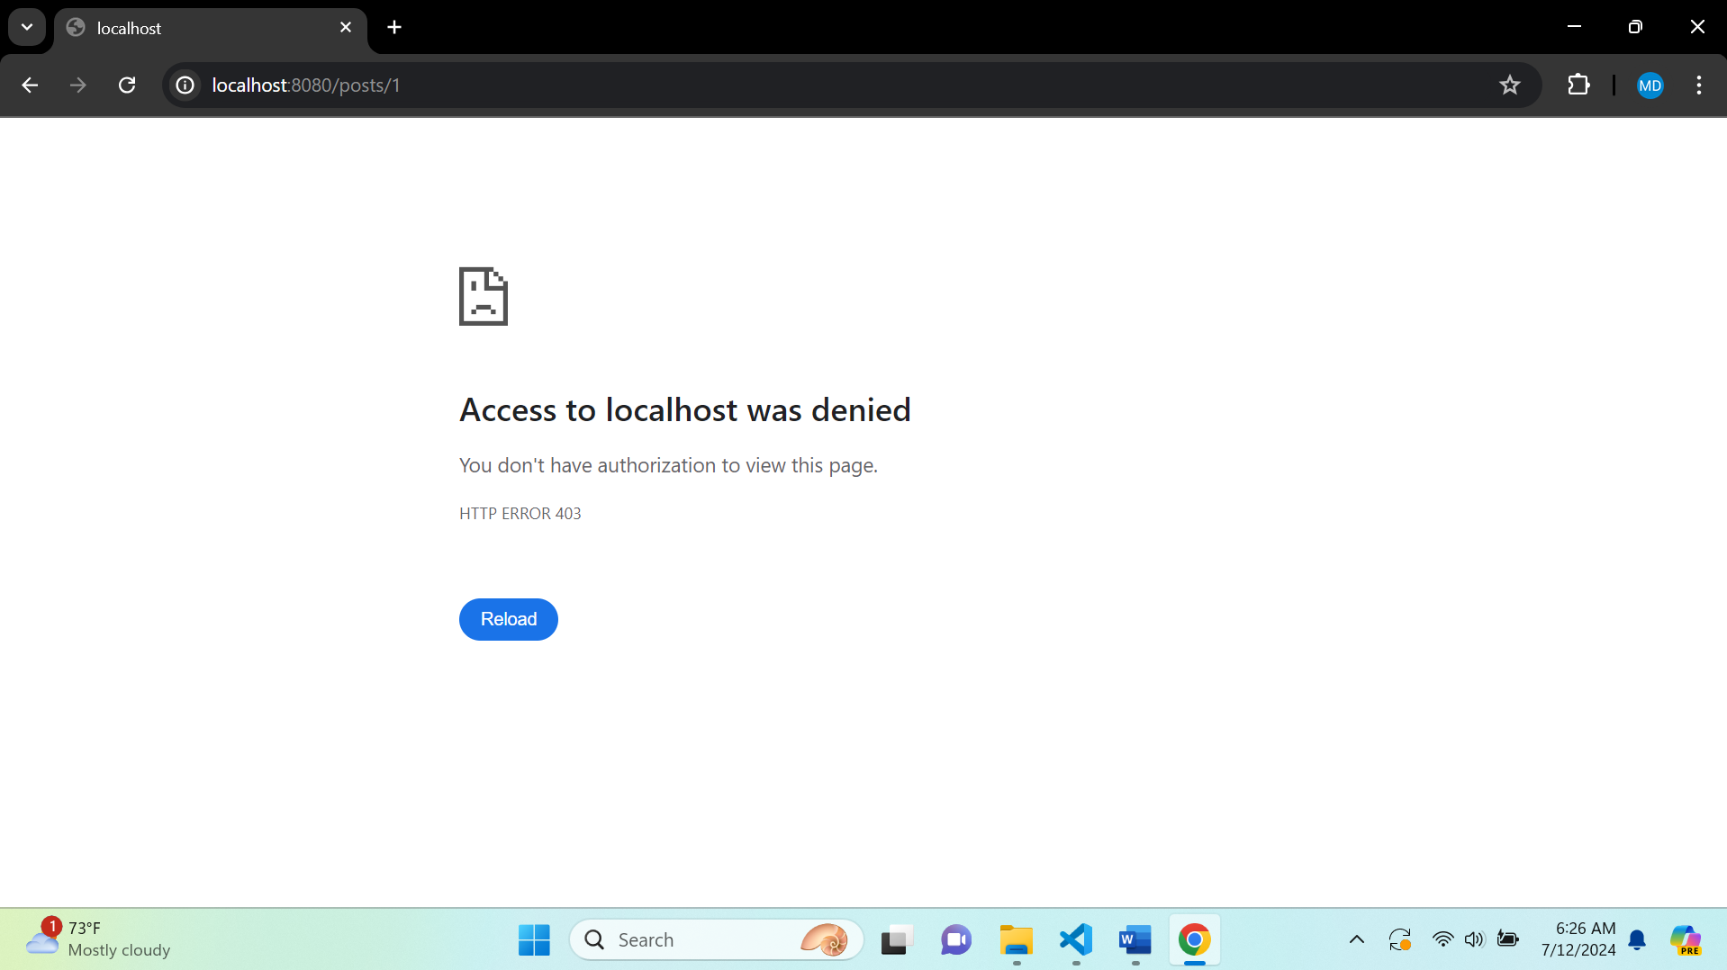

**Updated header.html**

<!DOCTYPE html>

<html lang="en" xmlns:th="http://www.thymeleaf.org"

                xmlns:sec="http://www.thymeleaf.org/extras/spring-security">

<head>

    <meta charset="UTF-8">

    <meta name="viewport" content="width=device-width, initial-scale=1.0">

    <title>StudyEasy</title>

    <!-- Include CSS and JS files here -->

</head>

 <!-- header section strats -->

 <header class="header_section">

    <div class="container">

      <nav class="navbar navbar-expand-lg custom_nav-container ">

        <a class="navbar-brand" href="index.html">

          <span>

            StudyEasy

          </span>

        </a>

        <button class="navbar-toggler" type="button" data-toggle="collapse" data-target="#navbarSupportedContent" aria-controls="navbarSupportedContent" aria-expanded="false" aria-label="Toggle navigation">

          <span class=""> </span>

        </button>

        <div class="collapse navbar-collapse" id="navbarSupportedContent">

          <ul class="navbar-nav  mx-auto ">

            <li class="nav-item ">

              <a class="nav-link" href="/">Home </a>

            </li>

            <span sec:authorize="!isAuthenticated()">

            <li class="nav-item">

              <a class="nav-link" href="/register">Register</a>

            </li>

            </span>

            <span sec:authorize="!isAuthenticated()">

            <li class="nav-item">

              <a class="nav-link" href="/login">login</a>

            </li>

          </span>

          <span sec:authorize="isAuthenticated()">

            <li class="nav-item">

              <a class="nav-link" href="/profile">Profile</a>

            </li>

          </span>

          <span sec:authorize="hasRole('ROLE_ADMIN')">

            <li class="nav-item">

              <a class="nav-link" href="/admin">admin</a>

            </li>

          </span>

          <!-- <span sec:authorize="hasAuthority('ACCESS_ADMIN_PANEL')">

            <li class="nav-item">

              <a class="nav-link" href="/admin">admin</a>

            </li>

          </span> -->

            <!--logout-->

          <span sec:authorize="isAuthenticated()">

            <li class="nav-item">

              <a class="nav-link" href="/logout">logout</a>

            </li>

          </span>

          </ul>

        </div>

      </nav>

    </div>

  </header>

  <!-- end header section -->

</html>

**Updated home.html**

<!DOCTYPE html>

<html>

<head th:replace="/fragments/head :: head">

<body class="sub_page">

  <div class="hero_area">

    <div class="bg-box">

      <img src="images/nav-bg.jpg" alt="">

    </div>

    <!-- header section strats -->

    <header th:replace="/fragments/header :: header">

      <!-- end header section -->

  </div>

  <!-- about section -->

  <section class="about_section layout_padding">

    <div class="container  ">

      <div class="posts" th:each="post : ${posts}">

        <h3><a th:href="@{'/posts/' + ${post.id}}" th:text="${post.title}">Title</a></h3>

        <h5 th:text="'Author: '+ ${post.account.firstname} + ' | Created at: '+ ${post.createdAt}"></h5>

        <p th:text="${post.body}">body</p>

        <hr color="grey"/>

      </div>

    </div>

  </section>

  <!-- end about section -->

  <!-- footer section -->

  <footer th:replace="/fragments/footer :: footer">

    <!-- footer section -->

</body>

</html>

**Create a Post Controller**

package org.studyeasy.SpringBlog.Controller;

import org.springframework.stereotype.Controller;

@Controller

public class PostController {

}