**Spring Boot - View Post With Edit Options**

**Original Code of post.html**

<!DOCTYPE html>

<html lang="en" xmlns:th="http://www.thymeleaf.org">

<head th:replace="/fragments/head :: head">

  <title>StudyEasy Demo - Post Page</title>

</head>

<body class="sub_page">

  <div class="hero_area">

    <div class="bg-box">

      <img src="images/nav-bg.jpg" alt="">

    </div>

    <header th:replace="/fragments/header :: header">

  </div>

  <!-- about section -->

  <section class="about_section layout_padding">

    <div class="container  ">

      post data

    </div>

  </section>

  <footer th:replace="/fragments/footer :: footer"></footer>

</body>

</html>

**Updated code of post.html**

<!DOCTYPE html>

<html lang="en" xmlns:th="http://www.thymeleaf.org">

<head th:replace="/fragments/head :: head">

    <title>StudyEasy Demo - Post Page</title>

</head>

<body class="sub_page">

    <div class="hero_area">

        <div class="bg-box">

            <img th:src="@{/images/nav-bg.jpg}" alt=""> -> Change

        </div>

        <header th:replace="/fragments/header :: header"></header>

    </div>

    <!-- about section -->

    <section class="about_section layout_padding">

        <div class="container">

            <!-- Your post content goes here -->

            <p>Post data goes here...</p>

        </div>

    </section>

    <footer th:replace="/fragments/footer :: footer"></footer>

</body>

</html>

**Final code of Post.html**

<!DOCTYPE html>

<html lang="en" xmlns:th="http://www.thymeleaf.org">

<head th:replace="/fragments/head :: head">

    <title>StudyEasy Demo - Post Page</title>

</head>

<body class="sub_page">

    <div class="hero_area">

        <div class="bg-box">

            <img th:src="@{/images/nav-bg.jpg}" alt="">

        </div>

        <header th:replace="/fragments/header :: header"></header>

    </div>

    <!-- about section -->

    <section class="about_section layout_padding">

        <div class="container">

            <div class="post">

                <h3><a th:text="${post.title}">Title</a></h3>

                <h5 th:text="'Author: '+ ${post.account.firstname} + ' | Created at: '+ ${post.createdAt}"></h5>

                <p th:text="${post.body}">body</p>

                <hr color="grey"/>

                <a th:href="@{'/edit_post/'+ ${post.id}}" class="btn btn-secondary btn-lg active" role="button" aria-pressed="true">Edit</a>

              </div>

        </div>

    </section>

    <footer th:replace="/fragments/footer :: footer"></footer>

</body>

</html>

**Output – After clicking on the link you get like below**

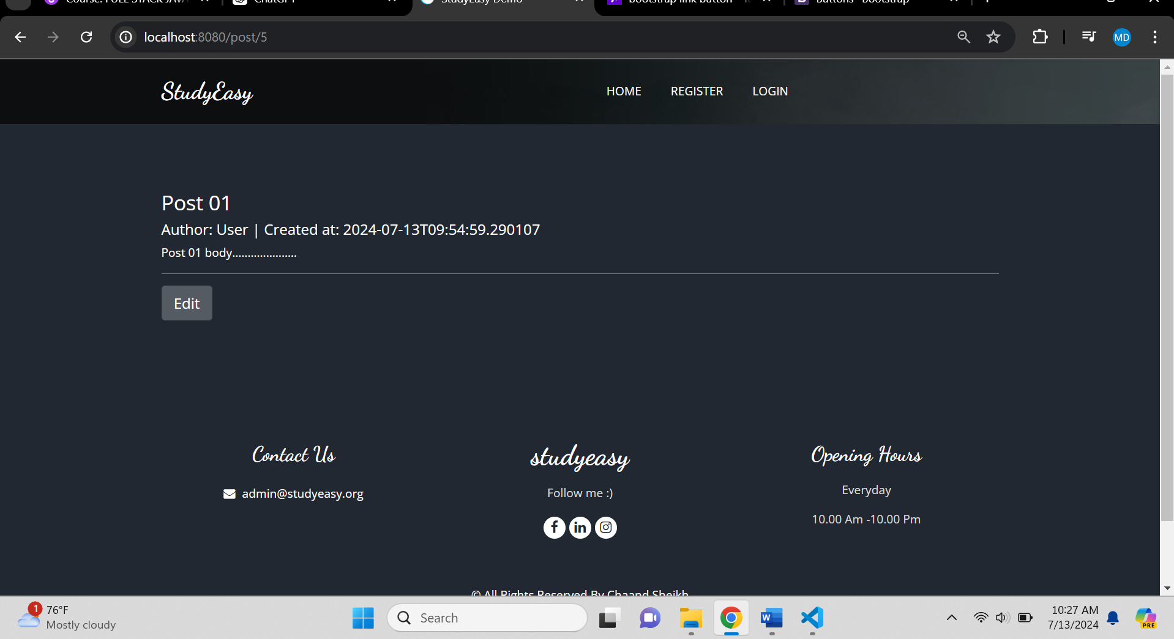

**The Edit operation should be given should be only clicked by the author and that authorized user and also who is logged in.**

**We will check whether the current user is author or not and we use concept – Principal**

**PostController.java**

 @GetMapping("/post/{id}")

    public String getPost(@PathVariable Long id, Model model, Principal principal){



        Optional<Post> optionalPost = postService.getById(id);

        String authUser = "email";

        if(optionalPost.isPresent()){

            Post post = optionalPost.get();

            model.addAttribute("post", post);

            //get username of current logged in session user



            //String authUsername = SecurityContextHolder.getContext().getAuthentication().getName();



            if(principal != null){

                authUser = principal.getName();

            }

            if(authUser.equals(post.getAccount().getEmail())){

                model.addAttribute("isOwner", true);

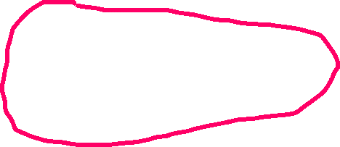

            }else{

                model.addAttribute("isOwner", false);

            }

            return "post_views/post";

        }else{

            return "404";

        }

    }

**Code for the Edit Operation Authentication**

  <div class="align-right" sec:authorize="isAuthenticated()" th:if="${isOwner}">

      <a th:href="@{'/edit_post/'+ ${post.id}}" class="btn btn-secondary btn-lg active" role="button" aria-pressed="true">Edit</a>

 </div>

**Updated code**

  <div sec:authorize="isAuthenticated()" th:if="${isOwner}">

      <a th:href="@{'/edit_post/'+ ${post.id}}" class="btn btn-secondary btn-lg active" role="button" aria-pressed="true">Edit</a>

 </div>

**Output After above code**

**Case 1 : Login as super editor**

**No access for user**

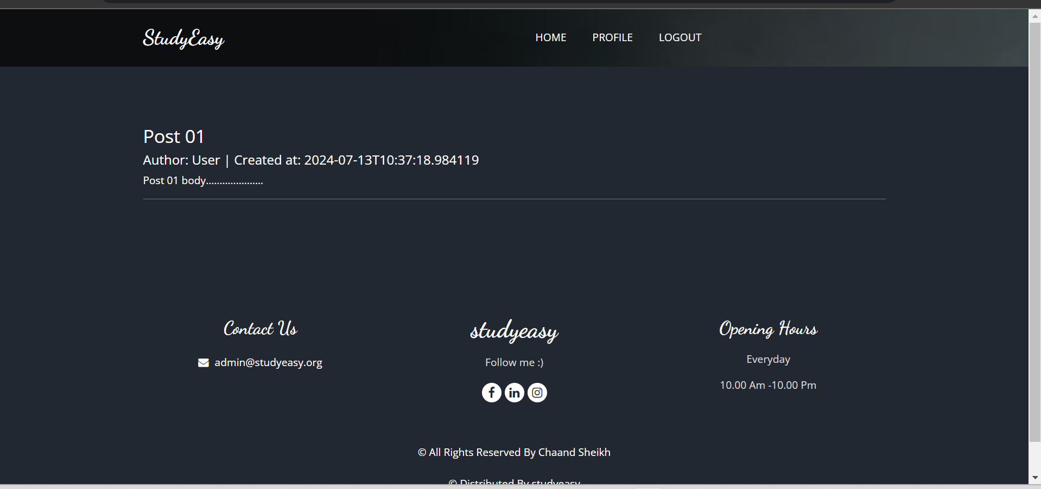

**No access for admin**

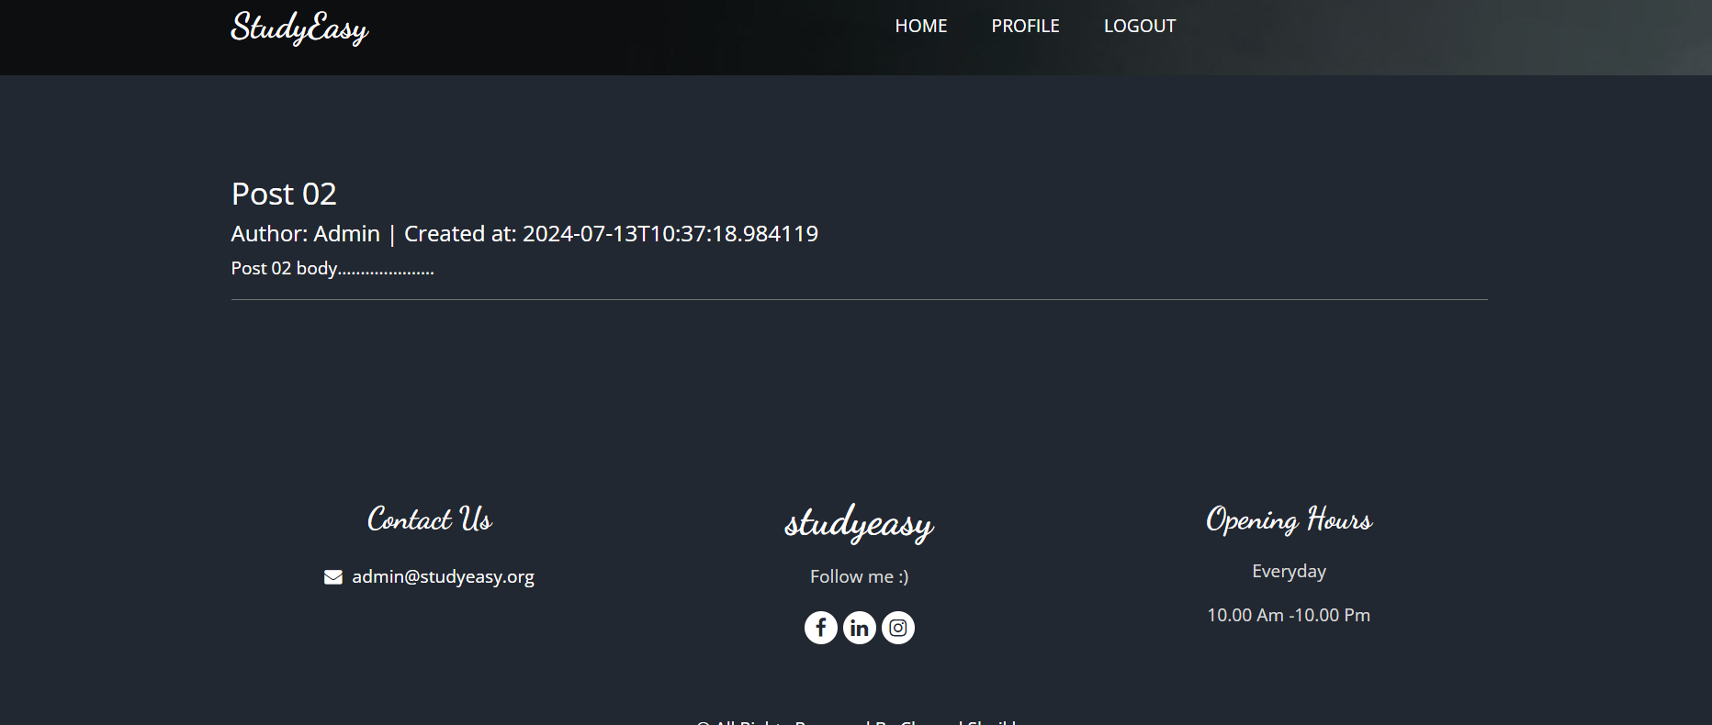

**Case 2 : Login as Admin**

**Access is there for Admin**

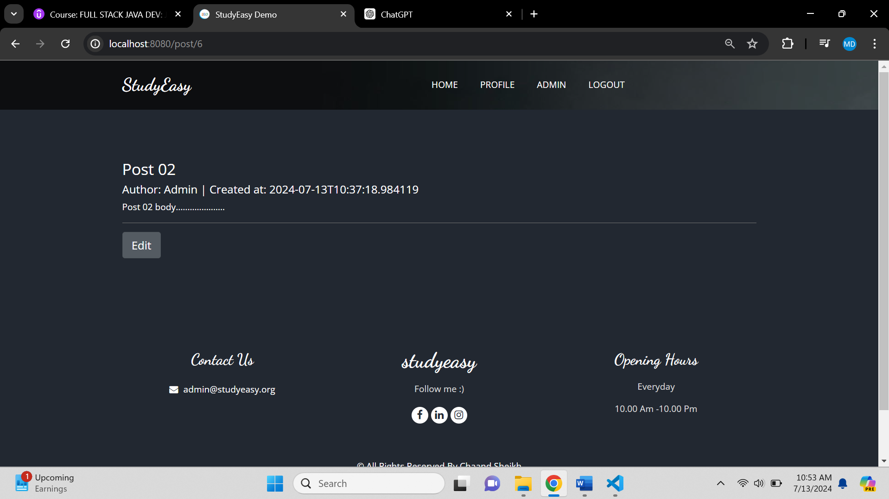

**Access is not there for user**

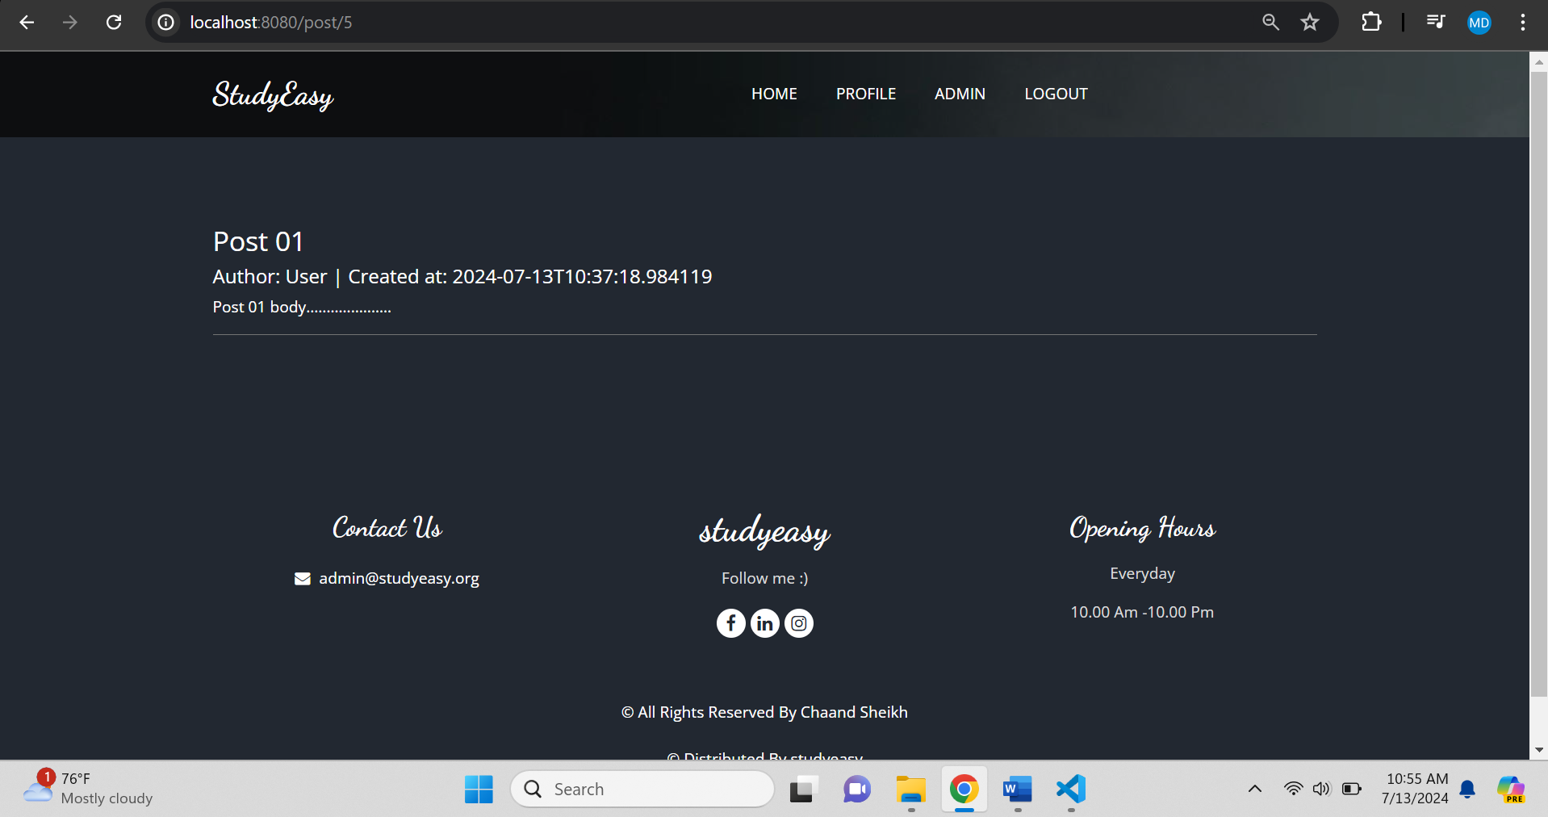

**Case 3 : Login as User**

**Access is there for User**

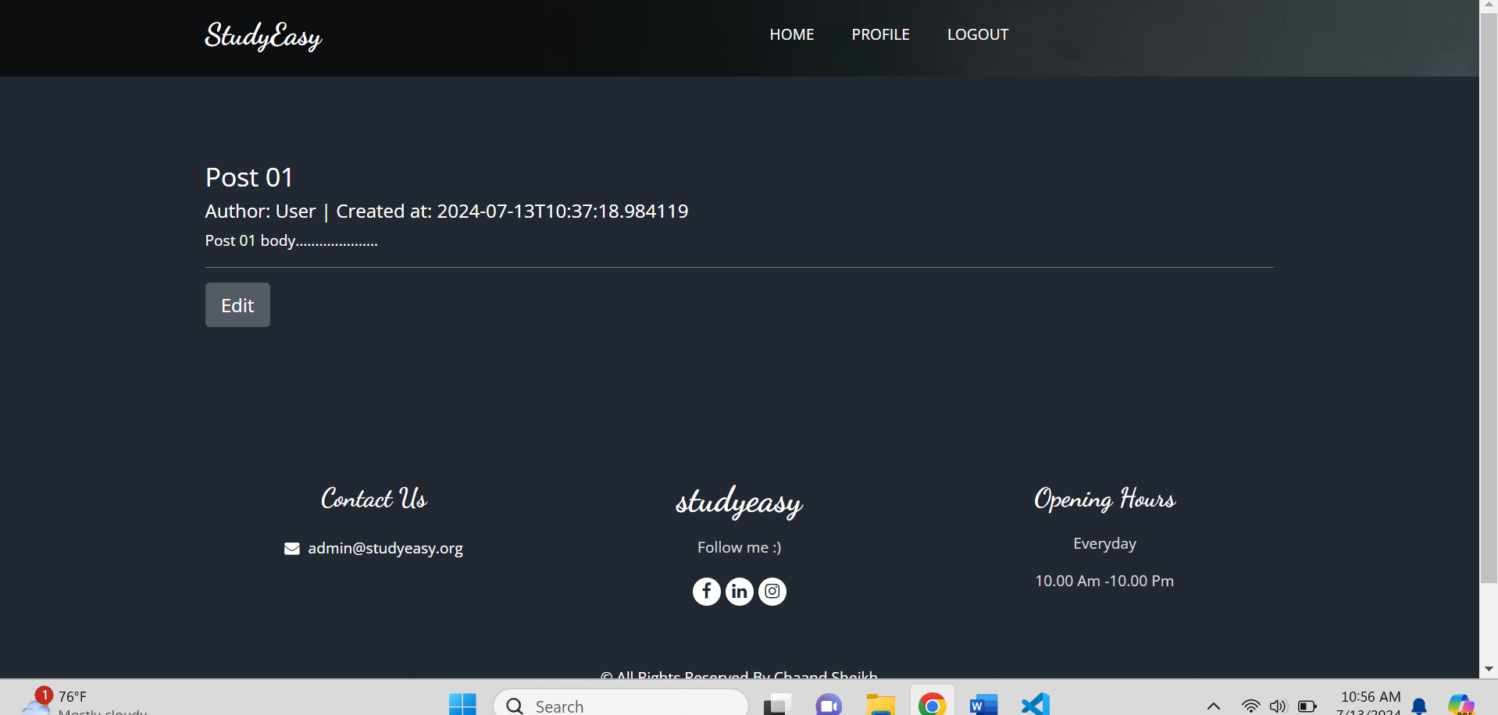

**Access is not there for admin**

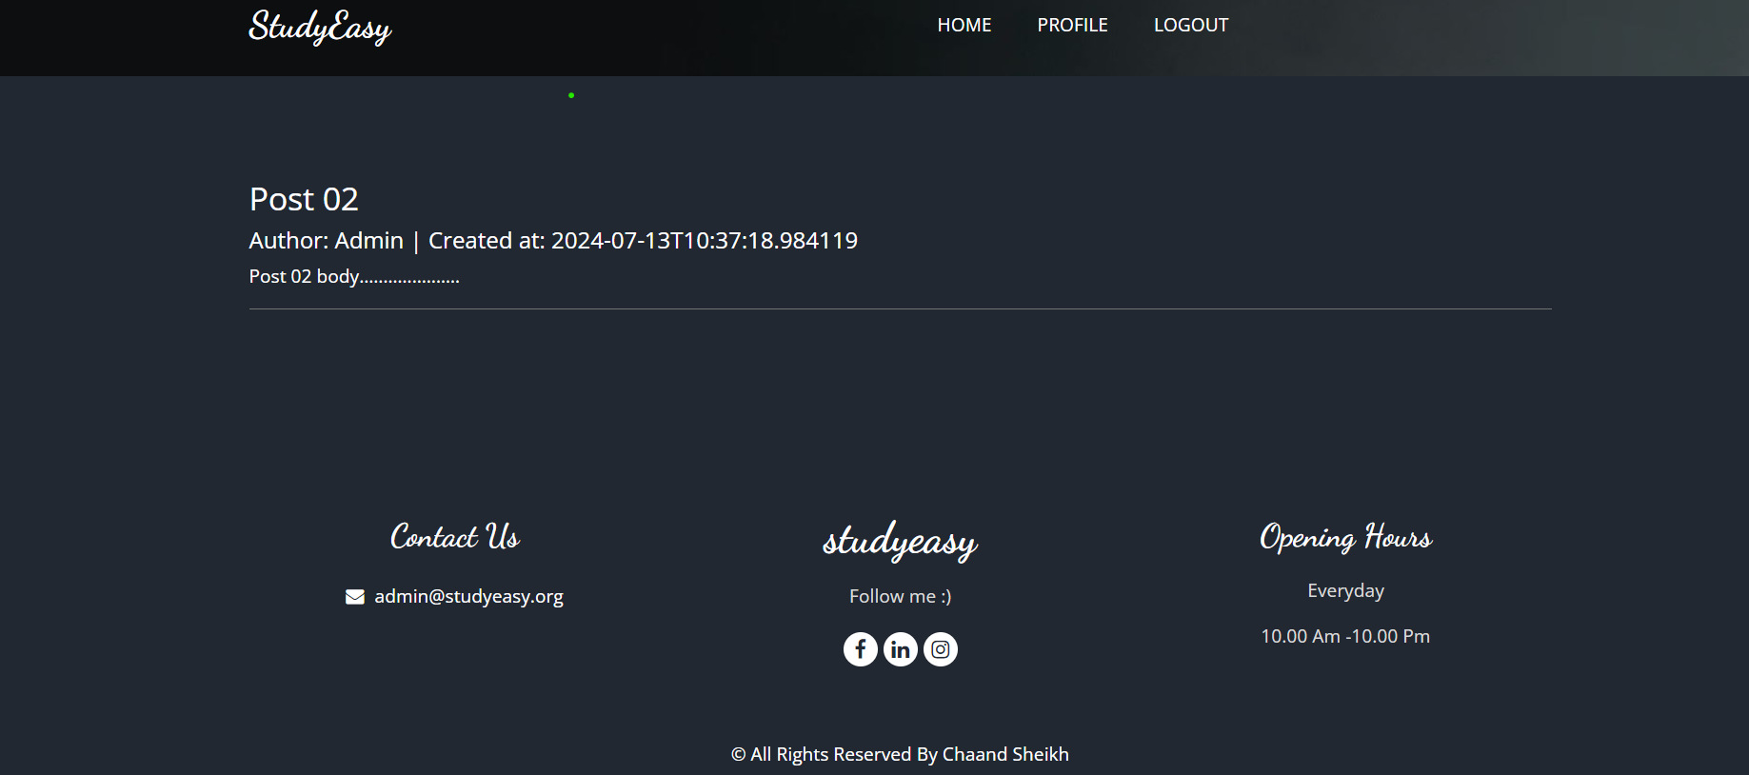

**Add Post – Allowed only to the user**

 <span sec:authorize="isAuthenticated()">

            <li class="nav-item">

              <a class="nav-link" href="/add_post">Add Post</a>

            </li>

          </span>

<!DOCTYPE html>

<html  lang="en"

xmlns:th="http://www.thymeleaf.org"

xmlns:sec="http://www.thymeleaf.org/extras/spring-security">

 <!-- header section strats -->

 <header class="header_section">

    <div class="container">

      <nav class="navbar navbar-expand-lg custom_nav-container ">

        <a class="navbar-brand" href="index.html">

          <span>

            StudyEasy

          </span>

        </a>

        <button class="navbar-toggler" type="button" data-toggle="collapse" data-target="#navbarSupportedContent" aria-controls="navbarSupportedContent" aria-expanded="false" aria-label="Toggle navigation">

          <span class=""> </span>

        </button>

        <div class="collapse navbar-collapse" id="navbarSupportedContent">

          <ul class="navbar-nav  mx-auto ">

            <li class="nav-item ">

              <a class="nav-link" href="/">Home </a>

            </li>

            <span sec:authorize="!isAuthenticated()">

            <li class="nav-item">

              <a class="nav-link" href="/register">Register</a>

            </li>

            </span>

            <span sec:authorize="!isAuthenticated()">

            <li class="nav-item">

              <a class="nav-link" href="/login">login</a>

            </li>

          </span>

          <span sec:authorize="isAuthenticated()">

            <li class="nav-item">

              <a class="nav-link" href="/profile">Profile</a>

            </li>

          </span>

          <span sec:authorize="isAuthenticated()">

            <li class="nav-item">

              <a class="nav-link" href="/add_post">Add Post</a>

            </li>

          </span>

          <span sec:authorize="hasRole('ROLE_ADMIN')">

            <li class="nav-item">

              <a class="nav-link" href="/admin">admin</a>

            </li>

          </span>

          <!-- <span sec:authorize="hasAuthority('ACCESS_ADMIN_PANEL')">

            <li class="nav-item">

              <a class="nav-link" href="/admin">admin</a>

            </li>

          </span> -->

          <span sec:authorize="isAuthenticated()">

            <li class="nav-item">

              <a class="nav-link" href="/logout">logout</a>

            </li>

          </span>

          </ul>

        </div>

      </nav>

    </div>

  </header>

  <!-- end header section -->

</html>

**Output – Login as user**

