**SpringBoot_Handle Add Post In Spring Boot**

**Additional Level of security to both Get and Post Methods**

@PreAuthorize("isAuthenticated()")

**Text Editor Updated Code**

<input id="editor" th:field="*{body}" name="body" type="textarea" class="form-control" placeholder="body" />

**Change to**

<textarea id="editor" th:field="*{body}" name="body"/>

**Security**

<p th:text="${post.body}">body</p>

What th:text does is it will not allow any script or anything to run. It is a security feature.

**Editor Text Modify**

**Replace th:text with th:utext in post.html and home.html**

<p th:utext="${post.body}">body</p>

**Output**

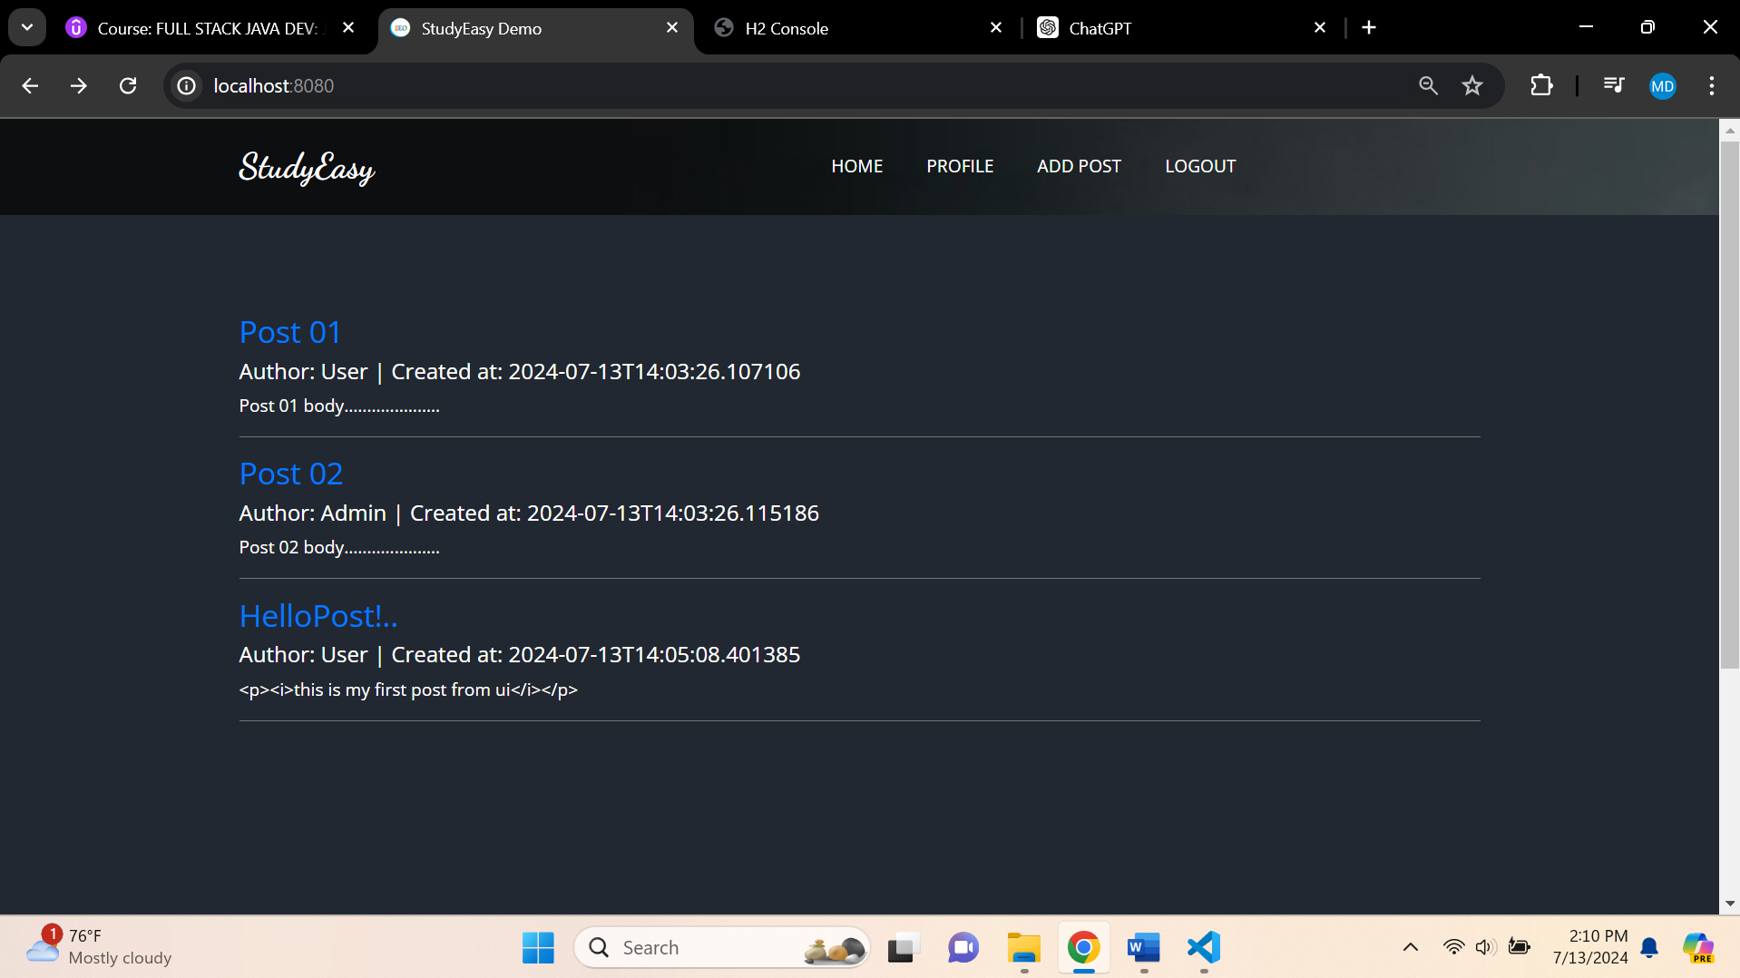

**Changes to**

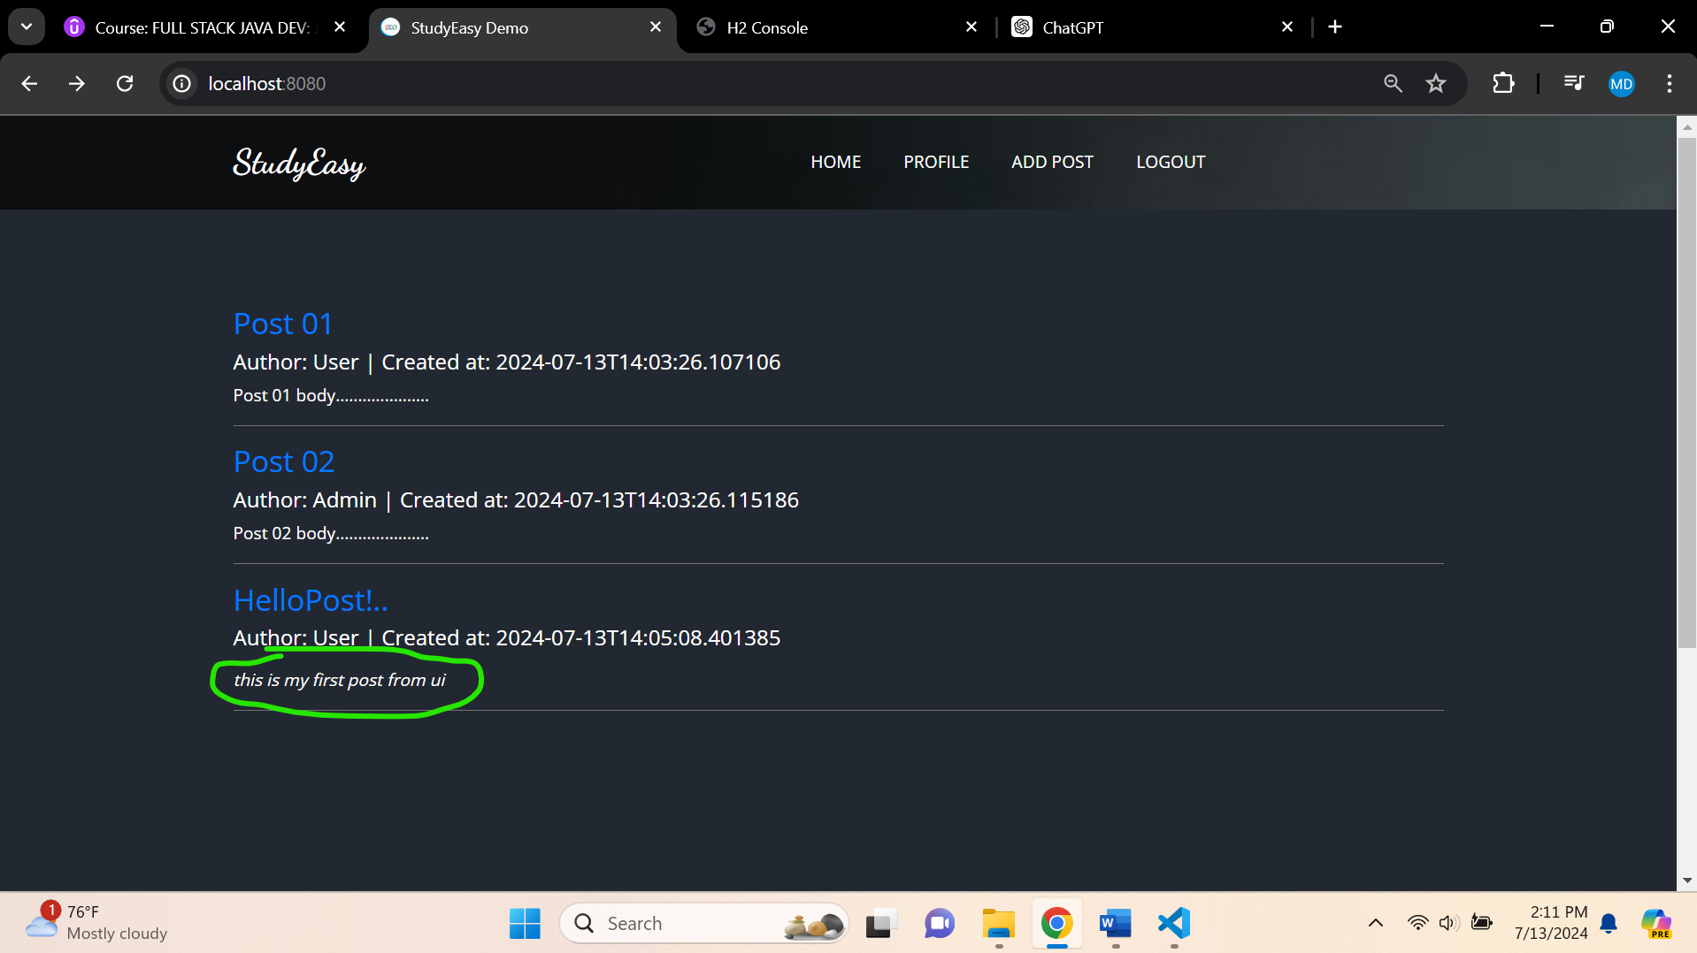

**Updated header.html**

<!DOCTYPE html>

<html  lang="en"

xmlns:th="http://www.thymeleaf.org"

xmlns:sec="http://www.thymeleaf.org/extras/spring-security">

 <!-- header section strats -->

 <header class="header_section">

    <div class="container">

      <nav class="navbar navbar-expand-lg custom_nav-container ">

        <a class="navbar-brand" href="index.html">

          <span>

            StudyEasy

          </span>

        </a>

        <button class="navbar-toggler" type="button" data-toggle="collapse" data-target="#navbarSupportedContent" aria-controls="navbarSupportedContent" aria-expanded="false" aria-label="Toggle navigation">

          <span class=""> </span>

        </button>

        <div class="collapse navbar-collapse" id="navbarSupportedContent">

          <ul class="navbar-nav  mx-auto ">

            <li class="nav-item ">

              <a class="nav-link" href="/">Home </a>

            </li>

            <span sec:authorize="!isAuthenticated()">

            <li class="nav-item">

              <a class="nav-link" href="/register">Register</a>

            </li>

            </span>

            <span sec:authorize="!isAuthenticated()">

            <li class="nav-item">

              <a class="nav-link" href="/login">login</a>

            </li>

          </span>

          <span sec:authorize="isAuthenticated()">

            <li class="nav-item">

              <a class="nav-link" href="/profile">Profile</a>

            </li>

          </span>

          <span sec:authorize="isAuthenticated()">

            <li class="nav-item">

              <a class="nav-link" href="/posts/add">Add Post</a>

            </li>

          </span>

          <span sec:authorize="hasRole('ROLE_ADMIN')">

            <li class="nav-item">

              <a class="nav-link" href="/admin">admin</a>

            </li>

          </span>

          <!-- <span sec:authorize="hasAuthority('ACCESS_ADMIN_PANEL')">

            <li class="nav-item">

              <a class="nav-link" href="/admin">admin</a>

            </li>

          </span> -->

          <span sec:authorize="isAuthenticated()">

            <li class="nav-item">

              <a class="nav-link" th:href="@{/logout}">logout</a>

            </li>

          </span>

          </ul>

        </div>

      </nav>

    </div>

  </header>

  <!-- end header section -->

</html>