**SpringBoot_Handle Add Edit Post Form In Spring Boot**

**Edit Post**

  th:action="@{'/posts/{id}/edit' (id=${post.id})}"

**Add below code in Post controller**

 @GetMapping("/posts/{id}/edit")

    @PreAuthorize("isAuthenticated()")

    public String getPostForEdit(@PathVariable Long id, Model model){

        Optional<Post> optionalPost = postService.getById(id);

        if(optionalPost.isPresent()){

            Post post = optionalPost.get();

            model.addAttribute("post", post);

            return "post_views/post_edit";

        }else{

            return "404";

        }

    }

**Post_edit.html**

<!DOCTYPE html>

<html lang="en" xmlns:th="http://www.thymeleaf.org">

  <head th:replace="/fragments/head :: head">

<body class="sub_page">

  <div class="hero_area">

    <div class="bg-box">

      <img th:src="@{/images/nav-bg.jpg}" alt="">

    </div>

    <header th:replace="/fragments/header :: header">

  </div>

 <!-- book section -->

 <section class="food_section layout_padding">

    <div class="container">

      <div class="heading_container">

      </div>

      <div class="row">

        <div class="col-md-6">

          <div class="form_container">

            <h3>Edit post</h3>

            <form action="#"

                th:action="@{'/posts/{id}/edit' (id=${post.id})}"

                th:object="${post}"

                method="post">

              <div class="form-group">

                <input type="hidden" id="account" name="account" th:field="*{account}">

                <input id="title" th:field="*{title}" name="title" type="text" class="form-control" placeholder="title" />

              </div>

              <div class="form-group">

                <textarea id="editor" th:field="*{body}" name="body"/>

              </div>

                <button type="submit" class="btn btn-primary">

                  Edit Post

                </button>

            </form>

          </div>

        </div>

    </div>

  </section>

  <!-- end book section -->

  <footer th:replace="/fragments/footer :: footer">

</body>

</html>

**Output**

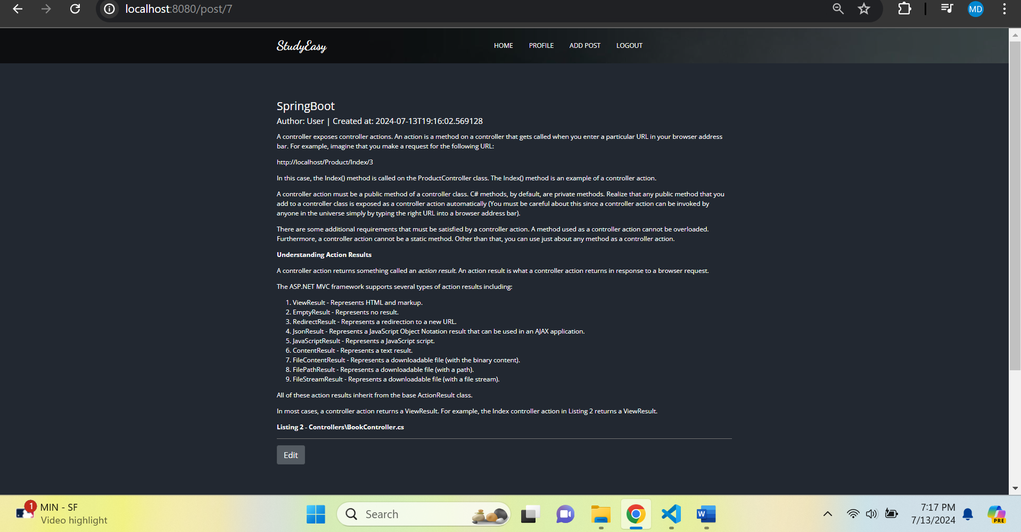

**After clicking on edit button**

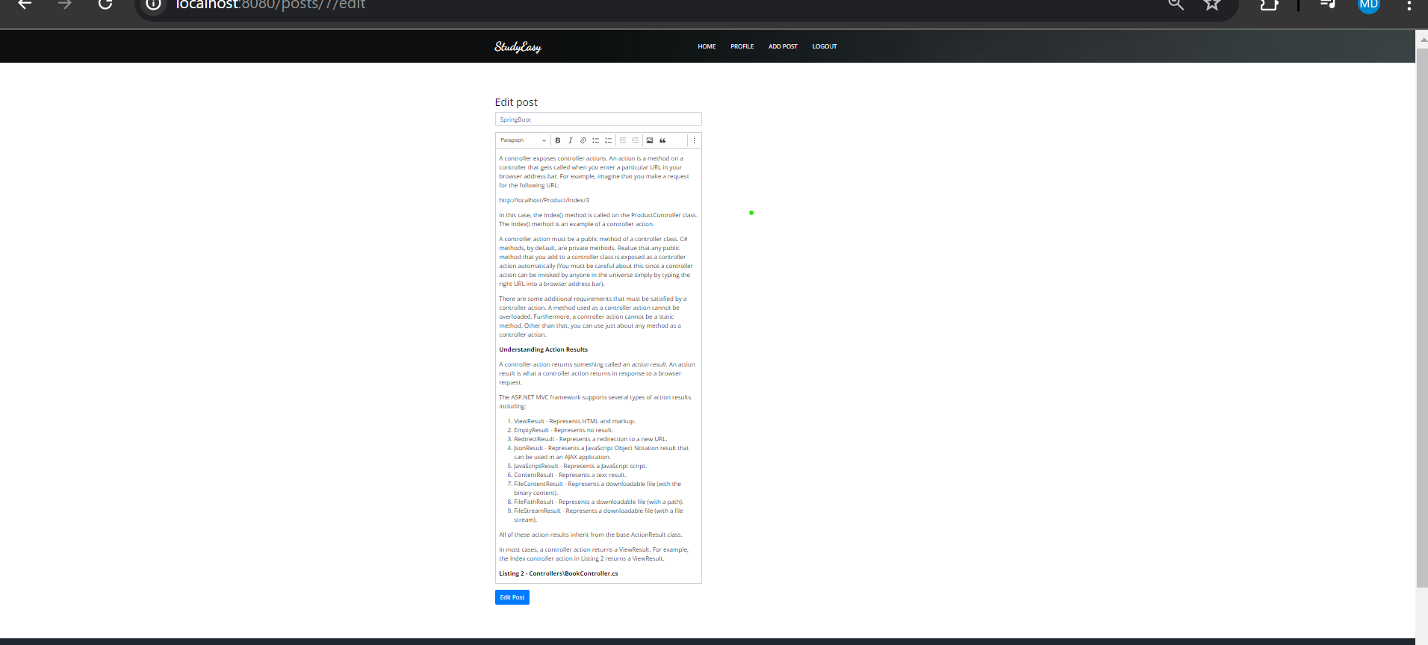

**In Post.html**

  <div sec:authorize="isAuthenticated()" th:if="${isOwner}">

                    <a th:href="@{'/posts/'+ ${post.id} + '/edit'}" class="btn btn-secondary btn-lg active" role="button" aria-pressed="true">Edit</a>

                </div>