**SpringBoot - Update Profile (Account) on the Spring Boot Blog**

**AccountController Add below code**

@PostMapping("/profile")

    @PreAuthorize("isAuthenticated()")

    public String post_profile(@Valid @ModelAttribute Account account, BindingResult bindingResult,

            Principal principal) {

        if (bindingResult.hasErrors()) {

            return "account_views/profile";

        }

        String authUser = "email";

        if (principal != null) {

            authUser = principal.getName();

        }

        Optional<Account> optionalAccount = accountService.findOneByEmail(authUser);

        if (optionalAccount.isPresent()) {

            Account account_by_id = accountService.findOneById(account.getId()).get();

            account_by_id.setAge(account.getAge());

            account_by_id.setDate_of_birth(account.getDate_of_birth());

            account_by_id.setFirstname(account.getFirstname());

            account_by_id.setGender(account.getGender());

            account_by_id.setLastname(account.getLastname());

            account_by_id.setPassword(account.getPassword());

            accountService.save(account_by_id);

  SecurityContextHolder.clearContext();

            return "redirect:/";

        } else {

            return "redirect:/?error";

        }

    }

**In AccountService – add below code**

  public Optional<Account> findOneById(long id) {

        return accountRepository.findById(id);

    }

**In profile.html – add below code – hidden id**

 <!--Hidden Id--> <input type="hidden" id="id" name="id" th:field="*{id}"/>

**Output**

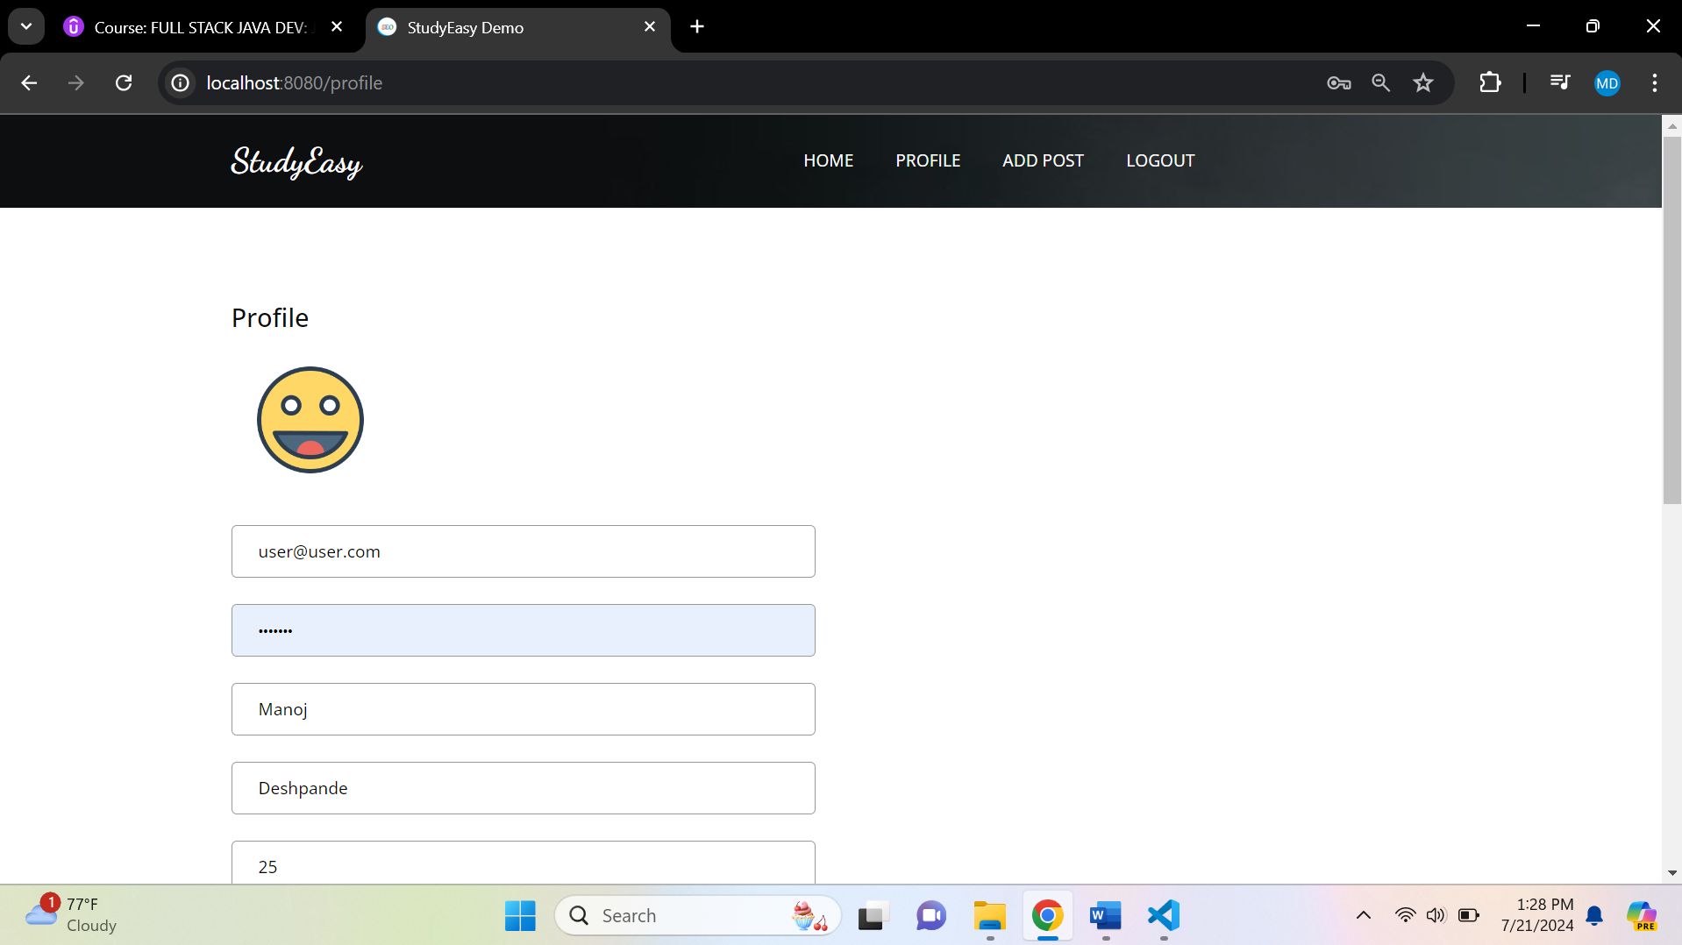

**After updating – it will logout – it will return to home page**

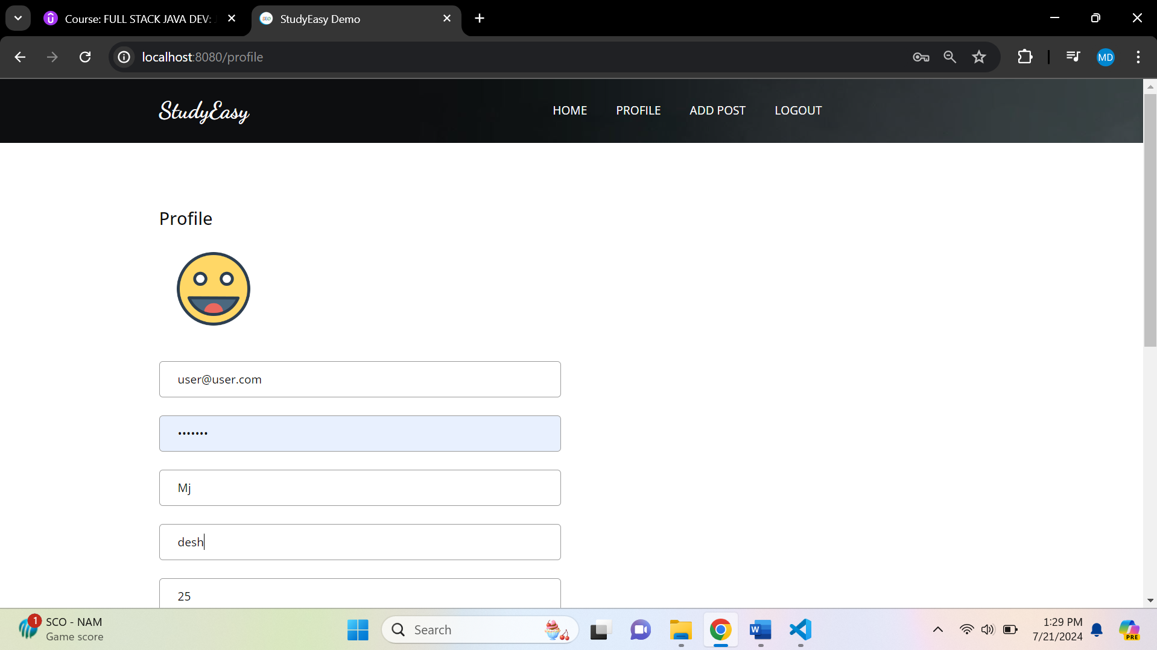

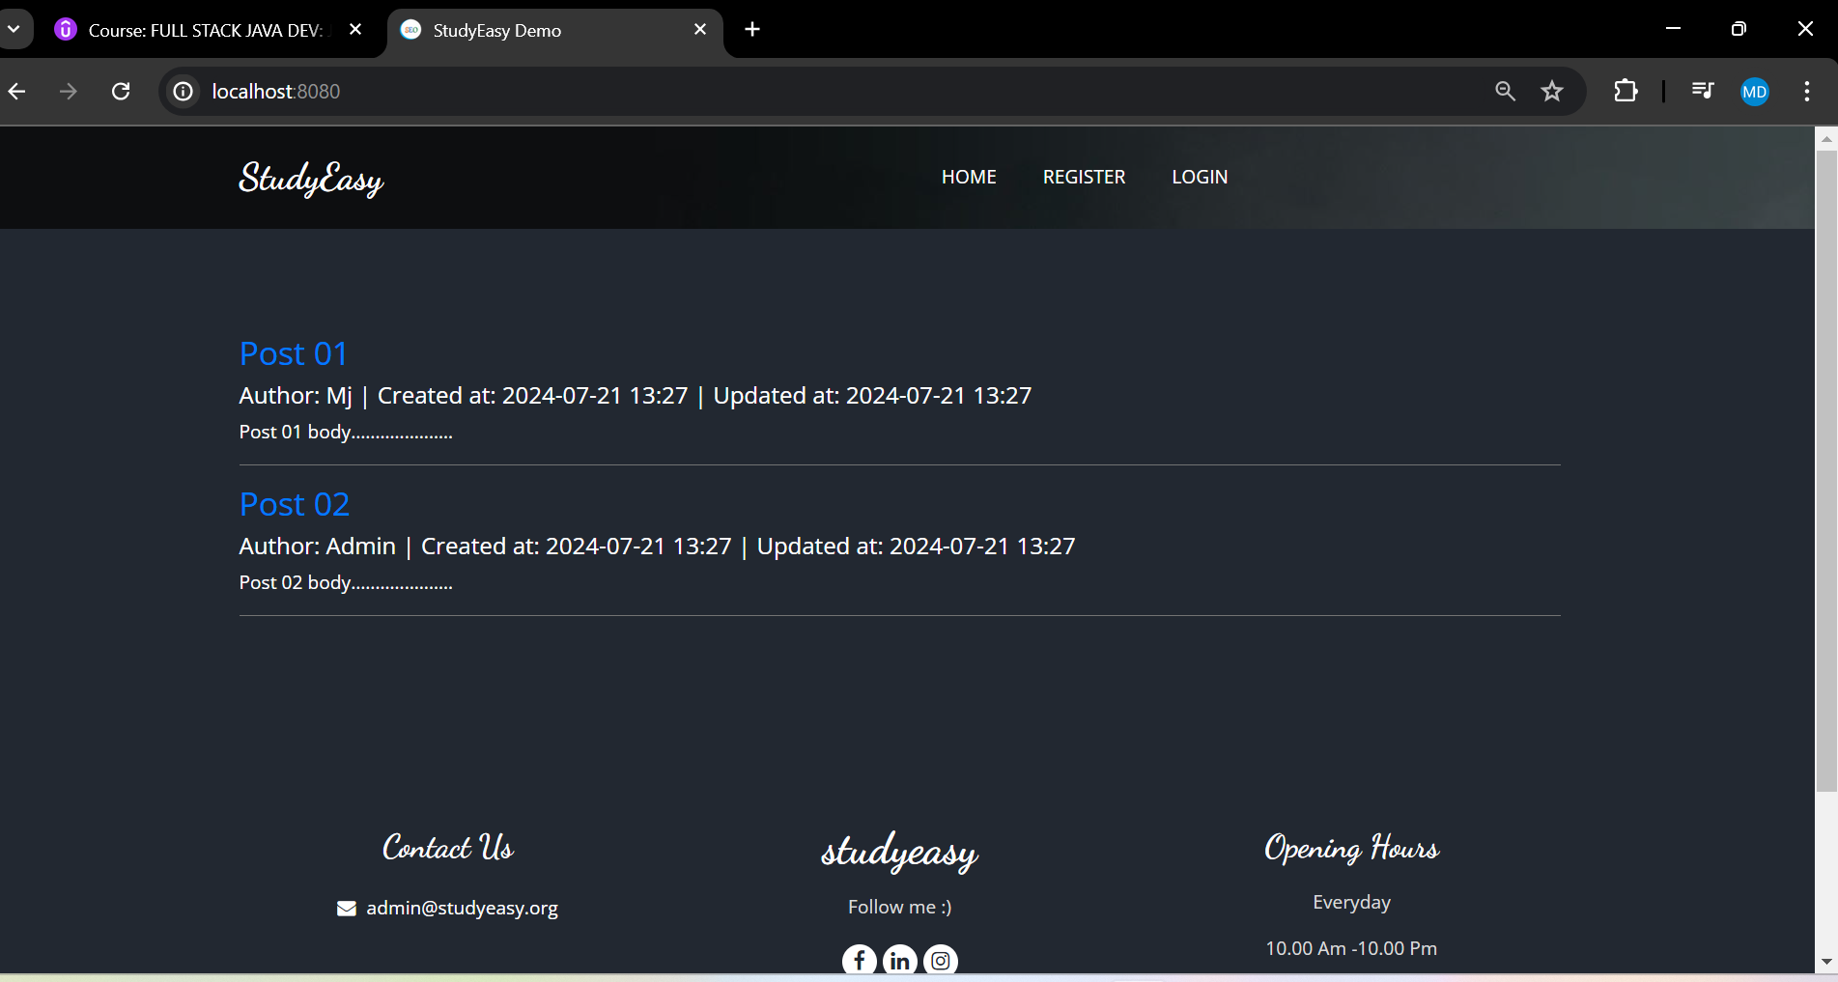

**You have to login again**

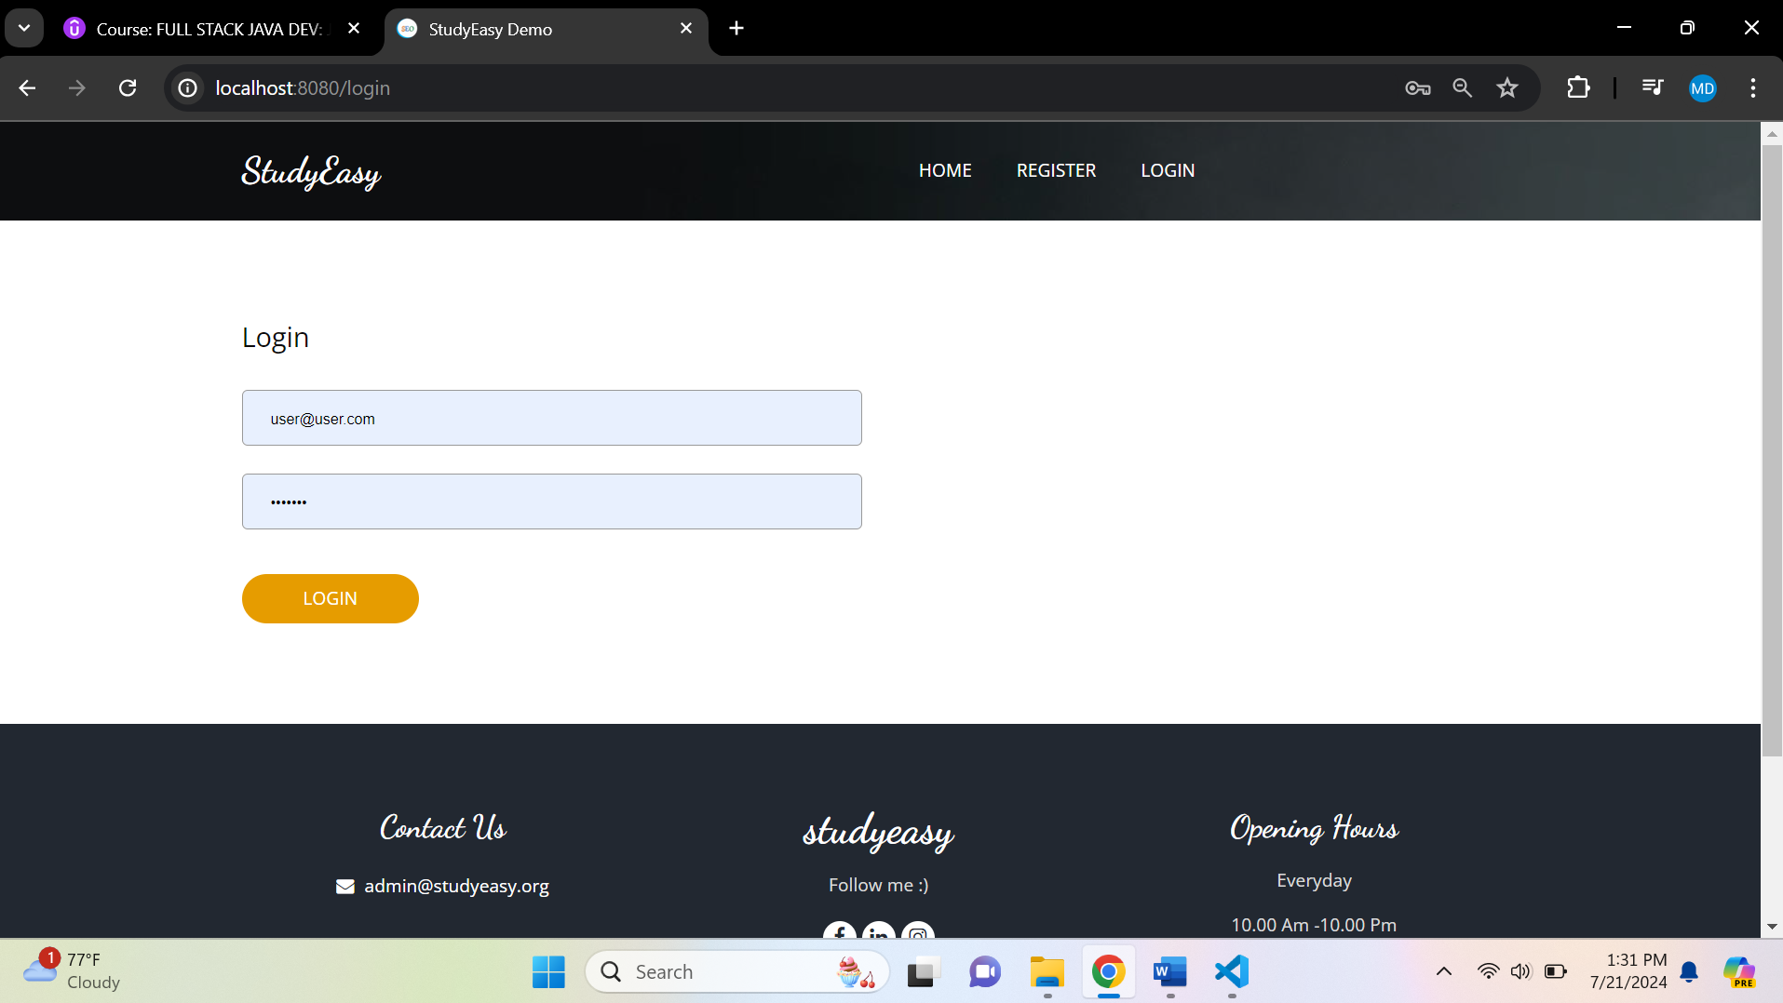

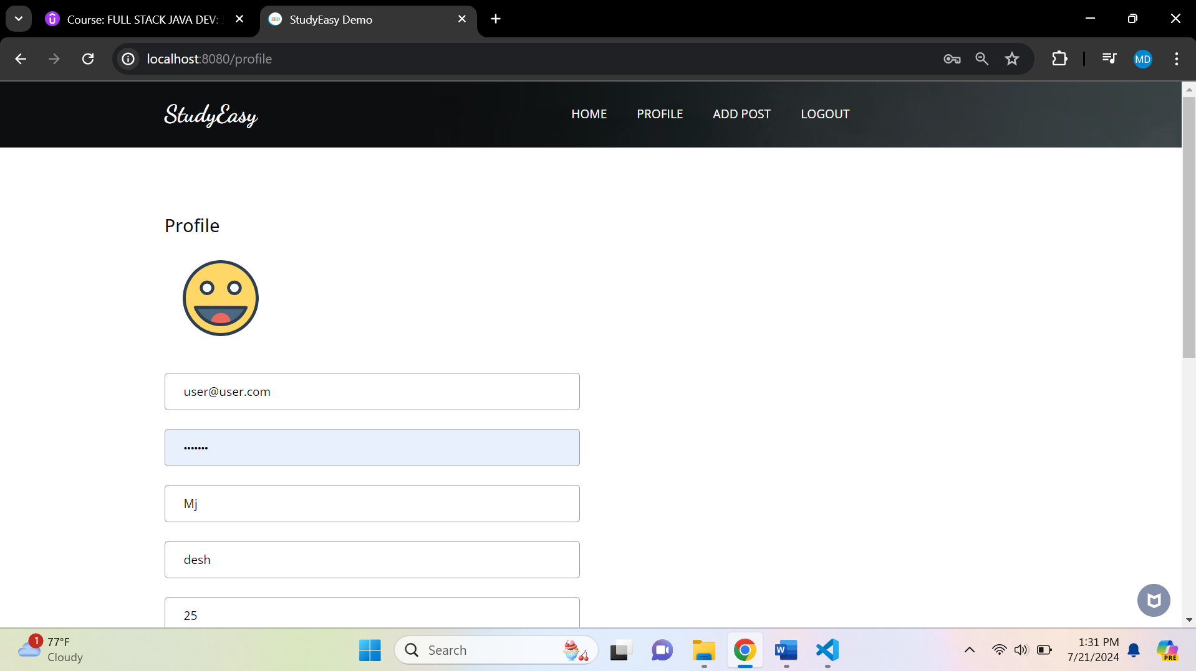

**As you can see fields have been updated after user changes his profile he has to log in again – because of below line.**

 SecurityContextHolder.clearContext();