**SpringBoot – Sending Email for Password Reset**

When it comes to Gmail, you have to create App Password in order to send email using application.

Created a new account under like below

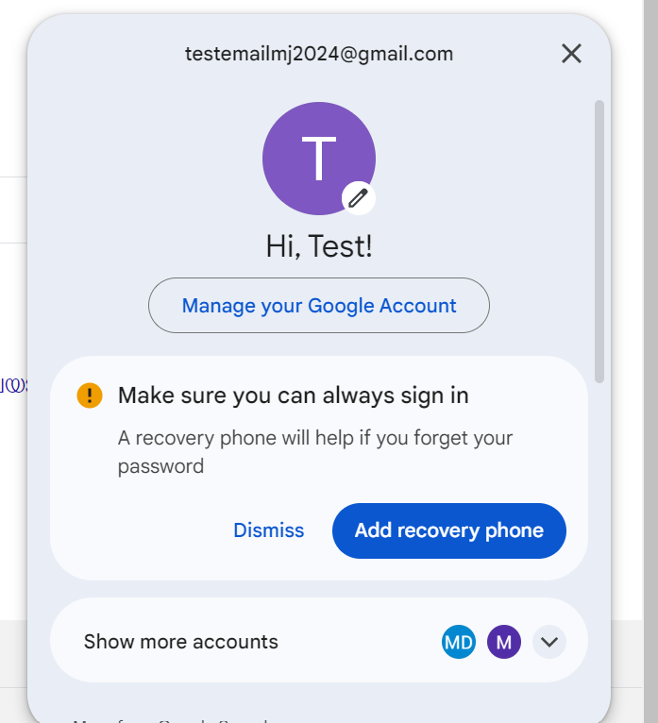

Manage Your Google Account -> Security -> To enable AppPassword -> You have to enable 2 step verification -

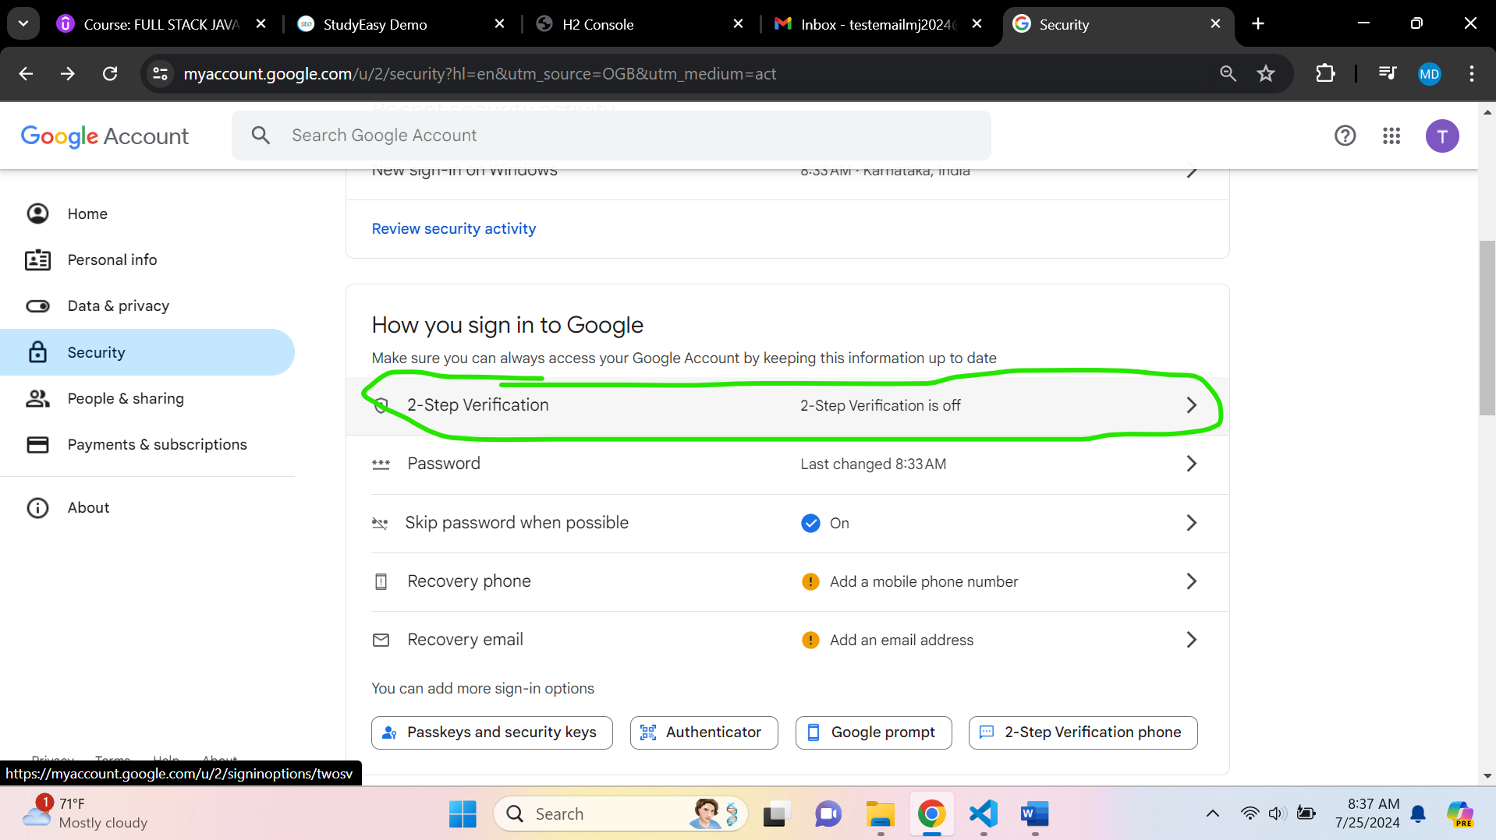

Enter Phone Number

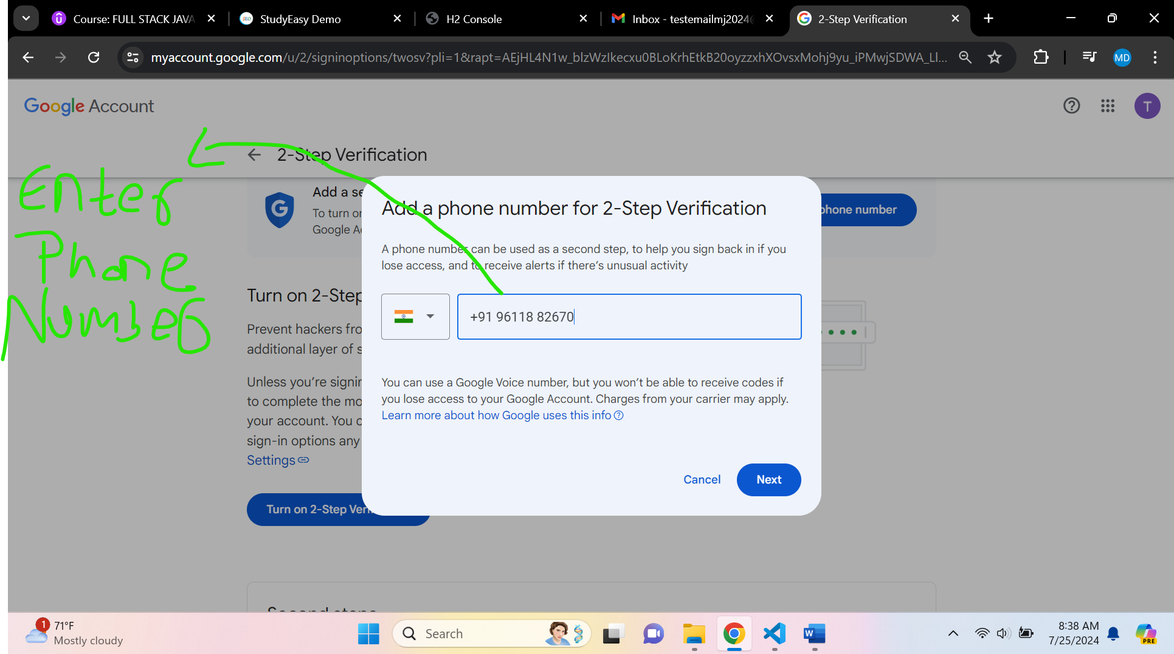

Enter Code and click next

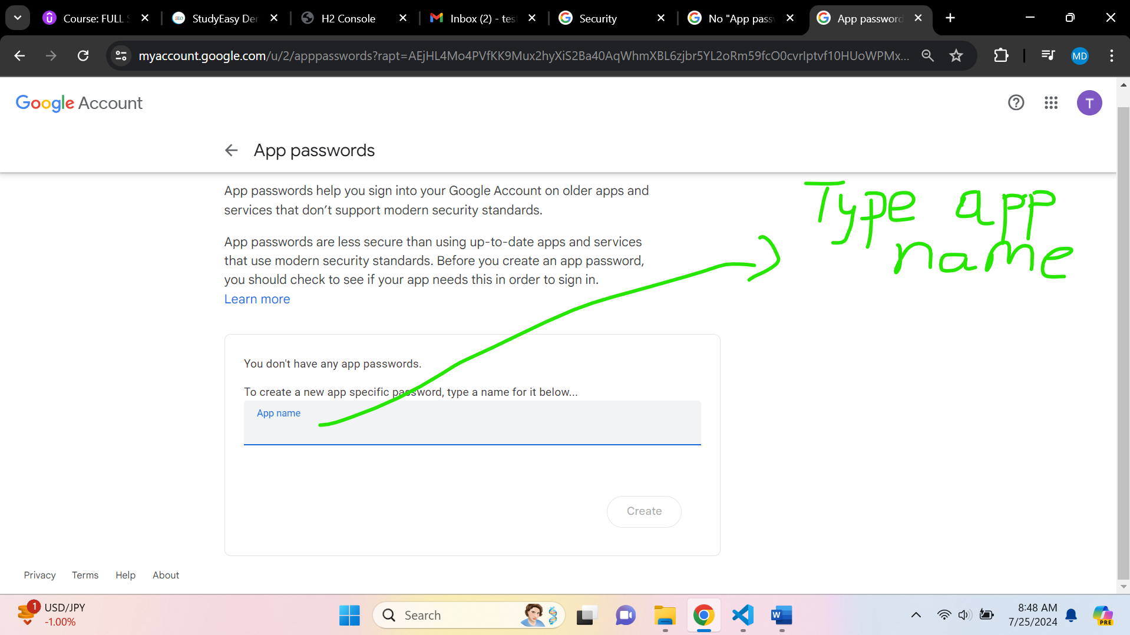

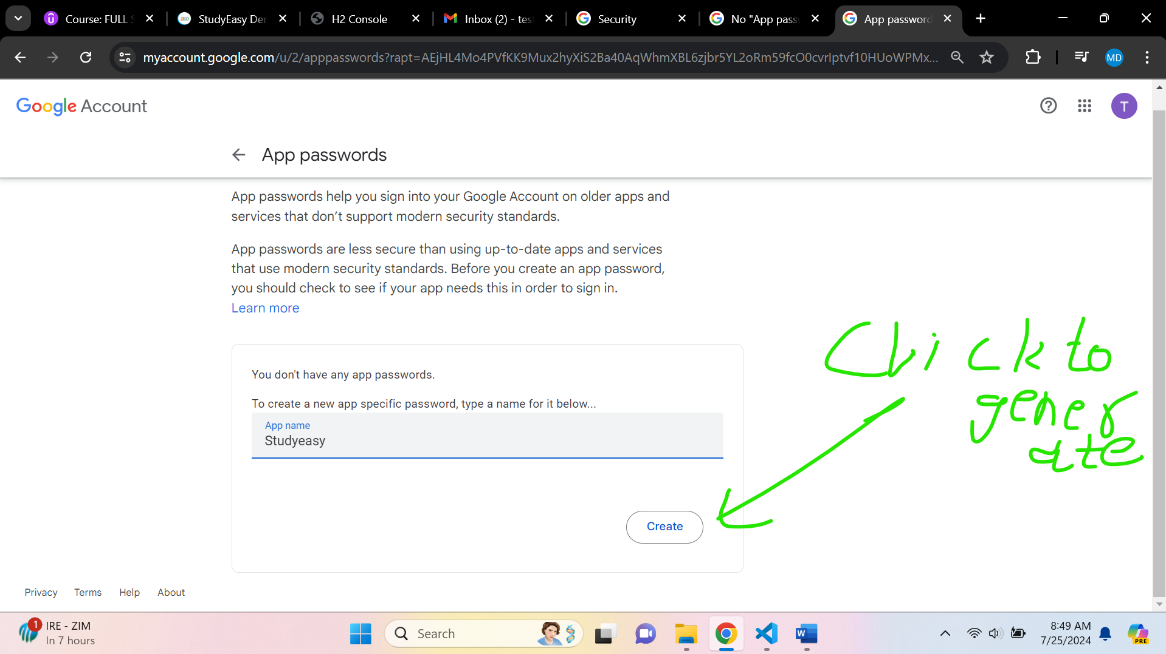

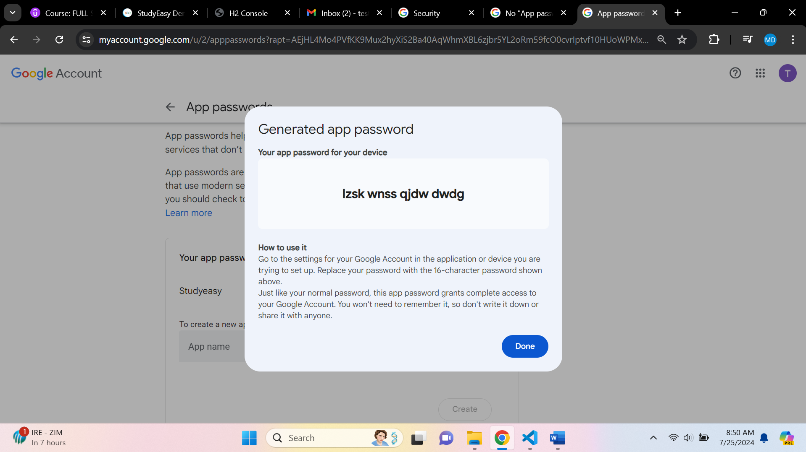

It is a One time Show password. -> **lzsk wnss qjdw dwdg**

**In application.properties -> add below code**

# Email settings

spring.mail.username=testemailmj2024@gmail.com

spring.mail.password=testmailmj2024_$

spring.mail.host=smtp.gmail.com

spring.mail.port=587

spring.mail.properties.mail.smtp.auth=true

spring.mail.properties.mail.smtp.starttls.enable=true

spring.mail.smtp.ssl.trust=smtp.gmail.com

spring.mail.transport.protocol=smtp

Create a new file -> secret.properties in resources folder -> Move it to new file

secret.properties

spring.mail.username=testemailmj2024@gmail.com

spring.mail.password=testmailmj2024_$

Import this file

# Spring Import - secret.properties

spring.config.import=secret.properties

or

# Spring Import - secret.properties

# spring.config.import=secret.properties

# Spring Import - secret.properties - make this import as optional

spring.config.import=optional:secret.properties