**Spring Boot – Reset Password Reset Password – Wrap Up**

**In Account Controller -> Update change password (get) and add update password(post)**

 // Token is the parameter which is present in the URL, that was sent when reset

    // button clicked and stored in db ; ("token")

    @GetMapping("/change-password")

    public String change_password(Model model, @RequestParam("token") String token, RedirectAttributes attributes) {

        if (token.equals("")) {

            attributes.addFlashAttribute("error", "Invalid Token");

            return "redirect:/forgot-password";

        }

        Optional<Account> optional_account = accountService.findByToken(token);

        if (optional_account.isPresent()) {

            Account account = accountService.findById(optional_account.get().getId()).get();

            LocalDateTime now = LocalDateTime.now();

            if (now.isAfter(optional_account.get().getPassword_reset_token_expiry())) {

                attributes.addFlashAttribute("error", "Token expired");

                return "redirect:/forgot-password";

            }

            model.addAttribute("account", account);

            return "account_views/change-password";

        }

        attributes.addFlashAttribute("error", "Invalid token");

        return "redirect:/forgot-password";

    }

    // Token is the parameter which is present in the URL, that was sent when reset

    // button clicked and stored in db ; ("token")

    @PostMapping("/change-password")

    public String post_change_password(@ModelAttribute Account account, RedirectAttributes attributes) {

        Account account_by_id = accountService.findById(account.getId()).get();

        account_by_id.setPassword(account.getPassword());

        account_by_id.setToken("");

        accountService.save(account_by_id);

        attributes.addFlashAttribute("message", "Password Updated");

        return "redirect:/login";

    }

}

**change-password.html**

<!DOCTYPE html>

<html lang="en" xmlns:th="http://www.thymeleaf.org">

<head th:replace="/fragments/head :: head">

<body class="sub_page">

  <div class="hero_area">

    <div class="bg-box">

      <img th:src="@{/resources/static/images/nav-bg.jpg}" alt="">

    </div>

    <header th:replace="/fragments/header :: header">

  </div>

  <!-- book section -->

  <section class="book_section layout_padding">

    <div class="container">

      <div class="heading_container">

        <h4>

          Change Password

        </h4>

      </div>

      <div class="row">

        <div class="col-md-6">

          <div class="form_container">

            <!--Success Message-->

            <p th:text="${message}" th:if="${message ne null}" class="alert alert-primary"></p>

            <form action="#" th:action="@{/change-password}" th:object="${account}" method="post">

              <div>

                <!--Hidden Id-->

                <input type="hidden" id="id" name="id" th:field="*{id}" />

                <input id="password" name="password" th:field="*{password}" type="password" class="form-control"

                  placeholder="Password" required />

              </div>

              <div>

                <input id="password_confirm" name="password_confirm" type="password" class="form-control"

                  placeholder="Confirm Password"  oninput="check(this)" required />

              </div>

              <script language='javascript' type='text/javascript'>

                function check(input) {

                  if (input.value != document.getElementById('password').value) {

                    input.setCustomValidity('Password Must be Matching.');

                  } else {

                    // input is valid -- reset the error message

                    input.setCustomValidity('');

                  }

                }

              </script>

              <div class="btn_box">

                <button type="submit">

                  Update Password

                </button>

              </div>

            </form>

          </div>

        </div>

      </div>

  </section>

  <!-- end book section -->

  <footer th:replace="/fragments/footer :: footer">

</body>

</html>

**Output**

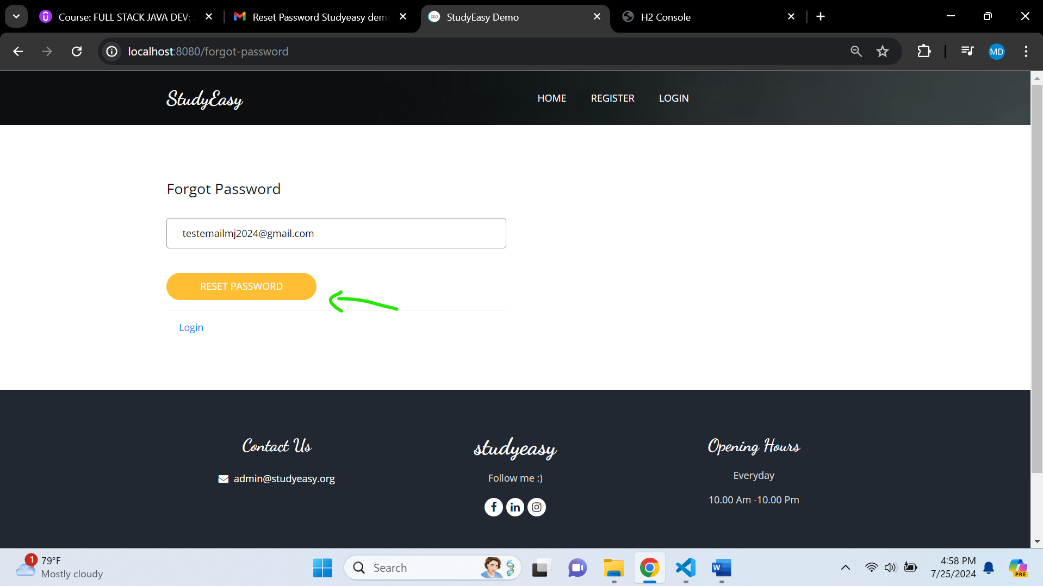

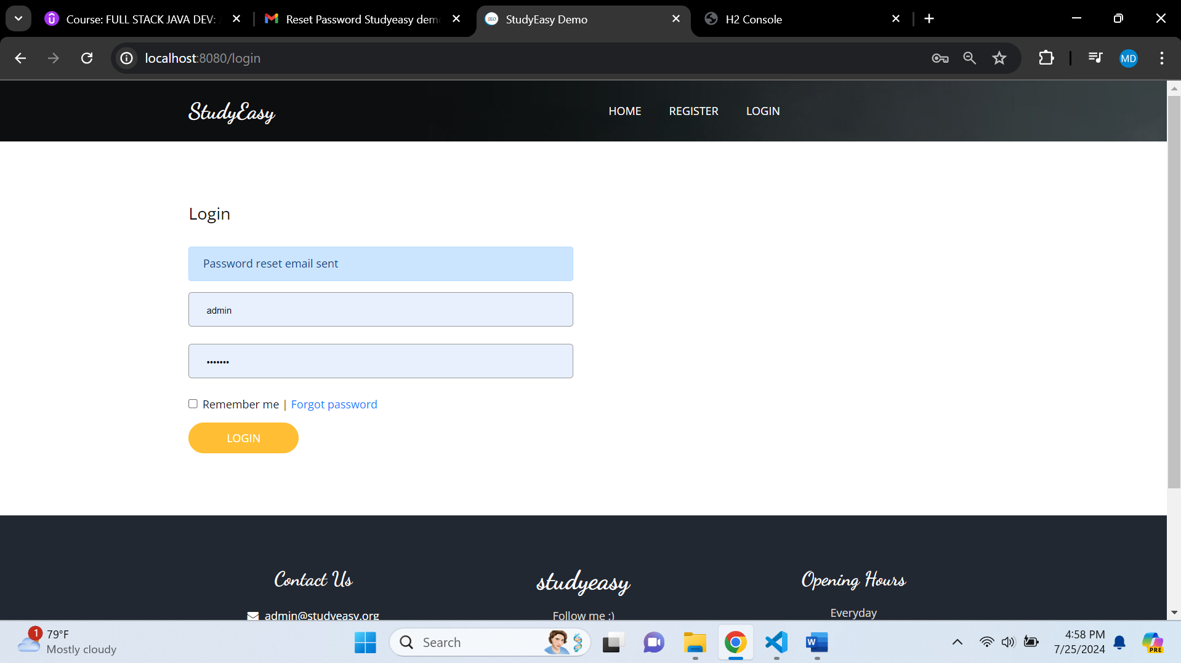

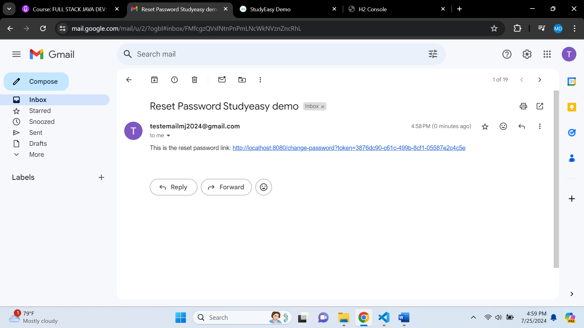

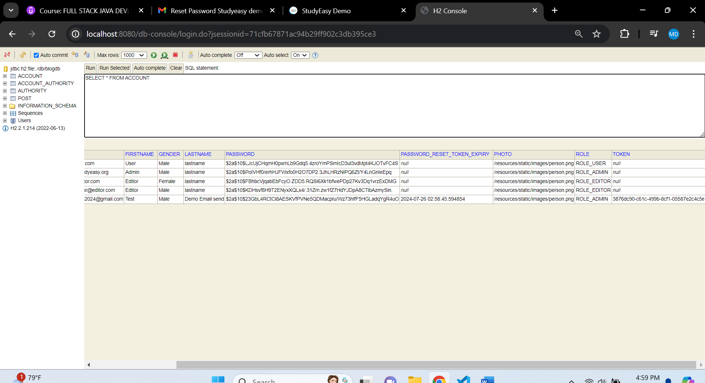

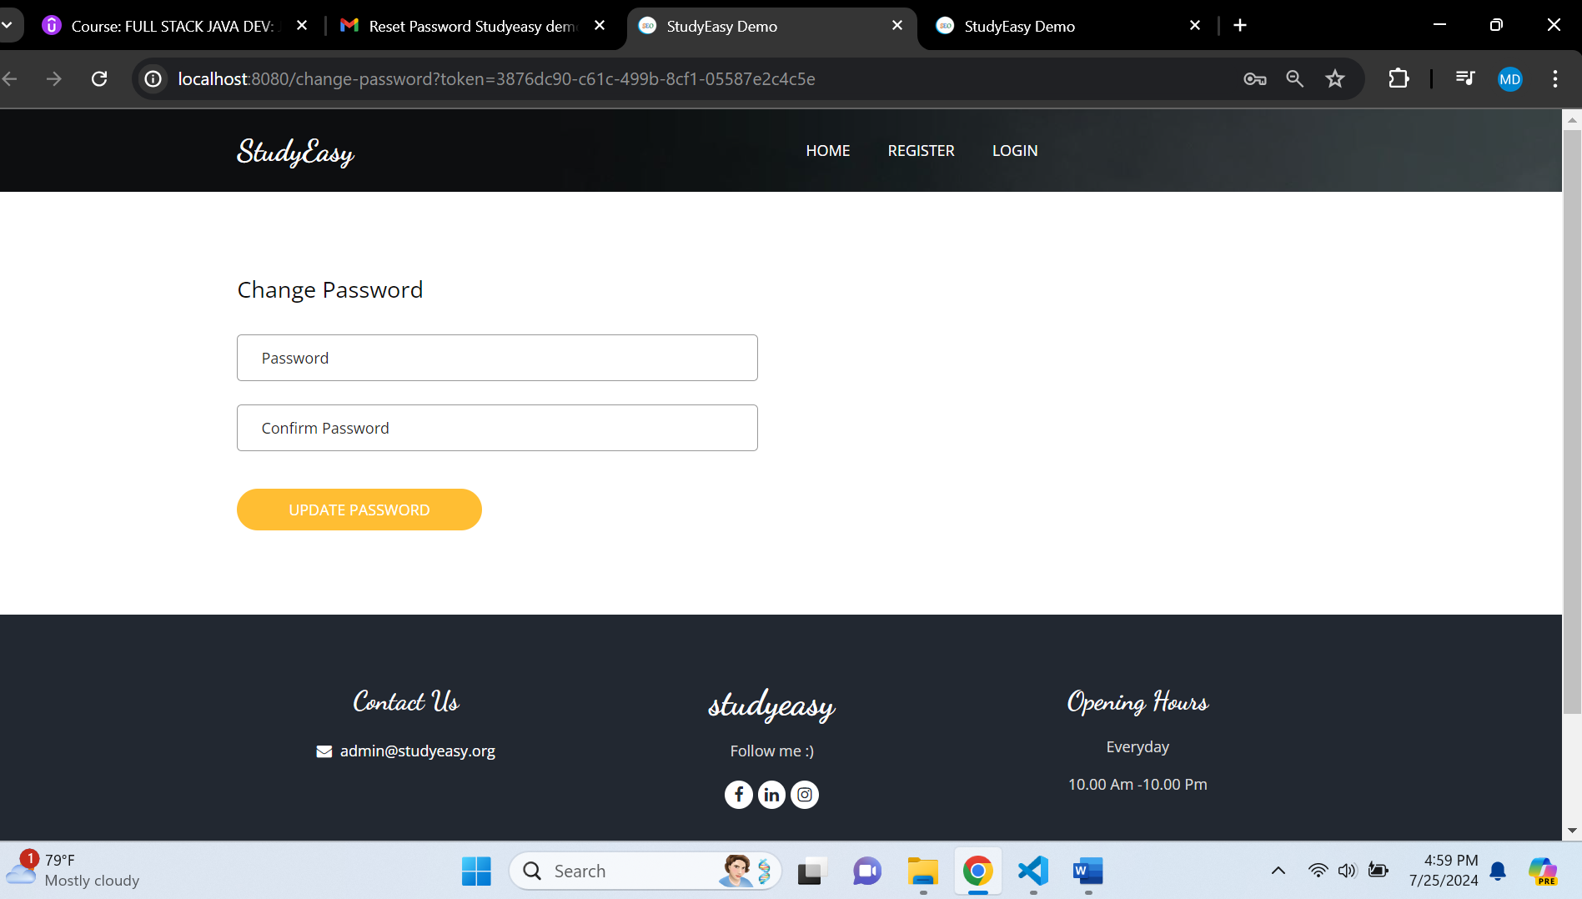

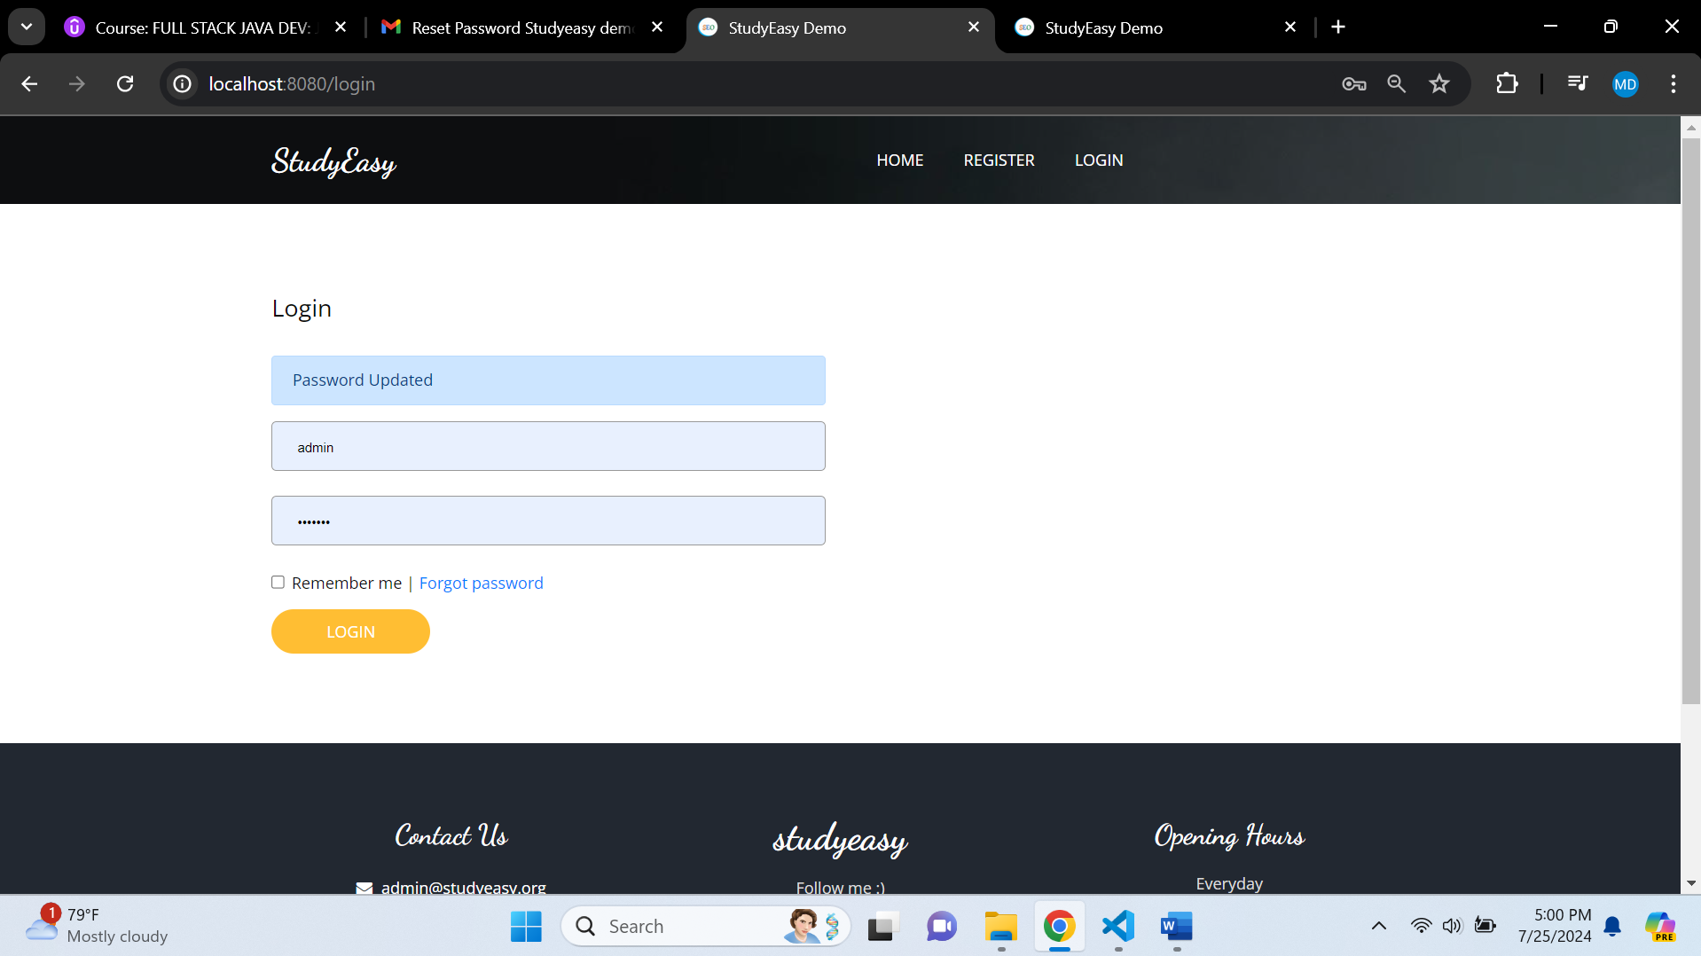

**Try to login with new password**

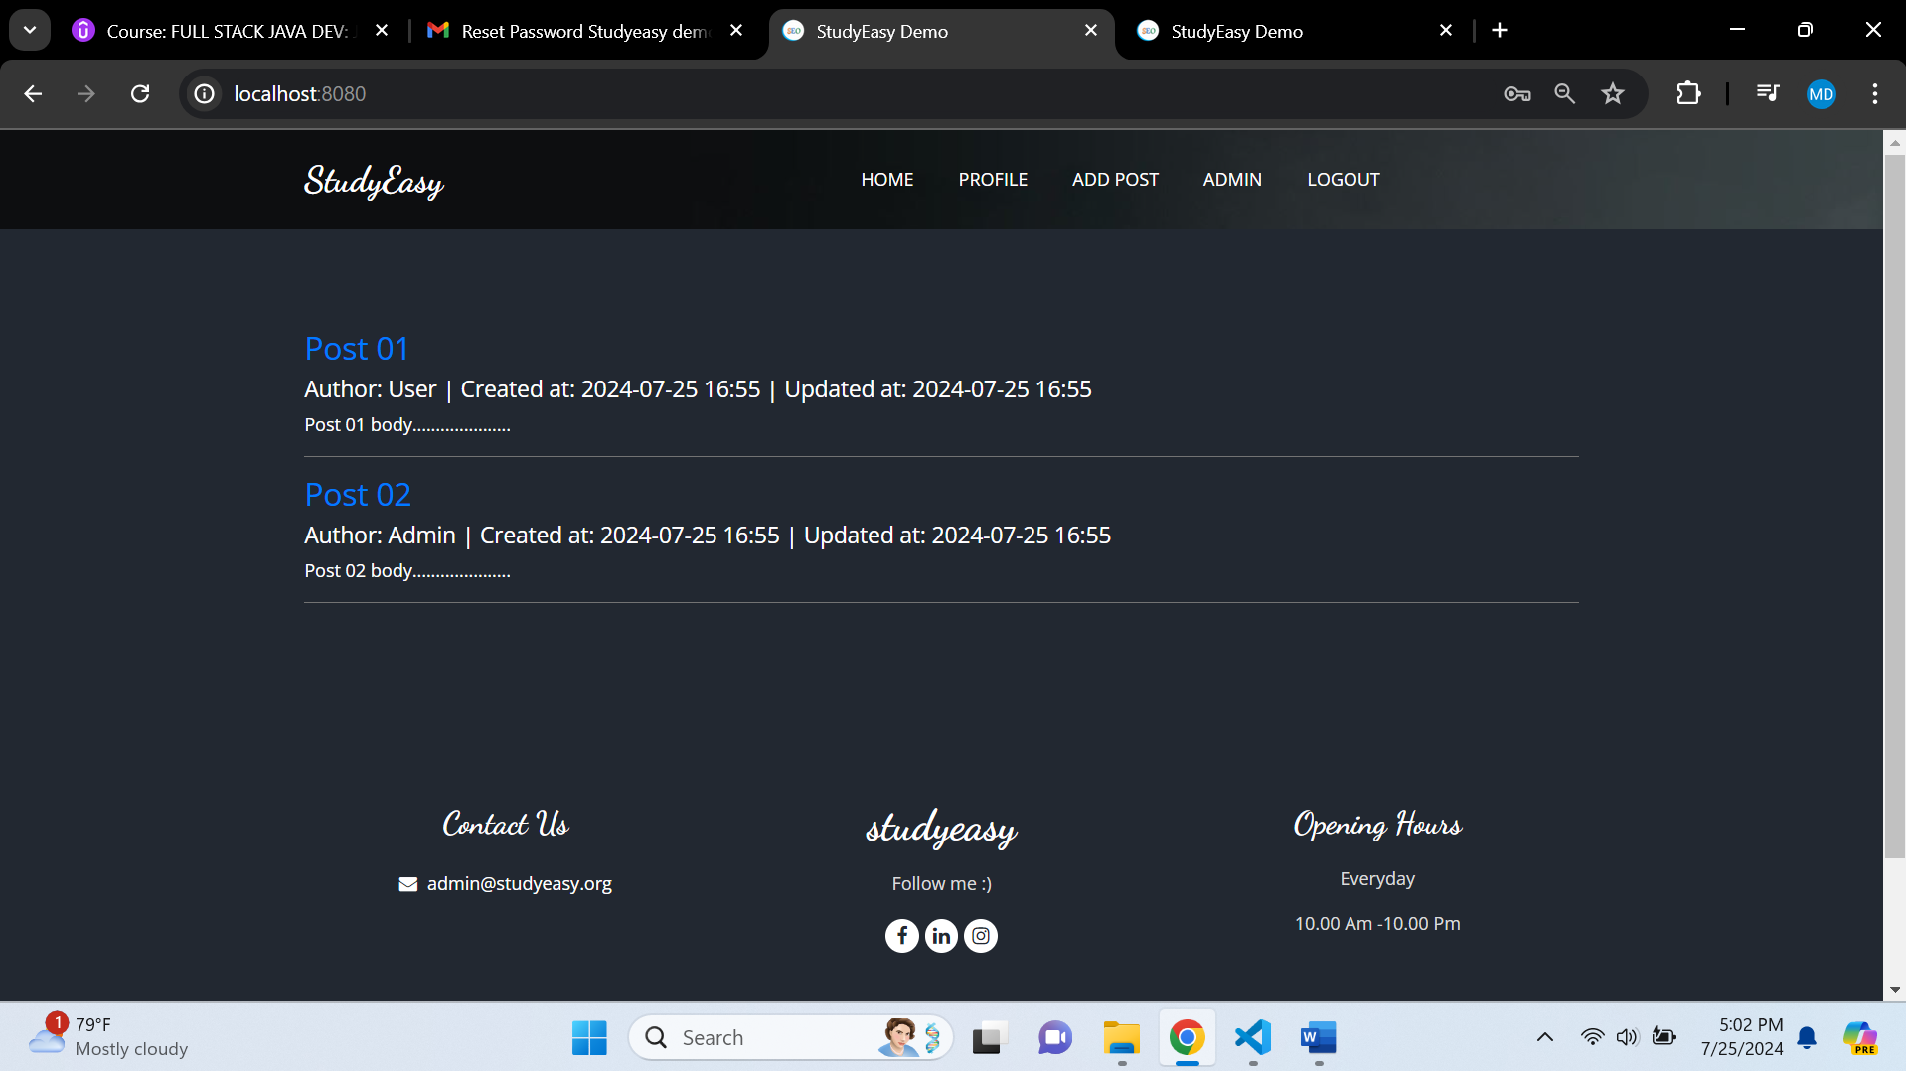

**Login is successful**