**Spring Boot – Spring Boot Logging**

In HomeRestController.java -> add below piece of code

//Adding Logger

    Logger logger = LoggerFactory.getLogger(HomeRestController.class);

    @GetMapping("/")

    public List<Post> home() {

        logger.error("This is a test log error");

        return postService.findAll();

    }

Structure

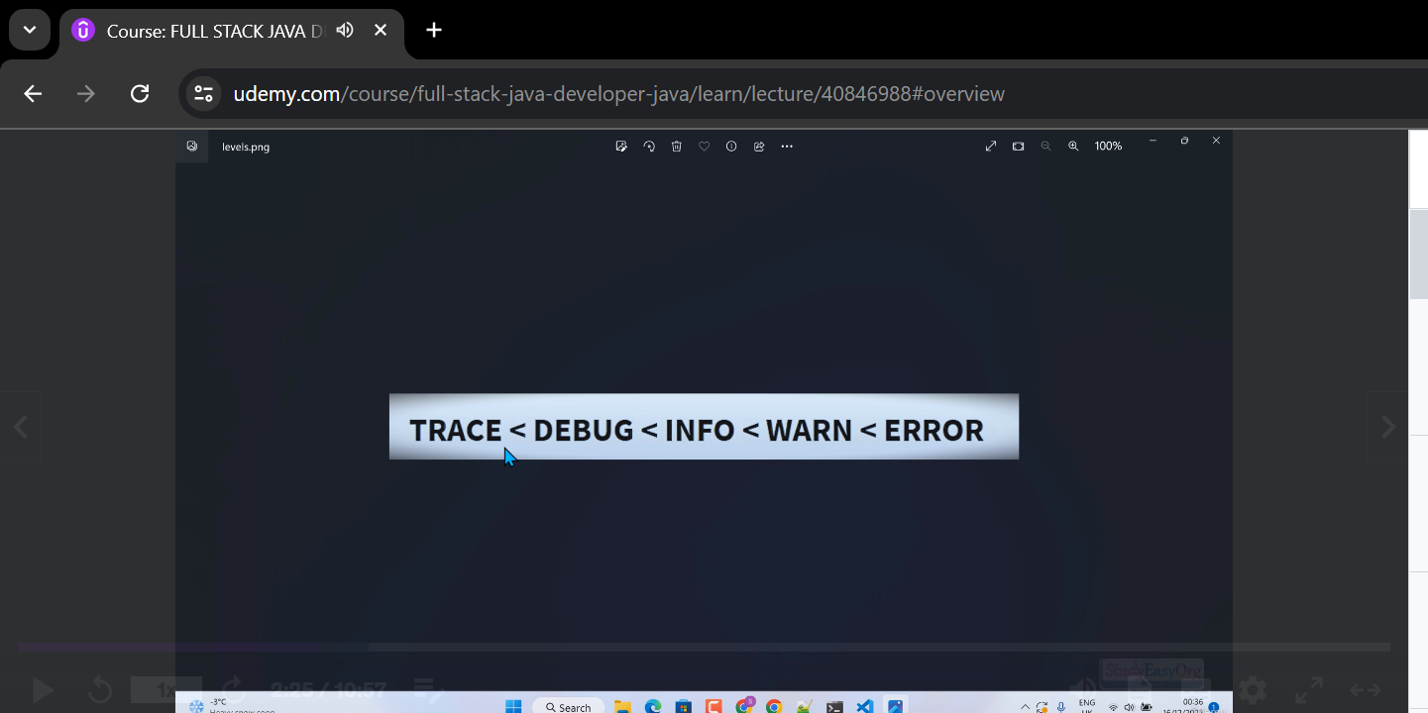

Trace: General working of the application

Debug: Checking every possible scenario where there could be an issue

Info:

Warn:

Error:

**Output(In Console)**

Servlet'

2024-07-27 23:48:57.476 INFO 20320 --- [nio-8080-exec-4] o.s.web.servlet.DispatcherServlet : Initializing Servlet 'dispatcherServlet'

2024-07-27 23:48:57.479 INFO 20320 --- [nio-8080-exec-4] o.s.web.servlet.DispatcherServlet : Completed initialization in 1 ms

2024-07-27 23:48:57.482 ERROR 20320 --- [nio-8080-exec-4] o.s.S.controller.HomeRestController : This is a test log error

2024-07-27 23:48:58.291 INFO 20320 --- [ restartedMain] .ConditionEvaluationDeltaLoggingListener : Condition evaluation unchanged

**2024-07-27 23:49:01.111 ERROR 20320 --- [nio-8080-exec-7] o.s.S.controller.HomeRestController : This is a test log error**



**Storing the logs**

**In application.properties -> add below piece of code**

# Logging settings

logging.level.org.studyeasy.SpringBlog=DEBUG

logging.pattern.console=%d [%level] %c{1.} [%t] %m%n

logging.file.name= = appLog.log

logging.pattern.file=%d [%level] %c{1.} [%t] %m%n

# %d    -> date

# level -> level of log we have

# %c    -> class

# %t    -> thread

# %m    -> message

# %n    -> new line

**Output**

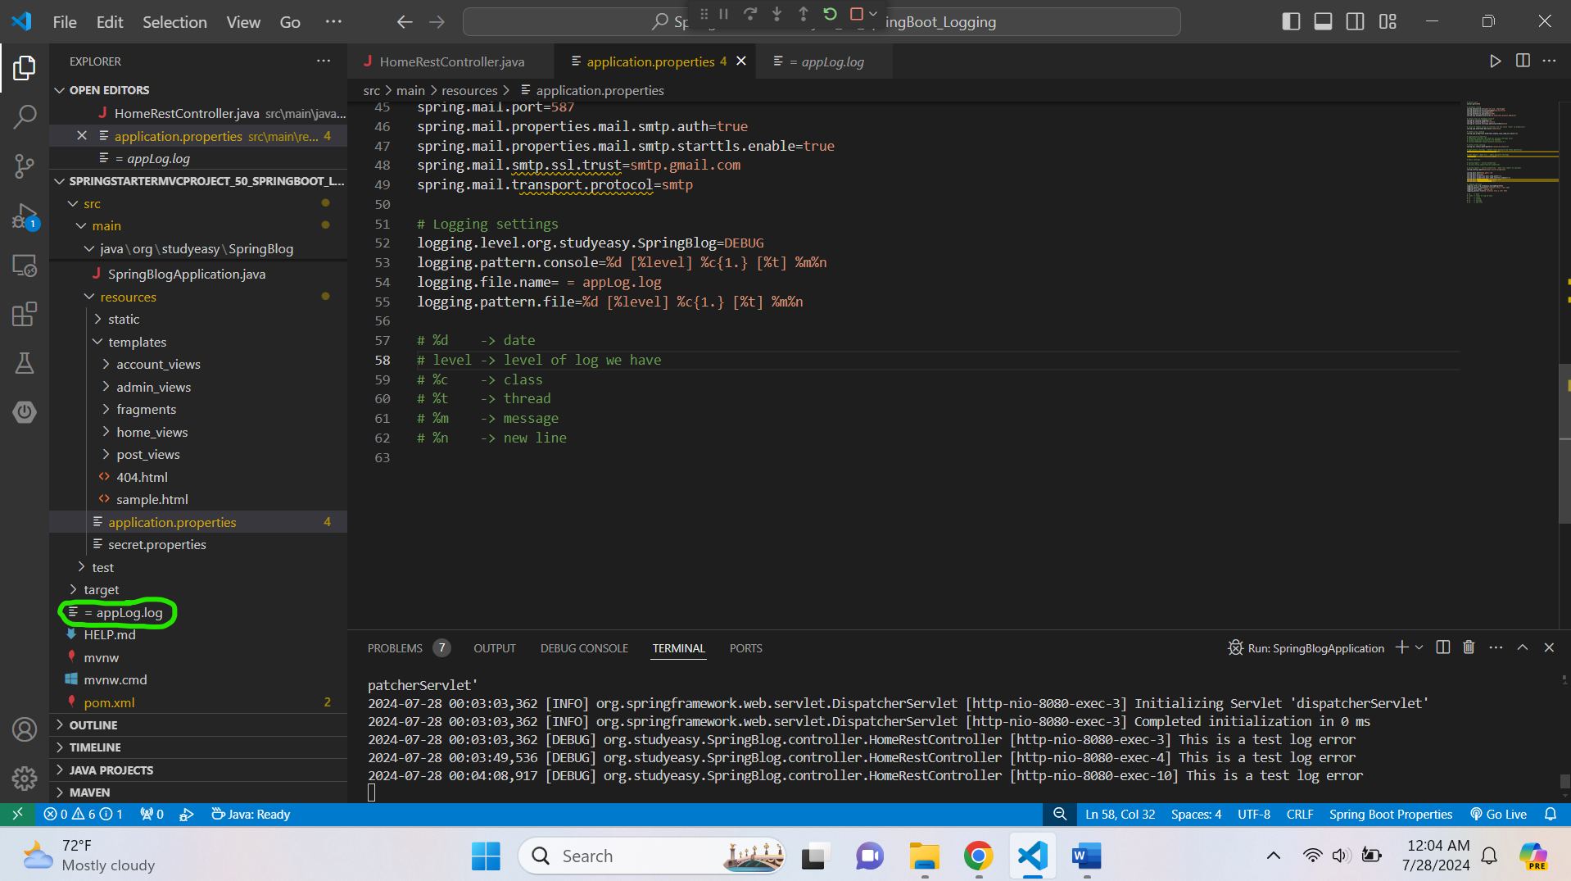

**In applog.log -> it will look like below**

2024-07-28 00:02:52,404 [INFO] org.studyeasy.SpringBlog.SpringBlogApplication [restartedMain] Starting SpringBlogApplication using Java 17.0.11 on Lenovo with PID 10324 (D:\RECYCLE BIN EXTRAS\ONLY_DOCS\JavaUdemy\Java_SpringBoot_MiniProject_01_Continued_DifferentVersion_2\SpringStarterMVCProject_50_SpringBoot_Logging\target\classes started by Lenovo in D:\RECYCLE BIN EXTRAS\ONLY_DOCS\JavaUdemy\Java_SpringBoot_MiniProject_01_Continued_DifferentVersion_2\SpringStarterMVCProject_50_SpringBoot_Logging)

2024-07-28 00:02:52,404 [DEBUG] org.studyeasy.SpringBlog.SpringBlogApplication [restartedMain] Running with Spring Boot v2.7.5, Spring v5.3.23

2024-07-28 00:02:52,404 [INFO] org.studyeasy.SpringBlog.SpringBlogApplication [restartedMain] No active profile set, falling back to 1 default profile: "default"

2024-07-28 00:02:52,796 [INFO] org.springframework.data.repository.config.RepositoryConfigurationDelegate [restartedMain] Bootstrapping Spring Data JPA repositories in DEFAULT mode.

2024-07-28 00:02:52,827 [INFO] org.springframework.data.repository.config.RepositoryConfigurationDelegate [restartedMain] Finished Spring Data repository scanning in 26 ms. Found 3 JPA repository interfaces.

2024-07-28 00:02:52,985 [INFO] org.springframework.boot.web.embedded.tomcat.TomcatWebServer [restartedMain] Tomcat initialized with port(s): 8080 (http)

2024-07-28 00:02:52,986 [INFO] org.apache.catalina.core.StandardService [restartedMain] Starting service [Tomcat]

2024-07-28 00:02:52,986 [INFO] org.apache.catalina.core.StandardEngine [restartedMain] Starting Servlet engine: [Apache Tomcat/9.0.68]

2024-07-28 00:02:53,009 [INFO] org.apache.catalina.core.ContainerBase.[Tomcat].[localhost].[/] [restartedMain] Initializing Spring embedded WebApplicationContext

2024-07-28 00:02:53,009 [INFO] org.springframework.boot.web.servlet.context.ServletWebServerApplicationContext [restartedMain] Root WebApplicationContext: initialization completed in 605 ms

2024-07-28 00:02:53,027 [INFO] com.zaxxer.hikari.HikariDataSource [restartedMain] HikariPool-3 - Starting...

2024-07-28 00:02:53,042 [INFO] com.zaxxer.hikari.HikariDataSource [restartedMain] HikariPool-3 - Start completed.

2024-07-28 00:02:53,043 [INFO] org.springframework.boot.autoconfigure.h2.H2ConsoleAutoConfiguration [restartedMain] H2 console available at '/db-console'. Database available at 'jdbc:h2:file:./db/blogdb'

2024-07-28 00:02:53,079 [INFO] org.hibernate.jpa.internal.util.LogHelper [restartedMain] HHH000204: Processing PersistenceUnitInfo [name: default]

2024-07-28 00:02:53,089 [INFO] org.hibernate.dialect.Dialect [restartedMain] HHH000400: Using dialect: org.hibernate.dialect.H2Dialect

2024-07-28 00:02:53,191 [INFO] org.hibernate.engine.transaction.jta.platform.internal.JtaPlatformInitiator [restartedMain] HHH000490: Using JtaPlatform implementation: [org.hibernate.engine.transaction.jta.platform.internal.NoJtaPlatform]

2024-07-28 00:02:53,192 [INFO] org.springframework.orm.jpa.LocalContainerEntityManagerFactoryBean [restartedMain] Initialized JPA EntityManagerFactory for persistence unit 'default'

2024-07-28 00:02:53,366 [INFO] org.springframework.security.web.DefaultSecurityFilterChain [restartedMain] Will secure any request with [org.springframework.security.web.session.DisableEncodeUrlFilter@752c259a, org.springframework.security.web.context.request.async.WebAsyncManagerIntegrationFilter@ffd97b4, org.springframework.security.web.context.SecurityContextPersistenceFilter@7b78a81e, org.springframework.security.web.header.HeaderWriterFilter@6510c06f, org.springframework.security.web.authentication.logout.LogoutFilter@79df9d71, org.springframework.security.web.authentication.UsernamePasswordAuthenticationFilter@4517f79c, org.springframework.security.web.authentication.www.BasicAuthenticationFilter@a0ad09b, org.springframework.security.web.savedrequest.RequestCacheAwareFilter@5af8b618, org.springframework.security.web.servletapi.SecurityContextHolderAwareRequestFilter@39080690, org.springframework.security.web.authentication.rememberme.RememberMeAuthenticationFilter@46e83a0c, org.springframework.security.web.authentication.AnonymousAuthenticationFilter@8c2f41d, org.springframework.security.web.session.SessionManagementFilter@6d726bb6, org.springframework.security.web.access.ExceptionTranslationFilter@3ee3f859, org.springframework.security.web.access.intercept.FilterSecurityInterceptor@4976c5ed]

2024-07-28 00:02:53,389 [WARN] org.springframework.boot.autoconfigure.orm.jpa.JpaBaseConfiguration$JpaWebConfiguration [restartedMain] spring.jpa.open-in-view is enabled by default. Therefore, database queries may be performed during view rendering. Explicitly configure spring.jpa.open-in-view to disable this warning

2024-07-28 00:02:53,544 [INFO] org.springframework.boot.devtools.autoconfigure.OptionalLiveReloadServer [restartedMain] LiveReload server is running on port 35729

2024-07-28 00:02:53,564 [INFO] org.springframework.boot.web.embedded.tomcat.TomcatWebServer [restartedMain] Tomcat started on port(s): 8080 (http) with context path ''

2024-07-28 00:02:53,571 [INFO] org.studyeasy.SpringBlog.SpringBlogApplication [restartedMain] Started SpringBlogApplication in 1.211 seconds (JVM running for 69.344)

2024-07-28 00:02:54,078 [INFO] org.springframework.boot.devtools.autoconfigure.ConditionEvaluationDeltaLoggingListener [restartedMain] Condition evaluation unchanged

2024-07-28 00:03:03,362 [INFO] org.apache.catalina.core.ContainerBase.[Tomcat].[localhost].[/] [http-nio-8080-exec-3] Initializing Spring DispatcherServlet 'dispatcherServlet'

2024-07-28 00:03:03,362 [INFO] org.springframework.web.servlet.DispatcherServlet [http-nio-8080-exec-3] Initializing Servlet 'dispatcherServlet'

2024-07-28 00:03:03,362 [INFO] org.springframework.web.servlet.DispatcherServlet [http-nio-8080-exec-3] Completed initialization in 0 ms

2024-07-28 00:03:03,362 [DEBUG] org.studyeasy.SpringBlog.controller.HomeRestController [http-nio-8080-exec-3] This is a test log error

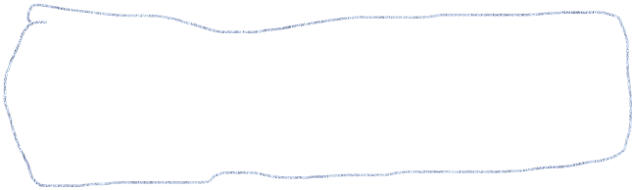2024-07-28 00:03:49,536 [DEBUG] org.studyeasy.SpringBlog.controller.HomeRestController [http-nio-8080-exec-4] This is a test log error

2024-07-28 00:04:08,917 [DEBUG] org.studyeasy.SpringBlog.controller.HomeRestController [http-nio-8080-exec-10] This is a test log error

**Updated HomeRestController.java**

package org.studyeasy.SpringBlog.controller;

import java.util.List;

import org.slf4j.Logger;

import org.slf4j.LoggerFactory;

import org.springframework.beans.factory.annotation.Autowired;

import org.springframework.web.bind.annotation.GetMapping;

import org.springframework.web.bind.annotation.RequestMapping;

import org.springframework.web.bind.annotation.RestController;

import org.studyeasy.SpringBlog.models.Post;

import org.studyeasy.SpringBlog.services.PostService;

@RestController

@RequestMapping("/api/v1")

public class HomeRestController {

    @Autowired

    private PostService postService;

    //Adding Logger

    Logger logger = LoggerFactory.getLogger(HomeRestController.class);

    @GetMapping("/")

    public List<Post> home() {

        logger.debug("This is a test log error");

        return postService.findAll();

    }

    // @GetMapping("/")

    // public List<Post> home() {

    //     logger.error("This is a test log error");

    //     return postService.findAll();

    // }

    // @GetMapping("/")

    // public String home() {

    //     logger.error("This is a test log error");

    //     return "sample response";

    // }

    // @GetMapping("/")

    // public List<Post> home() {

    //     return postService.findAll();

    // }

    //------------------xxxx Demo Display xxxxx----------------------------------------------

    // @GetMapping("/")

    // public List<String> home() {

    //     return List.of("Post 1", "Post 2", "Post 3");

    // }

}

2024-07-28 00:04:08,917 [DEBUG] org.studyeasy.SpringBlog.controller.HomeRestController [http-nio-8080-exec-10] This is a test log error

**[DEBUG] -> This is the level like debug, error and more.**